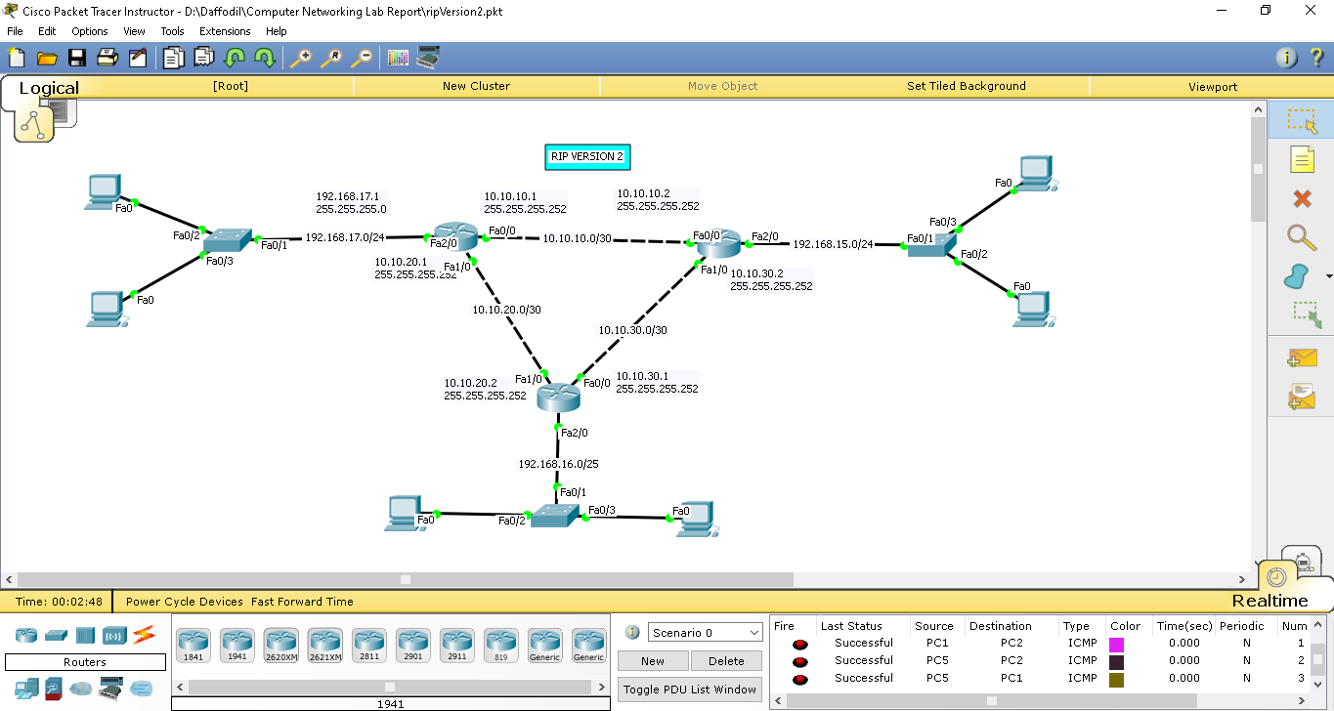

Here,

Router networks IP are,

10.10.10.0/30

10.10.20.0/30

10.10.30.0/30

And end device networks IP are,

192.168.17.0/24

192.168.15.0/24

192.168.16.0/25

**Router configuration**

Router 1>>

en

conf t

int fa0/0

ip address 10.10.10.1 255.255.255.252

no shut

exit

int fa1/0

ip address 10.10.20.1 255.255.255.252

no shut

exit

int fa2/0

ip address 192.168.17.1 255.255.255.0

no shut

exit

router rip

version 2

network 10.10.10.0

network 10.10.20.0

network 192.168.17.0

no auto summery

exit

Router 2>>

en

conf t

int fa0/0

ip address 10.10.10.2 255.255.255.252

no shut

exit

int fa1/0

ip address 10.10.30.2 255.255.255.252

no shut

exit

int fa2/0

ip address 192.168.15.1 255.255.255.0

no shut

exit

router rip

version 2

network 10.10.10.0

network 10.10.30.0

network 192.168.15.0

no auto summary

exit

Router 3>>

en

conf t

int fa0/0

ip address 10.10.30.1 255.255.255.252

no shut

exit

int fa1/0

ip address 10.10.20.2 255.255.255.252

no shut

exit

int fa2/0

ip address 192.168.16.1 255.255.255.128

no shut

exit

router rip

version 2

network 10.10.30.0

network 10.10.20.0

network 192.168.16.0

no auto summary

exit