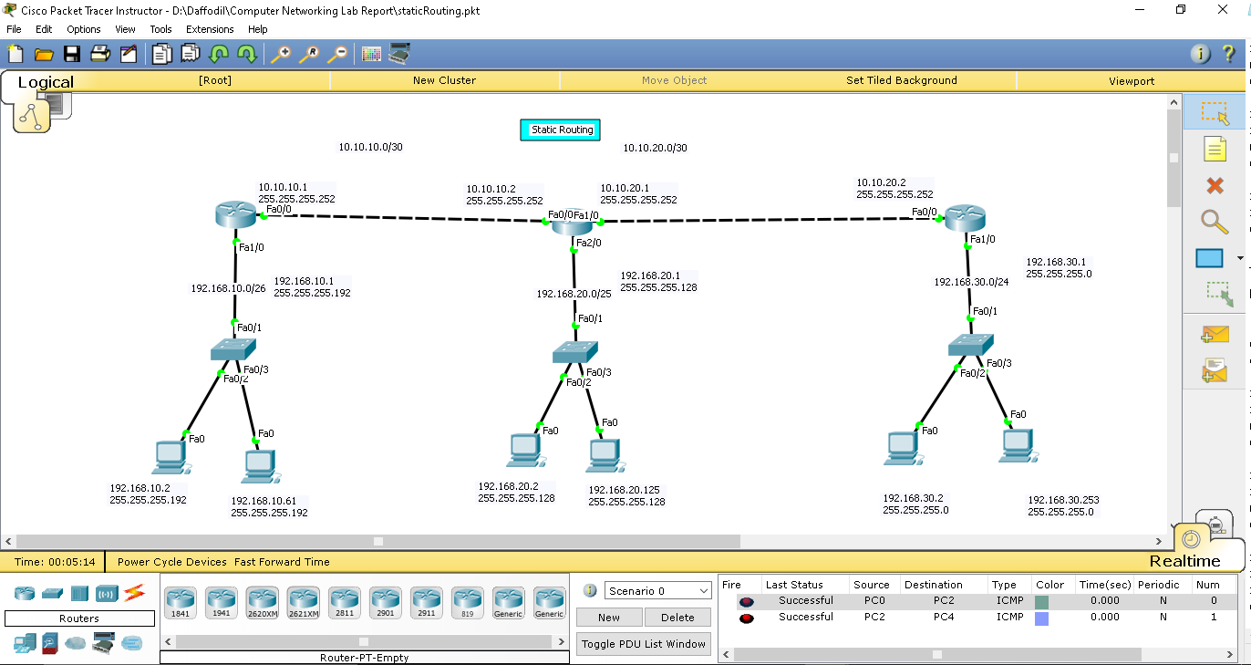

Here,

Router networks are,

10.10.10.0/30

10.10.20.0/30

10.10.30.0/30

And end device networks are,

192.168.10.0/26

192.168.20.0/25

192.168.30.0/24

**Router Configuration**

Router 1>>

----------

en

conf t

int fa0/0

ip address 10.10.10.1 255.255.255.252

no shut

exit

int fa1/0

ip address 192.168.10.1 255.255.255.192

no shut

exit

ip route 192.168.20.0 255.255.255.128 10.10.10.2

ip route 10.10.20.0 255.255.255.252 10.10.10.2

ip route 192.168.30.0 255.255.255.0 10.10.10.2

exit

Router 2>>

----------

en

conf t

int fa0/0

ip address 10.10.10.2 255.255.255.252

no shut

exit

int fa1/0

ip address 10.10.20.1 255.255.255.252

no shut

exit

int fa2/0

ip address 192.168.20.1 255.255.255.128

no shut

exit

ip route 192.168.10.0 255.255.255.192 10.10.10.1

ip route 192.168.30.0 255.255.255.0 10.10.20.2

exit

Router 3>>

----------

en

conf t

int fa0/0

ip address 10.10.20.2 255.255.255.252

no shut

exit

int fa1/0

ip address 192.168.30.1 255.255.255.0

no shut

exit

ip route 192.168.20.0 255.255.255.128 10.10.20.1

ip route 10.10.10.0 255.255.255.252 10.10.20.1

ip route 192.168.10.0 255.255.255.192 10.10.20.1

exit