

**Assignment**

**on**

**Logistic Regression**

**Submitted To:**

**Mr. Golam Rabbany**

**Lecturer, Department of CSE**

Daffodil International University

**Submitted By:**

**Md. Neamoth Ullah**

ID No: 162-15-8202

B.Sc. Program

Department of Computer Science & Engineering

Daffodil International University

# Logistic Regression

Logistic regression is a classification method.

Before knowing the “**Logistic regression**” we need to understand what is classification algorithm.

**Classification:** A predictive modeling problem where a class level is predicted for a given example of input.

There are some types of classification,

1. Binary Classification- Ex. 0,1
2. Multi-Class Classification- Monkey, Dog, Cat
3. Multi-Level Classification
4. Imbalance Classification- Medical Diagnostic

**Logistic Regression:** It is used for predicting the categorical depended variable using a given set of independent variable.

Ex. Some is COVID positive or not.

**Logistic Regression**  is a Binary Classification model to predict an output Yes/no or 0/1. But now a days we are also using this method for multi-class prediction also

Why do we call it Logistic Regression?

It’s a classification problem but we are still calling it with regression because its concept match with linear regression. And the 2nd reason is its predict a probability what regression do.

What make logistic regression unique?

The main thing is that is logistic regression we can predict some value to understand is that positive or negative. For example, we have some input for today’s raining probability. We trained out model with that input’s and the probability of raining is 0.01%. So we know that there will be no raining today. That’s how logistic regression works.

The python’s scikit-learn code to train a logistic regression classifier and make prediction is vary straight forward:

Import numpy as np  
import pandas as pd

From sklearn.linear_model import Logistic_Regression

#For load dataset

Data = pd.read_csv(“dataset.csv’)

X= data[:, 0:2]

Y= data[:,2]

#fit (train) the logistic regression classifier

Clf = logistic_regression(probability = true)

Model = clf.git(x,y)

#predict data for the model

Predict = clf.predict[(70,180)}

The general workflow of logistic regression is,

* Get a dataset
* Train a classifier
* Make a prediction such classifier

**Generalized linear model:** GLM is an advanced statistical modeling technique formulated by John Nelder and Robert and Robert Wedderburn in 1972.

**Equation: G(E1Y1) = α + βx1+yx2**

**Level Independent variable**

**Sigmoid Function:** A sigmoid function is a mathematical function which has a characteristic S-shaped curve. There is number of common sigmoid functions, such as the **Logistic function,** the **hyperbolic tangent,** and the **arctangent.**

The logistic regression make a S-Shape curve but linear regression make straight-line. In linear regression prediction is much more complicated because of the increasing number of X value. But in logistic regression the value will be remind in the range of 0-1.

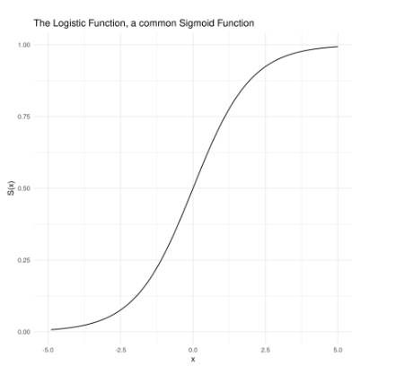

**Sigmoid Function Equation: $s(x)=\frac{1}{1+e^-x}$**

When the value of x is infinite , the value will be 1. When the x value will be minus infinite then the value will be 0.

We measure positive and negative radio with the boundary line of 0.5 value. If the prediction above 0.5 then it’s positive and if the value below 0.5 then it’s negative.

**Log odds : X= Wx+B**

The value of **“X”** determine with the log odds function. After calculate the log odds we get a possibility of 0 to 1.