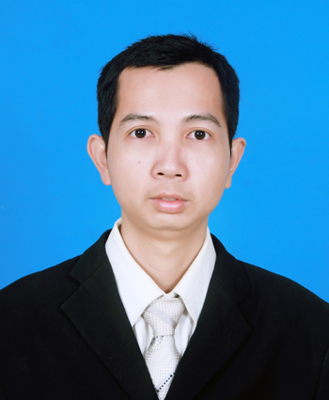
CURRICULUM VITAE
Name : Neang Tola
Address: #318, Street 30, Tek Thla,
SenSok, Phnom Penh, Cambodia.
H/P : 093 665 790
E-mail : neang.tola@gmail.com
I. Personal Data
Nationality : Cambodian
Sex : Male
Marital Status : Married
Date of birth : January 12th, 1987
Place of birth : Phnom Penh
II. Education
2013-2015 : Graduated Master degree from Norton University majoring in MsIT.
2006-2010 : Graduated Bachelor degree from Royal University of Phnom Penh (RUPP),
majoring in Computer Science and Engineering (CSE).
2008-2010 : Graduated from Asia Human Resource Development Center (Cambodia),
Field in Web Design.
2003-2006 : Studied at Samaki High School
III. Training Skills
2009-2010 : Took a course in Internet Programming include ASP, ASP.Net, XML, and XSL
2009 : Participated in Teaching English as Second Other Language 2009
2008-2009 : Took a course in Visual Basic 6.0 Programming and Ms. SQL Server
2004 : Took a course in Microsoft Word 2003
IV. Work Experiences
2014-Current : Working as Senior Web Developer at T.A.G Job Centre Co,. Ltd. Responsible for develop website of company, internal system, maintenance HR system and using technology PHP framework CodeIgniter, Laravel, Mysql and Postgresql.
2013-2014 : Worked as Web Developer at Musashi Advertising Co,. Ltd. Responsible develops in house project and client project from CodeIgniter Framework.
2010-2013 : Worked as PHP programmer at Manich Enterprise Co,.Ltd. Responsible for analyst Database, develop project form PHP or PHP framework, develop component of Joomla, design layout of website, and maintenance website clients.

2009-2010 : Worked as Researcher (Interviewer) at Indochina Research Limited. Responsible for collect data from real site and face to many position of each organization.
2008-2009 : Leader of Willingness Sharing Youth Club at Asia Human Resource
Development Center (Cambodia)
-Teaches HTML, CSS, ASP
-Repair and maintenance Computer
-Monthly report of working club
V. Languages
Khmer : Mother tongue
English : Speaking (good), Reading (good), Listening (good), and Writing (good)

VI. Hobbies
Exploring the internet for solving the computer’s problem, learning with forum web site and also learning with new technology on smart phone.
VII. Reference
- Mr. Chim Bunthoeurn (Lecturer at RUPP) Tel: 012 899 304
- Mr. Seng RengSey (Lecturer at Asia HRDC) Tel: 099 930 056

