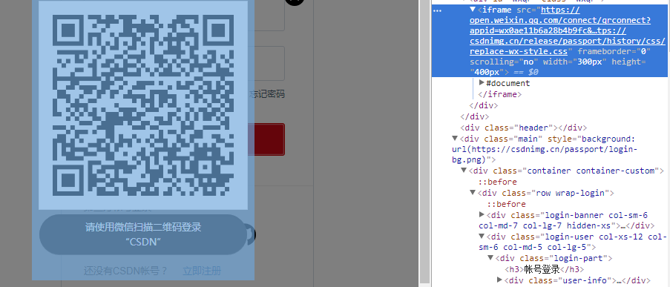

<https://open.weixin.qq.com/connect/qrconnect?appid=wx0ae11b6a28b4b9fc&scope=snsapi_login&redirect_uri=https://passport.csdn.net/account/weixin?qr=true&state=csdn&login_type=jssdk&self_redirect=default&style=white&href=https://csdnimg.cn/release/passport/history/css/replace-wx-style.css>

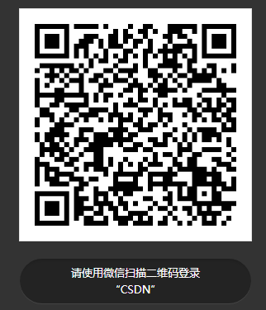

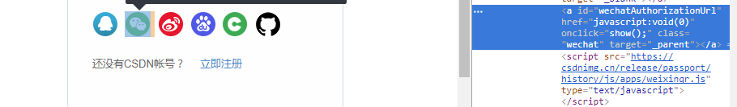

<https://csdnimg.cn/release/passport/history/js/apps/weixinqr.js>

