Veslo
Security & Data Processing Brief
Condensed two-page reference for client IT and information-security review
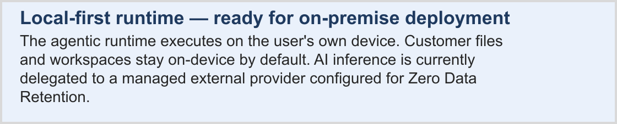
1. Executive summary
In brief. Veslo is a local-first, cloud-backed control surface for agentic work. The desktop application runs the workflow on the user's device, while cloud services provide identity, synchronization and centrally governed AI access.
• Local-first execution. Workspace files, source code and tool execution stay on-device by default.
• On-premise ready. The runtime is local by architecture and can operate inside the client's network.
• Zero Data Retention. Prompts and completions are processed transiently by the configured AI provider and are not retained or used for training.
• Centralized AI access. End users do not hold provider API keys; administrators bind users to approved providers and models.
• Two-layer authorization. Workspaces are explicitly authorized, and sensitive actions require per-run user permission.
• End-to-end audit trail. Each run records prompts, plans, tool calls, permission decisions, outputs and artifacts.
2. Data handling summary
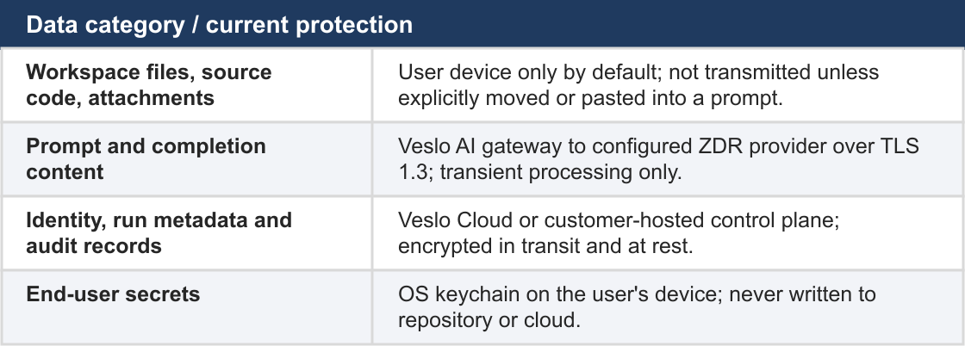

3. Security at a glance
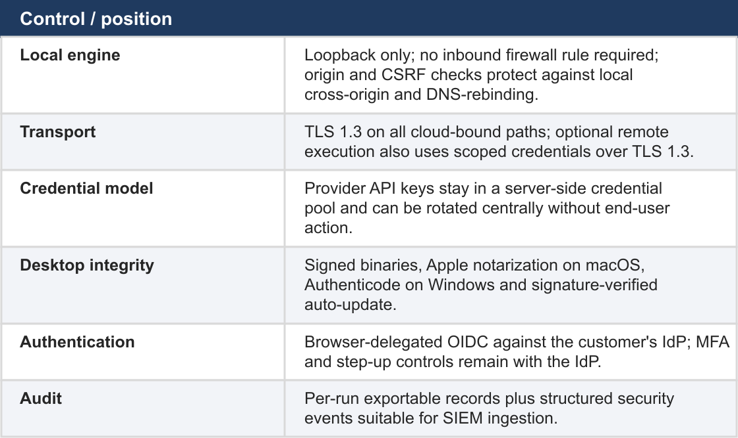
4. Compliance posture
• DPA package. Sub-processor list, EU SCCs and a Transfer Impact Assessment template are provided where international transfers apply.
• Provider assurance. The configured AI provider operates under ZDR and holds SOC 2 Type 2; report references are included in the DPA package.
• Veslo assurance. SOC 2 Type 2 and ISO 27001 for Veslo Cloud and the Veslo AI gateway are on the assurance roadmap; internal controls are available under NDA today.
• Data residency. Cloud-synced metadata is stored in the customer's deployment region; on-premise deployments keep residency inside the customer network.
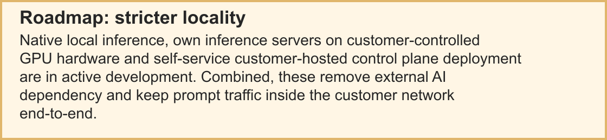
5. Review answers
• Are workspace files uploaded by default? No. They stay on-device unless explicitly moved, pasted into a prompt or routed to an enabled remote runtime.
• Are prompts stored by Veslo? Yes, in the run audit record. Retention is configurable and governed by the DPA; on-premise deployments keep records in the customer environment.
• Does the AI provider train on customer prompts? No. ZDR excludes prompt and completion content from training, fine-tuning and evaluation.
• Where do vulnerability reports go? To the published security contact and security.txt address with PGP; high-severity reports are acknowledged within one business day.

