**Introduction**

In my household, a high-end car, the Land Rover Defender 110 P400 SE, was purchased in the year 2024. It is a luxury SUV-type car known for its aggressive power, 4-wheel drive off-road capabilities, premium interior, and safety features. The car at the time was priced at around AUD 145,000. The decision to purchase the car was influenced by personal preferences, price, disposable income, and the availability of substitutes.

Land Rover belongs to the Premium SUV segment in passenger vehicles. This segment competes with other luxury car segments such as mid-size luxury SUVs and full-size luxury SUVs. The passenger vehicle industry is a competitive and dynamic industry.

This report is an analysis of decision-making processes through the lens of macroeconomic theories, focusing on consumer behaviour, supply and demand dynamics, market structure, and the macroeconomic environment. Each section is linked to theoretical principles and real-world insights, supported by data and diagrams to support the analysis.

This report aims to understand how economic frameworks guide rational and informed decisions even in complex, high-stake purchases such as that of a luxury vehicle.

**Economic Factors Influencing the Decision**

**a. Price and Income Constraints**  
At the time of purchase, the Land Rover Defender’s price was approximately AUD 145,937. With our household income, we could bear the cost, but taking an auto loan was a very informed decision. During that time, the cash rate was stable at 4.35% (RBA, 2024). Any increase in rates would have increased our monthly spend. Defender stood out when compared to other lower-range options as it offered a highly safe and tested car, 4-wheel drive, off-road capabilities, and features like advanced traction control.  
Therefore, the decision to spend more for the added feature and benefit instead of a lower version was worth it – this fits the definition of marginal analysis: comparing extra cost to extra value.

**b. Availability of Substitutes**  
The Premium SUV segment has options to choose from Jeep, Mercedes, and other car manufacturers. At a similar price range, Jeep offers the Grand Cherokee, Mercedes-Benz GLE, and Toyota’s Land Cruiser 300 series. In comparison to these brands, Jeep offers luxury features at a slightly more accessible price, a strong reputation in Australia’s market, and has a strong market legacy of being a rugged American engineering brand in the SUV and off-road category.  
This shows brand-based differentiation, and demand for such vehicles is price-inelastic.

**c. Preference and Opportunity Cost**  
With a fixed budget, the decision to purchase the luxury vehicle at a high price point meant losing the opportunity to go on a luxury vacation or an investment opportunity. This reflects the core idea of opportunity cost — giving up potential benefits from other choices when making a decision.

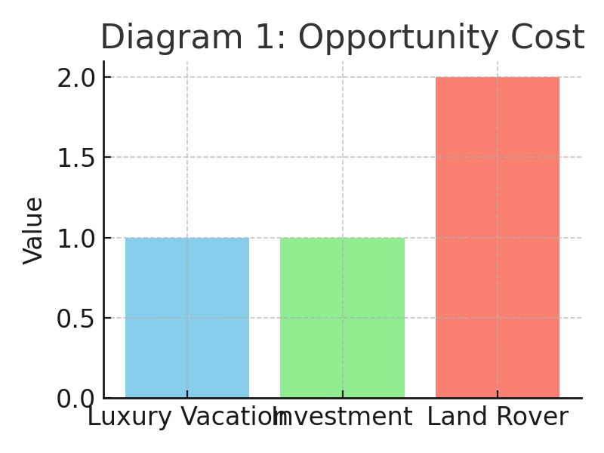

**Diagram 1: do this**

**Market Structure Analysis**

The luxury SUV market in Australia is dominated by major players: BMW, Mercedes-Benz, Land Rover, and Audi. These firms control the Australian luxury SUV market, and all these players are each influential participants holding most of the market share.

**Market Share of Luxury Brands in Australia 2024** *(Go Auto)*

|  |  |
| --- | --- |
| BMW | 2.1% |
| MERCEDES-BENZ | 1.7% |
| LEXUS | 1.1% |
| LAND ROVER | 0.7% |

In the year 2024 in the luxury segment, BMW sold 26,341 units, Mercedes-Benz sold 19,989 units, Audi sold 15,333, and Land Rover sold 7,910 units (GoAuto, 2024). These figures clearly show that these firms hold strong positions in the market, hence the oligopoly market.

**Key Characteristic of the Market**

**a. High Entry Barriers:** The limited competition in the luxury SUV market is dominated by these major players. Over 80% of global luxury SUV sales are from Mercedes-Benz, BMW, Audi, Land Rover, Lexus, and Jeep (Statista, 2024).

**b. Fewer Sellers:** In the luxury SUV segment, there are a few firms that hold significant market share. They have the power to influence price and product. These players have higher profits as they face lesser competition, and price is not a differentiator.  
Land Rover differentiates from competitors through product differentiators, such as its British heritage, latest features, and its rugged design.

**Diagram 2: Kinked Demand Curve in Oligopoly**

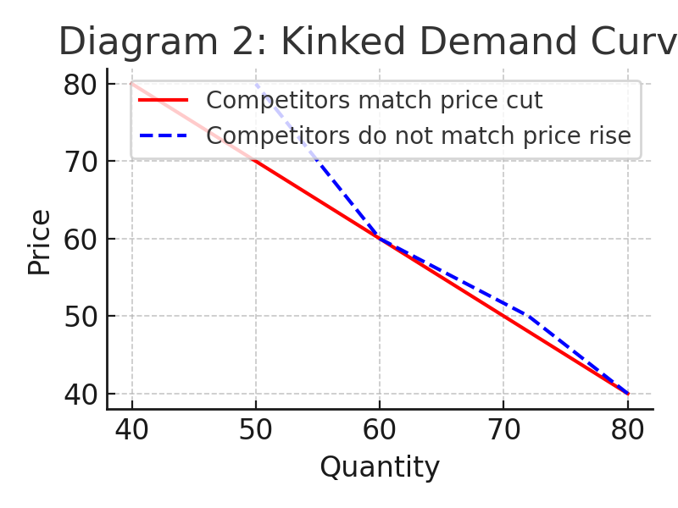

**Demand-Side Dynamics**

The Australian market in the year 2024 experienced an increase in demand for Land Rover. Ford reported an outstanding 234% increase in sales in the first quarter compared to last year (CarsGuide, 2024). The SUV segment accounts for 56.9% of Australia’s car market in the same year (CarExpert, 2025). At the same time, dealers reported that cars registered in 2023 were waiting to be delivered.

Post-pandemic semiconductor shortages and shipping delays are still ongoing problems for manufacturers. Despite the actual price not swinging by much, dealerships didn’t offer discounts, and according to automotive news, customers were ready to pay a premium.

**Supply-Side Factors**

The manufacturer was facing delayed production and could not push production to match demand. As discussed above, demand rose significantly, but production could not scale to match the long-waiting customer demand.

The shortage of aluminium caused by issues with suppliers (DailyWrap, 2024) and ongoing border issues disrupted the supply chain, clearly slowing down production, marking its ninth month of continuous drop.

It has been reported that Defender saw an increase from $250 to over $4,000, but it is still unclear whether the price rose proportionally to the increase in demand. However, the price increase is justified.

**Diagram 3: Supply and Demand Equilibrium Shift**

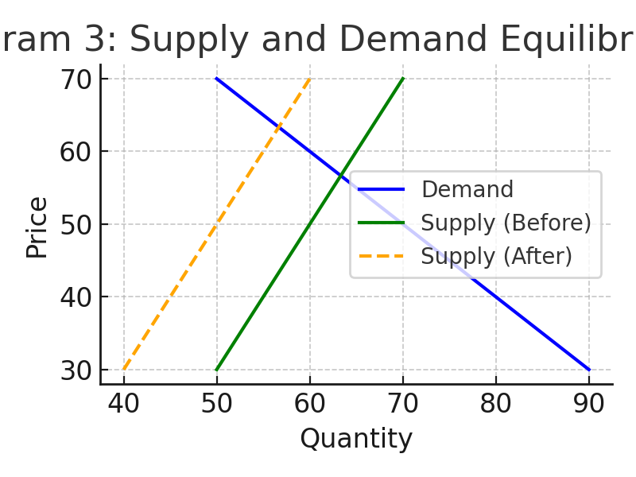

**Future Economic Impacts on the Product**

The car manufacturing industry is highly reactive to inflation, interest rates, and changes in consumer income.

**a. Inflation**

Inflation disturbs purchasing power due to the increased cost of goods and services. As the cost of goods and services in the market rises substantially, money loses its purchasing power.

Inflation affects both the consumer and the manufacturer. An increase in the inflation rate will increase production costs as material, logistics, and labor costs go up. In such cases, retailers are forced to increase the cost of Defender.

The inflation rate fluctuated between 2–4% in the years 2023 and 2024, and the Reserve Bank of Australia targets 2–3%. As of now, it remains steady, which means the cost to the manufacturer and price of the car to consumers continues to remain steady.

**b. Interest Rates**  
Interest rate is the cost of borrowing money, set by the country’s central bank (RBA in Australia). Paying in full cash means debt-free, room to negotiate, and less overhead expense in the future. While car loans have their own benefits (e.g., credit score increases, cash savings), they come with a monthly commitment, and missed payments might harm credit score. It all comes down to preference—whether a consumer can pay the full amount in cash or opt for a car loan.

CommBank is offering a saving of 0.70% through the EV Access Program, which means a customer can save up to $25,000 over the life of a 7-year loan (CommBank, 2024). Such initiatives enable more consumers to purchase a luxury SUV.

While an increase in rates discourages middle-income buyers from purchasing expensive vehicles like the Defender, hence the market for luxury SUVs declines.

**c. Changes in Consumer Income**  
As consumers’ income changes, so too do their purchasing habits. Theoretically, when income rises, demand for goods also tends to rise.

As this is a luxury product, any decrease in income proportionally decreases purchasing power. One might become hesitant to prioritize cars over other needs in such cases.  
It would be impossible to predict the income of all consumers, but data from 2012 to 2023 shows that monthly earnings in Australia were 3740 USD and increased to 4026 USD in 2024. So, if income remains stable and as long as consumers have disposable income, we can expect more growth in the Land Rover market in upcoming years.

**Conclusion**

We purchased a Land Rover Defender 110 P400 SE in 2024. We chose this specific brand and model because of its off-road capabilities and luxury. Choosing Land Rover over Mercedes, BMW, and others was a well-thought-out purchase considering its superior safety and performance despite the high cost.

Through thorough research, it is clear that the Luxury SUV market is an oligopoly. BMW, Mercedes, Lexus, Audi, and Land Rover dominate this segment. The dynamics of this market are such that competition is limited, allowing each firm to operate successfully.  
This segment is growing year-on-year despite global supply chain issues, semiconductor shortages, and reduced production.

The market seems very positive and stable for the future, but part of that depends on how inflation, interest rates, and consumer income levels behave going forward

**References**

**GoAuto. (2024, January 13). *BMW remains Australia’s top luxury car brand*. Retrieved from** [**https://www.goauto.com.au/news/bmw/bmw-remains-australia-rsquo-s-top-luxury-car-brand/2025-01-13/95427.html**](https://www.goauto.com.au/news/bmw/bmw-remains-australia-rsquo-s-top-luxury-car-brand/2025-01-13/95427.html)

**Statista. (2024). *Global production of luxury cars by make*. Retrieved from** [**https://www.statista.com/statistics/262921/global-production-of-luxury-cars-by-make/**](https://www.statista.com/statistics/262921/global-production-of-luxury-cars-by-make/)

**CarExpert. (2025). *Australia’s worst selling SUVs of 2024*. Retrieved from** [**https://www.carexpert.com.au/car-news/australias-worst-selling-suvs-of-2024**](https://www.carexpert.com.au/car-news/australias-worst-selling-suvs-of-2024)

**Daily Wrap. (2024). *Jaguar Land Rover faces production delays due to aluminium shortage*. Retrieved from** [**https://dailywrap.net/en-gb/jaguar-land-rover-faces-production-delays-due-to-aluminium-shortage,7056085961480321a**](https://dailywrap.net/en-gb/jaguar-land-rover-faces-production-delays-due-to-aluminium-shortage,7056085961480321a)

**CommBank. (2024, December). *EVs more affordable for Aussies*. Retrieved from** [**https://www.commbank.com.au/articles/newsroom/2024/12/evs-more-affordable-for-aussies.html**](https://www.commbank.com.au/articles/newsroom/2024/12/evs-more-affordable-for-aussies.html)

**CarsGuide. (2024). *Ford sales surge 234% in Q1 2024*. Retrieved from [**[**https://www.carsguide.com.au**](https://www.carsguide.com.au)**]**

**Reserve Bank of Australia. (2024). *Interest rate decision*. [**[**https://www.rba.gov.au/**](https://www.rba.gov.au/)**]**