
Addis Ababa University
College of Technology & Built Environment
School of Information Technology and Engineering
Natural Language Processing — Assignment 1
Amharic N-gram Language Models
Corpus analysis, intrinsic and extrinsic evaluation, and a next-word suggestion system on the GPAC corpus
Group members:
Neibyu Daniel
Yonas Tadesse
Selamawit Siferh
Instructor: Fantahun B. (PhD)
October 2026
Contents
Summary 3
1. Introduction 4
1.1 Corpus 4
1.2 Implementation 4
2. Task 1 — N-gram Language Model 5
1.1 Preprocessing and corpus statistics 5
1.2 Creating n-grams (n = 1, 2, 3, 4) 6
1.3 N-gram probabilities and the top-10 n-grams 6
1.4 Conditional probability of a word given the previous word 8
1.5 N-gram frequencies after stop-word removal 8
1.6 Word clouds before and after stop-word removal 10
1.7 Probability of a sentence 11
1.8 Random sentence generation 12
3. Task 2 — Intrinsic Evaluation (Perplexity) 14
3.1 Setup 14
3.2 Results 14
3.3 Effect of training-set size 15
3.4 Discussion 15
4. Task 3 — Extrinsic Evaluation 16
4.1 Discussion 17
5. Task 4 — Amharic Predictive Text and Next-Word Suggestion 18
5.1 Design 18
5.2 Example suggestions 18
5.3 Deployment 18
6. Limitations and Future Work 20
Conclusion 20
References 21

Summary
We built n-gram language models (n = 1–4) on the General Purpose Amharic Corpus (GPAC): 1,063 MB of text, which after cleaning gives 5,057,938 sentences and 77,222,568 tokens with 1,818,474 distinct words. All four tasks were completed and run locally on the full corpus:
- Task 1 (n-gram model): corpus statistics, n-grams for n = 1–4, n-gram and conditional probabilities, stop-word analysis, word clouds, sentence probabilities and random sentence generation.
- Task 2 (intrinsic evaluation): on held-out sentences, interpolated Kneser-Ney perplexity falls from 10,682 (unigram) to 1,220, 760 and 676 for n = 2, 3, 4. Unsmoothed MLE gives zero probability to 72.6% of test tokens at n = 4, and add-one smoothing gets worse as n grows.
- Task 3 (extrinsic evaluation): in three downstream tasks the ranking is the same as for perplexity. Top-5 next-word accuracy rises from 9.8% (n = 1) to 35.9% (n = 4); a predictive keyboard saves 51.7% of keystrokes with a trigram; and a trigram model tells real sentences from corrupted ones 80%–99% of the time, depending on the corruption.
- Task 4 (application): an interactive Amharic next-word suggestion app (top-5 suggestions with probabilities, click to insert, mid-word completion), deployed on Hugging Face Spaces: https://huggingface.co/spaces/nebadan/amharic-next-word
One methodological finding: 24.5% of GPAC sentences are exact repeats. Without removing them before the train/test split, the same sentences appear in both sets and the evaluation scores are inflated. All evaluation results in this report use the deduplicated data.

1. Introduction
A statistical language model assigns a probability to a sequence of words. An n-gram model approximates the probability of each word using only the previous n − 1 words (the Markov assumption):
P(w₁ … wₘ) ≈ ∏ᵢ P(wᵢ | wᵢ₋ₙ₊₁ … wᵢ₋₁), with the MLE estimate P(wᵢ | h) = C(h wᵢ) / C(h)
Amharic is a Semitic language written in the Ge'ez (Ethiopic) script. Its rich morphology — prepositions, conjunctions, possessives and object markers attach to the word — produces a very large vocabulary, which makes the data-sparsity problem of n-gram models particularly visible. This assignment studies that problem on a large real corpus and turns the model into a practical predictive-text tool.

1.1 Corpus
GPAC (General Purpose Amharic Corpus) was created by Gereme, Zhu, Ayall and Alemu (Information 12(1):20, 2021) as part of their work on Amharic fake-news detection. It was collected mainly from Amharic news websites, blogs and other web sources. The version provided for the assignment is a single 1.06 GB UTF-8 text file without line breaks.

1.2 Implementation
All code was written for this assignment in Python (numpy) and runs locally. Standard Python dictionaries of tuples do not fit 50 million distinct 4-grams in memory, so each n-gram is stored as a 64-bit hash of its word ids in sorted numpy arrays; look-ups are binary searches and all probabilities for a test set are computed in vectorised form. Building the four orders on 77 M tokens takes about two minutes. The full notebook (all tasks, ~19 minutes) needs about 22 GB of RAM.
Module | Purpose
amharic_lm/text.py | normalisation, sentence splitting, tokenisation, stop-word list
amharic_lm/corpus.py | streaming preprocessing, id encoding, train/test split
amharic_lm/ngram.py | hashed n-gram tables; MLE, add-k and interpolated Kneser-Ney; prediction; generation
amharic_lm/evaluate.py | next-word prediction, keystroke savings, corrupted-sentence discrimination
notebooks/Assignment1_Amharic_Ngram.ipynb | all tasks with outputs
app/app.py | Gradio next-word suggestion app (Hugging Face Space)

2. Task 1 — N-gram Language Model

1.1 Preprocessing and corpus statistics
The preprocessing pipeline:
- Unicode NFC normalisation.
- Homophone normalisation. Modern Amharic writes the same sound with several letters: ሀ/ሐ/ኀ, ሰ/ሠ, አ/ዐ and ጸ/ፀ (plus ኣ/ዓ → አ and ሃ → ሀ). All seven vowel orders of each family are mapped to one form, so e.g. ሐገር and ሀገር become the same word.
- Sentence segmentation on ። (full stop), ፡፡ (two word-separators — the most common sentence end in this web corpus), ፧, ?, ! and ፨. The 1 GB single-line file is read in 4-million-character chunks cut at sentence ends.
- Tokenisation. Ethiopic punctuation (፡ ፣ ፤ ፥ ፦) and ASCII punctuation become spaces; dots and slashes inside abbreviations are removed (ዓ.ም → አም, ዶ/ር → ዶር); numbers, including 1,000,000 and dates, become one <NUM> token; Latin-script text and symbols are dropped.

Statistic | Value
Raw file size | 1,063 MB
Raw characters / whitespace tokens | 424,397,739 / 81,653,055
Sentences (unique) | 5,057,938 (3,818,593)
Repeated sentences | 24.5%
Tokens after cleaning | 77,222,568
Vocabulary size (types) | 1,818,474
Type/token ratio | 0.0235
Hapax legomena (words seen once) | 747,921 (41.1% of vocabulary)
Mean / median sentence length | 15.3 / 12 tokens
Mean word length (by token / by type) | 4.10 / 5.98 characters
Stop-word share of tokens | 15.8%
Zipf slope (log-log rank/frequency) | -1.20
Heaps' law fit V = K·N^β | K = 54.4, β = 0.58
Table 1. GPAC corpus statistics after preprocessing.
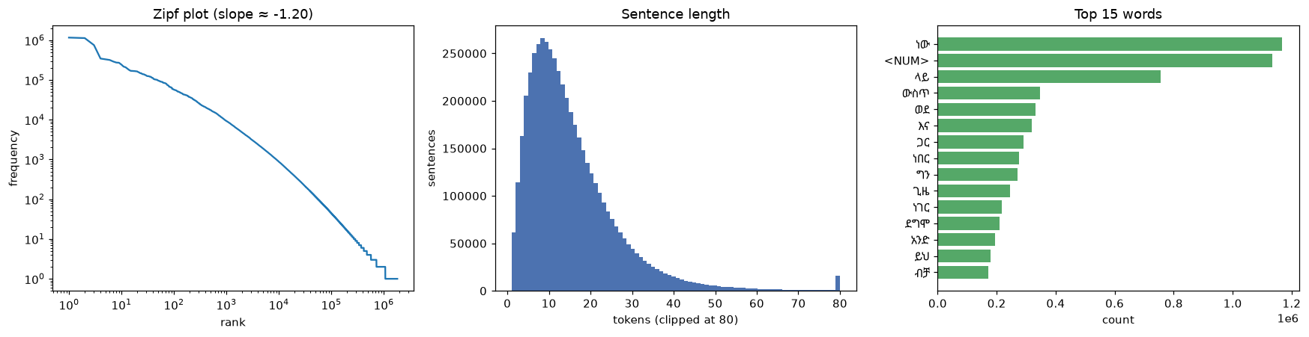
Figure 1. Zipf plot, sentence-length distribution and the most frequent words.
The frequency distribution follows Zipf's law (slope -1.20). The vocabulary keeps growing with corpus size — Heaps' exponent β = 0.58 — and 41% of all word types occur only once. Both are typical of a morphologically rich language: one lemma appears in many inflected and prefixed forms (e.g. ኢትዮጵያ, የኢትዮጵያ, በኢትዮጵያ, ለኢትዮጵያ, ኢትዮጵያን …). The most frequent tokens are function words such as ነው (is), ላይ (on), ውስጥ (in), ወደ (to) and እና (and).
GPAC is crawled from the web, and 24.5% of its sentences are exact repeats (agency datelines such as “… ኢሳት ዜና”, re-published articles). Task 1 describes the corpus as given; for evaluation (Tasks 2–4) each sentence is kept once.

1.2 Creating n-grams (n = 1, 2, 3, 4)
Each sentence is padded with n − 1 start symbols <s> and one end symbol </s>; n-grams never cross sentence boundaries. For example, the bigrams of “ኢትዮጵያ በአፍሪካ ቀንድ ትገኛለች” are <s>_ኢትዮጵያ, ኢትዮጵያ_በአፍሪካ, በአፍሪካ_ቀንድ, ቀንድ_ትገኛለች, ትገኛለች_</s>. Sample n-grams of the first corpus sentence are printed in the notebook.
n | Distinct n-grams | Total n-grams | Seen only once
1 | 1,818,475 | 82,280,506 | 41.1%
2 | 23,678,855 | 82,280,506 | 57.8%
3 | 44,328,844 | 82,280,506 | 66.7%
4 | 52,024,702 | 82,280,506 | 70.3%
Table 2. Number of n-grams in the full corpus.
The number of distinct n-grams grows quickly with n: there are 52.0 million distinct 4-grams in 82.3 million positions, and 70% of them are seen only once. Most 4-gram contexts therefore carry almost no statistical evidence, which is the root of the sparsity results in Tasks 2 and 3.

1.3 N-gram probabilities and the top-10 n-grams
The probability of an n-gram is its relative frequency among all n-grams of the same order, P(w₁…wₙ) = C(w₁…wₙ) / Σ C(·). Sentence-boundary symbols are excluded from the lists.
# | 1-gram | Count | P
1 | ነው | 1,166,232 | 1.42e-2
2 | <NUM> | 1,133,725 | 1.38e-2
3 | ላይ | 754,668 | 9.17e-3
4 | ውስጥ | 346,534 | 4.21e-3
5 | ወደ | 331,101 | 4.02e-3
6 | እና | 318,864 | 3.88e-3
7 | ጋር | 291,523 | 3.54e-3
8 | ነበር | 275,013 | 3.34e-3
9 | ግን | 271,507 | 3.30e-3
10 | ጊዜ | 244,114 | 2.97e-3
Table 3. Top 10 1-grams (full corpus, with stop-words).
# | 2-gram | Count | P
1 | በ <NUM> | 135,279 | 1.64e-3
2 | ከ <NUM> | 107,871 | 1.31e-3
3 | አ ም | 99,372 | 1.21e-3
4 | <NUM> አ | 92,590 | 1.13e-3
5 | የ <NUM> | 49,484 | 6.01e-4
6 | ነገር ግን | 44,744 | 5.44e-4
7 | ቀን <NUM> | 44,236 | 5.38e-4
8 | <NUM> ቀን | 41,699 | 5.07e-4
9 | <NUM> ሚሊዮን | 36,806 | 4.47e-4
10 | <NUM> ኛ | 36,151 | 4.39e-4
Table 4. Top 10 2-grams (full corpus, with stop-words).
# | 3-gram | Count | P
1 | <NUM> አ ም | 89,581 | 1.09e-3
2 | <NUM> ቀን <NUM> | 34,317 | 4.17e-4
3 | ቀን <NUM> አ | 33,328 | 4.05e-4
4 | በ <NUM> አ | 27,976 | 3.40e-4
5 | እ ኤ አ | 16,757 | 2.04e-4
6 | ከ <NUM> በላይ | 12,677 | 1.54e-4
7 | <NUM> ሚሊዮን ብር | 12,105 | 1.47e-4
8 | አ በ <NUM> | 10,627 | 1.29e-4
9 | <NUM> እስከ <NUM> | 9,978 | 1.21e-4
10 | ከ <NUM> እስከ | 8,835 | 1.07e-4
Table 5. Top 10 3-grams (full corpus, with stop-words).
# | 4-gram | Count | P
1 | ቀን <NUM> አ ም | 32,904 | 4.00e-4
2 | <NUM> ቀን <NUM> አ | 29,677 | 3.61e-4
3 | በ <NUM> አ ም | 27,522 | 3.34e-4
4 | ኤ አ በ <NUM> | 8,640 | 1.05e-4
5 | እ ኤ አ በ | 8,621 | 1.05e-4
6 | ከ <NUM> እስከ <NUM> | 7,676 | 9.33e-5
7 | ከ <NUM> አ ም | 6,256 | 7.60e-5
8 | <NUM> አ ም ጀምሮ | 5,772 | 7.02e-5
9 | ቀን <NUM> አም ኢሳት | 5,720 | 6.95e-5
10 | <NUM> አም ኢሳት ዜና | 5,646 | 6.86e-5
Table 6. Top 10 4-grams (full corpus, with stop-words).
Unigrams are dominated by function words and the number token. The higher-order lists are dominated by dates and numbers — ቀን <NUM> አ ም (“day … E.C.”), በ <NUM> አ ም, እ ኤ አ (“G.C.”) — because news text dates nearly every event. The fact that አ ም still appears as two tokens shows that the abbreviation ዓ.ም is often written with spaces (ዓ ም) in the source text.

1.4 Conditional probability of a word given the previous word
Using bigram counts, P(wᵢ | wᵢ₋₁) = C(wᵢ₋₁ wᵢ) / C(wᵢ₋₁ ·):
Previous word | Word | C(prev word) | C(prev ·) | P(word | prev)
ኢትዮጵያ | ውስጥ | 8,185 | 102,553 | 0.0798
አዲስ | አበባ | 31,453 | 89,283 | 0.3523
ጠቅላይ | ሚኒስትር | 19,908 | 41,152 | 0.4838
በአፍሪካ | ቀንድ | 821 | 13,789 | 0.0595
የቡና | ምርት | 246 | 3,900 | 0.0631
የኢትዮጵያ | ህዝብ | 12,256 | 113,865 | 0.1076
ብሔራዊ | ባንክ | 2,449 | 36,759 | 0.0666
ቀንድ | ትገኛለች | 0 | 2,814 | 0.0000
Table 7. Bigram conditional probabilities (MLE).
Most likely next words for a few contexts:
Previous word | Most likely next words (P)
ኢትዮጵያ | ውስጥ (0.080), ነገ (0.014), ቡና (0.010), ላይ (0.008), <NUM> (0.007), የጋራ (0.007)
አዲስ | አበባ (0.352), ዘመን (0.058), ነገር (0.033), አበባን (0.030), አመት (0.017), አለም (0.013)
የቡና | ምርት (0.063), ዋጋ (0.036), ቤት (0.029), ግብይት (0.027), መገኛ (0.025), ችግኝ (0.021)
ጠቅላይ | ሚኒስትር (0.484), ሚኒስትሩ (0.181), ፍርድ (0.047), አቃቤ (0.043), ሚንስትር (0.027), ሚኒስቴር (0.015)
በአፍሪካ | ህብረት (0.088), ቀንድ (0.060), ውስጥ (0.045), ዋንጫ (0.036), ደረጃ (0.032), አህጉር (0.021)
Table 8. Top followers by bigram probability.
Strong collocations such as ጠቅላይ → ሚኒስትር (prime → minister) and አዲስ → አበባ (Addis → Ababa) have high conditional probabilities. The pair ቀንድ → ትገኛለች (“horn → is located”) was never observed, so its MLE probability is exactly zero — even though it is perfectly grammatical. This is the main weakness of unsmoothed MLE estimates.

1.5 N-gram frequencies after stop-word removal
We built a list of 163 Amharic function words — copulas (ነው, ናቸው, ነበር), conjunctions (እና, ግን, ወይም), postpositions (ላይ, ውስጥ, ጋር), demonstratives (ይህ, እነዚህ), pronouns, quantifiers and common reporting verbs (ገልጸዋል, ተናግረዋል) — plus <NUM>. Removing them deletes 12,235,835 tokens (15.8% of the corpus); n-grams are then rebuilt over the remaining words.
# | 1-gram | Count | P
1 | አቶ | 169,389 | 2.42e-3
2 | መንግስት | 167,369 | 2.39e-3
3 | ቤት | 165,868 | 2.37e-3
4 | ስራ | 158,148 | 2.26e-3
5 | ሰው | 153,887 | 2.20e-3
6 | ሰዎች | 138,694 | 1.98e-3
7 | አ | 132,985 | 1.90e-3
8 | ህዝብ | 121,099 | 1.73e-3
9 | ቀን | 121,053 | 1.73e-3
10 | የኢትዮጵያ | 113,865 | 1.63e-3
Table 9. Top 10 1-grams after stop-word removal.
# | 2-gram | Count | P
1 | ቀን አ | 39,491 | 5.64e-4
2 | አዲስ አበባ | 31,458 | 4.49e-4
3 | በአዲስ አበባ | 24,075 | 3.44e-4
4 | ምክር ቤት | 23,888 | 3.41e-4
5 | አለም አቀፍ | 21,294 | 3.04e-4
6 | ጠቅላይ ሚኒስትር | 19,908 | 2.84e-4
7 | የአዲስ አበባ | 19,705 | 2.81e-4
8 | በአሁኑ ወቅት | 18,971 | 2.71e-4
9 | ፍርድ ቤት | 17,533 | 2.50e-4
10 | ኤ አ | 16,902 | 2.41e-4
Table 10. Top 10 2-grams after stop-word removal.
# | 3-gram | Count | P
1 | እ ኤ አ | 16,757 | 2.39e-4
2 | ቀን አም ኢሳት | 6,090 | 8.70e-5
3 | አም ኢሳት ዜና | 6,009 | 8.58e-5
4 | ተወካዮች ምክር ቤት | 5,599 | 8.00e-5
5 | በአለም አቀፍ ደረጃ | 5,344 | 7.63e-5
6 | የአዲስ አበባ ከተማ | 4,902 | 7.00e-5
7 | በአዲስ አበባ ከተማ | 4,033 | 5.76e-5
8 | አበባ ከተማ አስተዳደር | 3,951 | 5.64e-5
9 | የእድገትና ትራንስፎርሜሽን እቅድ | 3,796 | 5.42e-5
10 | እ አ አ | 3,768 | 5.38e-5
Table 11. Top 10 3-grams after stop-word removal.
# | 4-gram | Count | P
1 | ቀን አም ኢሳት ዜና | 6,007 | 8.58e-5
2 | ቀን አ ኢሳት ዜና | 3,701 | 5.28e-5
3 | የህዝብ ተወካዮች ምክር ቤት | 2,855 | 4.08e-5
4 | የአዲስ አበባ ከተማ አስተዳደር | 2,606 | 3.72e-5
5 | ኦርቶዶክስ ተዋህዶ ቤተ ክርስቲያን | 2,195 | 3.13e-5
6 | የኢትዮጵያ ኦርቶዶክስ ተዋህዶ ቤተ | 1,649 | 2.35e-5
7 | ጠቅላይ ሚኒስትር አብይ አህመድ | 1,594 | 2.28e-5
8 | ጠቅላይ ሚኒስትር መለስ ዜናዊ | 1,327 | 1.89e-5
9 | ወሮበላ የዘራፊ ቡድን ስብስብ | 1,273 | 1.82e-5
10 | ለህዝብ ተወካዮች ምክር ቤት | 1,198 | 1.71e-5
Table 12. Top 10 4-grams after stop-word removal.
After removal the lists show content words and multi-word names: places (አዲስ አበባ), institutions (ምክር ቤት, የህዝብ ተወካዮች ምክር ቤት — House of Peoples' Representatives; ፍርድ ቤት — court), titles with names (ጠቅላይ ሚኒስትር አብይ አህመድ, ጠቅላይ ሚኒስትር መለስ ዜናዊ), and news-agency boilerplate (… ኢሳት ዜና). The 3- and 4-gram lists now read like a topic index of Ethiopian news.

1.6 Word clouds before and after stop-word removal
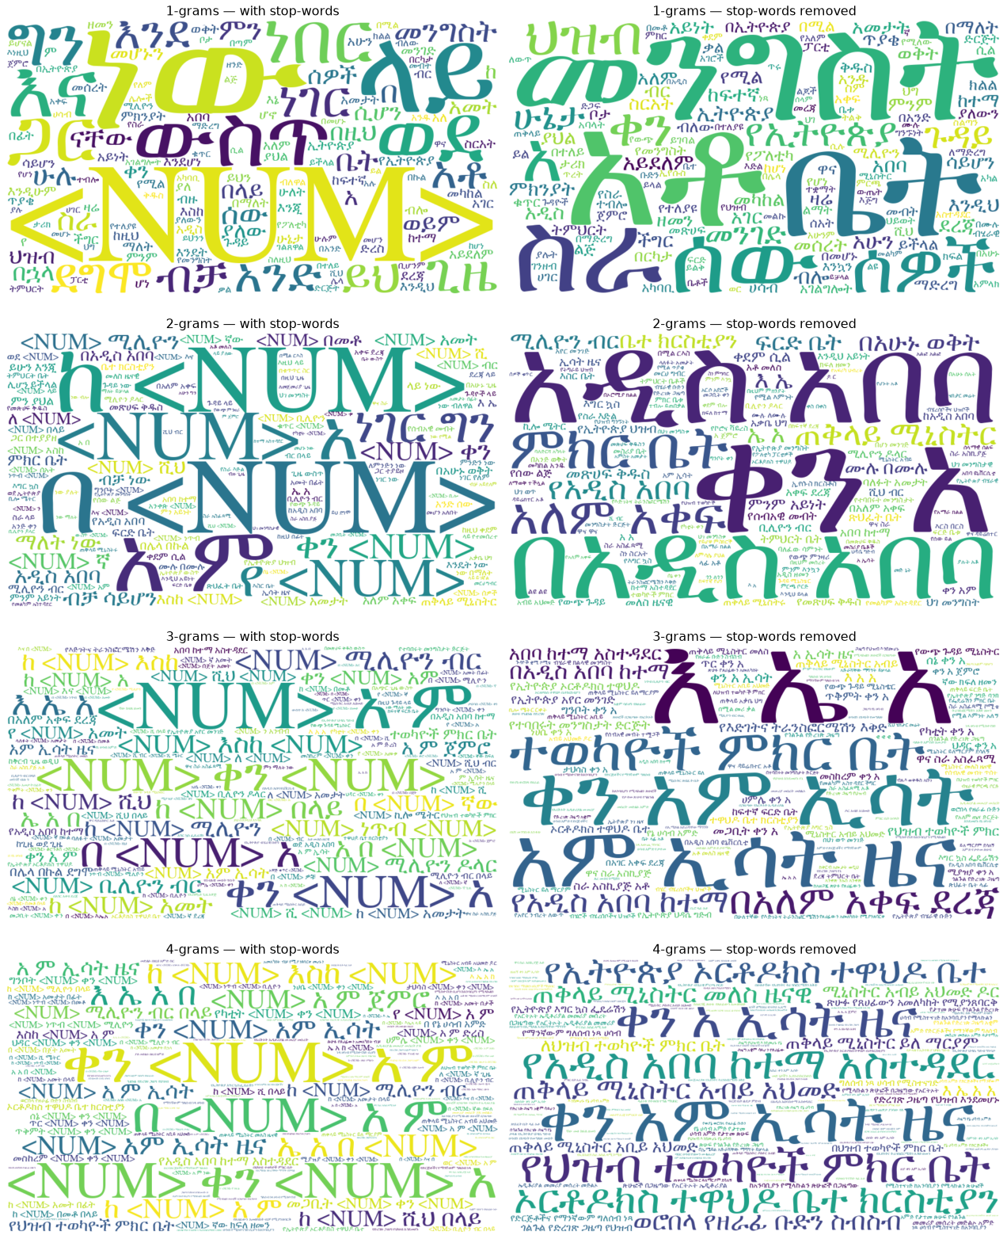
Figure 2. Word clouds of the 150 most frequent n-grams, n = 1–4 (left: with stop-words, right: stop-words removed).
With stop-words the clouds are dominated by grammatical words and date patterns; after removal, named entities and topics (government, people, Addis Ababa, the Prime Minister, parliament, church) become visible.

1.7 Probability of a sentence
The sentence probability is the product of the conditional probabilities of each word (and </s>) given the previous n − 1 words. We report log₁₀ probabilities for unsmoothed MLE and for interpolated Kneser-Ney (KN, Section 3), which never assigns zero, plus the per-word perplexity under KN.
Sentence | n | log₁₀ P (MLE) | log₁₀ P (KN) | PP (KN)
ኢትዮጵያ በአፍሪካ ቀንድ ትገኛለች። | 1 | -16.80 | -16.80 | 2,293
ኢትዮጵያ በአፍሪካ ቀንድ ትገኛለች። | 2 | −∞ (P = 0) | -11.56 | 205
ኢትዮጵያ በአፍሪካ ቀንድ ትገኛለች። | 3 | −∞ (P = 0) | -11.05 | 162
ኢትዮጵያ በአፍሪካ ቀንድ ትገኛለች። | 4 | −∞ (P = 0) | -11.10 | 166
አዲስ አበባ የኢትዮጵያ ዋና ከተማ ናት። | 1 | -19.78 | -19.78 | 670
አዲስ አበባ የኢትዮጵያ ዋና ከተማ ናት። | 2 | -12.63 | -12.60 | 63
አዲስ አበባ የኢትዮጵያ ዋና ከተማ ናት። | 3 | -8.54 | -8.48 | 16
አዲስ አበባ የኢትዮጵያ ዋና ከተማ ናት። | 4 | -7.11 | -7.06 | 10
ጠቅላይ ሚኒስትሩ ዛሬ ለፓርላማው ሪፖርት አቀረቡ። | 1 | -24.79 | -24.79 | 3,480
ጠቅላይ ሚኒስትሩ ዛሬ ለፓርላማው ሪፖርት አቀረቡ። | 2 | -14.63 | -14.68 | 125
ጠቅላይ ሚኒስትሩ ዛሬ ለፓርላማው ሪፖርት አቀረቡ። | 3 | −∞ (P = 0) | -15.19 | 148
ጠቅላይ ሚኒስትሩ ዛሬ ለፓርላማው ሪፖርት አቀረቡ። | 4 | −∞ (P = 0) | -14.10 | 103
ቡና የኢትዮጵያ ዋነኛ የውጭ ምንዛሪ ምንጭ ነው። | 1 | -24.81 | -24.81 | 1,264
ቡና የኢትዮጵያ ዋነኛ የውጭ ምንዛሪ ምንጭ ነው። | 2 | -17.46 | -17.43 | 151
ቡና የኢትዮጵያ ዋነኛ የውጭ ምንዛሪ ምንጭ ነው። | 3 | -12.65 | -13.42 | 48
ቡና የኢትዮጵያ ዋነኛ የውጭ ምንዛሪ ምንጭ ነው። | 4 | −∞ (P = 0) | -10.78 | 22
ትገኛለች ቀንድ በአፍሪካ ኢትዮጵያ። | 1 | -16.80 | -16.80 | 2,293
ትገኛለች ቀንድ በአፍሪካ ኢትዮጵያ። | 2 | −∞ (P = 0) | -22.34 | 29,444
ትገኛለች ቀንድ በአፍሪካ ኢትዮጵያ። | 3 | −∞ (P = 0) | -22.18 | 27,259
ትገኛለች ቀንድ በአፍሪካ ኢትዮጵያ። | 4 | −∞ (P = 0) | -21.90 | 23,936
Table 13. Sentence probabilities. The last sentence is the first one with its words reversed (control).
Trigram factor | MLE | Kneser-Ney
P(ኢትዮጵያ | <s> <s>) | 0.0039 | 0.0040
P(በአፍሪካ | <s> ኢትዮጵያ) | 0.0072 | 0.0075
P(ቀንድ | ኢትዮጵያ በአፍሪካ) | 0.1657 | 0.1738
P(ትገኛለች | በአፍሪካ ቀንድ) | 0.0000 | 2.74e-6
P(</s> | ቀንድ ትገኛለች) | 0.0000 | 0.6311
Table 14. Trigram factors of P(ኢትዮጵያ በአፍሪካ ቀንድ ትገኛለች).
For “ኢትዮጵያ በአፍሪካ ቀንድ ትገኛለች” (Ethiopia is located in the Horn of Africa) the unigram probability is 10^-16.8. For n ≥ 2 the MLE probability is zero, because the bigram ቀንድ ትገኛለች never occurs in the corpus (Table 14). Kneser-Ney backs off to the probability of ትገኛለች as a continuation, giving P(sentence) ≈ 10^-11.0 with a trigram. The reversed control sentence has the same unigram probability (a unigram model ignores word order), but under the bigram–4-gram models it is about 10^11 times less likely, so the higher-order models clearly prefer the grammatical order. Longer common sentences such as “አዲስ አበባ የኢትዮጵያ ዋና ከተማ ናት” are seen in the corpus and get a non-zero MLE probability even at n = 4.

1.8 Random sentence generation
Sentences were generated with Shannon's method: start from <s>, repeatedly sample the next word from the MLE distribution P(w | previous n − 1 words) and stop at </s> (or after 30 words).

1-gram
- በሚቀጥለው ነው ነውጠኛ በእጃቸው ይደረጋል የማያውቁ ተችግረናል አጥባቂዎችን ከተባለው ተቀጣን አመት አይደለም መኮንን ነጥብ አስተሳሰብ ዋስትና በኢ ወታደራዊና ሶስት የተተካው ሮበርትስ ም አቆጠቀጠር ቁጥር ማለት እንኳን መልካም መሆኑ ደረጃ ለታዳሚው ።
- ብዝ ማምታታት የሚል የሚነሱትን ።
- የሚያስችል ከኖርዌይ እንዲሁም ምስራች ማሜ እንዲያውም የሚያልፈው ወረዳ አንድነት ያለው ።

2-gram
- እነዚህ ህገ መንግስታዊ ባልሆነ ምክንያት ሆኖ ለምሳሌ የደቡብ ትግራይንና ተጋሩን ማዳከም የሚለዉን ጥያቄ ማደር ይበጃልና ።
- የኦሮሚያ ክልል ከሌላው ጋር ተወዳድረው <NUM> ብር <NUM> ኛ ሳምንት ይፋ አድርጓል ።
- ወደፊት ማራመድ ያሻል ።

3-gram
- ግን ያን ያህል የምታሰጋ ልትሆን ባልቻለች ነበር ።
- ያም ሆኖ ቹንግ ኬዮንና ጁሊ ቅር የሚላቸው ነገር ይኸውም ስልጠና በመስጠት በኢትዮጵያ የተለያዩ የልማት ስትራቴጂዎችን ነድፈን እየሰራን ነው ።
- ህወሀት ኢህ አዴግ አምባገነን መንግስት ለይስሙላና በተግባር ባዶ የሆነ የቅንጦት ግድብ የፈለገውን ያህል ለውጥ እያስመዘገብን እንደሆነ ስንቶቻችን እናውቅ ይሆን ።

4-gram
- የስኳር ፕሮጀክቶቹ የመስኖ የእርሻ የሲቪልና የኢንጂነሪንግ ስራዎችን በአንድ የያዘ ሆኖ ሁሉንም በአንድ የአገር ውስጥ ቴሌቪዥን የተመለከትኩት ነገር ነው ።
- እንዲህ ያለው ወጪን የማስመለስ አካሄድ ትልቅ ጉዳት ያመጣል ።
- ጥግ የተቀመጠው ረዳት ስለ ዛር ሲሰማ እንደመንዘፍዘፍ አደረገው ።
What happens as n increases:
- Unigram: words are independent draws by frequency. The output is a bag of frequent words with no syntax and random length.
- Bigram: adjacent word pairs are grammatical (possessive + noun, noun + postposition), but the sentence drifts to a new topic every word or two and rarely forms a complete clause.
- Trigram: phrases of 3–5 words are fluent and many sentences end with a finite verb (ነበር, ይገኛል, ገልጿል) — the normal Amharic subject–object–verb ending. Coherence still breaks over longer spans.
- 4-gram: output looks like real news sentences — because large parts are real sentences. Most 4-gram contexts occurred only once or twice (70% of 4-grams are singletons), so sampling copies long stretches of training text verbatim.
Increasing n trades novelty for fluency: local grammaticality improves quickly, but the number of possible contexts grows exponentially, so beyond n = 3 the model mostly memorises its training data instead of generalising.

3. Task 2 — Intrinsic Evaluation (Perplexity)

3.1 Setup
The corpus was deduplicated (each distinct sentence kept once), then split at random into 98% training and 2% test sentences (seed 42); 0.5% of training was held out as a development set to tune add-k. The vocabulary contains every word seen at least twice in training (840,861 words); other words map to <UNK>, so the model has a probability for unknown words. The test OOV rate is 2.43%.
 | Sentences | Tokens
Training | 3,723,357 | 59,848,314
Development | 18,831 | —
Test | 76,405 | 1,230,336
Table 15. Data split (after deduplication).
Perplexity is the inverse probability of the test set normalised by the number of predicted tokens N (all words plus </s>): PP = exp(−(1/N) Σ ln P(wᵢ | hᵢ)). Lower is better. Four estimators were compared for each order:
- MLE — no smoothing.
- Laplace (add-1): (C(h w) + 1) / (C(h) + V).
- Add-k: the same with k tuned on the development set (best k = 1e-5, 5e-4, 1e-4, 1e-5 for n = 1–4).
- Interpolated Kneser-Ney: P(w|h) = max(C(h w) − D, 0)/C(h) + D·N₁₊(h •)/C(h) · P_KN(w | shorter h), with D = n₁/(n₁ + 2n₂) per order and continuation counts N₁₊(• h w) for the lower orders.

3.2 Results
n | MLE | MLE zero-prob tokens | Laplace (add-1) | Add-k (tuned) | Kneser-Ney
1 | 10,682 | 0.0% | 10,715 | 10,682 | 10,682.2
2 | ∞ | 24.0% | 39,834 | 2,843 | 1,219.8
3 | ∞ | 57.8% | 262,315 | 21,540 | 760.0
4 | ∞ | 72.6% | 420,137 | 69,018 | 675.9
Table 16. Test-set perplexity.
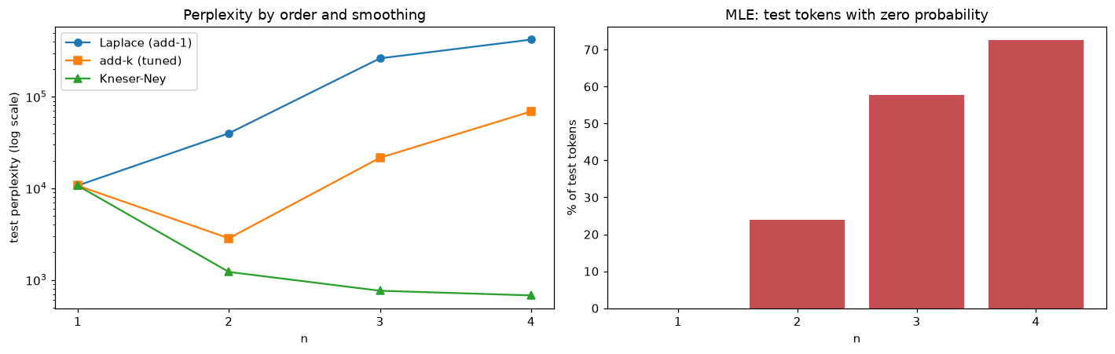
Figure 3. Perplexity by order and smoothing (left, log scale) and the share of test tokens that MLE gives zero probability (right).

3.3 Effect of training-set size
Training tokens | n = 1 | n = 2 | n = 3 | n = 4
3.0 M | 11,243 | 3,050 | 2,826 | 2,858
9.0 M | 10,913 | 2,181 | 1,877 | 1,868
23.9 M | 10,770 | 1,618 | 1,229 | 1,179
59.8 M | 10,682 | 1,220 | 760 | 676
Table 17. Kneser-Ney test perplexity vs. training-set size.
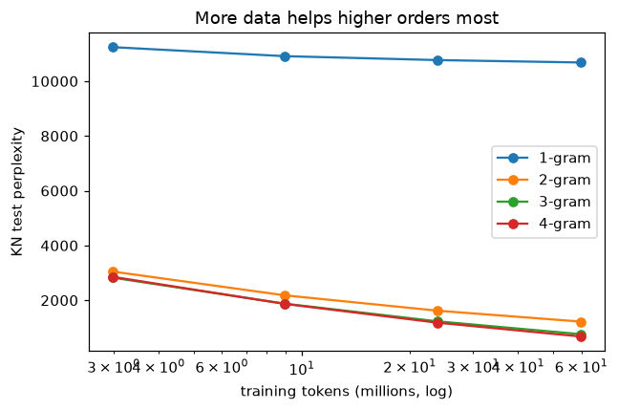
Figure 4. Learning curves.

3.4 Discussion
- MLE cannot be evaluated beyond unigrams: 24% of test tokens get zero probability with bigrams and 73% with 4-grams, so perplexity is infinite. This is the sparsity problem measured directly.
- Add-one smoothing gets worse as n grows (10,715 → 420,137). With V ≈ 1 million, adding 1 to every possible continuation gives almost all probability mass to unseen events. Tuning k down to 10⁻⁴–10⁻⁵ helps a lot, but add-k still peaks at the bigram and then degrades, because it never uses lower-order information.
- Kneser-Ney improves at every order: 10,682 → 1,220 → 760 → 676. Interpolation lets an unseen 4-gram fall back on trigram, bigram and unigram evidence. The gain from 3 to 4 (11%) is smaller than from 2 to 3 (38%): diminishing returns.
- More data helps higher orders most. With 3.0 M training tokens the 4-gram is no better than the trigram (2,858 vs 2,826); with 60 M tokens it is 11% better. The unigram hardly changes. The amount of data, not the model, limits higher-order n-grams.
- The perplexities are much higher than typical values for English n-gram models, whose vocabularies are far smaller. With 840,861 word types, every Amharic prediction has many more alternatives; sub-word units (morphemes or BPE) would lower this considerably.
- Deduplication matters. In a first run on the raw (non-deduplicated) data the 4-gram KN perplexity was about 111 instead of 676, because a quarter of the sentences are repeats and many test sentences had been seen in training. The honest numbers are the ones above.

4. Task 3 — Extrinsic Evaluation
Perplexity measures how well a model predicts text, but not whether it helps in an application. We placed each Kneser-Ney model (n = 1–4) into three downstream tasks, all on the held-out test sentences:
- Next-word prediction — the task behind Task 4. For 5,000 random test positions the model ranks the whole vocabulary given the history; we report top-1/3/5/10 accuracy and mean reciprocal rank (MRR@10).
- Keystroke savings (KSS) in a simulated predictive keyboard. For 1,500 test words the user types one letter at a time until the intended word appears among 5 suggestions, then taps it (1 keystroke; the space is automatic). KSS = 1 − keystrokes used / keystrokes needed without prediction.
- Real vs. corrupted sentence discrimination — a fluency / grammaticality judgement of the kind used in spelling and grammar checking and for ranking speech-recognition or machine-translation outputs. For 3,000 test sentences the model must give the real sentence a higher probability than a copy with (a) two adjacent words swapped, (b) one word replaced by a random frequent word, or (c) all words shuffled. Chance level is 50%.
n | Top-1 | Top-3 | Top-5 | Top-10 | MRR@10 | KSS | Swap | Replace | Shuffle
1 | 5.5% | 8.4% | 9.8% | 11.4% | 0.072 | 37.0% | 50.0% | 40.4% | 50.0%
2 | 15.1% | 21.7% | 25.3% | 31.2% | 0.196 | 48.5% | 89.0% | 79.5% | 98.9%
3 | 21.5% | 29.6% | 33.3% | 38.7% | 0.266 | 51.7% | 89.9% | 79.7% | 98.9%
4 | 24.4% | 32.4% | 35.9% | 40.3% | 0.293 | 52.2% | 89.7% | 79.9% | 98.8%
Table 18. Extrinsic results (Kneser-Ney). Columns 2–6: next-word prediction; KSS: keystroke savings with 5 suggestions; last three: discrimination accuracy.
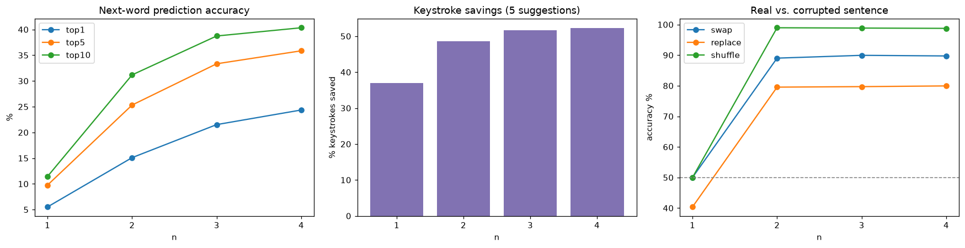
Figure 5. Extrinsic results by model order.
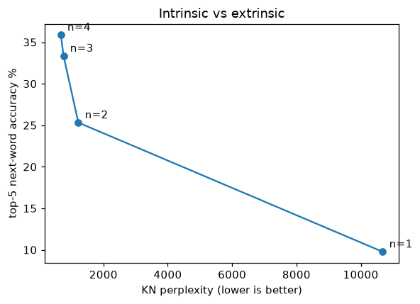
Figure 6. Lower perplexity goes with higher next-word accuracy.

4.1 Discussion
- Context is what makes prediction work. Top-5 accuracy goes 9.8% → 25.3% → 33.3% → 35.9% for n = 1–4. The ranking of models is the same as with perplexity (Figure 6), so here the intrinsic measure was a good predictor of extrinsic usefulness.
- Keystroke savings are large even for weak models (37.0% for the unigram, 52.2% for the 4-gram). Amharic words are long (≈6 characters per word type), and after one or two letters the prefix already narrows the candidates sharply.
- The unigram model is at exactly 50% on swap and shuffle: it ignores word order, so every permutation has the same probability. On the replace task it scores below chance (40.4%) because the inserted words are frequent ones, which a unigram model prefers.
- Discrimination difficulty depends on the corruption. With a trigram, fully shuffled sentences are detected 98.9% of the time, a single adjacent swap 89.9% and a single replaced word 79.7%. A replacement changes only a few n-grams, and a frequent word often fits its neighbours locally. This task saturates already at n = 2–3: judging word order is easier than predicting the exact next word.
- Gains from 3 to 4 are smaller than from 2 to 3 in all tasks, consistent with the perplexity results and the sparsity of 4-grams.

5. Task 4 — Amharic Predictive Text and Next-Word Suggestion

5.1 Design
The suggestion engine follows the steps required in the assignment:
- Read the input and normalise/tokenise it exactly like the training corpus. Only the sentence currently being written is used (text after the last ። or ፡፡).
- Extract the final one or two words — trigram context by default; the user can switch to one word (bigram) or three words (4-gram). At the start of a sentence the context is padded with <s>.
- Retrieve candidate next words — every word observed after the context at each order (via a context index over the n-gram tables), plus the 300 most frequent words as a fallback.
- Estimate the probability of each candidate with interpolated Kneser-Ney, so unseen contexts back off smoothly instead of producing no suggestions.
- Return the top five suggestions with their probabilities. If the last word is only partly typed (no trailing space), only words starting with those letters are considered — word completion.
- Let the user select a suggestion and continue — clicking a suggestion inserts it (replacing the partial word) and the suggestions update immediately. ። is offered when the model predicts the end of the sentence; a button can also complete the sentence greedily.

5.2 Example suggestions
Input | Top-5 suggestions (P)
ኢትዮጵያ ውስጥ የቡና … | ፍጆታ (0.123), ዋጋ (0.099), የወጪ (0.052), ምርት (0.040), ግብይት (0.022)
ኢትዮጵያ በአፍሪካ … | ቀንድ (0.183), ውስጥ (0.053), ህብረት (0.041), አህጉር (0.038), ደረጃ (0.035)
አዲስ … | አበባ (0.504), ዘመን (0.249), አበባን (0.025), አድማስ (0.013), ነገር (0.012)
ጠቅላይ ሚኒስትር … | አብይ (0.145), መለስ (0.107), ይለማርያም (0.094), አቢይ (0.086), ይለ (0.053)
Table 19. Suggestions from the full trigram model.
For the assignment's example “ኢትዮጵያ ውስጥ የቡና …” the model suggests ፍጆታ, ዋጋ, የወጪ, ምርት, ግብይት — all plausible continuations about coffee (consumption, price, export, production, trade). ምርት (production), the assignment's own example, is ranked 4th: it is the most frequent continuation of የቡና as a bigram (Table 8), but with the extra context ውስጥ the trigram prefers other words, so the longer context changes the ranking.

5.3 Deployment
There are two versions of the app. The local version (app/app.py) is a Gradio app that loads the 4-gram model and computes exact Kneser-Ney probabilities for every query. Hugging Face now requires a paid plan to host Gradio apps, so the hosted version is a free static Space that runs entirely in the browser: https://huggingface.co/spaces/nebadan/amharic-next-word.
To keep the files small, the model is first pruned: bigrams, trigrams and 4-grams seen fewer than 3 times are removed (all unigrams are kept), giving a 122 MB model instead of ~1 GB. From this model we precompute the top-8 Kneser-Ney suggestions for the 178,429 one-word contexts seen at least 10 times and the 222,085 two-word contexts seen at least 20 times, plus a 239,185-word vocabulary (words seen at least 10 times) for word completion — a 17 MB compressed file. The JavaScript page applies the same normalisation and tokenisation as the Python code, looks up the two-word context, backs off to the one-word context and then to word frequency (backed-off scores are marked “~”), and filters by the typed prefix.
Model | n | Top-1 | Top-5 | MRR@10 | ms / query
full | 2 | 15.1% | 25.3% | 0.196 | 6.0
full | 3 | 21.5% | 33.3% | 0.266 | 10.1
full | 4 | 24.4% | 35.9% | 0.293 | 14.3
pruned (app) | 2 | 15.0% | 24.5% | 0.192 | 1.5
pruned (app) | 3 | 18.3% | 28.5% | 0.227 | 2.5
pruned (app) | 4 | 18.7% | 29.0% | 0.231 | 3.5
Table 20. Next-word prediction with the full and the pruned (deployed) model.
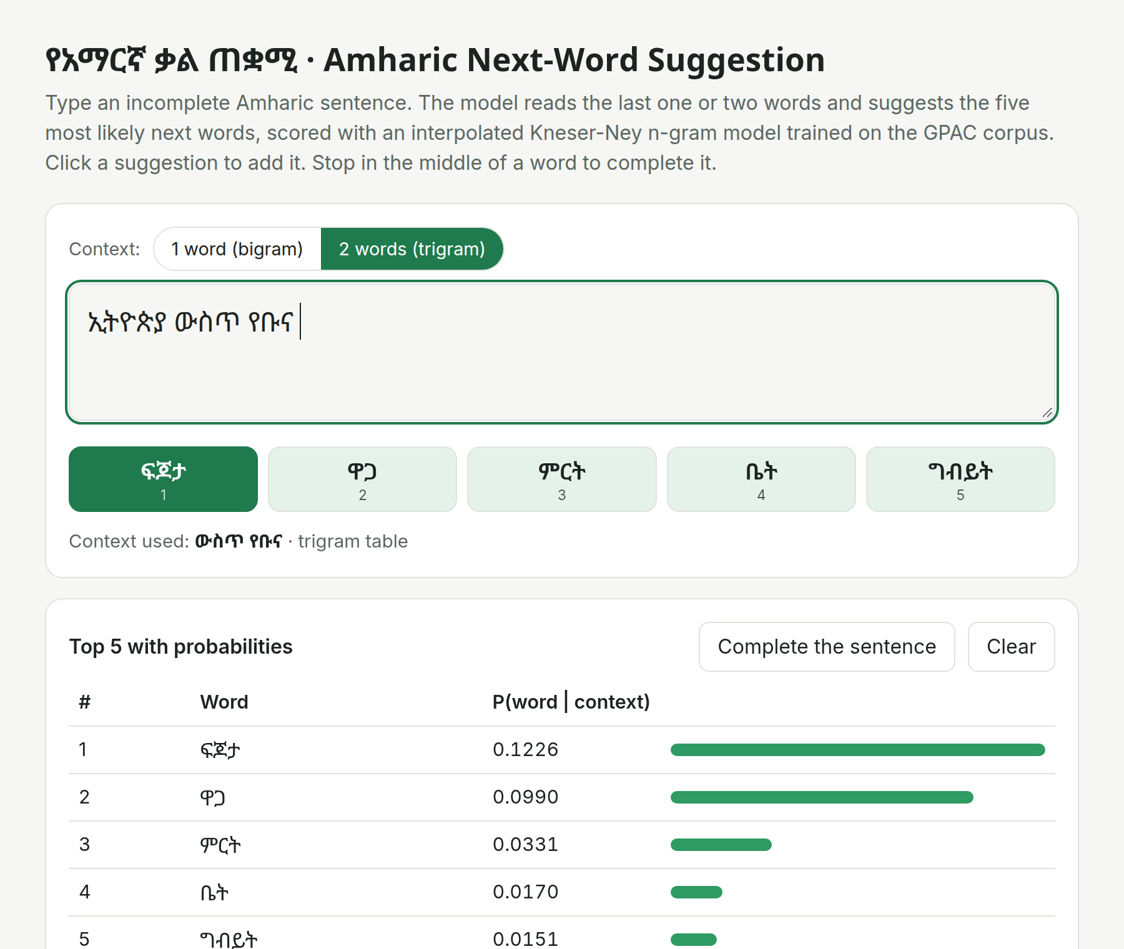
Figure 7. The hosted next-word suggestion app for the input “ኢትዮጵያ ውስጥ የቡና”.
To run the exact version locally: python app/app.py (it loads app/model/amharic_4gram_kn.npz written by the notebook). The static tables are rebuilt with python static_app/export_tables.py and published with static_app/deploy.sh.

6. Limitations and Future Work
- Word-level sparsity. Amharic's ~1.8 M word types make n-gram counts sparse. Morpheme- or sub-word-level models (e.g. BPE, or a morphological analyser such as HornMorpho) would share statistics across inflected forms.
- Normalisation choices. Homophone normalisation merges spelling variants but also changes the displayed spelling of suggestions (e.g. ሐ → ሀ). Abbreviations written with spaces (ዓ ም) remain split.
- Domain. GPAC is mostly news and political commentary; suggestions reflect that domain (dates, officials, institutions).
- Pruning trade-off. The deployed model is smaller and faster but less accurate than the full model (Table 20), and the static tables only cover frequent contexts. A paid or self-hosted server could run the full model with exact probabilities.
- Neural models. An LSTM or small Transformer language model would capture longer context; the n-gram models here are a strong, fast and interpretable baseline.

Conclusion
On 77 M tokens of Amharic, n-gram models behave as theory predicts: higher orders capture more context but suffer from sparsity, unsmoothed and add-one estimates fail, and Kneser-Ney smoothing turns the extra context into steady gains (perplexity 10,682 → 676). The extrinsic tasks confirm the same ranking. Used as a predictive keyboard, a trigram model ranks the intended word in its top five suggestions 33% of the time and saves 52% of keystrokes.

References
Gereme, F., Zhu, W., Ayall, T., & Alemu, D. (2021). Combating Fake News in “Low-Resource” Languages: Amharic Fake News Detection Accompanied by Resource Crafting. Information, 12(1), 20. https://doi.org/10.3390/info12010020
Jurafsky, D., & Martin, J. H. (2024). Speech and Language Processing (3rd ed. draft), Chapter 3: N-gram Language Models.
Kneser, R., & Ney, H. (1995). Improved backing-off for M-gram language modeling. Proc. ICASSP, 181–184.
Chen, S. F., & Goodman, J. (1999). An empirical study of smoothing techniques for language modeling. Computer Speech & Language, 13(4), 359–394.
Shannon, C. E. (1948). A Mathematical Theory of Communication. Bell System Technical Journal, 27, 379–423.

