**Part 1: Connect to Aspen MongoDB and push and pull data.**

Load Test data in mongo DB

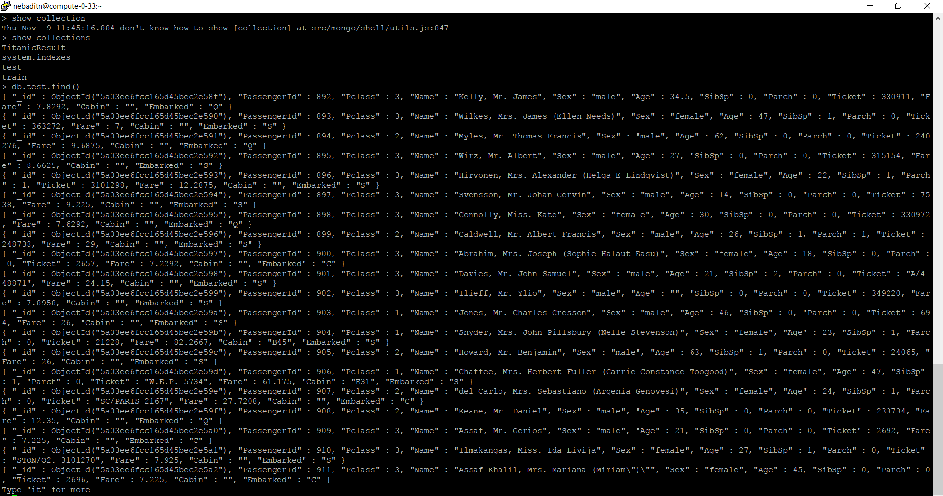

Load Train data in MongoDB

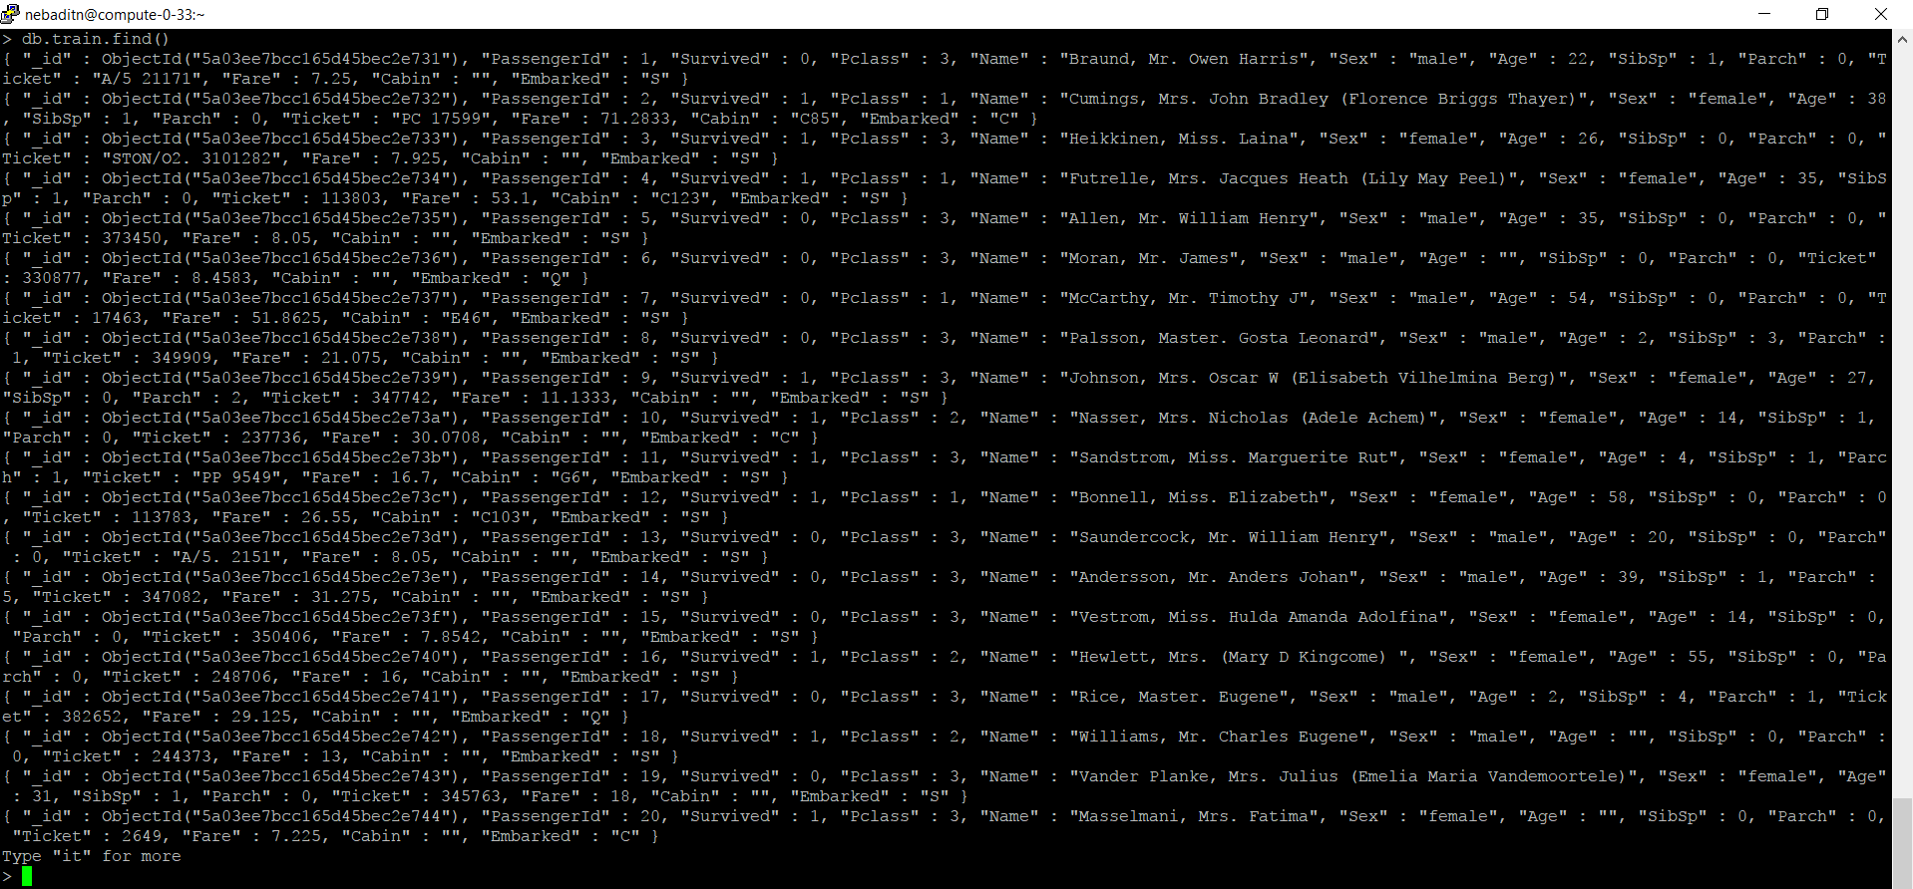

Titanic result in MongoDB

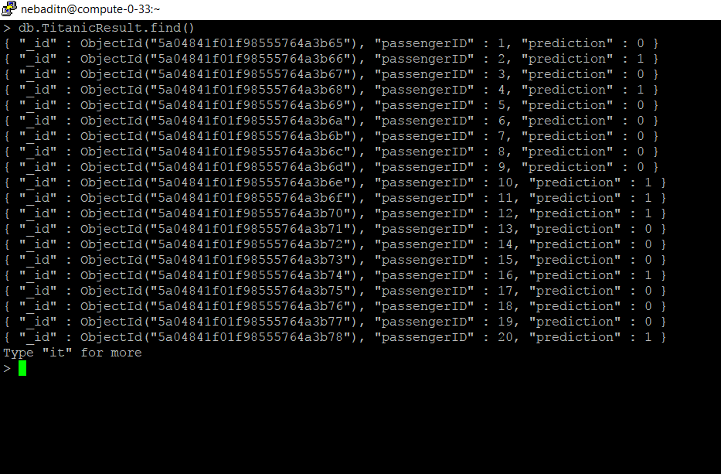

MongoDB Atlas

1. Push data into MongoDB Atlas

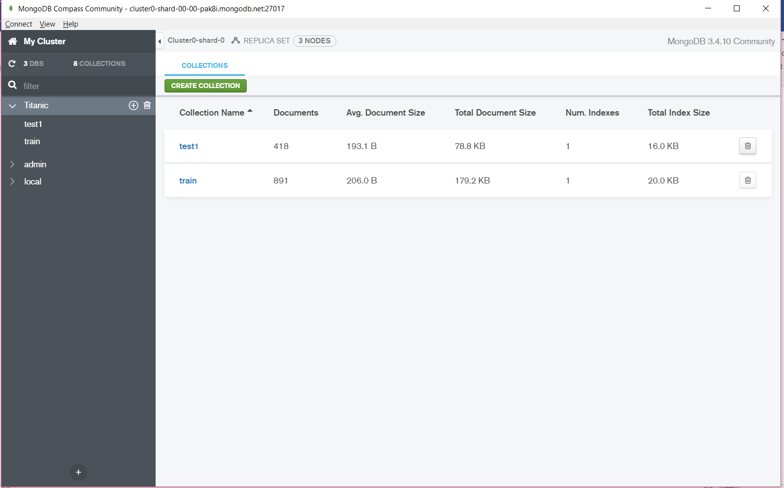

Push results to MongoDB Atlas

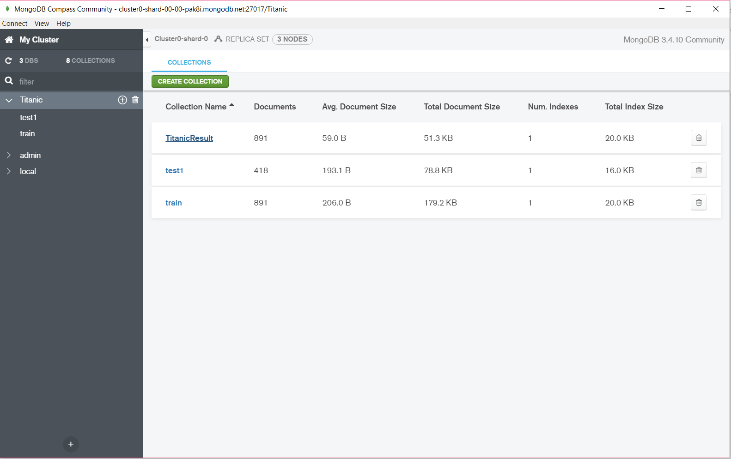

Kaggle Results

