**Part 1: Connect to Aspen MongoDB and push and pull data.**

Load Test data in mongo DB

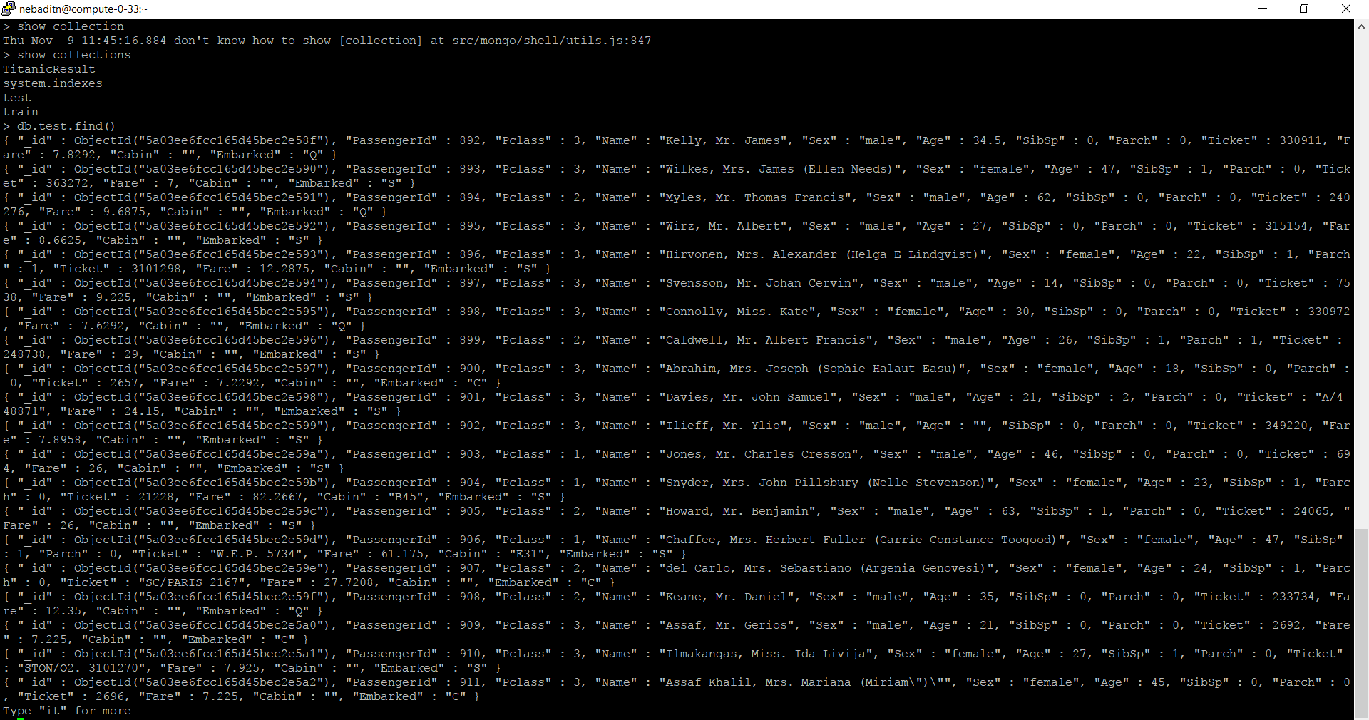

Load Train data in MongoDB

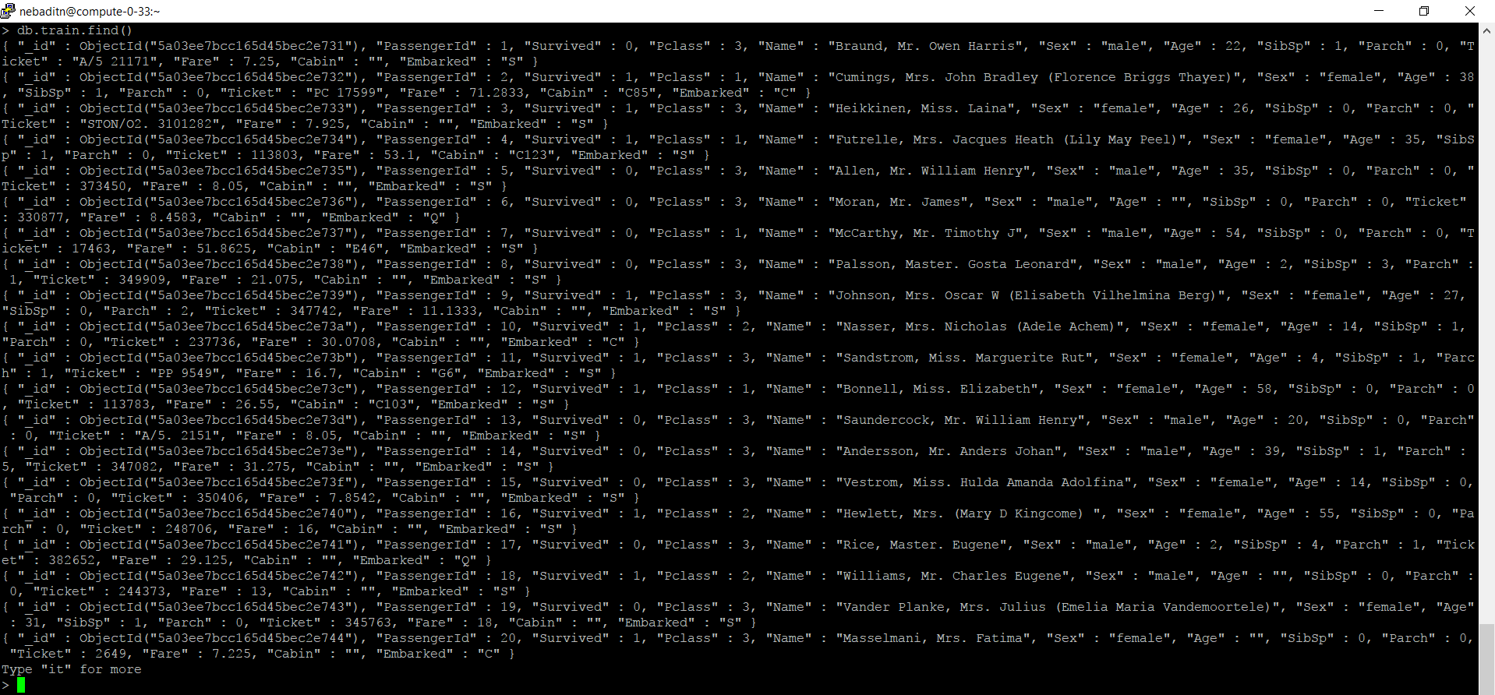

Titanic result in MongoDB

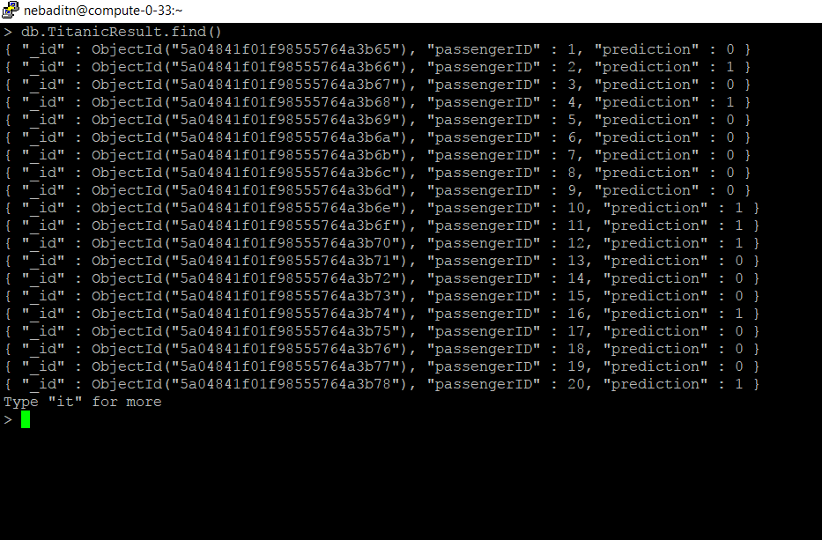

Export the result from MongoDB

