Topic: Global Warming and CO2 trends

Analyzing the relationship between CO2 emissions and global average temperature. The objective is to investigate if climate change shows up in the over time.

Datasets:

1. Temperature datasets.

<https://www.kaggle.com/berkeleyearth/climate-change-earth-surface-temperature-data>

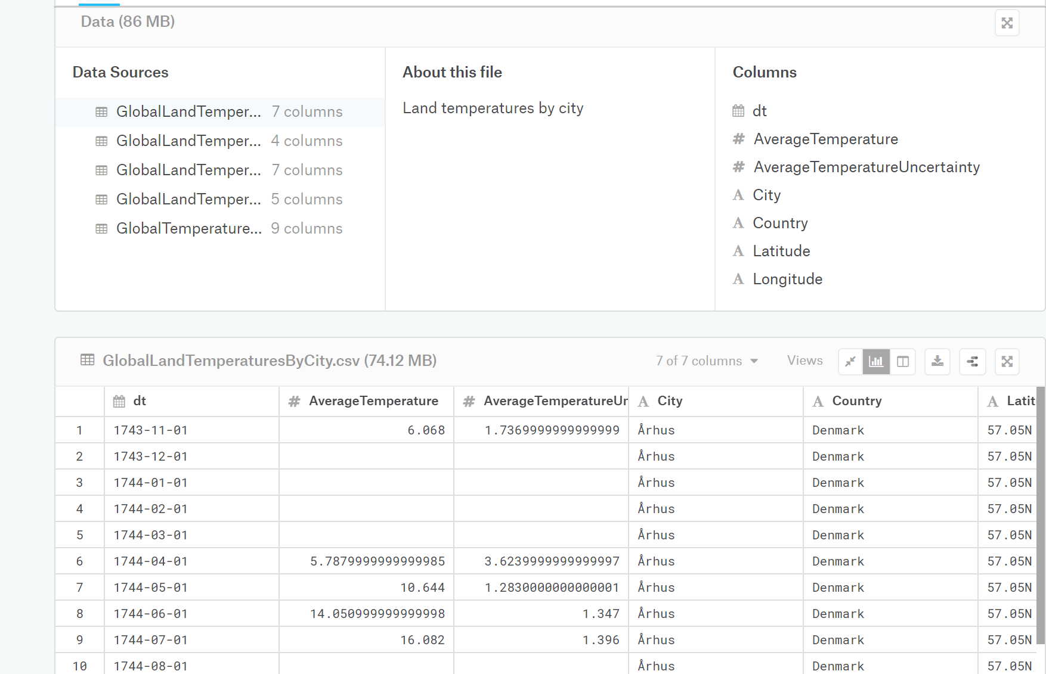

1. CO2 emissions dataset.

<https://data.worldbank.org/indicator/en.atm.co2e.pc>

Visualizations:

1. Heatmap of the world show temperature changes. Filter to select for 10 years, 25 years, 50 years.

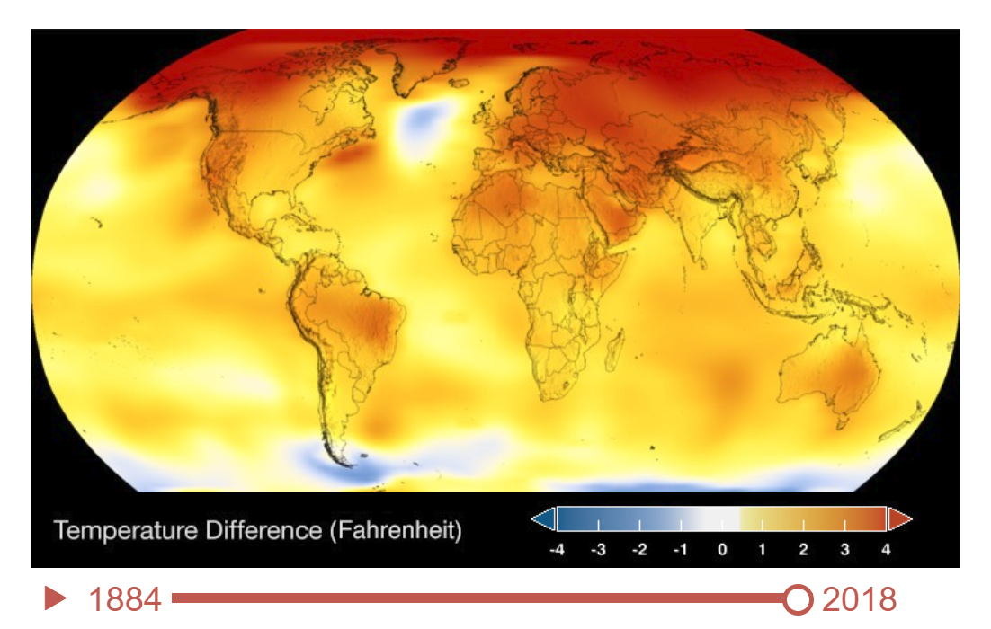

1. Bar/Line chart showing temperature by year.

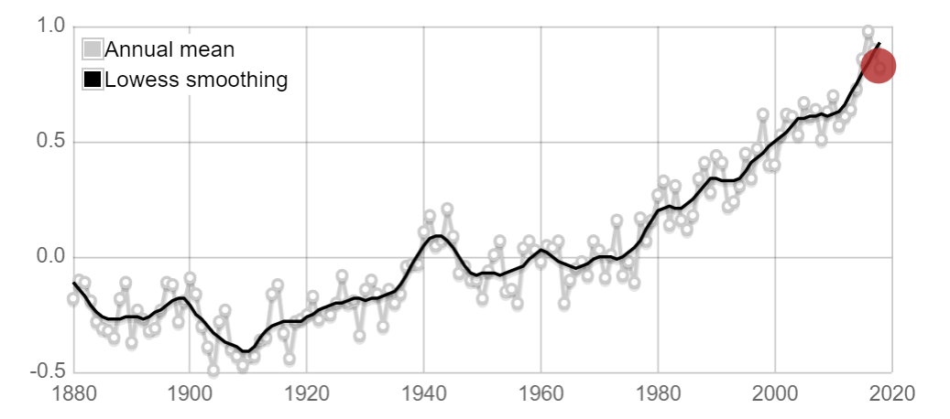

1. Bar/Line chart showing CO2 emissions by year.
2. Largest emitters of C02.

Repository:

<https://github.com/DouglasMatheny/Project2>