Kilibarda, Nebojsa 1001934192

1.a)

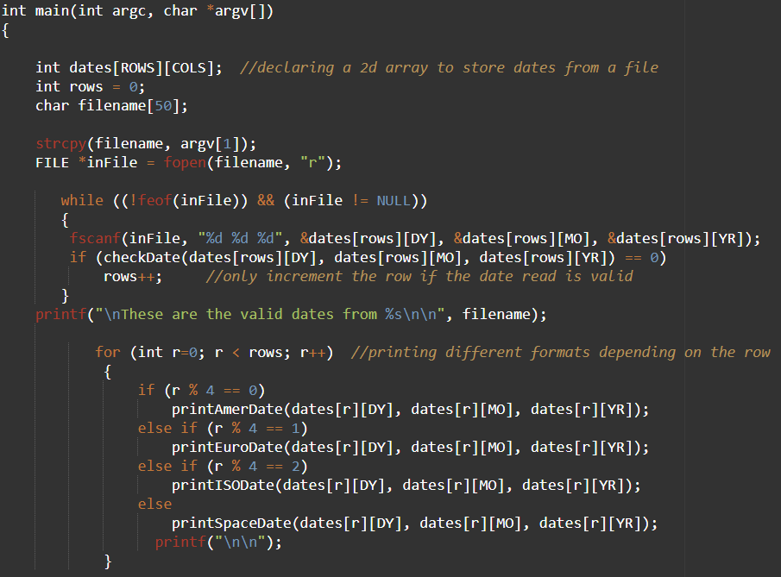

Output for 1.a

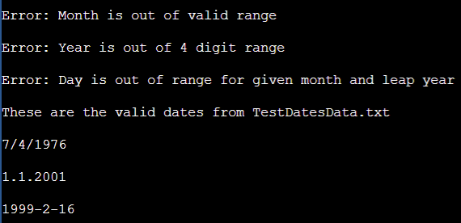

1.b)

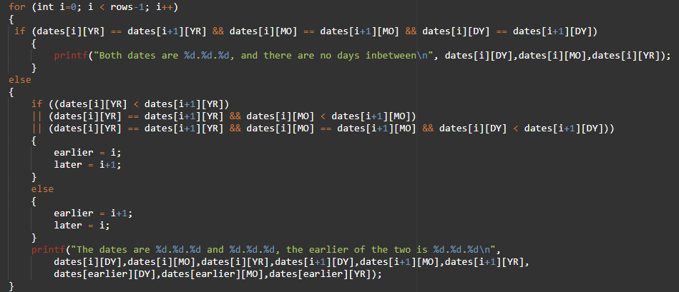

Output for 1.b

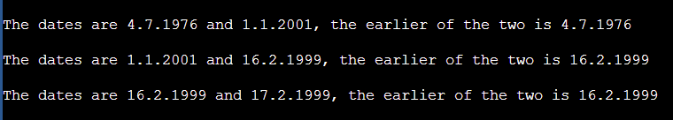

1.c)

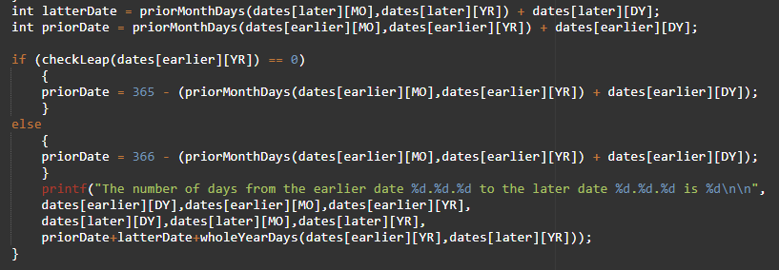

Function for 1.c

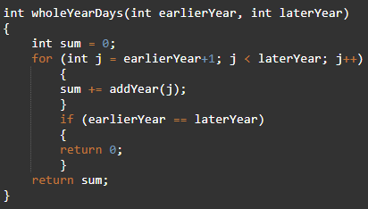

Output for 1.c (At this point I added more dates to the file)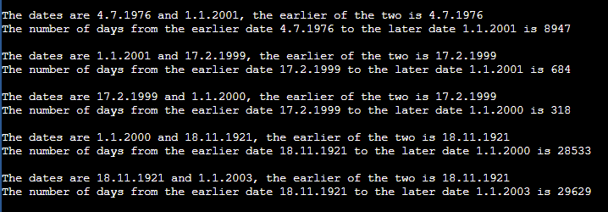

1.d) Please see the file NK4192Lab3Part1.c for this question.

2.a) Please see the file people.txt for this question.

2.b)

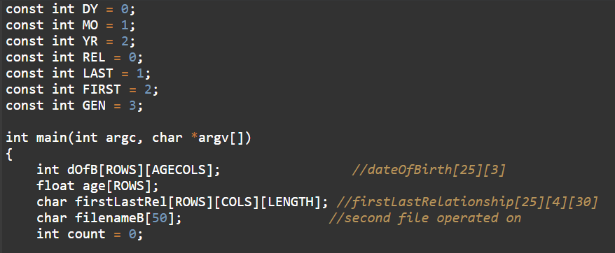

2.c) code

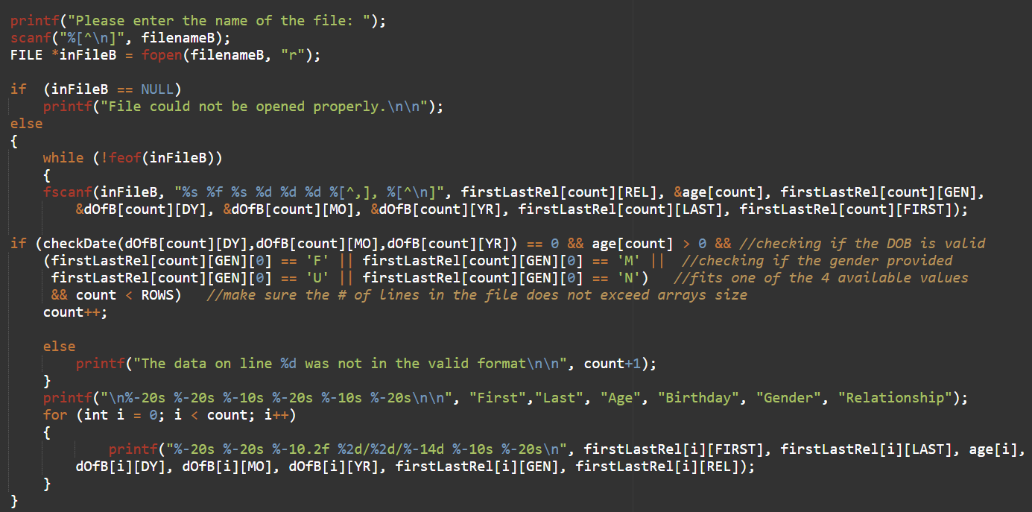

Output for 2.c)

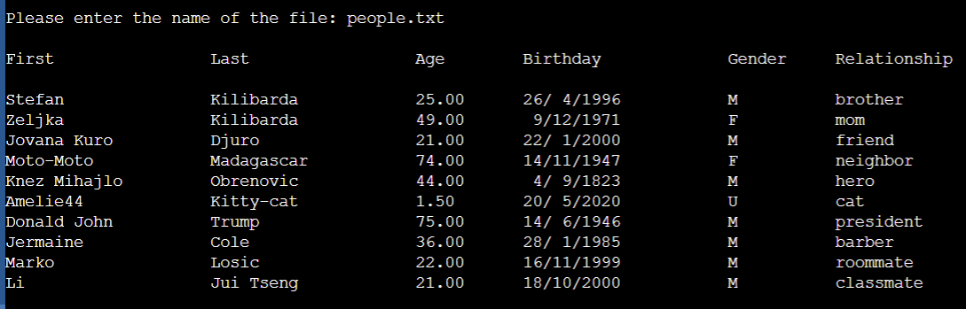

2.d) Please refer to file NK4192Lab3Part2c.c for this question.

2.e) code

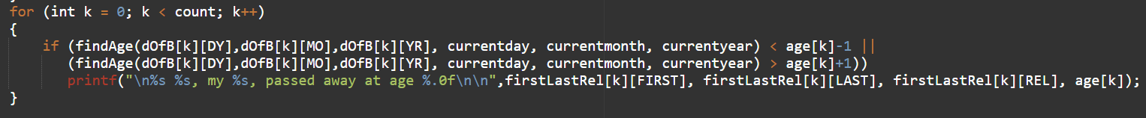

Function for 2.e)

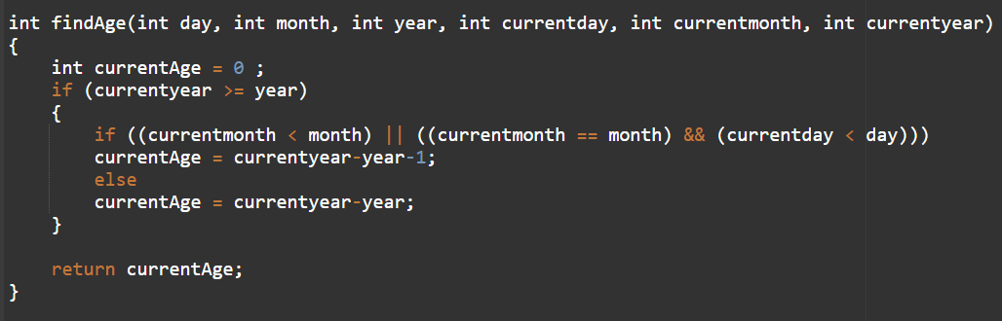

Output for 2.e)

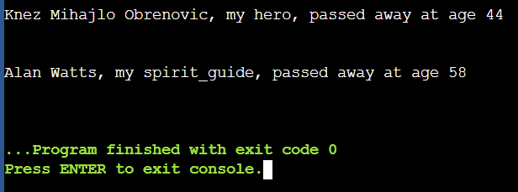

2.f) function, code, output

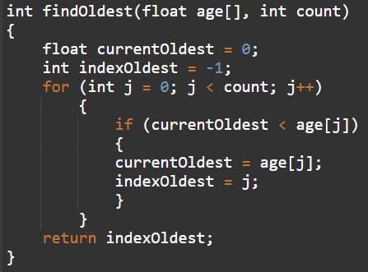

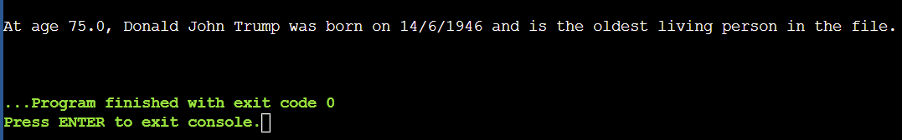

2.g) code

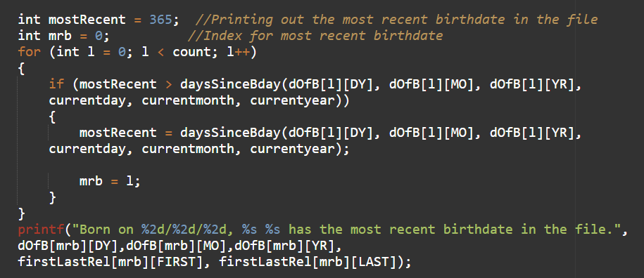

2.g)Output & Function

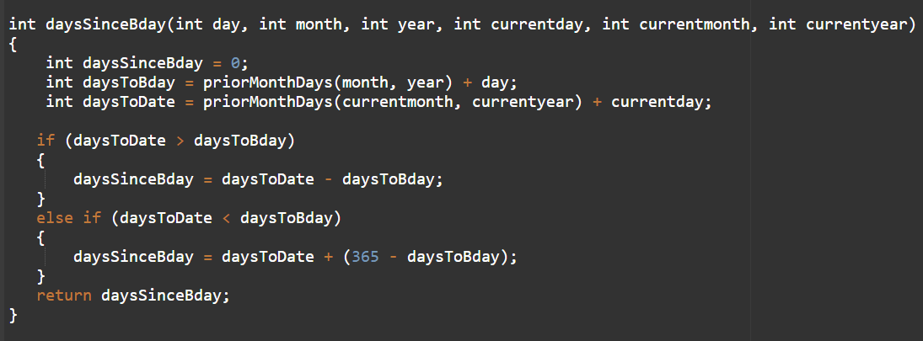

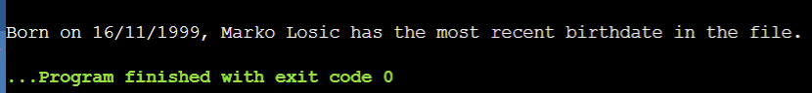

2.h) Please refer to files NK4192Lab3Part2e.c and peopleOut.txt for this question.

3) Please refer to file NK4192Lab3Part3.c for this question.