Kilibarda Nebojsa

1.a) Please see file NK4192Lab1Part1.c for this question.

1.b) Please see file NK4192Lab1Part1.c for this question.

1.c) Please see file NK4192Lab1Part1.c for this question.

1.d) Please see file NK4192Lab1Part1.c for this question.

1.e) Please see file NK4192Lab1Part1.c for this question.

1.f) Please see file NK4192Lab1Part1.c for this question.

1.g) Screenshots of all of the output:

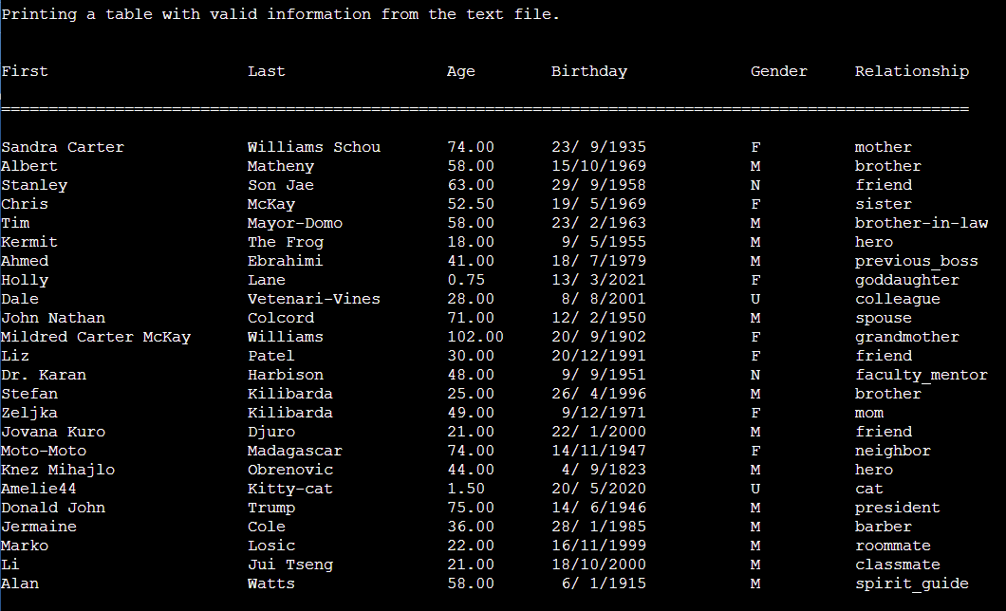

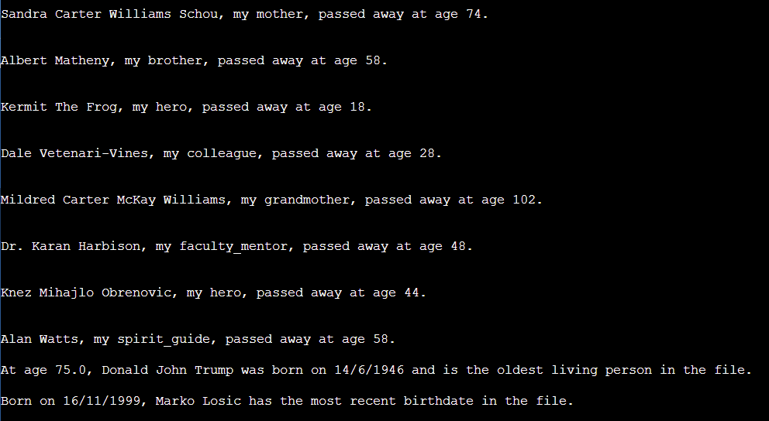

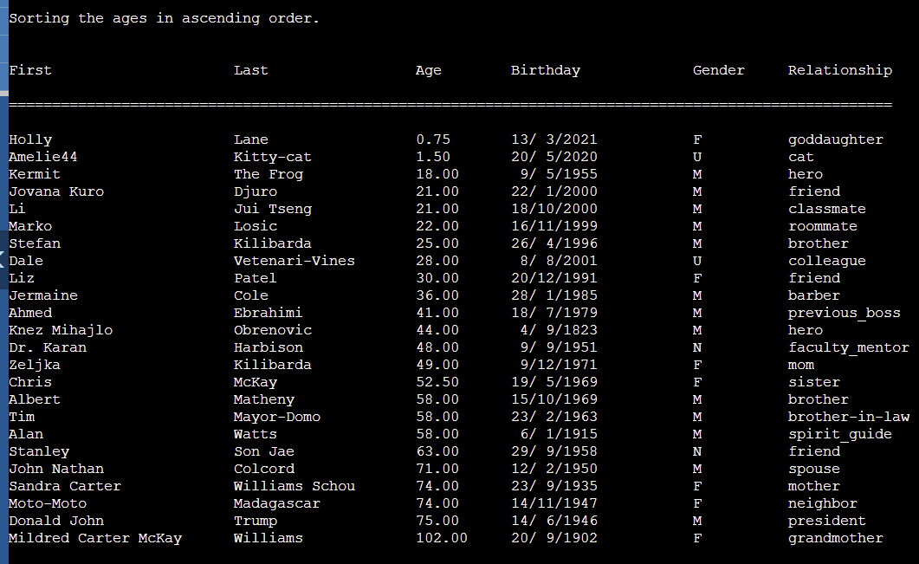

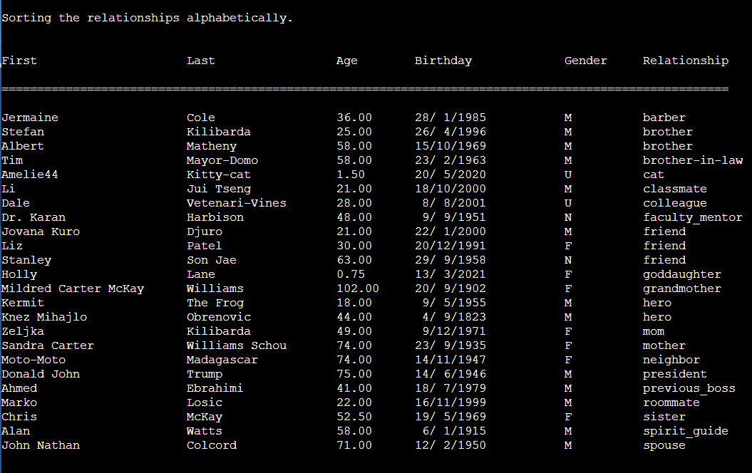

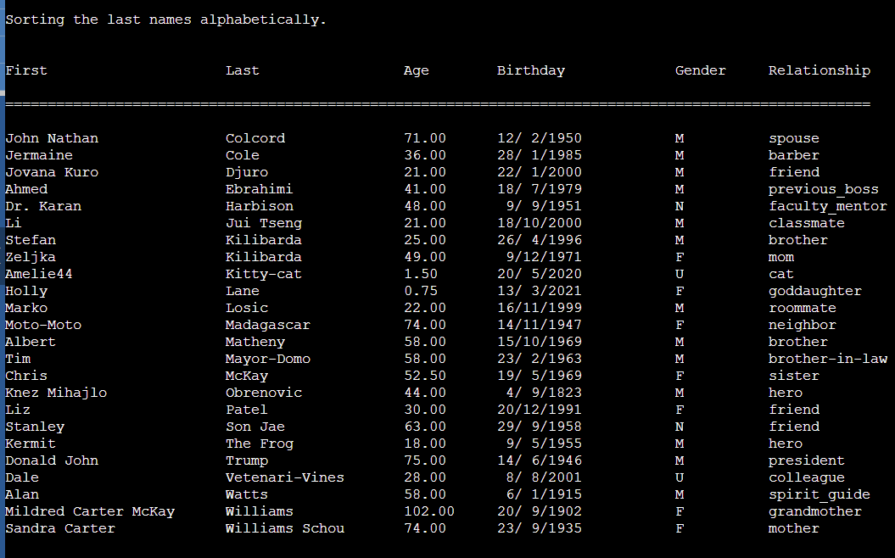

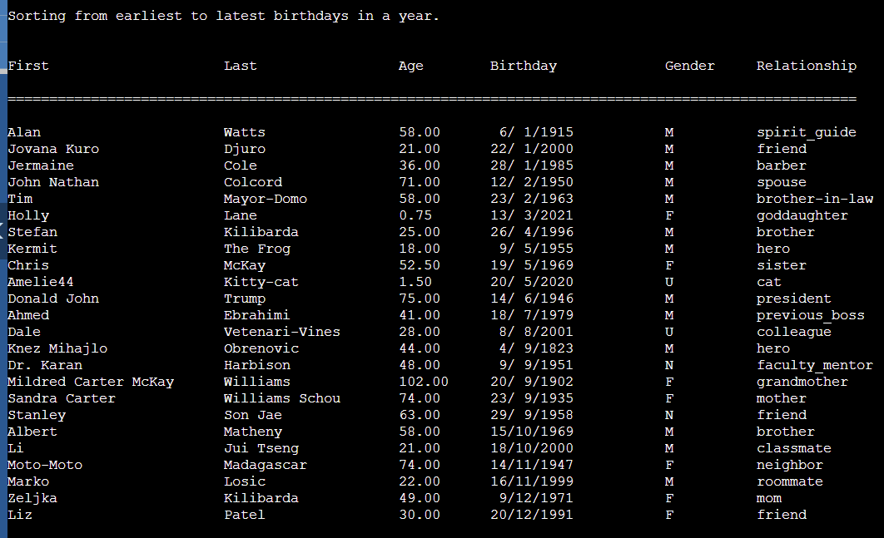

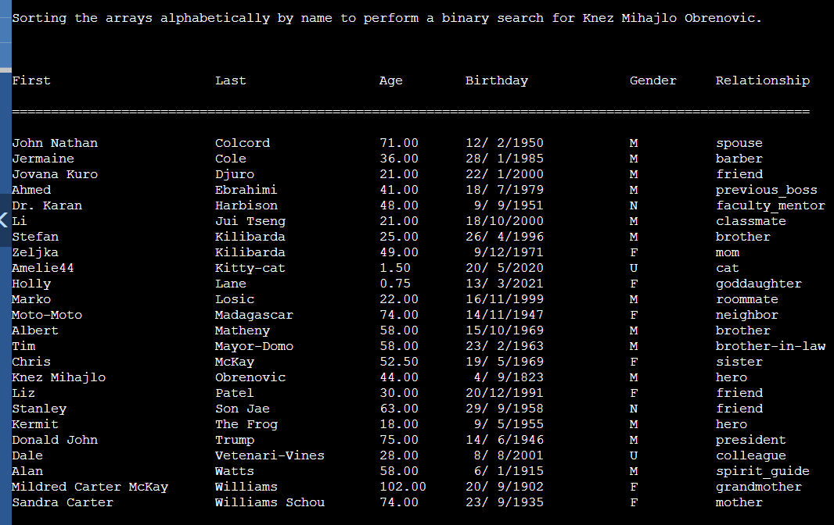

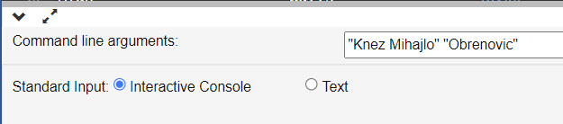

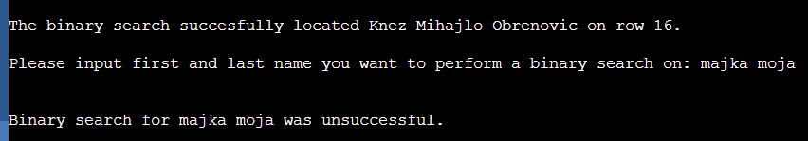

1.h) Please see file NK4192Lab1Part1.c for this question.

1.i) Code added for output file. In addition, refer to file L4OutNK4192.txt

