Extra Credit CSE 1310 Mini lab #1 Halloween

**Assigned: Friday, Oct 22, 2021**

**Due date: Sunday, Oct 31 (on Halloween!), 2021 at 11:59pm**

Since mini-labs are extra credit, the deadline is absolute.

If you miss the deadline to turn it in, then just treat it as a practice exercise

**Submission Requirements:** Your submission should be one document labeled XYZ1234MiniLab1 in either .docx, .pdf, or .odf (Open Office) format that includes Part A, Part B, and Part C as described below including the checklists.

Student Name: Nebojsa Kilibarda

Student UTA ID: 1001934192

**Problem to solve:**

Halloween is coming up. You want to create a giant jack-o-lantern face to put on the side of a building. In order to make your giant jack-o-lantern, you are going to cut out a huge orange circle as the background. Then you'll need to cut out three triangles and one half circle in black to make the face. You want to end up with a face like the picture on the right.

So you need to figure out the amount of orange and black material you need for your jack-o-lantern face. You are going to calculate a total minimum amount of material by calculating the area of the triangles and the area of the half circle for the black and then the amount of orange by using area formulas with a value given by the user for the diameter of the orange circle. The other values will be calculated in relation to that amount.

To calculate your amounts you need the following information:

* The diameter of the orange circle is exactly 5 times the length of the side of one triangle
* The diameter of the black half circle is exactly 3 times the length of the side of a triangle
* All three black triangles are the same size
* All three triangles are equilateral triangles

Use the formulas below for the area of the equilateral triangle and the area of a circle. The value of pi ($π$) is defined as the constant M_PI in the math.h header file so include that file and use the constant M_PI for $π$. Also assume that all measurements are in meters.

Area of a circle: A = r2 where *r* is the radius of the circle (half of the diameter)

Area of an equilateral triangle: A = a2 where *a* is the length of the side of the triangle

Write the pseudocode to calculate the area of material needed to make the giant jack-o-lantern face. Remember that the user will give you a diameter (*d*) for the orange circle and you'll need to use that to figure out the radius (*r*) and the side of the triangle (*a*). Be sure to 1) ask the user for the diameter of the circle in meters and 2) print out the final amount of orange material in the correct units for area and 3) the final amount of black material in the correct units for area

**Part A. PSEUDOCODE**

Write pseudocode for the formula {30%}

**Answer for Part A Pseudocode:**

1. Include the math.h header to allow for calculations as well as declaration of const pi

1. Declare the following variables:
   1. const double pi = M_PI (the math.h file library stores the value of pi in M_PI)
   2. float orange_diameter (the diameter of the orange circle, which we will ask for, it is sufficient to initialize without assigning a value)
2. Write a scanf statement asking the user to provide their desired diameter of the orange circle in meters, allowing floating point numbers. Assign this value to the diameter of the orange circle (&orange_diameter)

1. Keep declaring variables necessary for the computation:
2. float orange_radius = orange_diameter/2 (radius of the orange circle)
3. float orange_area = pi*pow(orange_radius,2) (area of the orange circle)
4. float a = orange_diameter/5 (length (a) of the side of triangle is ⅕ of the diameter of the orange circle)
5. float triangle_area = sqrt(3)/4*pow(a,2) (formula for the area of triangle)
6. float black_diameter = 3*a (diameter of black circle)
7. float black_radius = black_diameter/2 (radius of black circle)
8. float black_area = M_PI*pow(black_radius,2) (area of black circle)
9. float black_amount = 3*triangle_area+black_area/2 (This is the formula to calculate the amount of black material needed. It is the sum of areas of the three triangles and half of the area of black circle)

1. Print out the results of the computations using two separate print statements:
   1. (“The amount of orange material needed will be %f square meters”, orange_area)
   2. (“The amount of black material needed will be %f square meters”, black_amount)

**Grading for Part A Pseudocode :**

Formula pseudocode rubric:

|  |  |  |  |  |  |  |
| --- | --- | --- | --- | --- | --- | --- |
| Assessing  10 pts per line max | Exceeds Expectations  10 pts | Meets Expectations  7 - 9 pts | Needs Improvement  5 - 6 pts | Needs Substantial Work 0 – 4 pts | **Pts** | **Pts**  **\***  **Wt** |
| **Complete-ness {10%}**  **[weighting = 1}** | All steps of the formula are accounted for including creation of variables and storing final calculation | Most steps of the formula are accounted for including creation of some variables and storing final calculation | Some steps of the formula are accounted for. Few variables are created and/or final calculation is not stored | Few steps of the formula are accounted for. Variables and/or final calculation missing |  |  |
| **Clarity**  **{8%}**  **[weighting = .8}** | Written description of algorithm is clear and easy to interpret into code in a step by step fashion | Written description of algorithm is mostly clear. Most steps are easy to interpret into code | Written description of algorithm is unclear. Some steps can be interpreted into code | Written description of algorithm is not clear. Few steps can be turned into code |  |  |
| **Correctness**  **{12%}**  **[weighting = 1.2}** | Each step of the algorithm is mathematically correct. Overall formula is correct. | Most steps of algorithm are mathematically correct. Overall formula is mainly correct. | Some steps of algorithm are mathematically incorrect. Overall formula is close but not correct. | Most steps of algorithm are mathematically incorrect. Overall formula is not correct. |  |  |
| **Part A Pseudocode: Weighted Rubric Total out of 30 points possible <ATotal>** | | | | |  | |

**Part B. CODE**

Using the pseudocode for the formula, {50%}

1) Create a new C project with the standard class program header block,

2) In main, create a code framework with comments from pseudocode, then

3) Inside the framework, write code with additional explanatory comments to

**Answer for Part B Code :**

**/\*\*\*\*\*\*\*\*\*\*\*\*\*\*\*\*\*\*\*\*\*\*\*\*\*\*\*\*\*\*\*\*\*\*\*\*\*\*\*\*\*\*\*\*\*\*\*\*\*\*\*\*\*\*\*\*\*\*\*\*\*\*\*\*\*\*\*\*\*\*\*\*\*\*\*\*\*\***

**\* File: NK4192MiniLab1PartB.c**

**\* Author: Kili**

**\* Created on: 10/25/2021**

**\***

**\* UTA Student Name: Nebojsa Kilibarda**

**\* UTA ID: 1001934192**

**\*\*\*\*\*\*\*\*\*\*\*\*\*\*\*\*\*\*\*\*\*\*\*\*\*\*\*\*\*\*\*\*\*\*\*\*\*\*\*\*\*\*\*\*\*\*\*\*\*\*\*\*\*\*\*\*\*\*\*\*\*\*\*\*\*\*\*\*\*\*\*\*\*\*\*\*\*\*\*/**

**#include <stdio.h>**

**#include <math.h> //Include the math.h header to allow for calculations as well as declaration of const pi**

**int main()**

**{**

**const double pi = M_PI; //the value of pi is constant and M_PI is defined in the math.h library**

**float orange_diameter; // initialize diameter of the orange circle without passing a value**

**printf("Please provide the desired diameter of the jack-o-lantern in meters: "); // Ask user for the desired diameter of their jack-o-lantern**

**scanf("%f", &orange_diameter); //assigns the given value to the diameter of orange circle**

**// ORANGE CIRCLE //**

**float orange_radius = orange_diameter/2; // the radius of a circle is half of its diameter**

**float orange_area = pi*pow(orange_radius,2); // The formula for area of orange circle**

**// TRIANGLE //**

**float a = orange_diameter/5; // since we know that the sides of the triangle are 1/5 of diameter**

**float triangle_area = sqrt(3)/4*pow(a,2); // formula for the area of triangle**

**// BLACK CIRCLE //**

**float black_diameter = 3*a; //diameter of black circle**

**float black_radius = black_diameter/2; //radius of black circle**

**float black_area = pi*pow(black_radius,2); // formula for area of black circle**

**float black_amount = 3*triangle_area+(black_area/2); // amount of black material needed is the combined area of 3 triangles and 1/2 of area of black circle**

**printf("\nThe minimum amount of orange material needed for your jack-o-lantern is %f square meters.\n", orange_area);**

**printf("\nThe minimum amount of black material needed is %f square meters.\n", black_amount);**

**return 0;**

**}**

**Grading for Part B Code :**

*Code checklist:*

**Code contents and formatting {24 points total; 3 points each}**

xxx My C code has the standard class header block comment with :

assignment name, OnlineGDB login name, date, my UTA name, and my UTA ID

xxx My C code uses my pseudocode as framework comments for the program

xxx My code stores the user input values into appropriate variables to use

xxx My program implements the steps of the pseudocode as C statements or blocks

xxx The steps of my program use the user's input values to execute the formula

xxx The final value of the formula is stored in a variable before output

xxx I used consistent formatting of braces, indentation, and blank lines

xxx I used meaningful variables names appropriate to the problem being solved

**Code correctness and completion {21 points total; 3 points each}**

xxx My code asks the user for appropriate input values

xxx My code accepts input from the user for the formula values

xxx The steps of my program correctly implement the formula

xxx The formula value is printed in a meaningful output message to the user

xxx The final value of the formula output by the program is correct

xxx My code runs without any errors or warnings

xxx I did not use shortcut operators (ex. ++, *=)

**Coding activity {5 pts total; 1 pt each}**

xxx I wrote my formula pseudocode myself

xxx I wrote all of my C code myself

xxx I tested my C code with at least three different sets of values

xxx I debugged my code myself and/or I got help from Dr. T, the TAs, my peers, or others

xxx I only used concepts already discussed in the class lectures prior to this due date

**Part B Code CHECKLIST TOTAL**

**Part C. SCREENSHOTS**

Using your C code, {20%}

Execute your code with the input values below and show a screenshot of each set of output (one screenshot for each set of input values). {Each screenshot is worth 4%}

a) user inputs 10 for diameter

b) 8.4

c) 20

d) An input value you choose with a decimal part

e) An input value you choose with a value larger than 20

**Answer for Part C Screenshots : // List each labeled set of values followed by its screenshot**

**C.a)** User inputs 10 for diameter

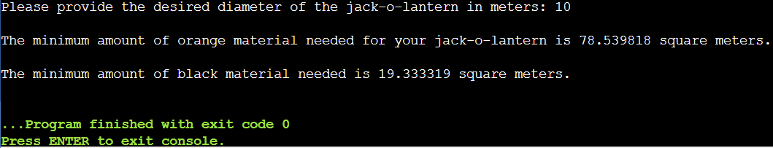

**C.b)** User inputs 8.4 for diameter

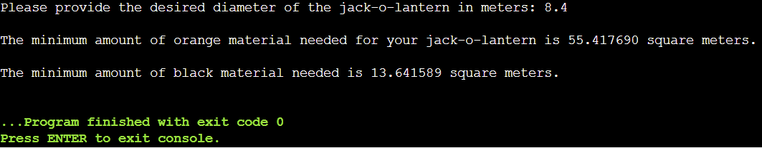

**C.c)** User inputs 20 for diameter

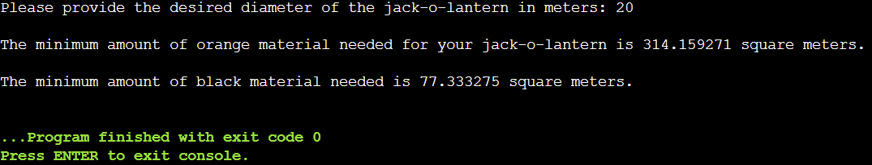

**C.d)** User inputs 4.44 for diameter

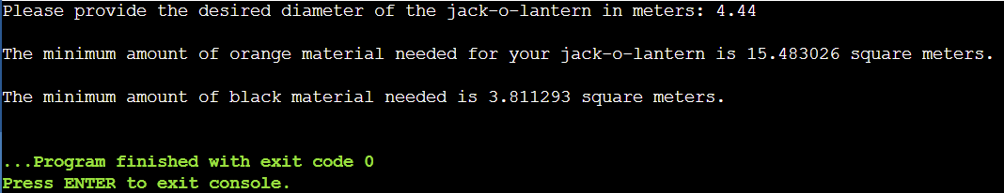

**C.e)** User inputs 21 for diameter

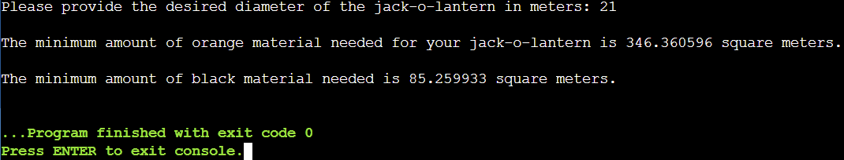

**Grading for Part C Screenshots :**

C.a) <score>

C.b) <score>

C.c) <score>

C.d) <score>

C.e) <score>

**Part C Screenshots Total Score:**

**Mini lab grade:**

**<ATotal> Part A PSEUDOCODE Rubric**

**<BTotal> Part B CODE Checklist**

**<CTotal> Part C: SCREENSHOTS Score**

**<Total> Total: Sum of totals**