1. Link to GitHub repository: https://github.com/nebphilly/csd-310
2. Screenshot repository:
3. 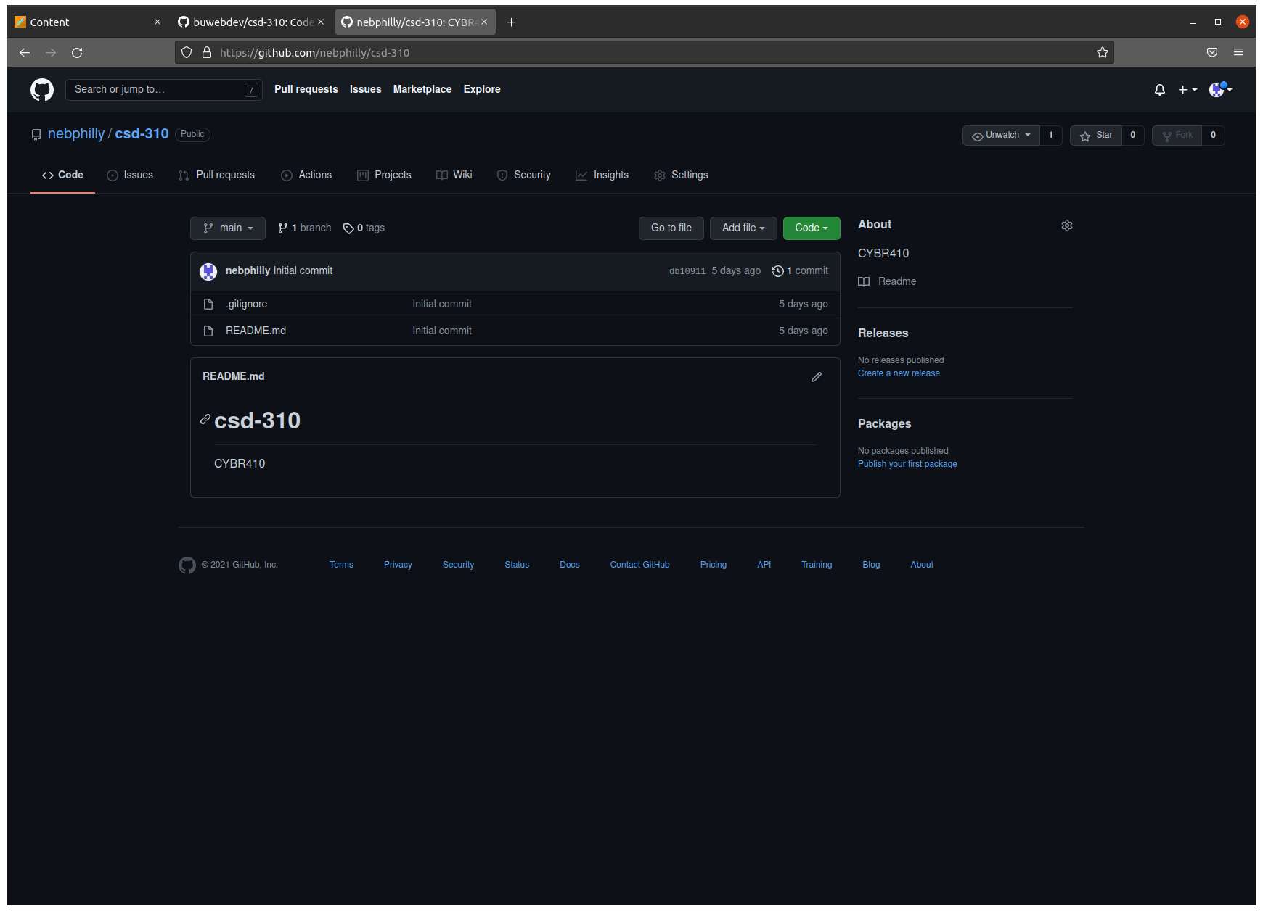Screenshot repository with added directories for proper structure as required:
4. 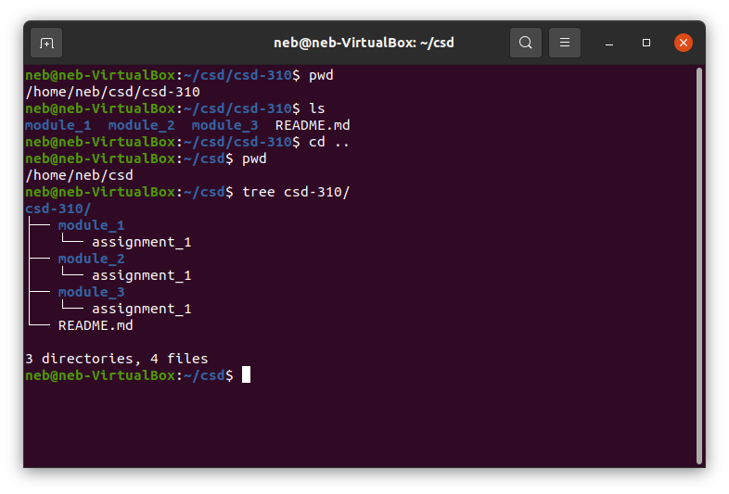I created another directory and cloned the school csd-310, with a screenshot.

