ORD based on PyShopper details.

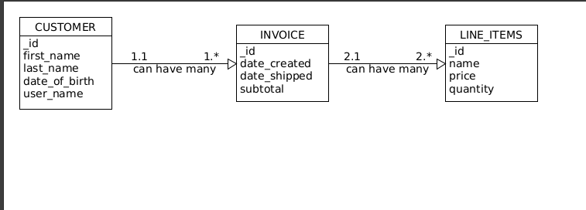 I used the “*” to indicate each follow on fields (INVOICE & LINE_ITEMS) can be many for the upper level table.

NoSQL data Structure.

