* ORD and NoSQL Diagram

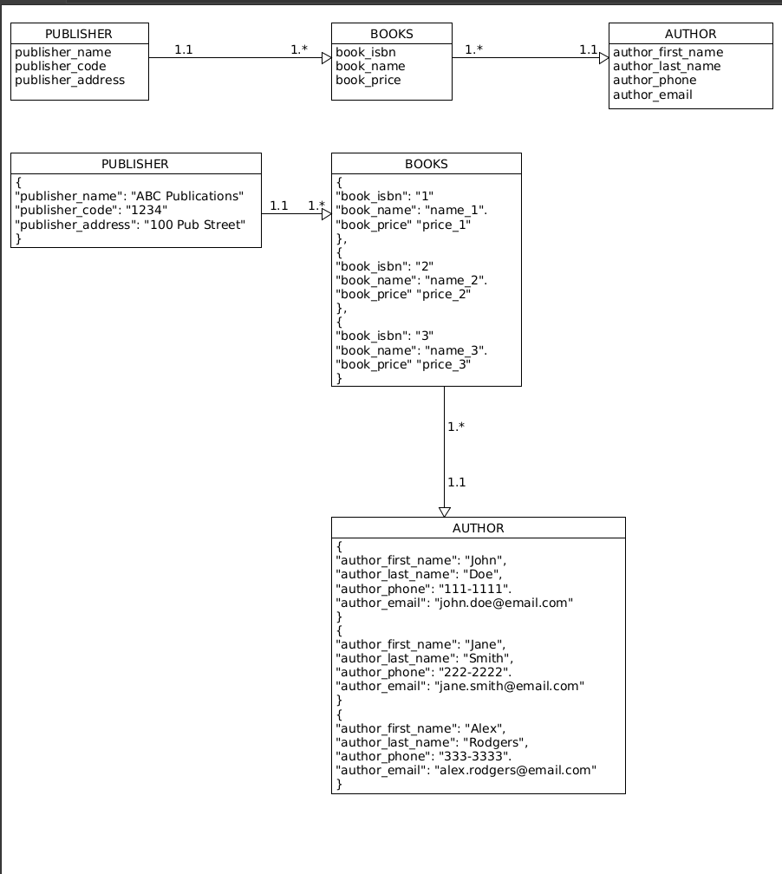

* NoSQL Data Structure

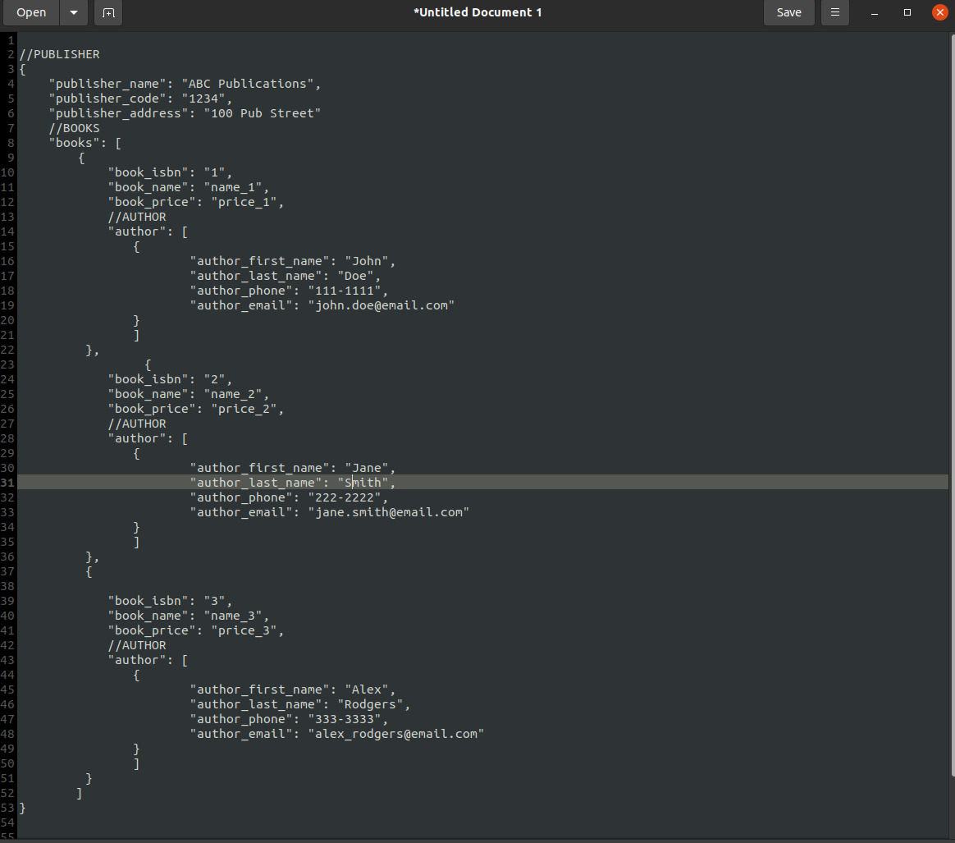

* Business Rules
  + One PUBLISHER has many BOOKS
  + Many BOOKS could have one AUTHOR

This was difficult to display exactly how I intended to group the data. The ISBN number could be the primary key that would potential sort all the associated data, which would be the author information. Many ISBNs could have the same author however, many authors would also me in the database.