* Database screenshot
* 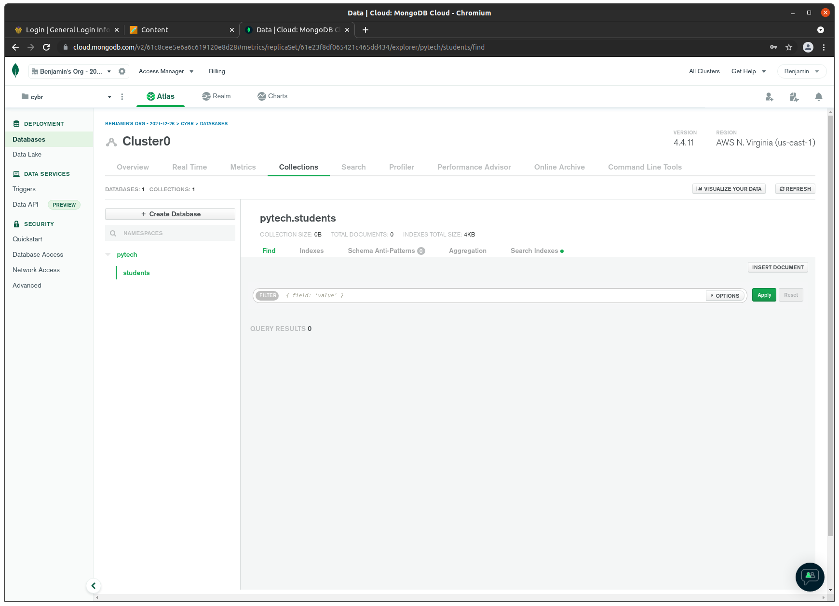Github link: https://github.com/nebphilly/csd-310/tree/master