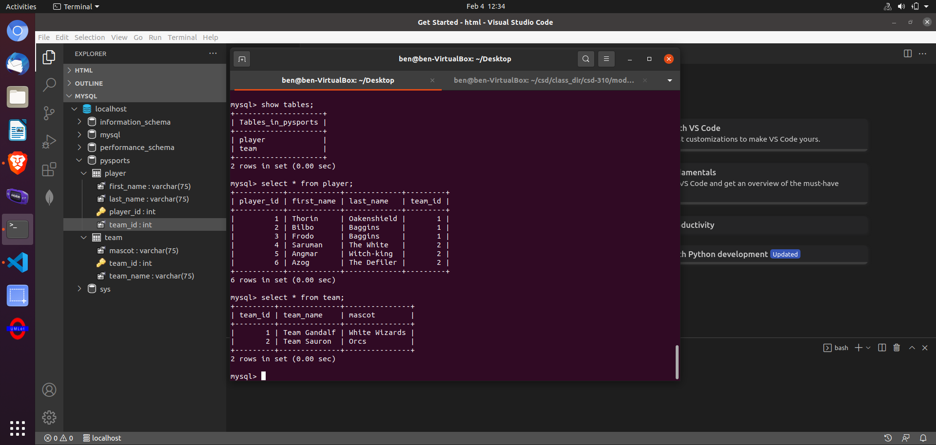I missed a screenshot of the script output and was concerned running it again may mess up my data. However, I’ve provided the outputs showing the script ran correctly and built the tables.

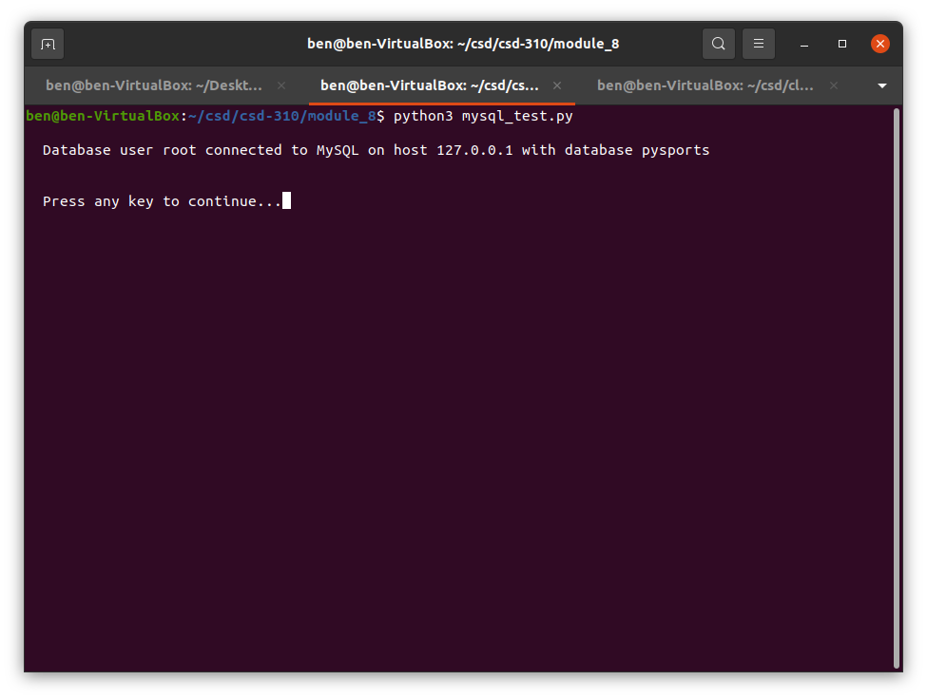Since the directions create the new user ‘pysports_user’ and then immediately drop the new user. I modified the python connection script to use the ‘root’ user to verify connectivity.