**FakeNooz**

Noah Brown

Benjamin Swanson

William Howley

Naylan Adre

Jack Bauman

Sprint 2 Plan

Completion: February 21, 2018 | Version 2 | February 7, 2018

The goal of this sprint is to implement processes in which the program sorts out articles from different websites based on relativity, popularity/importance, and user interest. This sprint is primarily focused on user experience/accessibility, as well as creating a base for the GUI.

**User Story 1: As a reader, I want to be given a list of articles related to an article that I give so that I can see multiple perspectives.**

* Task 1: Investigate getting tags from newspaper (1)
* Task 2: Tag articles with topics (3)
* Task 3: Sort and present articles by tag (2)

**User Story 2: As a reader, I want related articles to be pushed out automatically so that I don’t need to find them.**

* Task 1: Similarity search for related articles (3)
* Task 2: Allow user to add own sources (3)
* Task 3: Take in URL provided by reader (1)

**User Story 3: As a reader, I need the most important stories to show up first so that I can get a quick overview of current news.**

* Task 1: Find popular topics in recent news using LSI (2)
* Task 2: Pull down list of articles based on topics (2)

**User Story 4: As a reader, I need an easily navigable way to read the news.**

* Task 1: Be able to take input from user in GUI (3)
* Task 2: Make software an executable (3)
* Task 3: Make window that can be navigated by clicks/buttons (5)
* Task 4: Investigate python packages like qt for GUI implementation (1)

**Team Roles and Initial Tasks**

Noah Brown – Product Owner, Developer

* User Story 1, Task 1

Benjamin Swanson – Developer

* User Story 3, Task 1

William Howley – Developer

* User Story 2, Task 3

Naylan Adre – Scrum Master, UX Designer

* User Story 4, Task 4

Jack Bauman – Developer

* User Story 2, Task 1

**Initial Burn Up Chart**

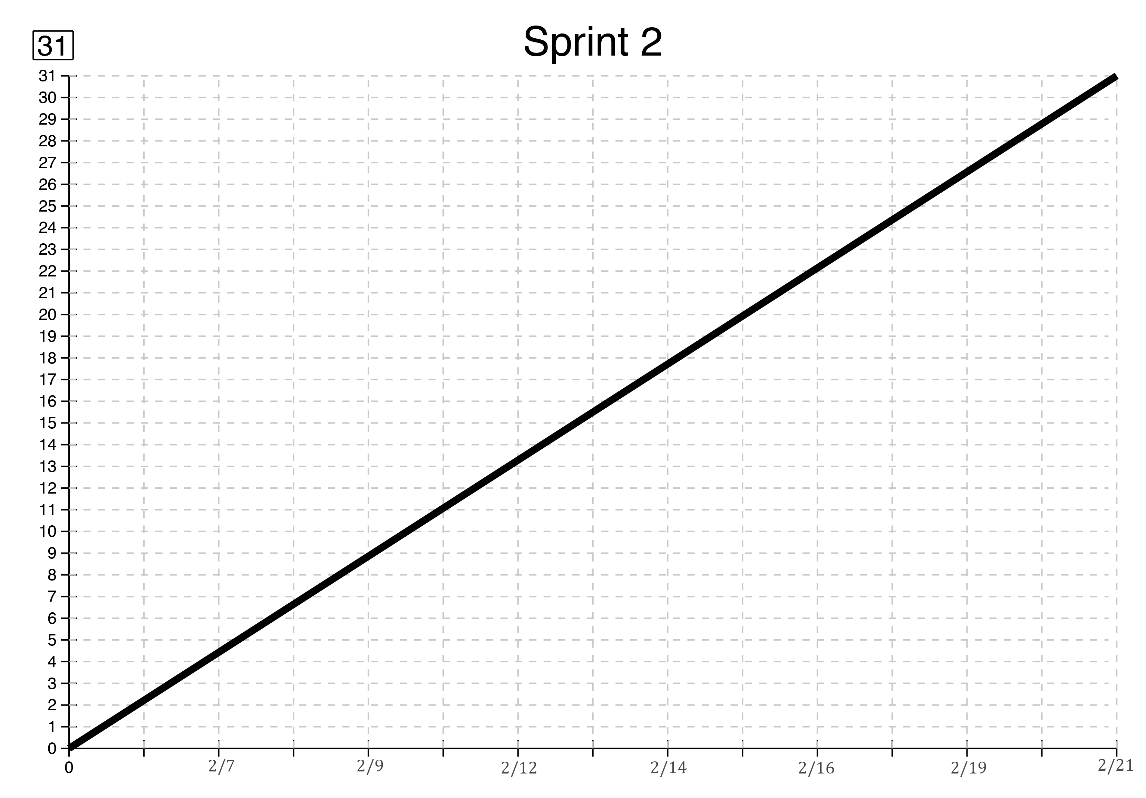

**Scrum Board – Lab 316**