

ADVANCED EMBEDDED SYSTEMS

STM32F103C8T6 Architecture, Low-Power Modes,
and Interrupt Wake-Up Mechanisms
Research Study

By:Nebiyat Biadglign CTC-1984-26

1. STM32F103C8T6 Device Overview and Key Specifications
The STMicroelectronics STM32F103C8T6 is a medium-density performance-line 32-bit microcontroller based on the ARM Cortex-M3 RISC core. Operating at clock frequencies up to 72 MHz, it incorporates 64 Kbytes of embedded Flash memory, 20 Kbytes of zero-wait-state SRAM, and a versatile peripheral set housed in a 48-pin LQFP package. The alphanumeric part designation encodes: STM32 (ARM 32-bit family), F103 (Performance line), C (48 pins), 8 (64 KB Flash), T (LQFP package), and 6 (industrial temperature range: -40 °C to +85 °C).
Hardware Parameter | Technical Specification / Capability | Operational Boundary / Domain
CPU Core Architecture | ARM 32-bit Cortex-M3 RISC with Thumb-2 instruction set | 72 MHz max (1.25 DMIPS/MHz)
Flash Memory | 64 Kbytes single-bank embedded Flash with prefetch buffer | 0x0800 0000 - 0x0800 FFFF
SRAM | 20 Kbytes zero-wait-state static RAM | 0x2000 0000 - 0x2000 4FFF
Operating Voltage | 2.0 V to 3.6 V operating range (nominal 3.3 V) | VDD, VDDA, VBAT (1.8 - 3.6 V)
Operating Temperature | -40 °C to +85 °C industrial operating range | TJ up to 105 °C
General-Purpose I/O | 37 fast GPIO pins, majority 5 V-tolerant, 18 MHz max toggle | Ports GPIOA, GPIOB, GPIOC, GPIOD
Analog Subsystem | 2 × 12-bit SAR ADCs (16 ch. total, 10 ext. on LQFP48, 1 µs conv.) | ADC1, ADC2, Temp Sensor, VREFINT
Timers | 1 × 16-bit Advanced PWM (TIM1), 3 × 16-bit General-Purpose (TIM2-4) | TIM1 on APB2; TIM2-4 on APB1
Communications | 3 × USART (4.5 Mb/s), 2 × SPI (18 Mb/s), 2 × I2C, USB FS, CAN 2.0B | Shared 512B SRAM between USB/CAN
DMA Controller | 7-channel DMA1 controller; peripheral-to-memory, memory-to-memory | AHB Bus master
Table 1: STM32F103C8T6 Hardware Specifications Summary (ST Datasheet DS5319 Rev 20)
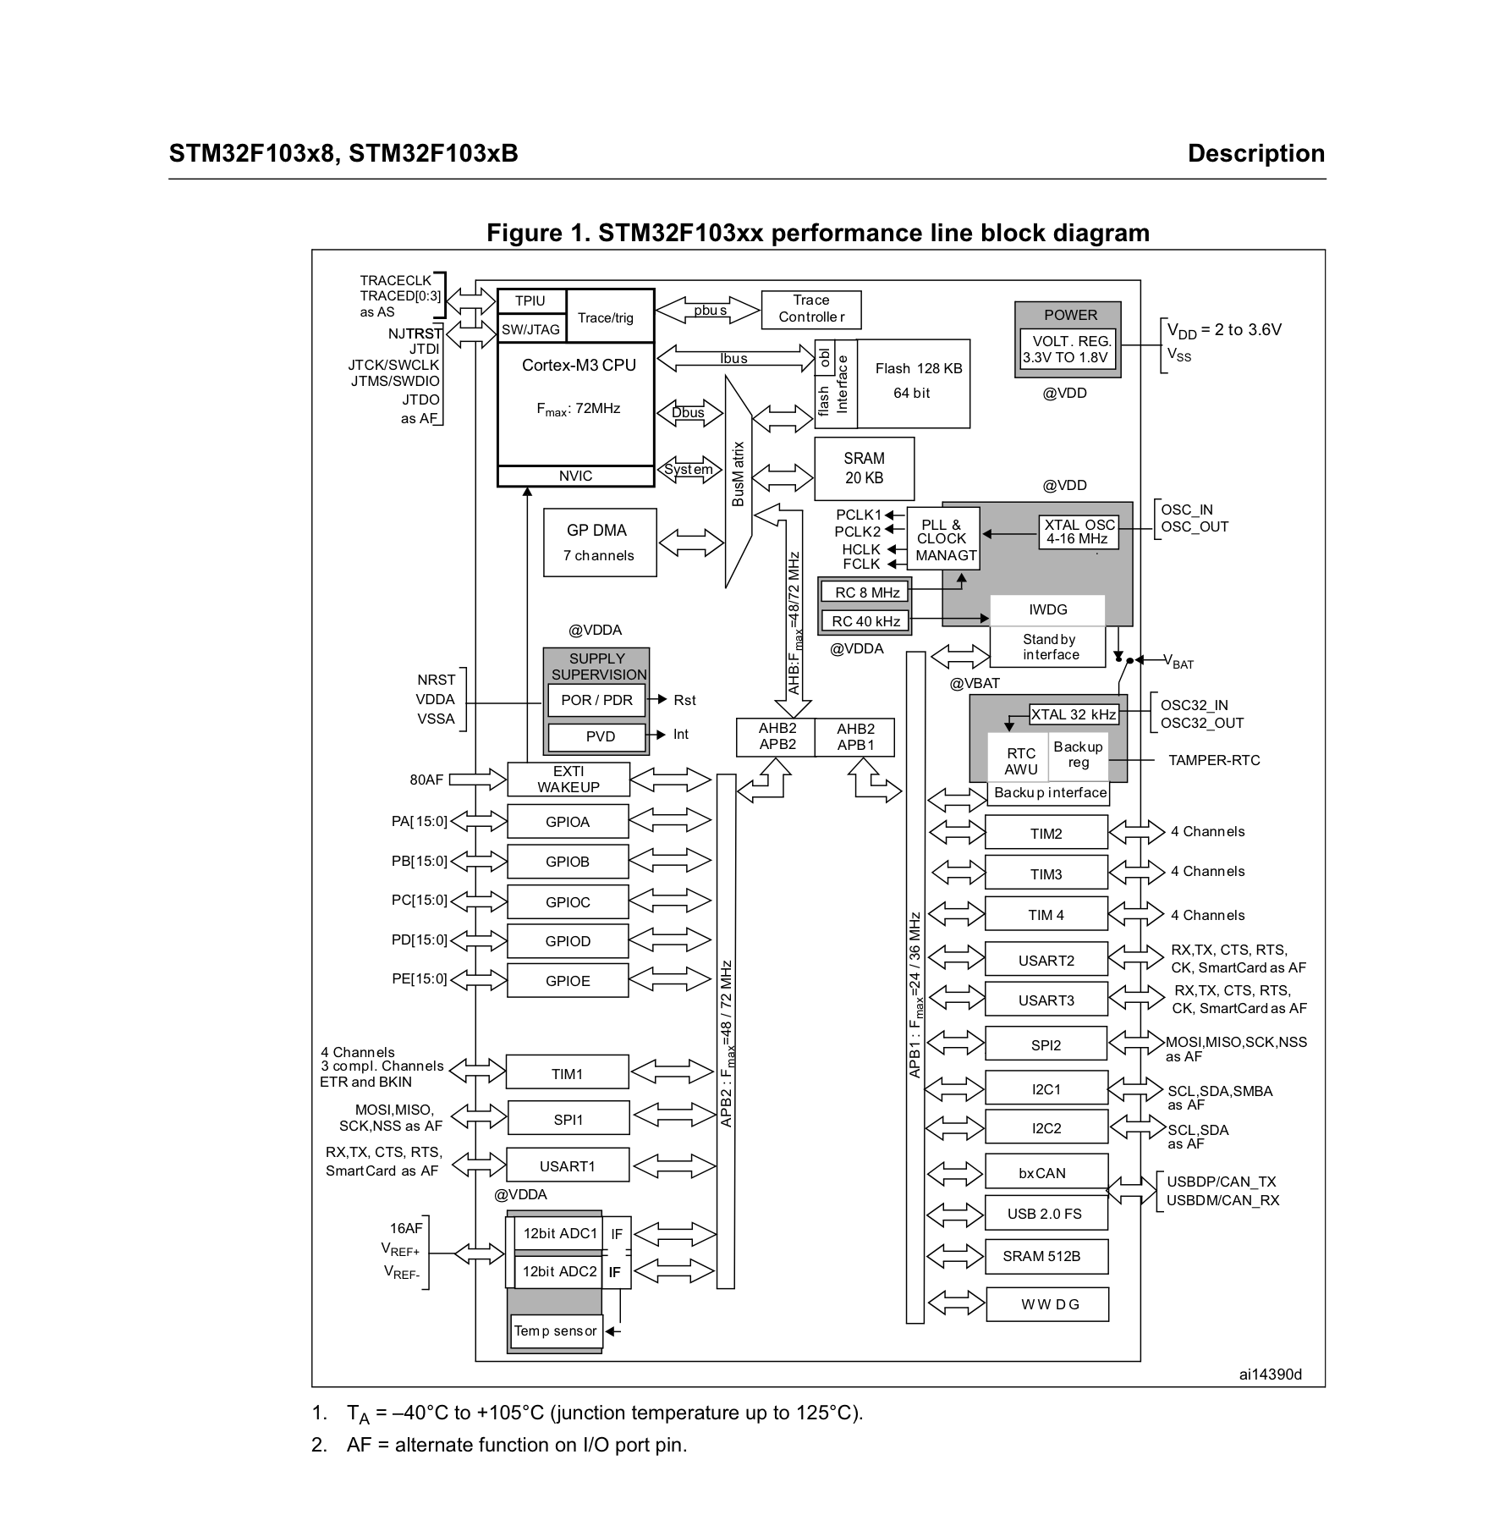
Figure 1: STM32F103xx Performance Line Block Diagram.
Source: STMicroelectronics, STM32F103x8/xB Medium-Density Performance Line Datasheet, DocID DS5319, Rev 20, July 2025, Section 2.1, p. 11.

2. Cortex-M3 Architecture, Memory, and Bus Organization
2.1 ARM Cortex-M3 Core Architecture and Pipeline
The ARM Cortex-M3 core implements the ARMv7-M architecture using the Thumb-2 instruction set, executing mixed 16-bit and 32-bit instructions without mode switching. It features a 3-stage instruction pipeline (Fetch, Decode, Execute) with branch speculation, hardware division (2-12 cycles), single-cycle multiplication, the Nested Vectored Interrupt Controller (NVIC), a 24-bit SysTick system timer, and power control registers (SCB->SCR).
2.2 Memory Organization and Address Map
The device features a unified 4 Gbyte linear address space. Table 2 outlines the physical memory map for the STM32F103C8T6.
Memory Region | Physical Address Range | Size | Functional Description & Allocation
Flash Memory | 0x0800 0000 - 0x0800 FFFF | 64 KB | User code, constants, and interrupt vector table
System Memory | 0x1FFF F000 - 0x1FFF F7FF | 2 KB | Factory pre-programmed USART1 serial bootloader
Embedded SRAM | 0x2000 0000 - 0x2000 4FFF | 20 KB | Zero-wait-state data RAM; preserved in Stop mode
APB1 Peripherals | 0x4000 0000 - 0x4000 77FF | 30 KB | TIM2-4, USART2-3, SPI2, I2C1-2, USB, CAN, PWR, BKP
APB2 Peripherals | 0x4001 0000 - 0x4001 3FFF | 16 KB | AFIO, EXTI, GPIOA-D, ADC1-2, TIM1, SPI1, USART1
AHB Peripherals | 0x4002 0000 - 0x4002 33FF | 13 KB | DMA1 (7 channels), RCC, Flash interface, CRC engine
System Control Space | 0xE000 0000 - 0xE00F FFFF | 1 MB | NVIC, SysTick, System Control Block (SCB)
Table 2: STM32F103C8T6 Memory Map Allocation (Reference Manual RM0008 Rev 21, Section 4)
2.3 Bus Matrix and Interconnect Architecture
The internal bus architecture uses a multi-layer AMBA bus matrix interconnecting four masters (I-Code, D-Code, System buses, and DMA1) with four slaves (Flash, SRAM, AHB-to-APB1, and AHB-to-APB2 bridges). Round-robin arbitration enables simultaneous DMA transfers and CPU code execution without mutual bus contention.

3. Clock/Reset, GPIO, and Peripheral Architecture
3.1 Reset and Clock Control (RCC) System
The RCC manages system resets across three domains: (1) Power Reset (POR/PDR and Standby exit); (2) System Reset (NRST pin, software reset, watchdogs); and (3) Backup Domain Reset (BDRST bit or full VDD/VBAT loss). The clock tree manages five oscillators: HSI (8 MHz RC, default wake-up clock), HSE (4–16 MHz crystal), PLL (up to 72 MHz), LSI (~40 kHz RC for IWDG), and LSE (32.768 kHz crystal for RTC). SYSCLK feeds AHB (HCLK, max 72 MHz), which prescales to APB1 (PCLK1, max 36 MHz) and APB2 (PCLK2, max 72 MHz).
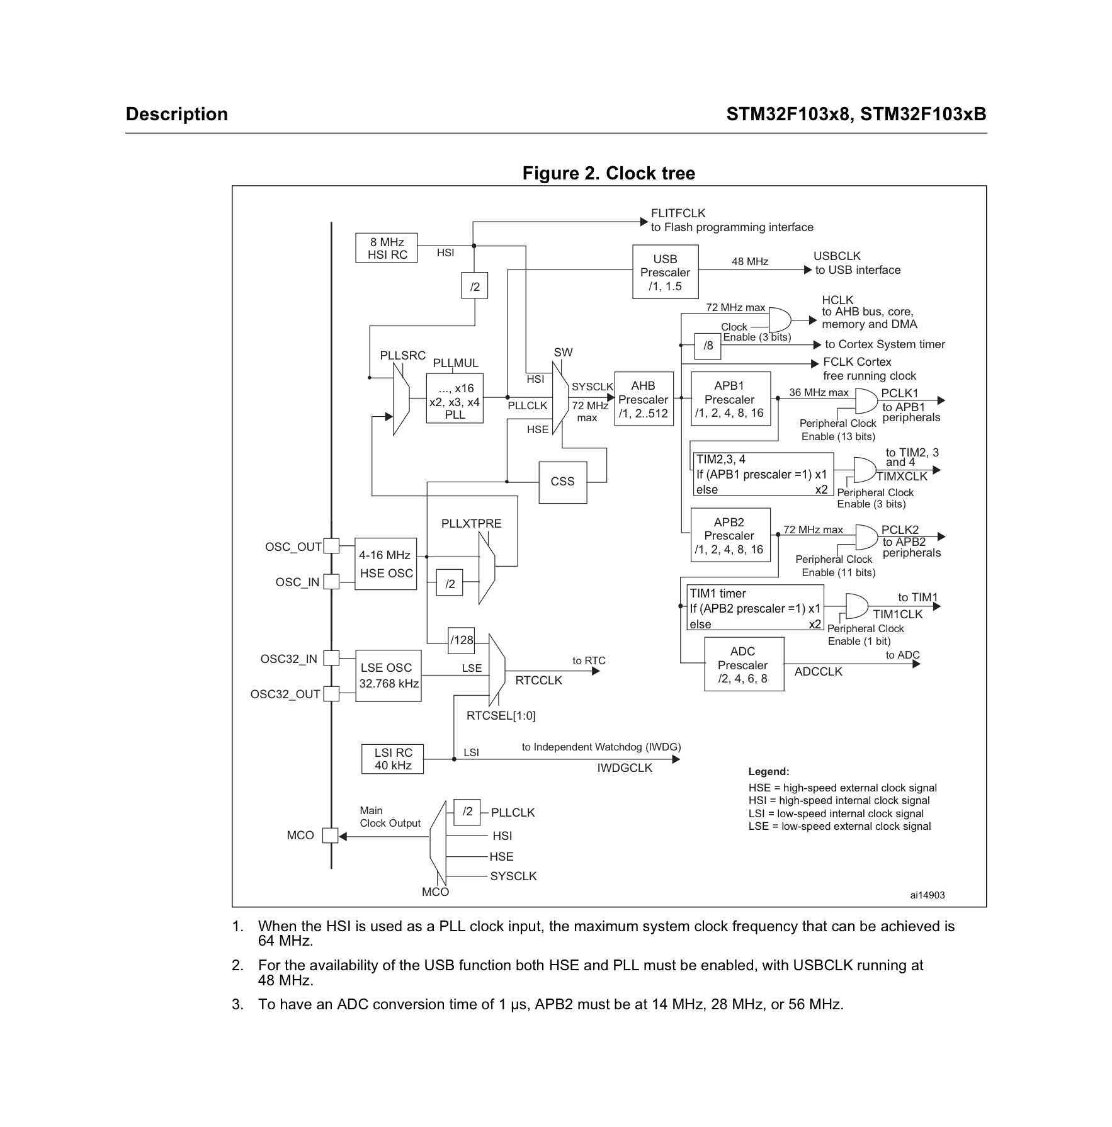
Figure 2: STM32F103C8T6 RCC Clock Tree.
Source: STMicroelectronics, STM32F103x8/xB Medium-Density Performance Line Datasheet, DocID DS5319, Rev 20, July 2025, Section 2.3.4, p. 12.
3.2 GPIO Modes and Pinout Configuration
Each GPIO pin is configured through the GPIOx_CRL and GPIOx_CRH registers using MODE and CNF fields. The available configurations include floating input, input with pull-up/pull-down, analog input, general-purpose output, and alternate-function output modes. In input pull-up/pull-down mode, the GPIO output-data register determines whether the internal resistor provides a pull-up or pull-down. The AFIO controller manages pin remapping.
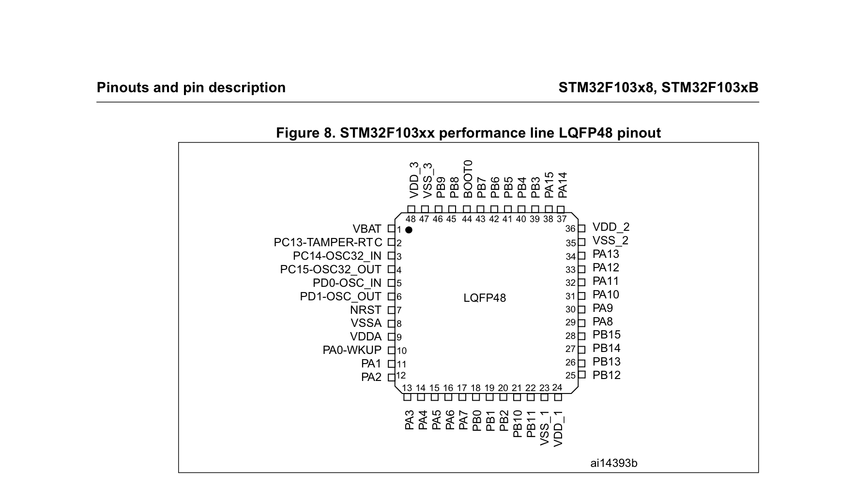
Figure 3: STM32F103xx Performance Line LQFP48 Pinout.
Source: STMicroelectronics, STM32F103x8/xB Medium-Density Performance Line Datasheet, DocID DS5319, Rev 20, July 2025, Section 3, p. 26.

3.3 Integrated Peripheral Subsystems Summary
Peripheral | Main Capability & Architecture
TIM1 | Advanced 16-bit PWM, complementary outputs, dead-time
TIM2–TIM4 | General-purpose timers, PWM, capture/compare
ADC1/ADC2 | Dual 12-bit SAR ADCs (10 external channels on LQFP48, 1 µs conversion)
DMA1 | 7-channel memory-to-memory and peripheral-to-memory transfer
USART1–3 | Asynchronous serial communication (USART1 up to 4.5 Mb/s)
SPI1/2 | Full-duplex serial peripheral interface (up to 18 Mb/s)
I2C1/2 | 100 kHz standard and 400 kHz fast-mode I2C interfaces
USB FS | USB 2.0 Full-Speed device controller (12 Mb/s)
CAN | bxCAN 2.0B Active controller with 3 TX mailboxes and 2 RX FIFOs
Table 3: STM32F103C8T6 Peripheral Subsystem Summary (Reference Manual RM0008 Rev 21)
SHARED SRAM HARDWARE ARCHITECTURE NOTE: The USB and CAN peripherals share a dedicated 512-byte SRAM area. Therefore, their simultaneous use is constrained by the shared-memory architecture and device limitations described by ST.
4. Interrupt Architecture: NVIC and EXTI
4.1 Nested Vectored Interrupt Controller (NVIC)
The ARM Cortex-M3 NVIC supports 68 maskable interrupt channels with 16 programmable priority levels implemented using 4 priority bits. Priority grouping configured in SCB->AIRCR splits these bits into preemption priority and sub-priority. The NVIC provides 12-cycle deterministic interrupt latency, automatic hardware context stacking/unstacking (R0–R3, R12, LR, PC, xPSR), tail-chaining (5-cycle transition), and late-arriving preemption.
4.2 External Interrupt/Event Controller (EXTI)
The EXTI block manages 20 edge-detector lines operating fully asynchronously without requiring internal clocks. Lines 0–15 are multiplexed across GPIO ports (PAx–PDx) through AFIO_EXTICR1–4 registers (e.g., EXTI0 maps to PA0, PB0, PC0, or PD0). Lines 16–19 connect to internal event sources: Line 16 is linked to PVD, Line 17 connects to the RTC Alarm, Line 18 handles USB Wake-Up, and EXTI line 19 is associated with Ethernet wake-up on connectivity-line devices and is not applicable to the STM32F103C8T6. Each line can be individually masked for interrupt generation (EXTI_IMR) or event generation (EXTI_EMR), and programmed for rising (EXTI_RTSR) or falling (EXTI_FTSR) edge triggers. In Stop mode, EXTI edge transitions wake the MCU asynchronously.

5. Power Management Architecture
5.1 Power Supply Domains and Voltage Distribution
The STM32F103 power architecture is partitioned into four independent supply domains:
1. VDD Domain (2.0 V to 3.6 V): Powers external I/O pins, reset circuitry, oscillators, and the internal regulator.
2. VDDA Domain (2.0 V to 3.6 V): Filtered analog supply for ADC1, ADC2, and the internal temperature sensor.
3. 1.8 V Core Domain: Stepped down by the on-chip regulator; powers Cortex-M3 core, SRAM, and digital peripherals.
4. VBAT Domain (1.8 V to 3.6 V): Powers the RTC, LSE 32.768 kHz oscillator, and 42 backup data registers (BKP_DRx).
5.2 Embedded Voltage Regulator Operating States
The internal step-down voltage regulator generates the 1.8 V core supply and operates in three distinct states:
• Main Regulator (MR) Mode: Delivers full 1.8 V power with maximum drive capability. Active in Run and Sleep modes.
• Low-Power Regulator (LPR) Mode: Maintains 1.8 V core voltage with reduced quiescent bias current and slower slew rate, reducing static leakage. Selected during Stop mode when the LPDS bit in PWR_CR is set to 1.
• Power-Down Mode: The 1.8 V regulator output is completely disabled. Internal core logic and SRAM lose all power. Active in Standby mode.
5.3 Power Voltage Detector (PVD) and Modes Master Table
The Power Voltage Detector monitors the VDD supply against a programmable threshold selected by bits PLS[2:0] in the PWR_CR register (2.2 V to 2.9 V). When enabled (PVDE = 1), the PVD sets the PVDO status bit in PWR_CSR when VDD drops below threshold and can trigger an interrupt via EXTI Line 16 for emergency data preservation.
Mode | CPU Core | Clocks Active / Stopped | SRAM State | Regulator | Wake-Up Sources | Main Use Case & Typical Current (3.3V, 25°C)
Run | Active (72 MHz) | All active | Retained | ON (MR) | None | Full active processing (~27 mA)
Sleep | Halted (gated) | All active | Retained | ON (MR) | Any NVIC interrupt or event | Depends on HCLK frequency and enabled peripherals.
Stop (MR) | Halted | 1.8V stopped | Retained | ON (MR) | Any EXTI line (GPIOs, RTC, PVD) | Fast wake-up with full RAM retention (~24 µA)
Stop (LPR) | Halted | 1.8V stopped | Retained | Low-Power | Any EXTI line (GPIOs, RTC, PVD) | Lowest power with full RAM retention (~14 µA)
Standby | Powered OFF | 1.8V stopped | LOST (Reset) | OFF | WKUP pin (PA0), RTC alarm, NRST | Ultra-low-power sleep with RAM loss (~2.0 µA)
Table 4: STM32F103C8T6 Low-Power Modes Comparison (RM0008 Rev 21 Table 11 & Datasheet Table 16)

6. Low-Power Operational Modes: Sleep, Stop, and Standby
6.1 Detailed Operational Analysis of Sleep, Stop, and Standby
Sleep Mode: Entered by clearing SLEEPDEEP in SCB->SCR and executing WFI or WFE. Sleep mode stops the CPU clock while selected peripherals and clocks can continue operating, so actual current consumption depends on the operating frequency and active peripherals. Wake-up latency is minimal (~12 clock cycles via NVIC).
Stop Mode: Entered by setting SLEEPDEEP in SCB->SCR, clearing PDDS in PWR_CR, and executing WFI or WFE. All clocks in the 1.8 V domain are halted; HSI, HSE, and PLL are stopped. SRAM and register contents are fully preserved. Wake-up occurs via any EXTI line. Quiescent current at 3.3 V, 25 °C is ~14 µA with the low-power regulator (LPDS = 1) and ~24 µA with the main regulator (LPDS = 0). Wake-up latency is ~5 µs.
Standby Mode: Entered by setting SLEEPDEEP in SCB->SCR, setting PDDS in PWR_CR, and executing WFI. The 1.8 V regulator is powered off; internal SRAM and CPU registers are entirely lost. Only the 42 Backup registers, RTC (if clocked by LSE/LSI), and WKUP pin logic remain active. Wake-up occurs via a rising edge on PA0/WKUP, RTC alarm, external NRST, or IWDG, triggering an internal System Reset. Current is ~2.0 µA (RTC off) / ~3.4 µA (RTC on).
6.2 Stop-Mode Clock Recovery Protocol
CRITICAL CLOCK RESTORATION PROTOCOL: Clock Recovery After Stop Mode: When exiting Stop mode, hardware automatically selects the 8 MHz HSI oscillator as SYSCLK. HSE and PLL remain disabled. Firmware must explicitly re-enable HSE, wait for stabilization (HSERDY), re-lock the PLL, and switch SYSCLK back to PLL output if 72 MHz operation is required.
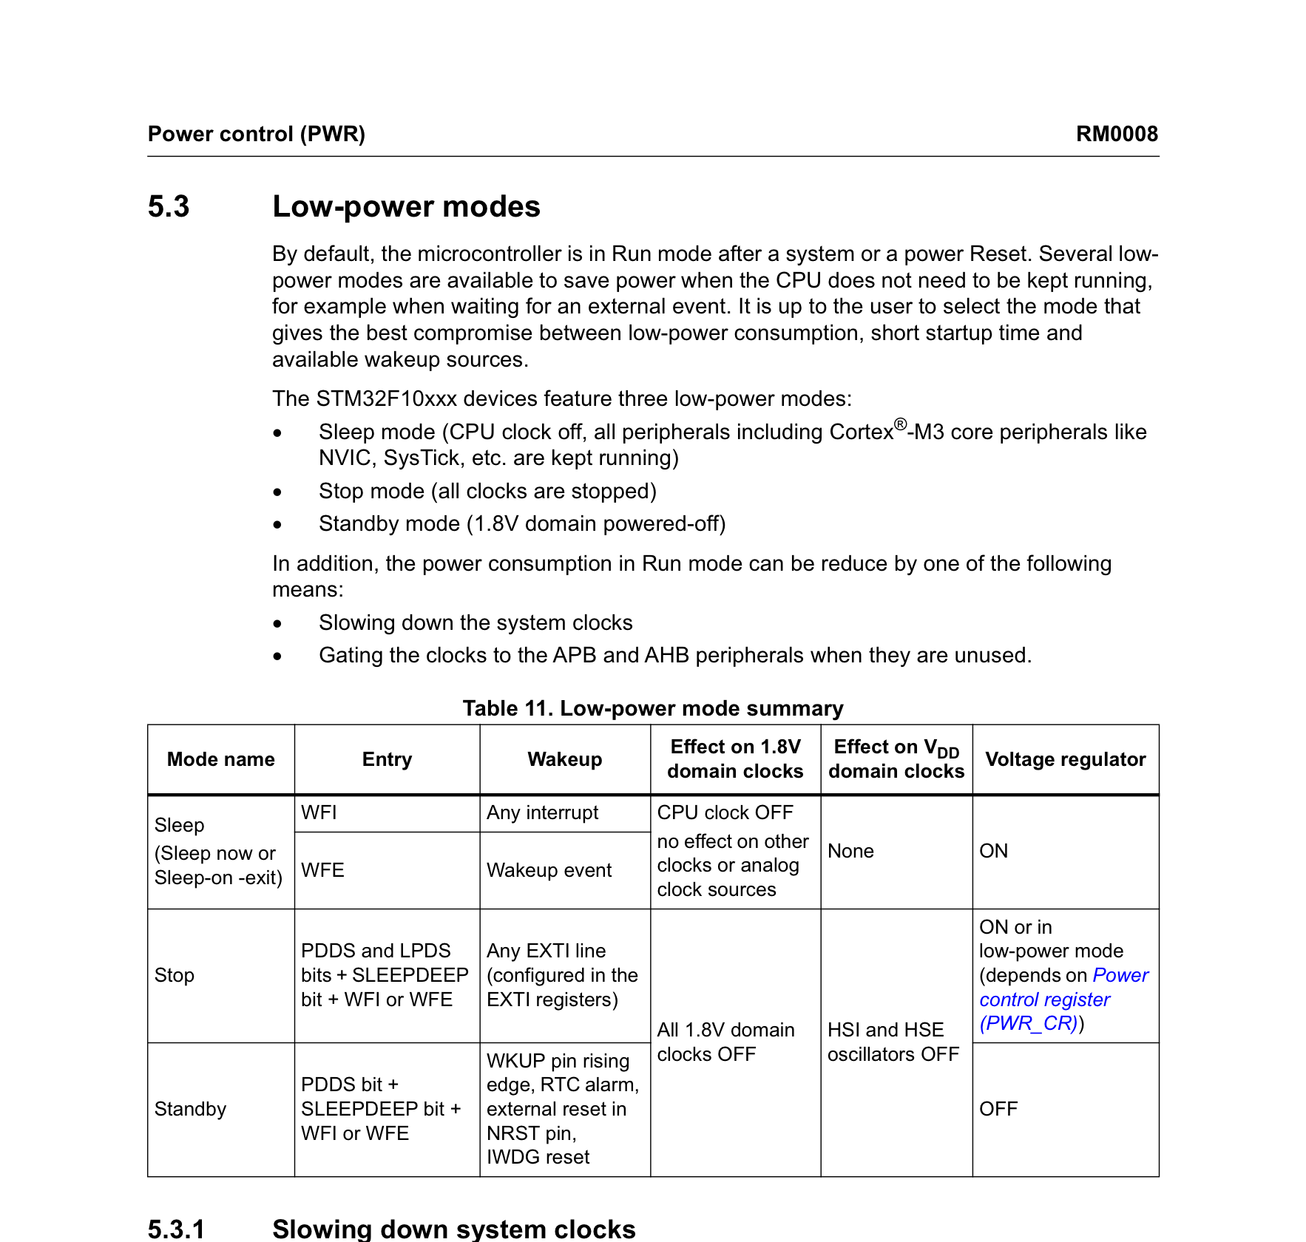
Figure 4: Low-Power Mode Summary — Table 11.
Source: STMicroelectronics, STM32F10xxx Reference Manual, DocID RM0008, Rev 21, February 2021, Section 5.3, p. 72.

7. Wake-Up Mechanisms, WFI/WFE, and Power Control Registers
7.1 Instruction Semantics: WFI vs WFE
• WFI (Wait For Interrupt): Suspends processor execution until an enabled NVIC interrupt occurs. Upon wake-up, the CPU branches to the interrupt vector handler, executes the ISR, and resumes execution at the instruction following WFI. If PRIMASK = 1, WFI wakes the CPU core but suppresses ISR vectoring.
• WFE (Wait For Event): WFE (Wait For Event) suspends processor execution until an event occurs. Events may be generated through the Cortex-M3 event mechanism, including EXTI event configuration or the SEV instruction. When WFE resumes execution, execution continues with the instruction following WFE rather than entering an ISR solely because of the event. WFE checks an internal 1-bit Event Register; if already set, WFE clears it and continues.
7.2 Power Control Registers (PWR_CR and PWR_CSR)
Table 5 details the bit-field definitions of the primary Power Control registers (base address 0x4000 7000). The APB1 peripheral clock must be enabled via RCC_APB1ENR (bit 28 PWREN) prior to accessing these registers.
Register [Bit] | Field Name | Access | Reset | Functional Description & Hardware Control Role
PWR_CR [0] | LPDS | RW | 0 | Low-Power Deep Sleep. 0 = Main regulator in Stop; 1 = Low-Power regulator in Stop.
PWR_CR [1] | PDDS | RW | 0 | Power Down Deep Sleep. 0 = Enter STOP mode on SLEEPDEEP=1; 1 = Enter STANDBY mode.
PWR_CR [2] | CWUF | RW | 0 | Clear Wakeup Flag. Write 1 to clear WUF in PWR_CSR. Must clear before Standby entry.
PWR_CR [3] | CSBF | RW | 0 | Clear Standby Flag. Write 1 to clear SBF in PWR_CSR.
PWR_CR [4] | PVDE | RW | 0 | Power Voltage Detector Enable. 1 = Enable PVD monitoring on VDD.
PWR_CR [7:5] | PLS[2:0] | RW | 000 | PVD Level Selection: 000=2.2V, 001=2.3V, 010=2.4V, ... 111=2.9V.
PWR_CR [8] | DBP | RW | 0 | Disable Backup Domain Protection. 1 = Enable write access to RTC and Backup registers.
PWR_CSR [0] | WUF | R | 0 | Wakeup Flag. Set by hardware on wake-up event. Cleared by CWUF=1 in PWR_CR.
PWR_CSR [1] | SBF | R | 0 | Standby Flag. Set by hardware on Standby entry. Cleared by CSBF=1 in PWR_CR.
PWR_CSR [2] | PVDO | R | 0 | PVD Output. 0 = VDD above PLS threshold; 1 = VDD below PLS threshold.
PWR_CSR [9] | EWUP | RW | 0 | Enable WKUP Pin. 1 = PA0 pin enabled as external wake-up source in Standby.
Table 5: PWR_CR and PWR_CSR Register Bit Definitions (Reference Manual RM0008 Rev 21, Section 5.4)
Standby Mode Wake-Up Flag Handling: Prior to entering Standby mode, firmware must set the CWUF bit in PWR_CR to ensure that the WUF flag in PWR_CSR is cleared. If WUF remains set from a prior event, the microcontroller will immediately wake up from Standby mode without entering the intended ultra-low-power sleep state.

8. Architectural Comparison: STM32F103C8T6 vs ATmega328P
8.1 Hardware Architecture Comparison
Table 6 provides a concise engineering comparison between the 32-bit ARM Cortex-M3 STM32F103C8T6 and the 8-bit AVR RISC ATmega328P.
Architectural Feature | ATmega328P (8-bit AVR) | STM32F103C8T6 (32-bit ARM Cortex-M3)
CPU Architecture | 8-bit AVR Harvard RISC | 32-bit ARM Cortex-M3 (ARMv7-M)
Clock Frequency | 16 MHz (20 MHz max) | 72 MHz max (8 MHz HSE + PLL ×9)
Throughput | 16 MIPS @ 16 MHz (~1 MIPS/MHz) | 90 DMIPS @ 72 MHz (1.25 DMIPS/MHz)
Flash / SRAM | 32 KB Flash / 2 KB SRAM | 64 KB Flash / 20 KB SRAM (10× SRAM)
Operating Voltage | 1.8 V to 5.5 V (typically 5.0 V) | 2.0 V to 3.6 V (nominal 3.3 V)
Active Current | ~9 mA @ 16 MHz, 5.0 V | ~27 mA @ 72 MHz, 3.3 V (~3 mA @ 8 MHz)
Deep Sleep Current | ~0.1 µA - 1 µA (Power-down) | ~14 µA (Stop LPR) / ~2.0 µA (Standby)
Interrupt Controller | 26 vectors, fixed priority, software stack | NVIC: 68 ch., 16 priorities, 12-cyc. hardware stack
DMA Support | None (CPU transfers all bytes) | 7-channel DMA1 (zero-CPU memory movement)
Timers | 3 (Timer0 8b, Timer1 16b, Timer2 8b) | 4 (TIM1 16b adv., TIM2-4 16b general)
Low-Power Modes | Idle, ADC Noise Red., Power-save, Power-down | Sleep, Stop (MR/LPR), Standby
Deep Sleep Wake-Up | INT0/1, pin change, watchdog, TWI | EXTI lines 0-19, RTC alarm, WKUP pin, NRST
Table 6: Architectural Comparison: ATmega328P vs STM32F103C8T6
8.2 Low-Power Mode Mapping and Energy Evaluation
Low-Power Mode Mapping: (1) Active -> Run mode; (2) Idle -> Sleep mode (CPU halted, peripherals active); (3) Power-down -> Stop mode (all synchronous clocks halted, RAM retained); (4) No direct AVR equivalent -> Standby mode (1.8 V regulator powered off, RAM lost, reset on wake).
Energy Evaluation: The ATmega328P can achieve lower deep-sleep current, while the STM32F103C8T6 provides substantially greater processing capability, memory capacity, DMA support, and peripheral integration. Therefore, energy efficiency should be evaluated using both active execution time and sleep current rather than comparing sleep-current values alone.

9. Applications, Advantages, Limitations, and Design Guidelines
Target Applications: Target Applications: Autonomous sensor nodes (Stop mode duty-cycling), portable medical instruments (12-bit ADC, USB), industrial motor control (TIM1 complementary PWM with deadtime), and CAN automotive telemetry.
Trade-Off Analysis: Key Trade-Offs: Offers high throughput (90 DMIPS @ 72 MHz) and autonomous 7-channel DMA1, but exhibits higher Stop mode static leakage (~14 µA) than dedicated ultra-low-power families, shares 512B SRAM between USB and CAN, and requires manual PLL clock re-synchronization upon Stop mode exit.
Engineering Guidelines: Low-Power Design Rules: (1) Configure unused pins as Analog Input (AIN) to eliminate parasitic input buffer leakage; (2) Gate inactive peripheral clocks in RCC; (3) Select Low-Power Regulator (LPDS = 1) in Stop mode; (4) Implement structured PLL re-lock routine post-WFI.
10. Conclusion
The STM32F103C8T6 combines 32-bit Cortex-M3 performance with multi-tier energy conservation. Stop mode with low-power regulator (LPDS = 1) provides optimal stateful low-power operation (~14 µA, full SRAM retention), provided firmware correctly manages post-wake HSI-to-PLL clock recovery. Understanding its architectural trade-offs ensures robust, energy-efficient firmware implementation.
By leveraging its 64 KB Flash, 20 KB SRAM, 7-channel DMA, and priority-driven NVIC, the designer can build deterministic, responsive embedded applications that minimize active CPU cycles and spend the maximum duty cycle in low-power sleep states.

11. References and Official Documentation Citations
[1] STMicroelectronics, "STM32F103x8, STM32F103xB Medium-Density Performance Line ARM-Based 32-Bit MCU Datasheet," DocID DS5319 Rev 20, July 2025. [Online]. https://www.st.com/resource/en/datasheet/stm32f103c8.pdf
[2] STMicroelectronics, "RM0008 Reference Manual: STM32F101xx, STM32F102xx, STM32F103xx, STM32F105xx and STM32F107xx Advanced Arm-Based 32-Bit MCUs," DocID CD00171190 Rev 21, February 2021. [Online]. https://www.st.com/resource/en/reference_manual/cd00171190-stm32f101103-105-107-stm32f100-series-armbased-32bit-mcus-stmicroelectronics.pdf
[3] STMicroelectronics, "STM32F103C8 Product Overview & Technical Documentation Portal," STMicroelectronics Official Catalog. [Online]. https://www.st.com/en/microcontrollers-microprocessors/stm32f103c8.html
[4] ARM Limited, "Cortex-M3 Technical Reference Manual," Document DDI 0337I, Revision r2p1, Cambridge, UK, 2010. [Online]. https://developer.arm.com/documentation/ddi0337/latest
[5] ARM Limited, "ARMv7-M Architecture Reference Manual," Document DDI 0403E.e, Cambridge, UK, 2021.
[6] Atmel Corporation (Microchip Technology Inc.), "ATmega328P 8-bit AVR Microcontroller with 32K Bytes In-System Programmable Flash Datasheet," Document 8161D-AVR-05/11, San Jose, CA, 2011. [Online]. https://ww1.microchip.com/downloads/en/DeviceDoc/Atmel-7810-Automotive-Microcontrollers-ATmega328P_Datasheet.pdf
[7] STMicroelectronics, "AN2629 Application Note: STM32F101xx, STM32F102xx and STM32F103xx Low-Power Modes," DocID 14240 Rev 5, Geneva, Switzerland.

