Data Wrangling QBS 181

Homework -1

Instructions:

* Print random 10 rows to show these changes. Please also include the code
* Insert the answers directly into this document.
* You may collaborate on the homework, but you must write it up yourselves.
* Please save the files in this format:
* Name of the file should be username(database)_HW1_QBS181
* Submit it via Canvas.



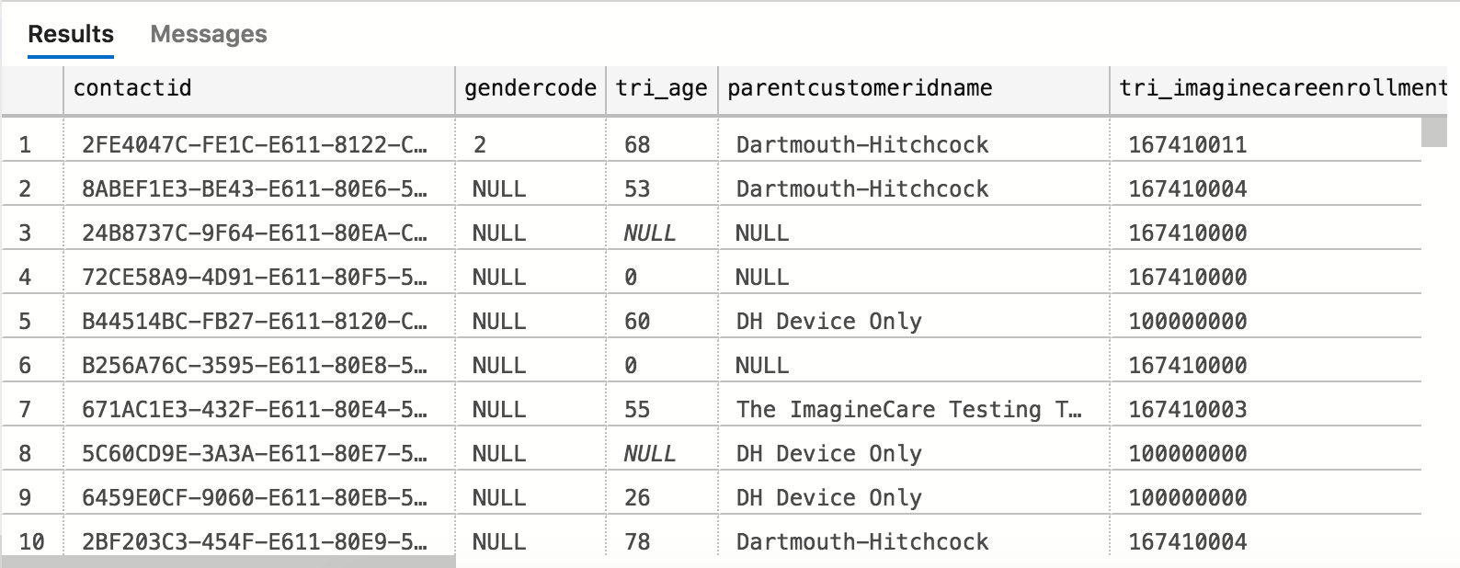

1. Rename all the columns for eg.,
2. TriAge to Age

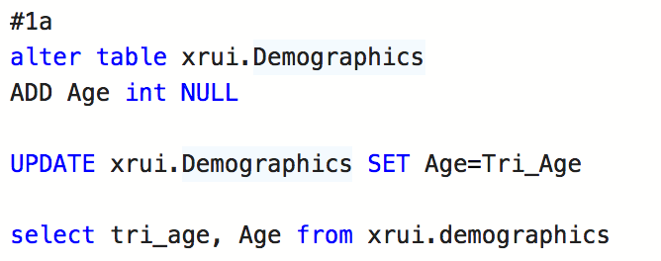

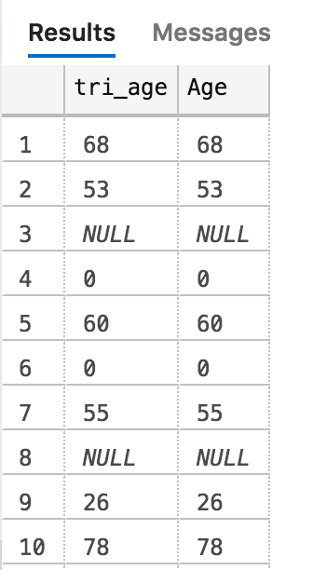

1. GenderCode to Gender

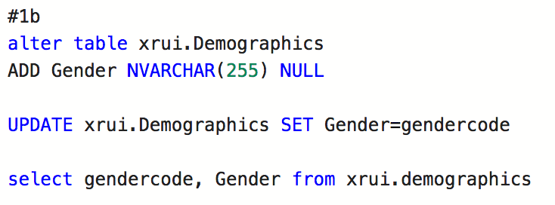

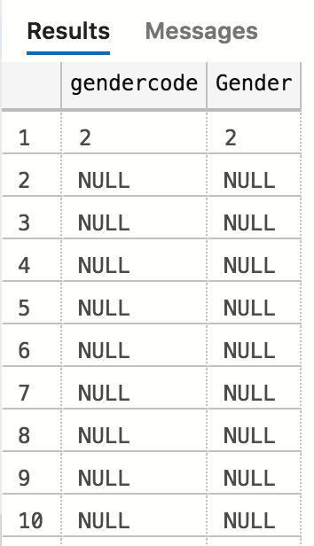

1. ContactID to ID

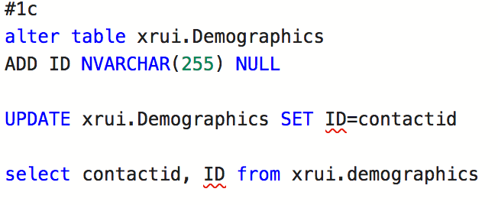

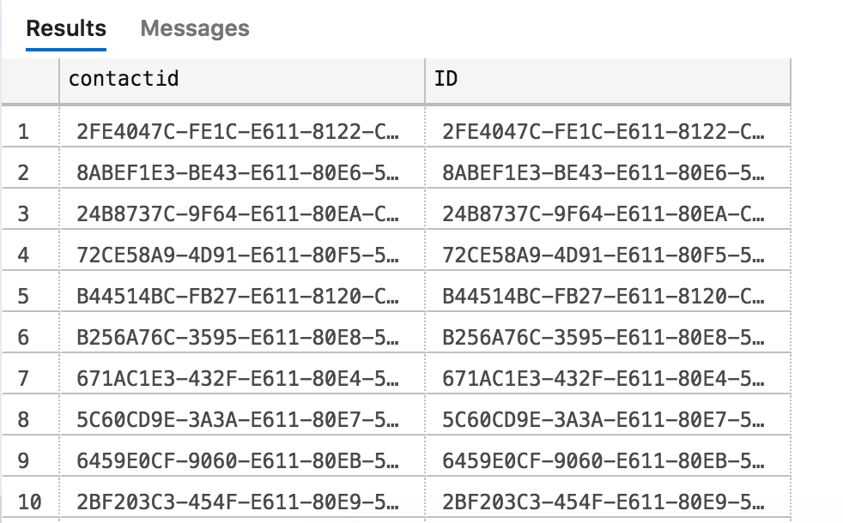

1. Address1Stateorprovince to State

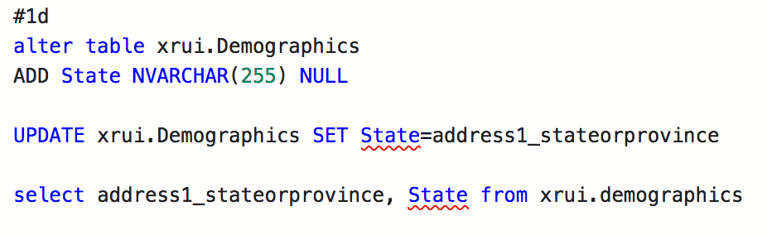

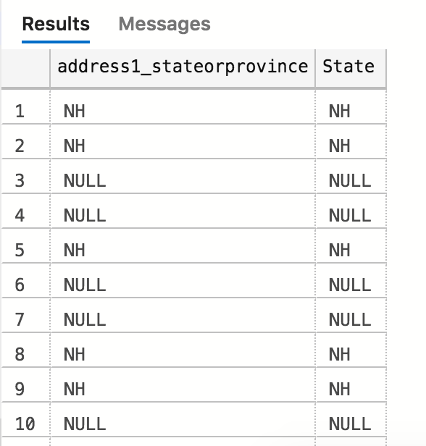

1. TriImagineCareenrollmentemailsentdate to EmailSentdate

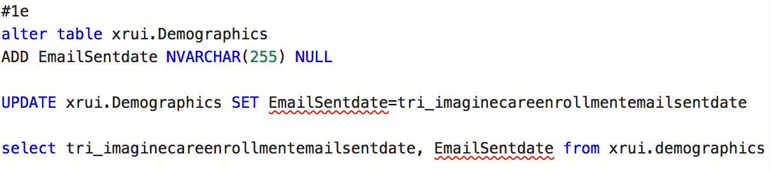

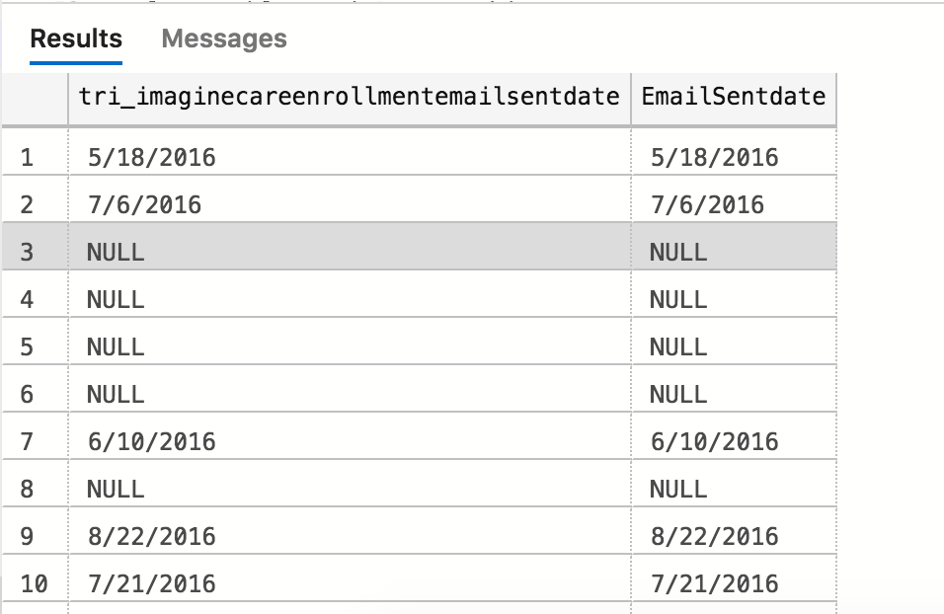

1. Trienrollmentcompletedate to Completedate

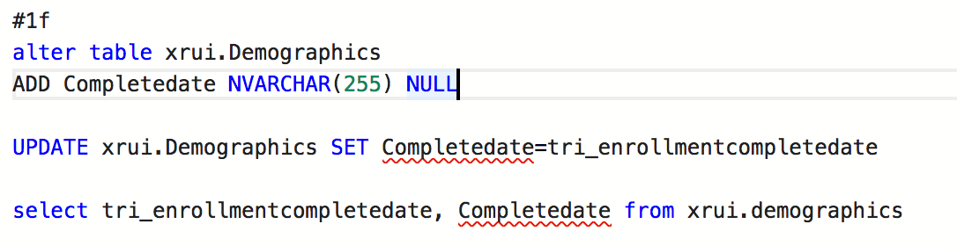

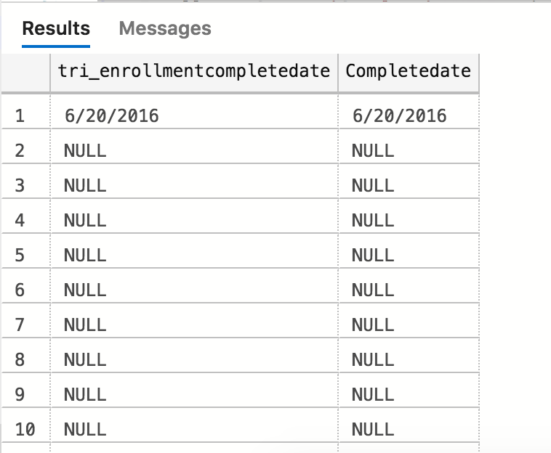

1. Calculate the time (in days) to complete enrollment and create a new column to have this data

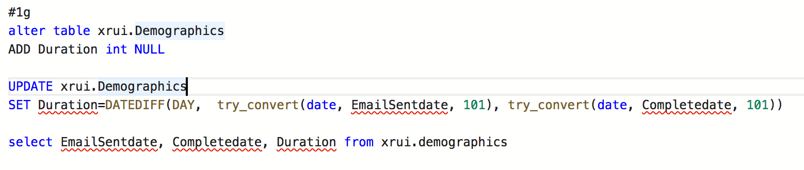

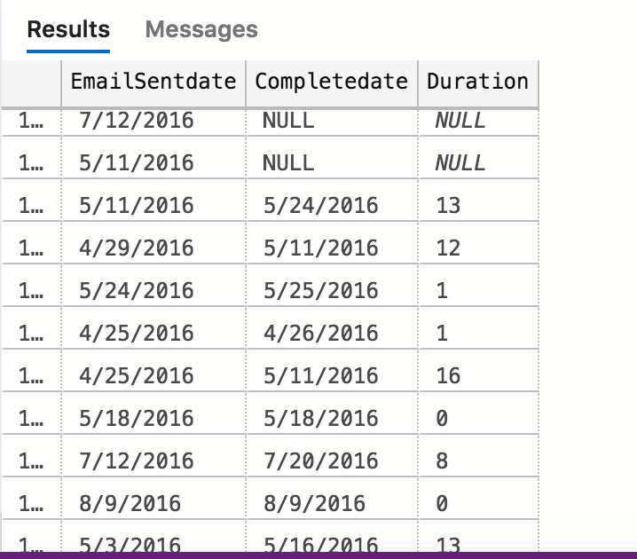

1. Create a new column “Enrollment Status”
2. Insert Status=Complete: code is 167410011

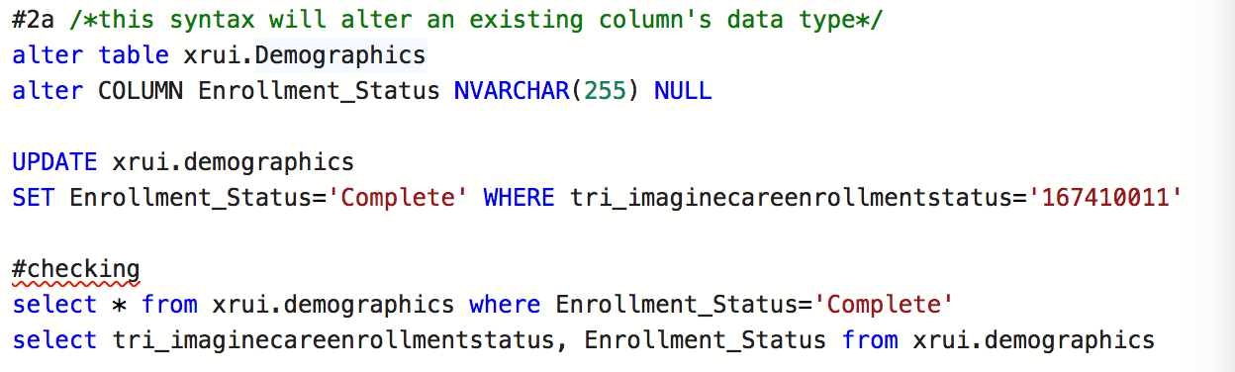

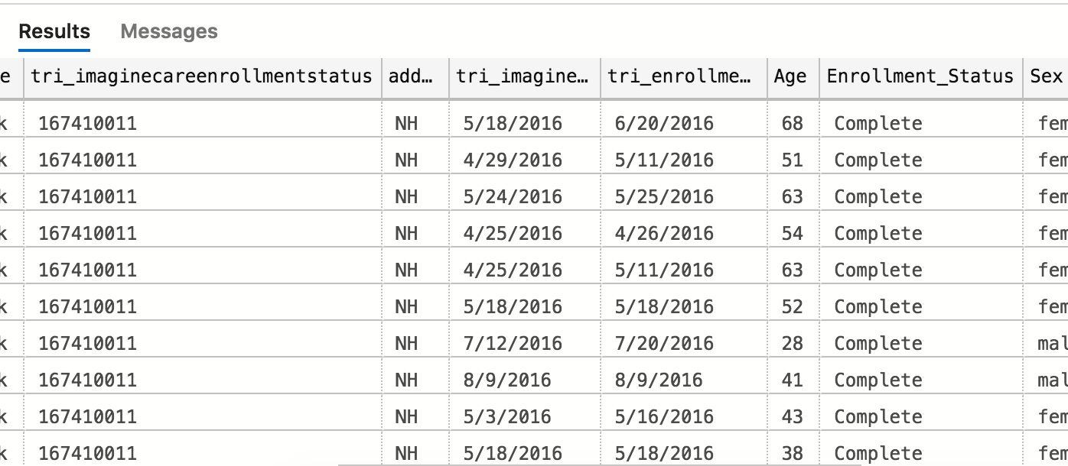

1. Insert Status=Email sent: code is 167410001

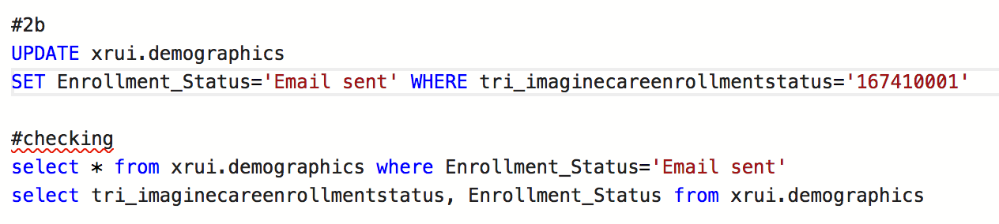

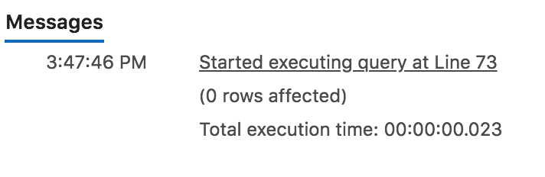

No row is affected, because tri_imaginecareenrollmentstatus=167410001 does not exist.

1. Insert Status=Non responder: Code is 167410004

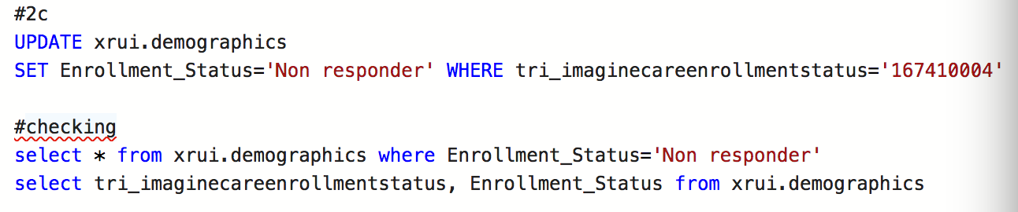

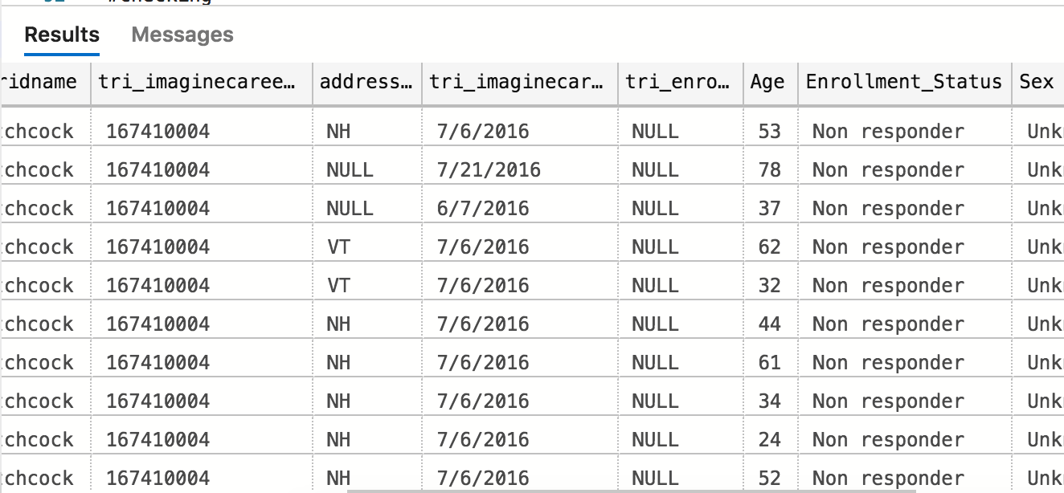

1. Insert Status=Facilitated Enrollment: Code is 167410005

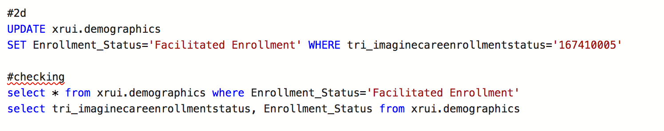

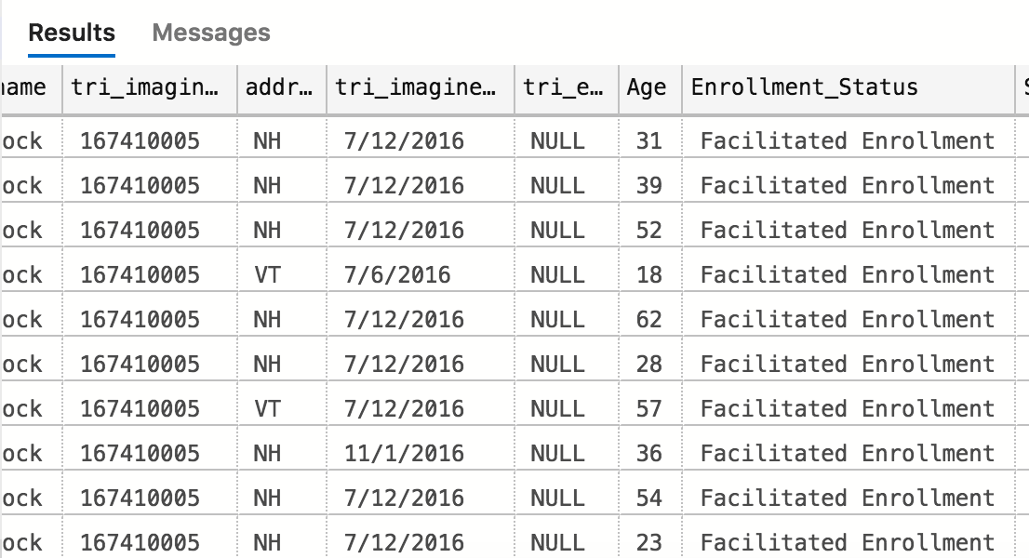

1. Insert Status= Incomplete Enrollments: Code is 167410002

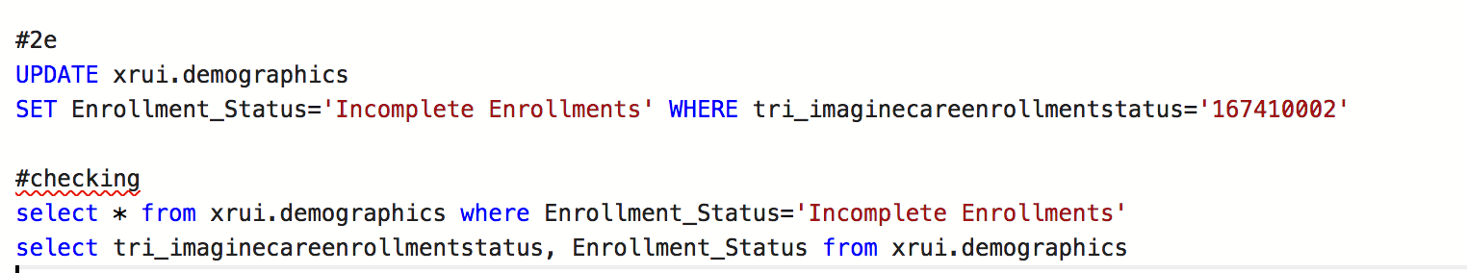

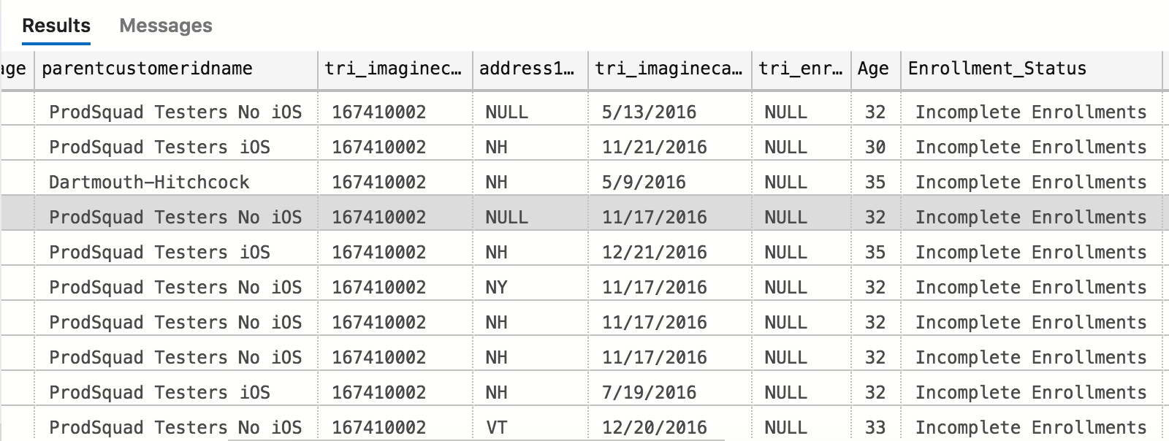

1. Insert Status= Opted Out: Code is 167410003

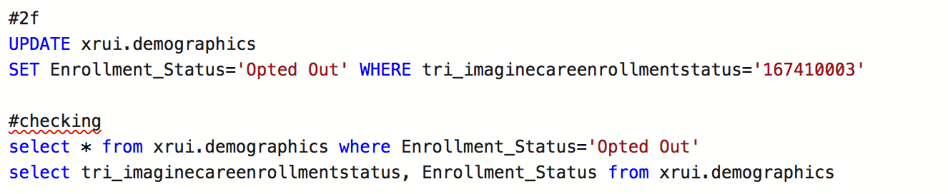

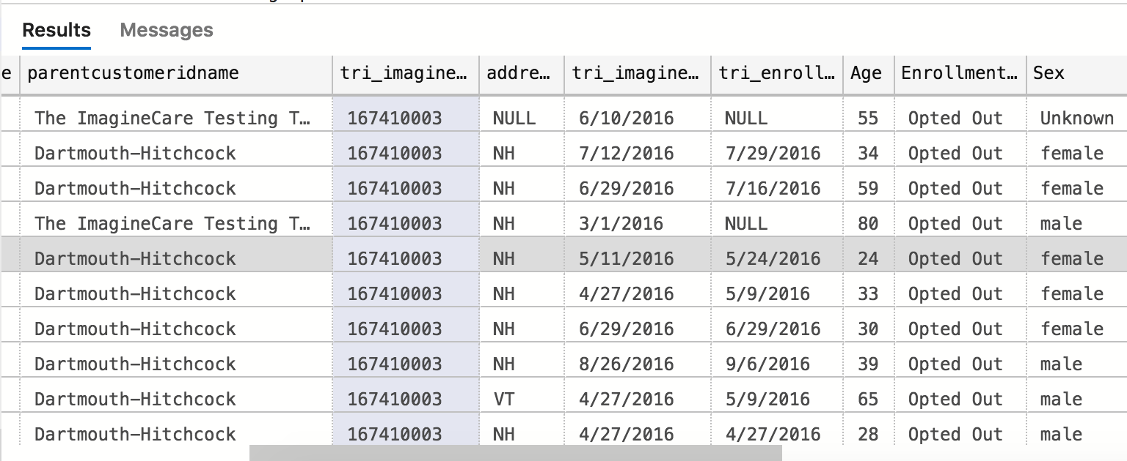

1. Insert Status= Unprocessed: Code is 167410000

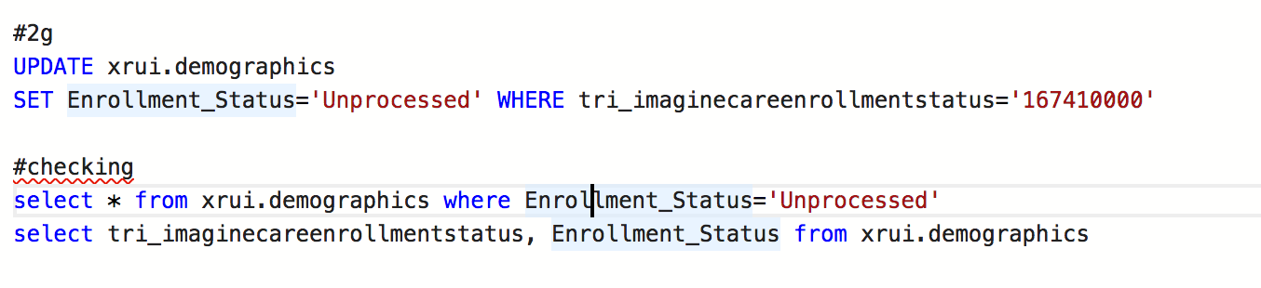

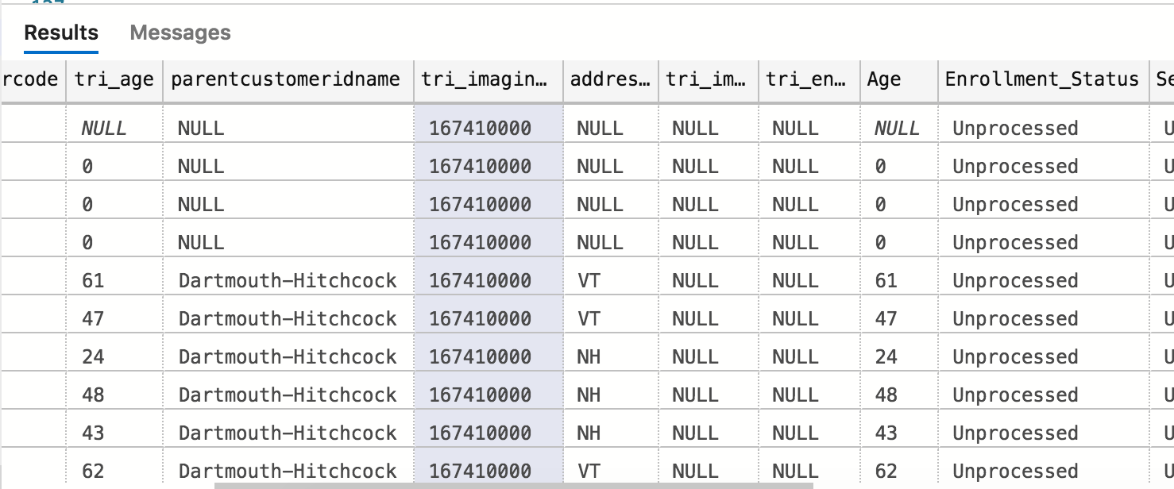

1. Insert Status= Second email sent: Code is 167410006

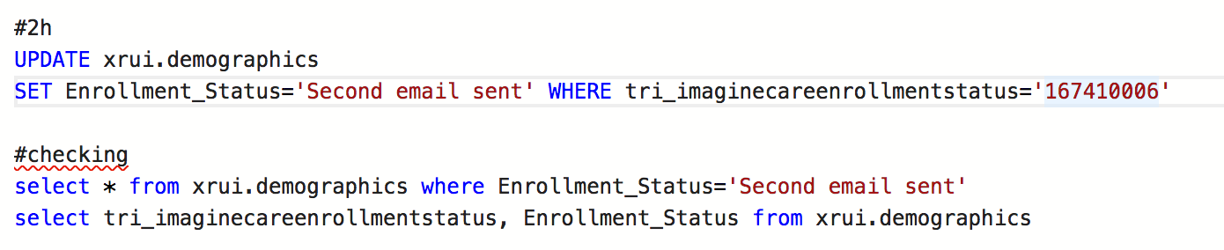

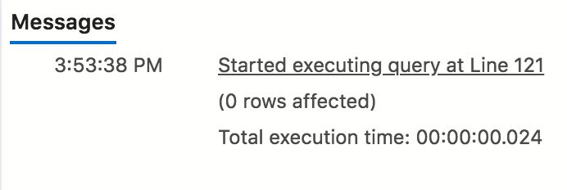

No row is affected, because tri_imaginecareenrollmentstatus=167410006 does not exist.

######Checking Q2 overall:

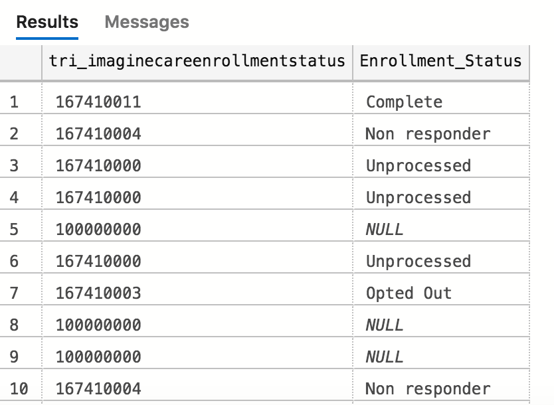

1. Create a new Column “Sex”
2. Insert sex=female if code=2

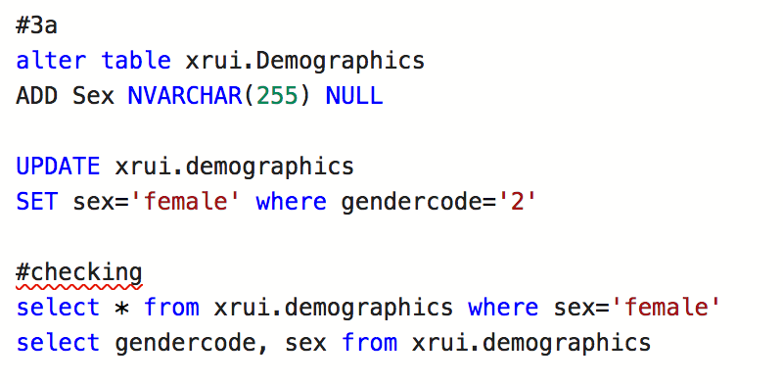

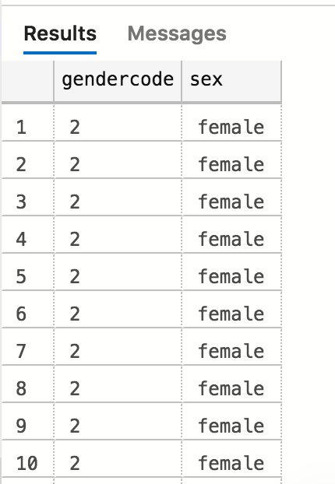

1. Insert sex=male if code=1

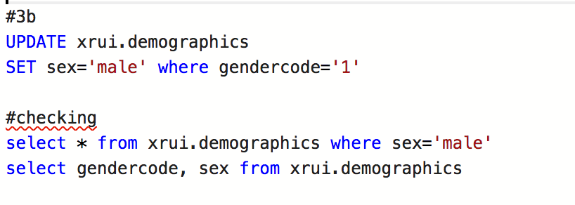

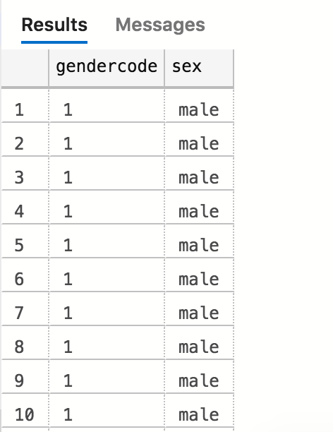

1. Insert sex=other if code =167410000

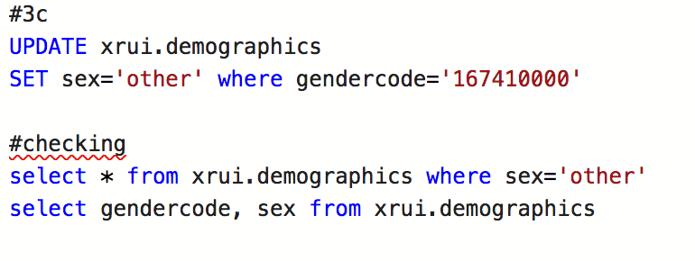

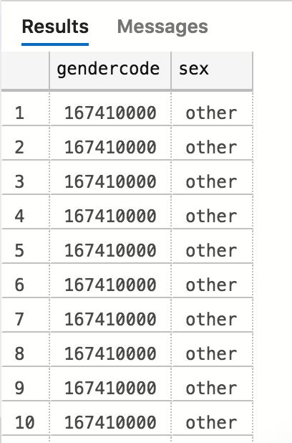

1. Insert sex=Unknown if code =’NULL’

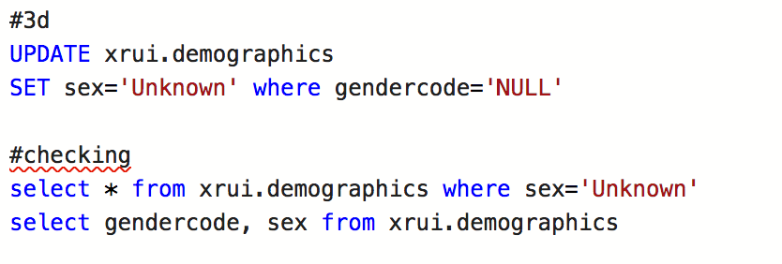

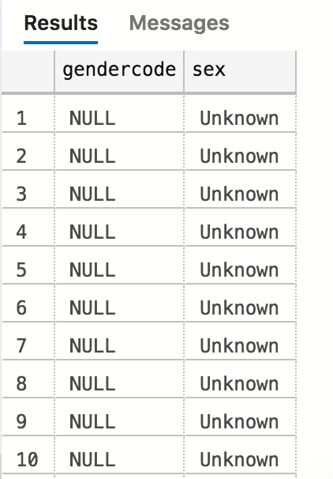

####checking for Q3 overall

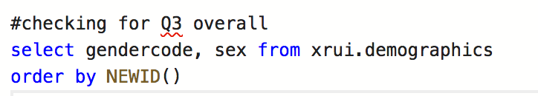

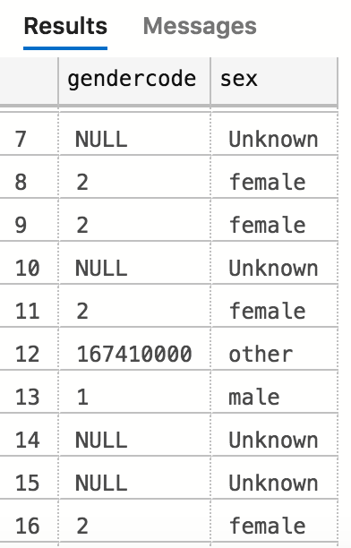

1. Create a new column “Age group” and create age groups with an interval of 25 yrs. for example 0-25 years as ‘0-25’, 26-50 as “26-50” and so on...

