
Development and Evaluation of an Interpretable Deep Learning Pipeline for Thyroid Lesion Classification Using Cytological and Ultrasound Images
A Midterm Research and Software Project Proposal
Course Code: 4-SRC-10-804
Title: Scientific Research and Communication
Team Name: MedAI
Team Members:
ID | Full Name | Role
230405 | Usmanov Lazizbek | Team Lead · ML Engineer · Researcher

Degree Program: BS in Computer Science
Supervisor: Dr. Eugene Castro
Date: October 2026
EXECUTIVE SUMMARY
Papillary thyroid carcinoma (PTC) is the most common thyroid malignancy, and its work-up relies on two complementary but separately interpreted examinations: ultrasound (US) imaging and fine-needle aspiration cytology. Deep learning has shown promise for each modality, yet published systems are mostly single-modality, trained on large private cohorts, and reported with accuracy-centred metrics that reveal little about generalisation, calibration, or the reasons behind a prediction. This proposal targets three problems observed in our own preliminary work: overfitting of a fully fine-tuned ConvNeXt-Tiny model on only 384 paired patients, fragmented and hard-to-reproduce experimental code, and limited interpretability and clinical evaluation. We therefore ask to what extent backbone freezing, regularisation and optimised training improve generalisation (RQ1); how a unified pipeline improves reproducibility, consistency and efficiency (RQ2); and how attention-based visualisation and clinical metrics improve interpretability and reliability assessment (RQ3). The proposed solution is a unified PyTorch pipeline that pairs one US image with a bag of two to seven cytology patches per patient, encodes both with ImageNet-pretrained ConvNeXt-Tiny backbones, aggregates patches with a transformer, and fuses the modalities through a [CLS]-token transformer. A preliminary fold-0 experiment reaches an AUROC of 0.979 (95% CI 0.948–0.997) with 100% sensitivity, while exposing weaker specificity and calibration. By the end of the semester, the MVP will deliver a five-fold cross-validated, ablation-tested model, a comprehensive evaluation report, and an inference tool with a web demo that returns a malignancy probability and patch-level relevance.
Keywords: thyroid cancer, papillary thyroid carcinoma, ultrasound, cytology, multimodal deep learning, ConvNeXt, transformer, multiple-instance learning, explainability, reproducibility.
Table of Contents
1. INTRODUCTION AND BACKGROUND 5
1.1 Background 5
1.2 Problem Context & Technical Motivation 5
1.3 Refined Research Topic and Proposed Intervention 6
1.4 Project Scope & Boundaries 6
2. PROBLEM STATEMENT, RESEARCH QUESTIONS, AND OBJECTIVES 7
2.1 Investigation and Contextual Synthesis 7
2.2 Research Problems 7
2.3 Problem Statement 8
2.4 Research Questions (RQs) 8
2.5 Research Objectives 8
3. LITERATURE REVIEW & RELATED WORK 10
3.1 Literature Search Strategy 10
3.2 Overview of Existing Solutions & Studies 10
3.3 Comparative Analysis Matrix 12
3.4 Critical Synthesis 12
3.5 Theoretical & Technical Justification 13
4. SYSTEM METHODOLOGY & TECHNICAL DESIGN 13
4.1 Software Development Methodology 13
4.2 System Architecture Modeling & Component Flow 14
4.3 Core Technical Implementation — Option B: Model Architecture & Data Pipeline 15
4.4 Preliminary Results (Fold 0) 18
4.5 Threats to Validity and Planned Mitigations 20
4.6 Ethical and Data Considerations 20
5. MVP DELIVERABLES & DEVELOPMENT TIMELINE 21
5.1 MVP Definition & Target Capabilities 21
5.2 MVP Conceptual Diagram 21
5.3 Implementation Roadmap (Milestones) 22
5.4 Evaluation Plan 22
5.5 Project Risks 22
6. CONCLUSION AND EXPECTED CONTRIBUTION 23
REFERENCES 24

List of Abbreviations
AUROC | Area under the receiver operating characteristic curve
AUPRC | Area under the precision–recall curve
CI | Confidence interval
CNN | Convolutional neural network
CV | Cross-validation
ECE | Expected calibration error
FNA | Fine-needle aspiration
MCC | Matthews correlation coefficient
MIL | Multiple-instance learning
MVP | Minimum viable product
PTC | Papillary thyroid carcinoma
TI-RADS | Thyroid Imaging Reporting and Data System
US | Ultrasound

1. INTRODUCTION AND BACKGROUND

1.1 Background
Thyroid cancer is among the most frequently diagnosed endocrine malignancies worldwide, with incidence that has risen sharply over recent decades [1]. Much of this rise is attributed to the widespread use of high-resolution neck ultrasound, which detects many small, often indolent nodules and has created a well-documented risk of overdiagnosis [2]. Papillary thyroid carcinoma (PTC) accounts for the large majority of thyroid cancers, so the practical clinical question for most nodules is binary: is the lesion benign, or is it PTC?
Current clinical practice answers this question in two stages [3]. First, a radiologist grades the nodule on ultrasound (US) using a structured risk system such as ACR TI-RADS, which scores composition, echogenicity, shape, margin and echogenic foci [4]. Second, suspicious nodules undergo fine-needle aspiration (FNA), and a cytopathologist reports the smear under the six-tier Bethesda System [5]. Both steps are human-interpreted, both suffer from inter-observer variability, and the indeterminate Bethesda categories leave a substantial fraction of patients without a definitive answer. Importantly, the two examinations are read by different specialists and are rarely combined in a single quantitative model.
In parallel, deep learning has transformed medical image analysis [6]. Convolutional neural networks (CNNs) trained on large sonographic cohorts have matched or exceeded radiologists on thyroid nodule classification [7], [8], and CNNs applied to cytology images or whole-slide FNA scans have shown high accuracy for PTC and malignancy prediction [9], [10]. Weakly supervised multiple-instance learning (MIL) has become the dominant paradigm in computational pathology, where a diagnosis is attached to a whole bag of image tiles rather than to individual tiles [11], [12].

1.2 Problem Context & Technical Motivation
Despite this progress, three gaps limit the usefulness of existing work, and each of them was observed directly in our own preliminary experiments:
- Generalisation under data scarcity. Most academic groups have access to hundreds, not tens of thousands, of patients. When we fine-tuned a fully unfrozen ConvNeXt-Tiny on our dataset of 384 paired patients, accuracy reached approximately 99% within the first epochs — a classic signature of memorisation rather than learning.
- Fragmented, irreproducible research code. Our first prototype (April 2026) was split across seven scripts (audit_data.py, split_data.py, dataset.py, model.py, train.py, evaluate.py, test_pipeline.py) with duplicated transform and model definitions. Such fragmentation is a known driver of the reproducibility crisis in machine-learning-based science, including silent data leakage [13], [14].
- Accuracy-only evaluation and black-box predictions. Medical AI reporting guidelines require discrimination, calibration, confidence intervals and clinically meaningful operating points [15], [16]. Clinicians also need to see why a model predicts malignancy; high-stakes decisions should not rely on unexplained black boxes [17].
From a Computer Science perspective, the problem is attractive because it combines four non-trivial technical challenges: (i) representation learning with very few labelled samples, (ii) fusion of heterogeneous inputs — a single grayscale-like US image and a variable-size, unordered set of colour cytology patches, (iii) software engineering of a reproducible, single-source-of-truth ML pipeline, and (iv) trustworthy evaluation and explainability of deep models. None of these is solved by a better hyper-parameter alone; they require architectural, algorithmic and engineering decisions, which is exactly what a software project can deliver.

1.3 Refined Research Topic and Proposed Intervention
The broad domain “AI for thyroid cancer detection” is narrowed to the following focused and feasible CS problem: patient-level binary classification (benign vs. PTC) from one ultrasound image and a bag of two to seven cytology patches, under a small-data regime, with a reproducible pipeline and an interpretable, clinically evaluated output.
The proposed technological intervention is a unified PyTorch [18] pipeline (main.py) built around a dual-encoder multimodal transformer. Two ImageNet-pretrained ConvNeXt-Tiny backbones [19] encode the US image and each cytology patch; a light transformer encoder [20] contextualises the patch bag in the spirit of attention-based MIL [21]; and a fusion transformer with a learnable [CLS] token performs intermediate fusion of both modalities [22]. Overfitting is controlled by partial backbone freezing and a regularisation recipe; evaluation uses a full panel of clinical metrics with bootstrap confidence intervals; and an explainability module ranks cytology patches by their relevance to the final decision. A companion tool (model_inference.py) exposes the trained model for single-patient, batch and interactive use.

1.4 Project Scope & Boundaries

In-Scope (MVP deliverables)
- Automated data audit and metadata generation with patient-level stratified 5-fold splits (no patient leakage).
- Dual-encoder ConvNeXt-Tiny + transformer fusion model for benign vs. PTC classification.
- Overfitting-control recipe (partial freezing, dropout, weight decay, label smoothing, warm-up + cosine LR, gradient clipping, early stopping) and its ablation study.
- Five-fold cross-validated evaluation with AUROC (bootstrap 95% CI), AUPRC, accuracy, balanced accuracy, F1, MCC, Cohen’s κ, sensitivity, specificity, PPV, NPV, Brier score and Youden-optimal threshold.
- Patch-level relevance visualisation for TP, TN, FP and FN cases, plus a gradient-based saliency comparison (Grad-CAM) as a stretch goal.
- Inference CLI (single, batch, demo modes) and a lightweight web demo (upload → P(PTC) → patch relevance).

Out-of-Scope (this semester)
- Clinical deployment, regulatory approval, or any use for real patient decisions — the system is a research prototype only.
- Prospective or multi-centre external validation and new data collection.
- Nodule detection or segmentation (bounding boxes) on ultrasound, and whole-slide image processing.
- Multi-class diagnosis (follicular, medullary, anaplastic carcinoma) or prediction of the six Bethesda categories.
- DICOM/PACS integration, user accounts, and mobile applications.

2. PROBLEM STATEMENT, RESEARCH QUESTIONS, AND OBJECTIVES

2.1 Investigation and Contextual Synthesis
Before formulating the research problems, we carried out four preliminary investigations. Their findings, summarised in Table I, ground every problem, question and objective that follows in observed evidence rather than assumption.
TABLE I. PRELIMINARY INVESTIGATIONS AND KEY FINDINGS
Investigation | What was done | Key finding
Data audit | Paired US and cytology files by patient ID across four directories; checked ID overlap and patch counts. | 384 paired patients (165 benign, 219 PTC); 2–7 patches per patient (63% have exactly 3); classes moderately imbalanced (57% PTC).
Baseline training | Fine-tuned a fully unfrozen ConvNeXt-Tiny with the original settings (dropout 0.1, lr 1e-4, 2 transformer layers, dim 768). | ~99% accuracy in early epochs — strong evidence of overfitting on a small dataset (RP1).
Code audit | Reviewed the first prototype repository (commit of 19 Apr 2026). | Seven separate scripts with duplicated transforms, model and loaders; results hard to reproduce (RP2).
Evaluation audit | Reviewed what the prototype reported and what CLAIM / TRIPOD+AI require [15], [16]. | Only accuracy/AUROC reported; no CI, calibration, operating-point analysis or explanation (RP3).

A brief stakeholder analysis (Table II) clarifies who is affected by these gaps and what each group needs from the system.
TABLE II. STAKEHOLDER ANALYSIS
Stakeholder | Interest / need | Implication for the system
Radiologists and endocrinologists | A second, objective opinion on nodules before or after FNA. | Calibrated malignancy probability and a clear operating threshold.
Cytopathologists | Support for difficult smears; to see which fields drive a decision. | Patch-level relevance ranking and visual explanation.
Patients | Fewer unnecessary surgeries and fewer missed cancers. | High sensitivity with acceptable specificity; transparent limitations.
ML researchers and reviewers | Results that can be reproduced and compared. | Single-source pipeline, fixed seeds, patient-level CV, full metric panel.
Course supervisor | A research-backed, working MVP by the end of the semester. | Scoped deliverables, milestone plan and measurable objectives.

2.2 Research Problems
The three research problems below were submitted and approved in the Week activity proposal (1 October 2026) and are reproduced without change.
TABLE III. APPROVED RESEARCH PROBLEMS
ID | Statement | Context / justification
RP1 | Overfitting and poor generalization in deep learning models used for thyroid lesion classification due to limited medical imaging datasets. | With approximately 385 patients, a fully unfrozen ConvNeXt-Tiny reached ~99% accuracy during early training. Effective regularization, backbone freezing, learning-rate optimization and early stopping are needed to improve generalization.
RP2 | The lack of unified and reproducible machine learning pipelines for thyroid lesion classification, leading to inconsistencies in data preprocessing, training, and model evaluation. | Separate implementations of preprocessing, architecture, training and evaluation introduce inconsistencies; a centralized pipeline must standardize metadata generation, loading, transformations, training and evaluation.
RP3 | Limited interpretability and insufficient clinical evaluation of deep learning models for medical image classification. | Accuracy alone does not describe reliability. Sensitivity, specificity, AUROC, calibration and predictive values are required, and visual explanations are needed to show which image regions drive predictions.

2.3 Problem Statement
Deep learning models for thyroid lesion classification are currently broken in three connected ways. They overfit small, paired clinical datasets, so their headline accuracy does not transfer to new patients; they are produced by fragmented code in which preprocessing, training and evaluation can silently diverge, so results cannot be reproduced or audited; and they are evaluated and delivered as opaque scores without calibration, confidence intervals or explanations, so their reliability cannot be judged. Clinicians (radiologists, endocrinologists and cytopathologists) are impacted because they cannot trust or interpret the output; patients are impacted through the risk of missed cancers or unnecessary surgery; and researchers are impacted because published numbers cannot be compared or built upon. The missing capability is a single, reproducible, interpretable pipeline that fuses ultrasound and cytology evidence, generalises on a small dataset, and reports clinically meaningful, uncertainty-aware performance.

2.4 Research Questions (RQs)
- RQ1: To what extent can backbone freezing, regularization techniques, and optimized training strategies improve the generalization performance of a ConvNeXt-Tiny-based thyroid lesion classification model on a limited medical imaging dataset?
- RQ2: How can a unified deep learning pipeline improve the reproducibility, consistency, and efficiency of thyroid lesion classification experiments using cytological and ultrasound images?
- RQ3: How can attention-based visualization and clinically relevant evaluation metrics improve the interpretability and reliability assessment of deep learning predictions for thyroid lesion classification?

2.5 Research Objectives

General Objective
To design, develop, implement, and evaluate a unified and interpretable deep learning pipeline for thyroid lesion classification using cytological and ultrasound images, with the aim of improving model generalization, experimental reproducibility, and evaluation reliability through regularization techniques, comprehensive performance metrics, and attention-based visualization.

Specific Objectives
- Objective 1 (Corresponds to RQ1): To implement and evaluate overfitting mitigation techniques, including backbone freezing, dropout, weight decay, label smoothing, learning rate optimization, gradient clipping, and early stopping, to improve the generalization performance of the ConvNeXt-Tiny-based classification model.
- Objective 2 (Corresponds to RQ2): To develop a unified and reproducible deep learning pipeline that integrates automated metadata generation, data preprocessing, model training, validation, inference, and performance evaluation for cytological and ultrasound thyroid images.
- Objective 3 (Corresponds to RQ3): To evaluate model performance using comprehensive classification and clinical metrics, including AUROC, AUPRC, sensitivity, specificity, F1-score, Matthews Correlation Coefficient, Brier Score, and bootstrap confidence intervals, and to implement attention-based visualization for interpreting model predictions.
To guide the later evaluation phase, each specific objective is operationalised with SMART success criteria in Table IV. The objective statements themselves are unchanged from the approved proposal; the table only adds the measurable targets and deadlines against which they will be judged.
TABLE IV. SMART OPERATIONALISATION OF THE SPECIFIC OBJECTIVES
 | Objective 1 (RQ1) | Objective 2 (RQ2) | Objective 3 (RQ3)
Specific | Ablate four configurations: A0 fully unfrozen baseline, A1 + partial freezing, A2 + regularisation, A3 + LR schedule, clipping and early stopping. | One entry point (main.py) and one shared model module used by both training and inference; config, seed and environment saved with every checkpoint. | Full metric panel at 0.5 and Youden thresholds; post-hoc calibration; relevance maps for TP/TN/FP/FN; faithfulness test of patch relevance.
Measurable | Mean ± SD AUROC over 5 folds; train–validation loss gap; fold-to-fold SD. | Re-run variance of AUROC; count of duplicated definitions; runtime per fold. | AUROC 95% CI, Brier score, expected calibration error (ECE), deletion-test win rate.
Achievable target | A3 mean AUROC ≥ 0.95 with fold SD ≤ 0.03; loss gap reduced ≥ 50% vs. A0. | Identical-seed re-runs within ±0.005 AUROC; 0 duplicated model/transform definitions. | Brier ≤ 0.08 and ECE ≤ 0.05 after temperature scaling; removing the top-ranked patch lowers P(PTC) more than a random patch in ≥ 70% of TP cases.
Relevant | Directly answers RQ1 (generalisation). | Directly answers RQ2 (reproducibility, consistency, efficiency). | Directly answers RQ3 (interpretability and reliability).
Time-bound | Weeks 7–10 | Weeks 4–9 | Weeks 9–13

Table V summarises the end-to-end traceability from problem to evidence, as required by the approved proposal activity.
TABLE V. TRACEABILITY MATRIX
Problem | Question | Objective | Evaluation evidence
RP1 Overfitting | RQ1 | O1 | Ablation table A0–A3, learning curves, 5-fold AUROC mean ± SD
RP2 Fragmented code | RQ2 | O2 | Re-run variance, single-entry pipeline, refactoring report, runtime log
RP3 Interpretability and evaluation | RQ3 | O3 | Metric panel with CIs, calibration curves, relevance maps, deletion test

3. LITERATURE REVIEW & RELATED WORK

3.1 Literature Search Strategy
Sources were identified in IEEE Xplore, PubMed, Google Scholar and arXiv using combinations of the terms “thyroid nodule”, “papillary thyroid carcinoma”, “ultrasound”, “cytology”, “fine-needle aspiration”, “deep learning”, “multiple instance learning”, “multimodal fusion”, “transfer learning”, “calibration” and “explainability”. Peer-reviewed journal and conference papers were prioritised, together with clinical guidelines that define the diagnostic standard and reporting checklists that define good evaluation practice. Studies were retained if they addressed at least one of the three research questions. Bibliographic details of every reference were verified against publisher or indexing records.

3.2 Overview of Existing Solutions & Studies

3.2.1 Deep learning on thyroid ultrasound
Li et al. trained deep CNNs on 131,731 sonographic images from 17,627 thyroid cancer patients and 180,668 control images, and validated them on one internal and two external cohorts, reporting AUROCs of 0.947, 0.912 and 0.908 [7]. On the internal set the model’s specificity (86.1%) was far higher than that of radiologists (59.4%), while sensitivity was similar. Buda et al. used a multitask CNN on two orthogonal US views to recommend biopsy, reaching 87% sensitivity and 52% specificity on 99 test nodules — on par with a three-expert ACR TI-RADS consensus [8], [4]. These studies show that US alone carries strong signal, but they rely on very large or single-institution cohorts, use a single modality, and provide limited insight into the basis of each prediction.

3.2.2 Deep learning on thyroid cytology
Guan et al. compared VGG-16 and Inception-v3 on 279 cytological images (159 PTC, 120 benign) cropped into fragments; VGG-16 achieved 97.66% fragment-level and 95% patient-level accuracy [9]. The test set, however, contained only 40 patients, so the estimate is fragile. Elliott Range et al. applied a machine-learning algorithm to whole-slide FNA images of 908 cases and predicted malignancy with 92.0% sensitivity, 90.5% specificity and an AUROC of 0.932, comparable to a cytopathologist (0.931) [10]. Cytology-only systems ignore the sonographic context in which the aspiration was taken, and whole-slide approaches require scanning infrastructure that many sites lack.

3.2.3 Multiple-instance learning and multimodal fusion
Because a diagnosis is attached to a patient rather than to each cytology field, the problem is naturally a multiple-instance learning (MIL) problem. Attention-based deep MIL learns permutation-invariant pooling over a bag of instances and provides per-instance attention weights [21]. In computational pathology, weakly supervised MIL has reached clinical-grade performance at scale [11] and data-efficient variants such as CLAM reduce the labelling burden [12]. Transformers [20], [23] generalise attention pooling by allowing instances to exchange information before aggregation. For combining modalities, the systematic review of Huang et al. distinguishes early, joint (intermediate) and late fusion and recommends joint fusion when modalities are complementary and the model can learn their interaction end-to-end [22].

3.2.4 Transfer learning and regularisation in small-data regimes
Features in early CNN layers are general and transfer well, whereas later layers are task-specific [24]. For medical imaging, Raghu et al. showed that much of the benefit of ImageNet pre-training comes from feature reuse in lower layers and that large models are often over-parameterised for small medical datasets [25]. ConvNeXt modernises the ResNet design with ideas from vision transformers and offers strong accuracy at moderate cost (ConvNeXt-Tiny, ≈28 M parameters) [19]. Standard regularisers — dropout [26], decoupled weight decay (AdamW) [27] and label smoothing [28] — reduce memorisation; label smoothing is also known to change the geometry of logits and to interact with calibration [28], [29].

3.2.5 Evaluation, calibration and reproducibility
CLAIM and TRIPOD+AI require reporting of discrimination with confidence intervals, calibration, data splits and operating points [15], [16]. Modern deep networks are frequently mis-calibrated, and temperature scaling is a simple, effective post-hoc fix [29]. MCC is more informative than accuracy or F1 on imbalanced binary data [30]; the Youden index provides a principled operating threshold [31]; and the bootstrap gives distribution-free confidence intervals [32]. Using the same validation fold for model selection and for reporting introduces optimistic bias [33], while leakage between training and test data is one of the most common causes of irreproducible ML findings [14], [13].

3.2.6 Interpretability
Grad-CAM produces class-discriminative saliency maps for CNNs [34]. For transformers, raw attention weights are not guaranteed to be faithful explanations [35]; attention rollout and attention flow aggregate attention across layers to obtain more reliable token importance [36]. Rudin argues that, in high-stakes settings, explanations must be faithful to the model and should be validated rather than assumed [17].

3.2.7 Software frameworks
The implementation builds on mature open-source tools: PyTorch and torchvision for models and pretrained weights [18], scikit-learn for metrics and stratified splitting [37], and Gradio for rapid, shareable model demos [38].

3.3 Comparative Analysis Matrix
TABLE VI. COMPARATIVE ANALYSIS OF EXISTING SOLUTIONS AND STUDIES
Existing solution / study | Methodology / technology | Strengths | Limitations / gaps | How our project differs
Li et al., 2019 [7] | Deep CNN ensemble on sonographic images; multicohort validation. | Very large dataset; external validation; specificity above radiologists. | US only; requires >100k images; limited explanation. | Fuses US with cytology; designed for a 384-patient regime; patch-level relevance.
Buda et al., 2019 [8] | Multitask CNN on two orthogonal US views; biopsy recommendation. | Direct comparison with ACR TI-RADS experts. | US only; small test set (99 nodules); decision is biopsy, not diagnosis. | Uses post-FNA cytology to classify benign vs. PTC at patient level.
Guan et al., 2019 [9] | VGG-16 vs. Inception-v3 on cropped cytology fragments. | High fragment- and patient-level accuracy. | Pilot size (40 test patients); cytology only; simple aggregation. | Learned transformer aggregation of patch bags plus US context; CIs and calibration.
Elliott Range et al., 2020 [10] | ML on whole-slide FNA images (908 cases). | Performance comparable to a cytopathologist (AUROC 0.932). | Needs whole-slide scanners; single modality. | Works from a few selected patches; adds US modality.
Ilse et al., 2018 [21] | Attention-based deep MIL pooling. | Permutation-invariant; per-instance weights. | Generic, unimodal; attention not validated as explanation. | Transformer bag encoder inside a multimodal model; relevance faithfulness test.
Campanella 2019 / Lu 2021 [11], [12] | Weakly supervised MIL on whole-slide histopathology. | Clinical-grade at scale; data-efficient variants. | Thousands of slides; heavy compute; histology not cytology. | Small-data, single-GPU design; cytology + US.
Huang et al., 2020 [22] | Systematic review of imaging + EHR fusion. | Clear taxonomy and implementation guidelines. | Focus on imaging + tabular data. | Applies joint (intermediate) fusion to two imaging modalities via a [CLS] transformer.
Liu et al., 2022 (ConvNeXt) [19] | Modernised pure-CNN backbone. | Strong accuracy/efficiency trade-off; good transfer. | Designed for natural images; full fine-tuning overfits small sets (our observation). | Partial freezing + regularisation recipe validated by ablation.
ACR TI-RADS / Bethesda (clinical standard) [4], [5] | Rule-based, human-scored risk categories. | Standardised, widely adopted, interpretable. | Inter-observer variability; indeterminate categories; modalities read separately. | Objective, combined quantitative score as decision support (research only).

3.4 Critical Synthesis
What works. CNNs extract strong diagnostic signal from both US and cytology, and attention-based MIL is an effective way to turn a bag of image fields into a single patient-level decision. Pretrained backbones and standard regularisers reliably reduce overfitting.
What fails or is missing. (i) Almost all thyroid studies are single-modality, although clinicians integrate US and cytology. (ii) The strongest results depend on cohorts that are orders of magnitude larger than what a typical research group has; small-data generalisation is rarely studied explicitly through ablation. (iii) Reporting is often limited to accuracy or AUROC without confidence intervals, calibration or threshold analysis, and code is rarely released as a single reproducible pipeline. (iv) Attention-based “explanations” are seldom tested for faithfulness.
Our position. This project builds on attention-based MIL, joint fusion and ConvNeXt transfer learning, diverges from prior thyroid work by fusing US and cytology at patient level in the small-data regime, and improves on common practice by making the overfitting controls, the pipeline and the evaluation themselves objects of measurement — directly corresponding to RQ1, RQ2 and RQ3.

3.5 Theoretical & Technical Justification
TABLE VII. DESIGN DECISIONS AND THEIR JUSTIFICATION IN THE LITERATURE
Design decision | Supporting literature | Rationale in this project
ConvNeXt-Tiny backbones (ImageNet weights) | [19], [24], [25] | Strong, efficient features; ≈28 M parameters fits a single GPU; transfer reduces data needs.
Freeze early stages, fine-tune late stages | [24], [25] | Early features are generic; limiting trainable parameters curbs memorisation of 384 patients.
Transformer encoder over cytology patches | [21], [20] | Permutation-invariant bag modelling with patch-to-patch context; handles 2–7 patches with masking.
Joint fusion with a learnable [CLS] token | [22], [23] | Lets US and cytology tokens interact end-to-end; [CLS] gives a single patient representation.
Dropout 0.4, AdamW wd 1e-3, label smoothing 0.05 | [26], [27], [28] | Complementary regularisers against overfitting; smoothing softens over-confident targets.
Warm-up + cosine LR, gradient clipping | [19], [20] | Stabilises early fine-tuning of pretrained weights and transformer layers.
Patient-level stratified 5-fold CV | [14], [33] | Prevents patient leakage; gives variance estimates; supports unbiased selection.
AUROC + bootstrap CI, MCC, Brier, Youden | [32], [30], [29], [31], [15] | Discrimination with uncertainty, imbalance-robust agreement, calibration and a principled threshold.
Cosine relevance of fused tokens; Grad-CAM as comparison | [36], [35], [34] | Cheap, model-internal relevance; validated by deletion test and contrasted with gradient saliency.

4. SYSTEM METHODOLOGY & TECHNICAL DESIGN

4.1 Software Development Methodology
The project follows an iterative, experiment-driven Agile process adapted for a one-person research team. Work is organised in two-week sprints, each ending with a runnable pipeline and a short experiment log. Every sprint follows the same loop: hypothesis → implementation → training run → evaluation → analysis → next hypothesis. This loop already produced the current design: the baseline run exposed overfitting, which motivated the freezing and regularisation changes now under ablation.
- Version control. Git with a protected main branch and short-lived feature branches merged through pull requests; Conventional Commit messages (e.g., feat:, fix:, docs:). Raw data and checkpoints are excluded via .gitignore, so the repository contains code, metadata and result artefacts only.
- Single source of truth. All hyper-parameters live in one CFG dictionary; transforms, datasets, the collate function and the model are defined once and reused by training, evaluation and visualisation.
- Reproducibility controls. Fixed seeds (42) for PyTorch, NumPy and fold assignment; the configuration is stored inside every checkpoint; metrics are written to CSV and figures to graphs/ automatically.
- Testing. Smoke tests on a small patient subset (shapes, masking, loss decreases), deterministic re-run checks, and metric sanity checks (e.g., AUROC of shuffled labels ≈ 0.5).

4.2 System Architecture Modeling & Component Flow
Fig. 1 shows the high-level architecture. A single entry point, run() in main.py, executes four stages in order; the inference layer reuses the trained checkpoint. Table VIII describes the responsibility of each module.
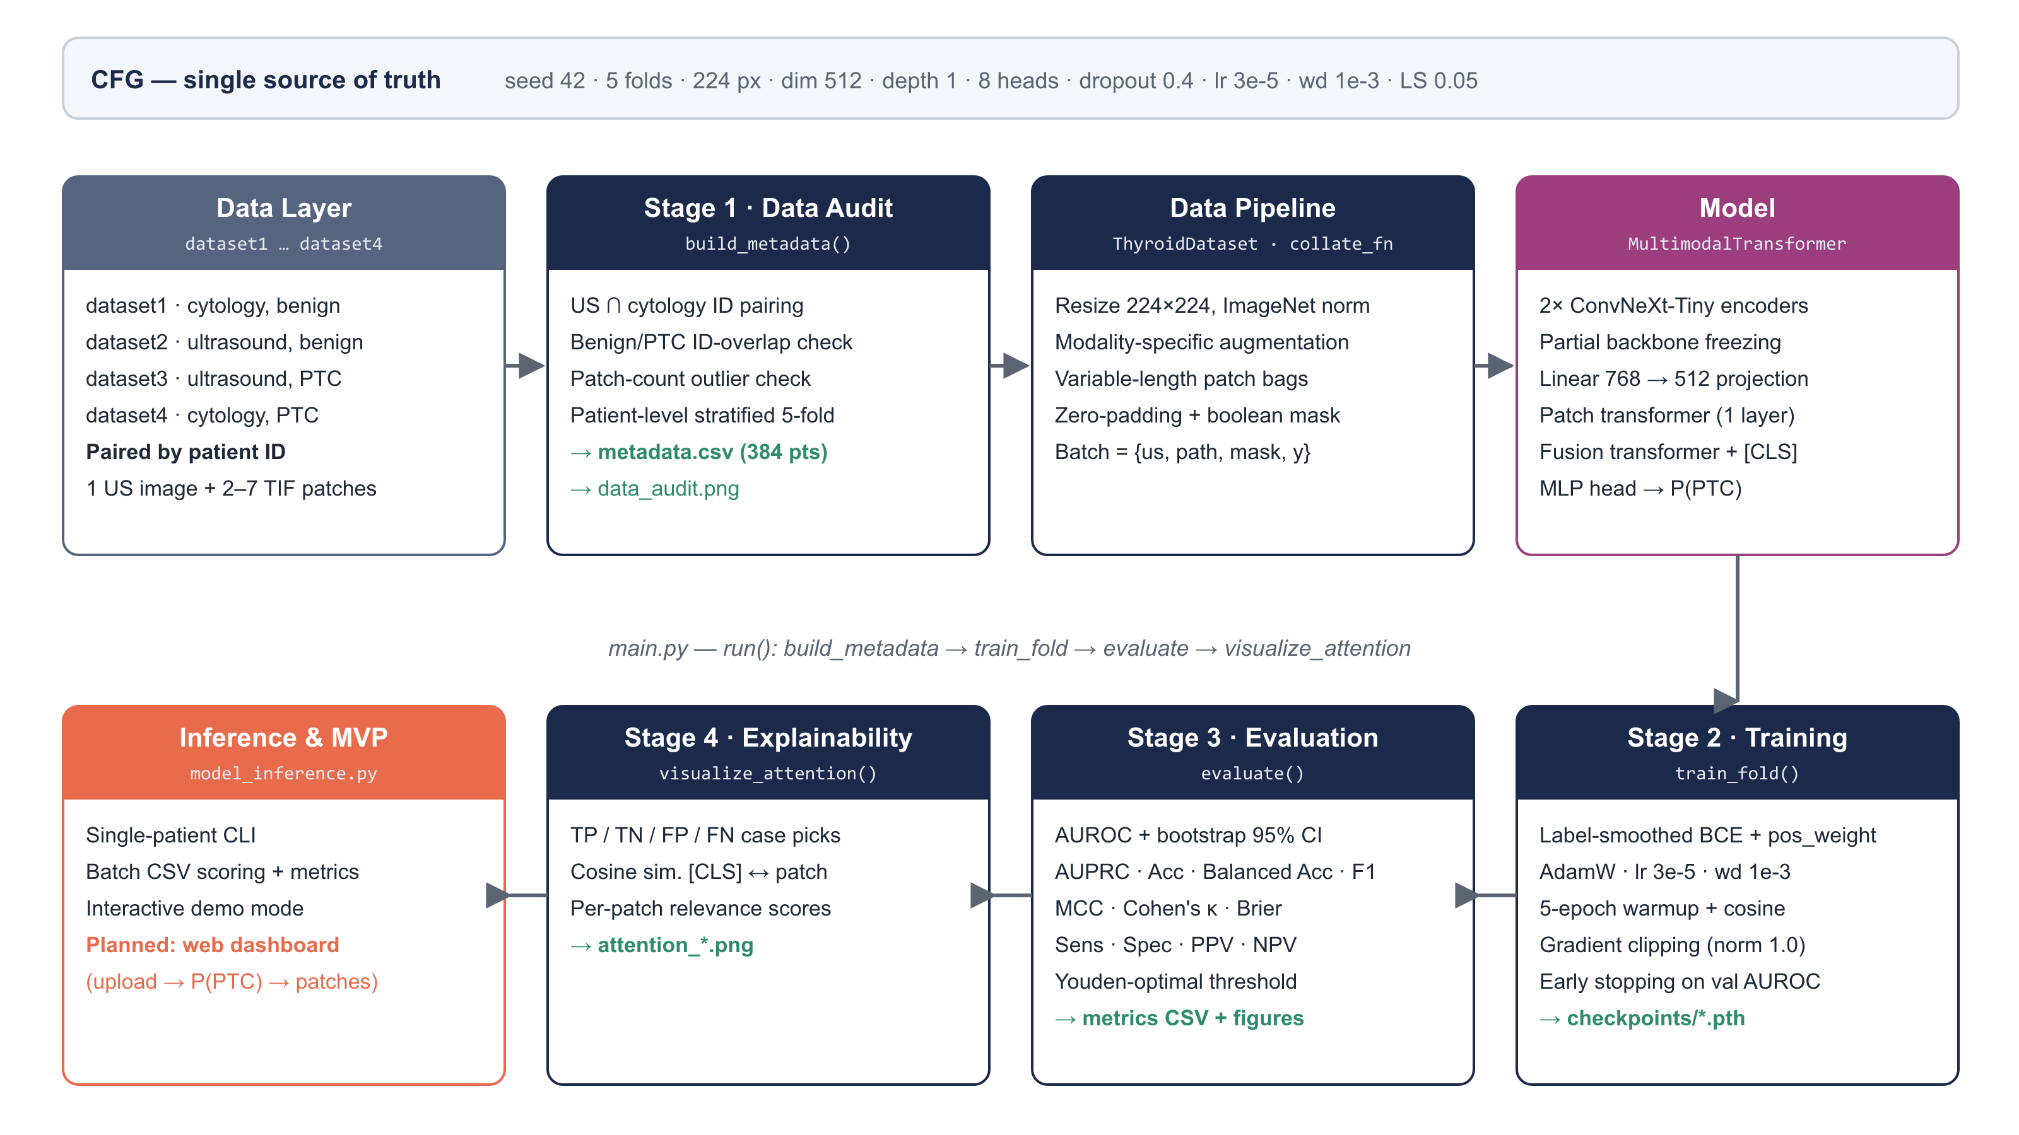
Fig. 1. High-level system architecture: configuration, data, model, training, evaluation, explainability and inference layers.
TABLE VIII. MODULE RESPONSIBILITIES
Layer / module | Implementation | Responsibility | Outputs
Configuration | CFG dict | Central hyper-parameters, paths and seeds. | Stored in each checkpoint
Data audit & metadata | build_metadata() | Pair US and cytology by patient ID, check overlaps and patch counts, assign stratified folds. | metadata.csv, data_audit.png
Data pipeline | ThyroidDataset, collate_fn, get_transforms() | Load and augment images; pad variable-length patch bags and build masks. | Batched tensors
Model | PatchEncoder, MultimodalTransformer | Encode, contextualise and fuse modalities; output a logit. | Logit, optional features
Training engine | train_fold(), LabelSmoothBCE | Optimise with regularisation, schedule, clipping, early stopping. | model_fold*_best.pth, training_fold*.png
Evaluation | evaluate() | Compute the metric panel, Youden threshold and bootstrap CI; plot curves. | metrics_fold*.csv, evaluation figures
Explainability | visualize_attention() | Select TP/TN/FP/FN cases and rank patches by relevance. | attention_*.png
Inference / MVP | model_inference.py (+ planned web demo) | Serve predictions for single patients, batches and interactive demo. | Report, figure, results CSV

4.3 Core Technical Implementation — Option B: Model Architecture & Data Pipeline
Because the project is a computer-vision / machine-learning pipeline, Option B of the template is used. The following sub-sections describe the data, preprocessing, model, training, evaluation, explainability and inference components.

4.3.1 Dataset and data audit
The dataset consists of four directories: cytological images of benign lesions (dataset1), ultrasound images of benign lesions (dataset2), ultrasound images of PTC (dataset3) and cytological images of PTC (dataset4). Patients are matched by the numeric ID shared by the US file name and the cytology patch prefix; only patients with both modalities are kept. Table IX and Fig. 2 summarise the audited dataset.
TABLE IX. AUDITED DATASET COMPOSITION
Property | Value
Paired patients | 384 (benign 165 · PTC 219)
Images per patient | 1 ultrasound image + 2–7 cytology patches (.tif)
Patch-count distribution | 2: 16 · 3: 243 · 4: 77 · 5: 26 · 6: 21 · 7: 1 patients (1,332 patches in total)
Cross-validation | Patient-level stratified 5-fold (seed 42); 76–77 patients per fold (33 benign / 43–44 PTC)
Leakage controls | Class-prefixed patient IDs; benign/PTC ID-overlap warning; folds assigned per patient, never per image

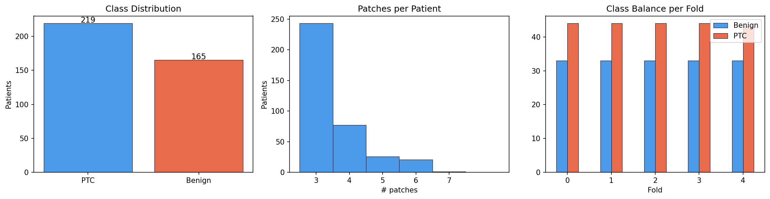
Fig. 2. Data audit: class distribution, number of cytology patches per patient, and class balance in each fold.

4.3.2 Pre-processing and augmentation
All images are converted to RGB, resized to 224 × 224 pixels and normalised with ImageNet statistics, matching the pretrained backbones. Augmentation is applied only to training folds and is modality-specific (Table X): cytology patches have no canonical orientation, so they receive stronger rotations and both flips, while ultrasound images keep their anatomical orientation and receive only mild perturbations. Variable-length patch bags are zero-padded to the longest bag in the batch and accompanied by a boolean mask so that padding never influences attention.
TABLE X. PRE-PROCESSING AND AUGMENTATION PIPELINE
Step | Ultrasound | Cytology patches
Decode and colour | PIL → RGB | PIL (.tif) → RGB
Resize | 224 × 224 | 224 × 224
Flip (train only) | Horizontal | Horizontal + vertical
Rotation (train only) | ±10° | ±90°
Colour jitter (train only) | Brightness 0.1, contrast 0.1 | Brightness 0.15, contrast 0.15, saturation 0.1
Normalisation | ImageNet mean/std | ImageNet mean/std
Batching | Stacked [B, 3, 224, 224] | Padded [B, N_max, 3, 224, 224] + mask [B, N_max]

4.3.3 Model backbone and transfer learning
Fig. 3 details the model. Two separate ConvNeXt-Tiny encoders [19], initialised with ImageNet weights, map the US image and every cytology patch to 768-dimensional vectors (the original classification layer is removed while its LayerNorm and flatten are kept). Separate encoders are used because ultrasound and stained cytology have very different image statistics. Each vector is projected to 512 dimensions (Linear → LayerNorm → Dropout). The patch tokens pass through a one-layer, eight-head pre-LayerNorm transformer encoder with key-padding masking, which lets patches exchange context. The sequence [CLS, US, P1 … PN] is then processed by a one-layer fusion transformer, and the output [CLS] token is classified by an MLP head (512 → 128 → 1, GELU) to give the logit; P(PTC) = σ(logit).
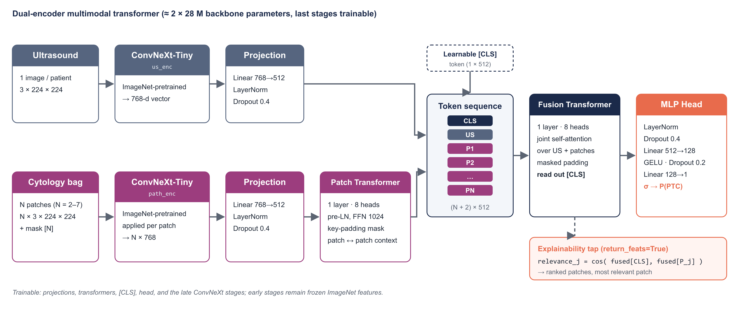
Fig. 3. Dual-encoder multimodal transformer: ConvNeXt-Tiny encoders, patch transformer, [CLS]-token fusion transformer, MLP head and explainability tap.
For transfer learning, the early backbone stages are frozen and only the later stages are fine-tuned, following evidence that early features are generic [24], [25]. In the current implementation, trainable parameters are selected by a name-matching rule; an audit during this proposal revealed that the rule is broader than intended (it also unfreezes some layers whose names merely contain the digits 5–7), so replacing it with explicit stage indexing and reporting the exact trainable-parameter count is a scheduled task for Weeks 7–8 (see Section 4.5).

4.3.4 Training strategy and overfitting control
Training minimises a label-smoothed binary cross-entropy with a positive-class weight computed from the training fold only (benign count ÷ PTC count), which counteracts the 57/43 class imbalance without leaking validation information. Optimisation uses AdamW over trainable parameters only, a five-epoch linear warm-up followed by cosine decay, gradient-norm clipping at 1.0, and checkpointing on the best validation AUROC with early stopping. Table XI lists the configuration changes made after the baseline run; their individual contributions will be quantified by the ablation study (Objective 1).
TABLE XI. OVERFITTING-CONTROL RECIPE: BASELINE VS. CURRENT CONFIGURATION
Component | Baseline | Current | Purpose
Backbone | Fully unfrozen | Early stages frozen | Reduce trainable capacity
Dropout | 0.1 | 0.4 | Stronger regularisation [26]
Weight decay (AdamW) | 1e-4 | 1e-3 | Penalise large weights [27]
Label smoothing | — | 0.05 | Soften over-confident targets [28]
Transformer depth | 2 | 1 | Simpler aggregator
Embedding dimension | 768 | 512 | Fewer head parameters
Learning rate | 1e-4 | 3e-5 (5-epoch warm-up + cosine) | Gentle fine-tuning
Gradient clipping | — | L2 norm 1.0 | Stable updates
Model selection | No early stopping | Best validation AUROC + early stopping | Threshold-free selection

TABLE XII. KEY TRAINING HYPER-PARAMETERS
Parameter | Value | Parameter | Value
Image size | 224 × 224 | Batch size | 2 patients
Epochs (max) | 10 | Early-stopping patience | 12 → to be tuned
Heads / FFN width | 8 / 1024 | Max patches per patient | 7
Folds | 5 (patient-level) | Seed | 42

4.3.5 Evaluation protocol
Evaluation follows CLAIM and TRIPOD+AI recommendations [15], [16] and is computed automatically for every fold. Threshold-free metrics (AUROC, AUPRC, Brier score) describe ranking quality and calibration; threshold-based metrics are reported both at 0.5 and at the Youden-optimal threshold J = max(sensitivity + specificity − 1) [31]. A 1,000-iteration patient-level bootstrap gives the 95% confidence interval of AUROC [32]. Table XIII maps each metric to its purpose.
TABLE XIII. EVALUATION METRICS AND THEIR ROLE
Metric | Definition (short) | Why it matters here
AUROC (+ 95% CI) | Area under the ROC curve; bootstrap CI | Threshold-free discrimination with uncertainty
AUPRC | Area under precision–recall curve | Informative under class imbalance
Sensitivity / Specificity | TP/(TP+FN), TN/(TN+FP) | Missed cancers vs. unnecessary surgery
PPV / NPV | TP/(TP+FP), TN/(TN+FN) | Meaning of a positive or negative result
Accuracy / Balanced accuracy | Overall / class-averaged recall | Comparability with prior work; imbalance-robust
F1, MCC, Cohen’s κ | Harmonic mean; correlation; chance-corrected agreement | Robust single-number summaries [30]
Brier score, ECE | Mean squared probability error; binned calibration gap | Are probabilities trustworthy? [29]
Youden threshold | argmax(TPR − FPR) | Principled operating point [31]

4.3.6 Explainability module
With return_feats=True, the model exposes the fused token sequence. The relevance of patch j is the cosine similarity between the fused [CLS] token and the fused token of patch j; patches are ranked and colour-coded from least to most relevant. The module automatically selects true-positive, true-negative, false-positive and false-negative cases (when present) for qualitative review. Because attention-derived scores are not guaranteed to be faithful [35], the evaluation plan adds a deletion test (remove the top-ranked vs. a random patch and measure the change in P(PTC)) and a comparison with attention rollout [36] and Grad-CAM saliency [34].

4.3.7 Inference flow
Fig. 4 shows the inference path implemented in model_inference.py. The script restores the configuration from the checkpoint, applies the evaluation transforms, runs a single forward pass, and returns the probability, the predicted class, a confidence score and the patch relevance ranking, together with a colour-coded figure. Batch mode writes a results CSV and, when labels are present, prints AUROC, accuracy and F1. The planned web demo will wrap exactly this function, so the user interface and the research code cannot diverge.
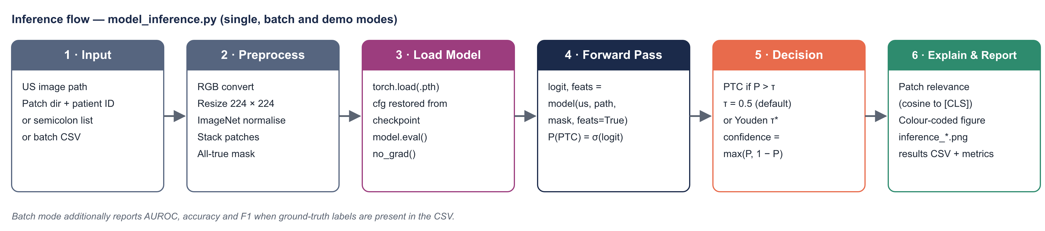
Fig. 4. Inference flow of the deployed model (single-patient, batch and interactive demo modes).

4.4 Preliminary Results (Fold 0)
A complete run of the current pipeline on fold 0 (307 training and 77 validation patients) produced the results in Table XIV and Figs. 5–8. These figures are preliminary: they come from one fold and from a checkpoint selected on that same fold, so they are optimistic and serve mainly to validate the pipeline and to guide the remaining work.
TABLE XIV. PRELIMINARY VALIDATION METRICS, FOLD 0 (N = 77; 33 BENIGN, 44 PTC)
Metric | Value | Metric | Value
AUROC | 0.979 (95% CI 0.948–0.997) | AUPRC | 0.984
Accuracy | 0.883 | Balanced accuracy | 0.864
Sensitivity (τ = 0.5) | 1.000 (44/44) | Specificity (τ = 0.5) | 0.727 (24/33)
PPV | 0.830 | NPV | 1.000
F1 | 0.907 | MCC | 0.777
Cohen’s κ | 0.753 | Brier score | 0.094
Youden threshold τ* | 0.892 | Sens / Spec at τ* | 0.977 / 0.848 (F1 0.935)

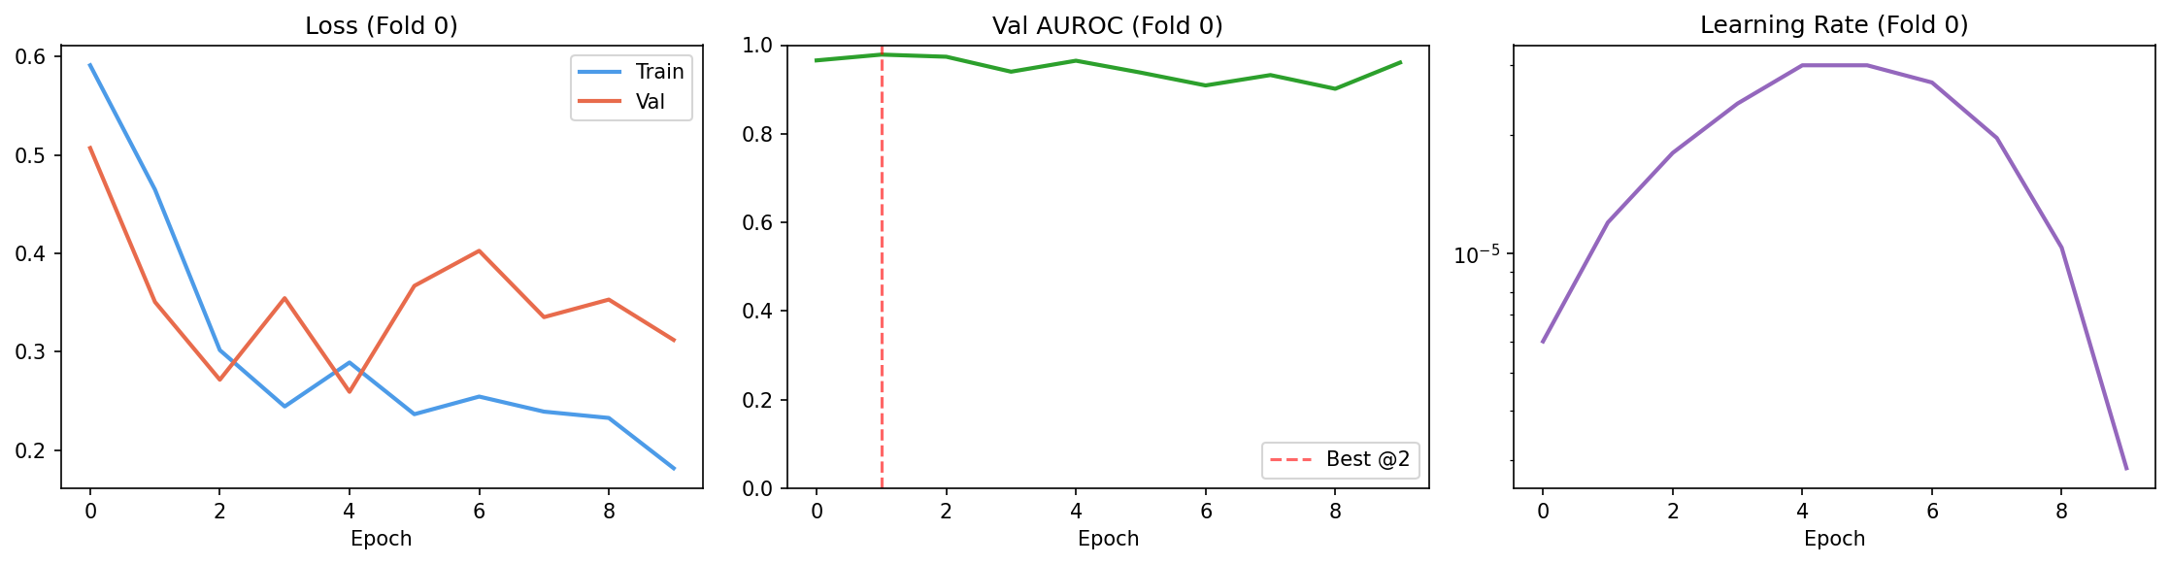
Fig. 5. Training dynamics on fold 0: training and validation loss, validation AUROC (best at epoch 2) and learning-rate schedule.
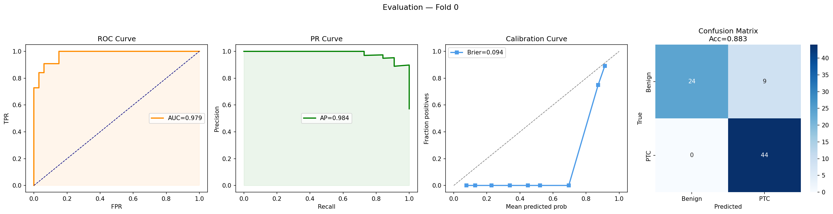
Fig. 6. Fold-0 evaluation: ROC curve, precision–recall curve, calibration curve and confusion matrix at τ = 0.5.
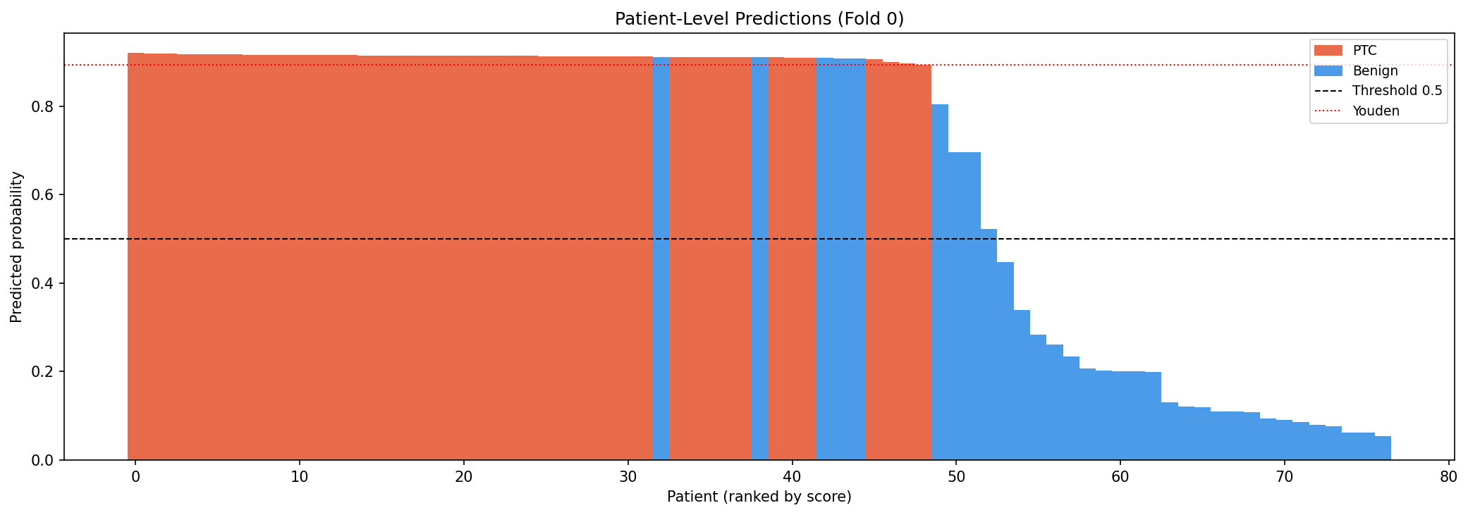
Fig. 7. Patient-level predicted probabilities on fold 0, ranked by score (red = PTC, blue = benign).
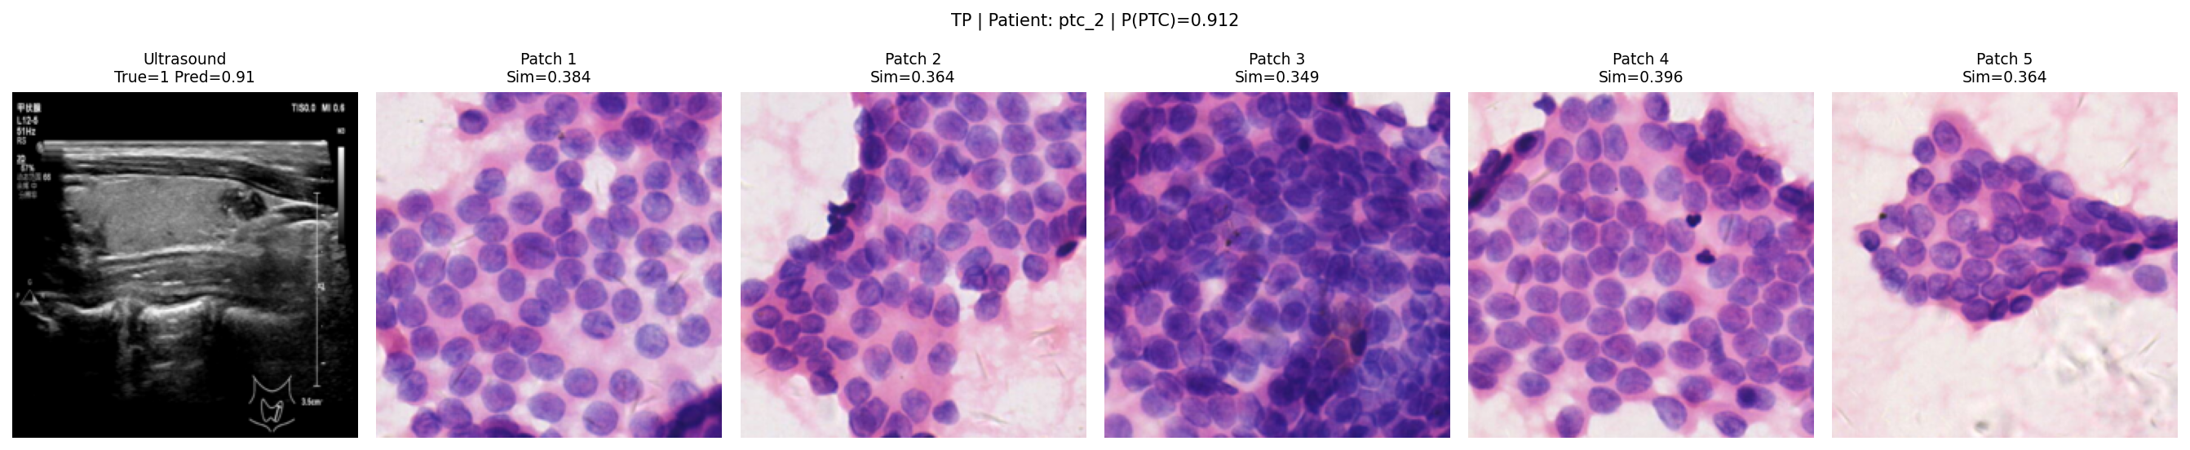
Fig. 8. Explainability output for a true-positive patient (P(PTC) = 0.912): ultrasound image and cytology patches with relevance scores.
Interpretation. Discrimination is already strong (AUROC 0.979) and no PTC case is missed at τ = 0.5, which is the clinically preferred error direction. However, (i) nine of 33 benign patients are flagged as PTC (specificity 0.727); (ii) the score distribution is compressed — almost all PTC scores lie in a narrow band around 0.91, so the calibration curve deviates strongly from the diagonal; and (iii) validation loss rises after epoch 5 while training loss keeps falling, and the best AUROC occurs at epoch 2, indicating that overfitting is reduced but not eliminated. Moving the threshold to the Youden point raises specificity to 0.848 at the cost of one missed PTC. These observations directly motivate the calibration, threshold-selection and ablation work planned for the second half of the semester.

4.5 Threats to Validity and Planned Mitigations
TABLE XV. THREATS TO VALIDITY IDENTIFIED DURING THE MIDTERM AUDIT
Threat | Evidence | Planned mitigation | Week
Single-fold estimate | Only fold 0 has been run. | Run all 5 folds; report mean ± SD and pooled CI. | 9
Selection bias | Best epoch chosen on the reporting fold [33]. | Inner validation split inside each training fold (nested selection). | 9–10
Early stopping inactive | Patience (12) exceeds max epochs (10). | Tune epochs/patience jointly in the ablation. | 8
Freezing rule too broad | Name-substring rule also unfreezes some early-stage layers. | Explicit stage indexing; log trainable-parameter count. | 7–8
Score compression / mis-calibration | PTC scores cluster near 0.91; calibration curve off-diagonal. | Temperature scaling on inner validation; report ECE and Brier [29]. | 11
Unvalidated explanations | Cosine relevance is not attention weight and may be unfaithful [35]. | Deletion test; compare with attention rollout and Grad-CAM [36], [34]. | 12
Duplicated model code | model_inference.py re-defines the model class. | Shared model.py module imported by both scripts. | 7
Limited generalisability | Single-source dataset of 384 patients. | State clearly as a limitation; no clinical claims. | 14

4.6 Ethical and Data Considerations
The images are used in anonymised form and are referenced only by numeric IDs; raw images are excluded from version control. The system is a research prototype and will be labelled “research use only” in every output; it is not intended to diagnose or treat patients. Limitations — single-source data, a modest sample size and the absence of external validation — will be stated explicitly in all results, in line with TRIPOD+AI [16].

5. MVP DELIVERABLES & DEVELOPMENT TIMELINE

5.1 MVP Definition & Target Capabilities
The MVP is the minimal set of working features that demonstrates the full path from raw paired images to an interpretable, evaluated prediction. Table XVI lists its capabilities, current status and acceptance criteria.
TABLE XVI. MVP CAPABILITIES, STATUS AND ACCEPTANCE CRITERIA
# | Capability | Status (midterm) | Acceptance criterion
1 | Automated data audit and patient-level 5-fold metadata | Done | metadata.csv regenerated identically from raw folders
2 | Dual-encoder multimodal transformer | Done | Forward pass on bags of 2–7 patches with masking
3 | Regularised training with checkpointing | Done (fold 0) | All 5 folds trained from one command
4 | Ablation of overfitting controls (A0–A3) | Planned | Ablation table with mean ± SD AUROC and loss gap
5 | Comprehensive evaluation + calibration | Partly done | Metric panel with CIs, ECE/Brier after temperature scaling
6 | Patch-relevance explainability + faithfulness test | Partly done | TP/TN/FP/FN figures; deletion-test win rate reported
7 | Inference CLI (single, batch, demo) | Done | Prediction + figure for any patient ID
8 | Web demo (Gradio) | Planned | Upload US + patches → P(PTC), decision, relevance strip

5.2 MVP Conceptual Diagram
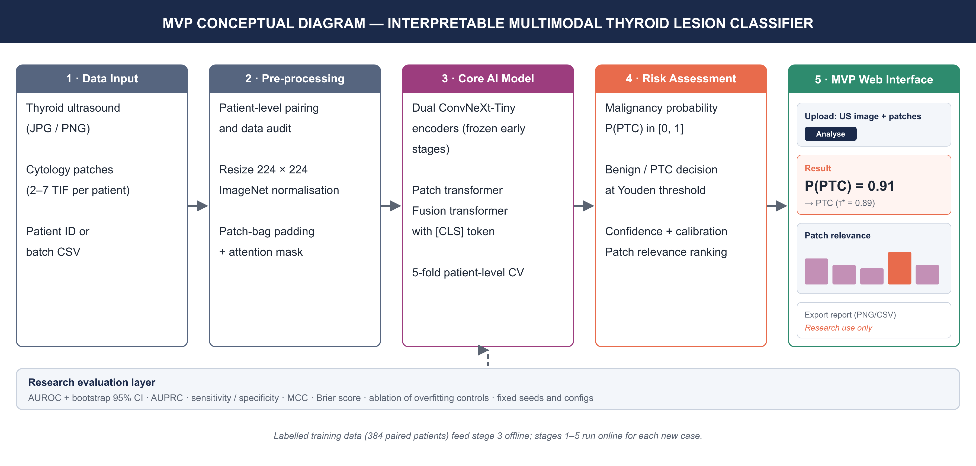
Fig. 9. MVP conceptual diagram: data input, pre-processing, core AI model, risk assessment and the planned web interface, supported by the research evaluation layer.

5.3 Implementation Roadmap (Milestones)
TABLE XVII. IMPLEMENTATION ROADMAP UP TO THE FINAL PRESENTATION
Phase / Week | Target deliverable / milestone | Responsible member | Status
Weeks 1–3 | Requirements, literature scan, data audit, environment setup (PyTorch, torchvision, scikit-learn); first prototype. | Usmanov Lazizbek | Completed
Weeks 4–6 | Core pipeline: unified main.py, multimodal model, baseline training, overfitting fixes, fold-0 run; inference CLI. | Usmanov Lazizbek | Completed
Weeks 7–8 | Midterm proposal and presentation; shared model.py; explicit stage freezing; epoch/patience fix; ablation setup. | Usmanov Lazizbek | In progress
Weeks 9–10 | Full 5-fold CV with nested selection; ablation A0–A3 (Objective 1); reproducibility re-runs (Objective 2); integration and MVP functional testing. | Usmanov Lazizbek | Planned
Weeks 11–12 | Temperature scaling and calibration analysis; deletion test, attention rollout and Grad-CAM; Gradio web demo; final system testing. | Usmanov Lazizbek | Planned
Week 13 | Research evaluation: answer RQ1–RQ3 against the SMART targets; error analysis of FP/FN cases. | Usmanov Lazizbek | Planned
Week 14 | Documentation: final report, README, reproducibility guide, final presentation and live demo. | Usmanov Lazizbek | Planned

5.4 Evaluation Plan
TABLE XVIII. PLANNED EXPERIMENTS MAPPED TO RESEARCH QUESTIONS
Exp. | Description | RQ | Primary outcome
E1 | Ablation A0 (unfrozen) → A3 (full recipe), 5 folds each | RQ1 | Mean ± SD AUROC; train–val loss gap
E2 | Three identical-seed re-runs and one different-seed run of the full pipeline | RQ2 | AUROC variance; runtime per fold
E3 | Full metric panel at 0.5 and Youden thresholds; temperature scaling | RQ3 | AUROC CI, Brier, ECE, sens/spec
E4 | Deletion test of patch relevance; comparison with attention rollout and Grad-CAM | RQ3 | Win rate vs. random patch
E5 | Modality ablation: US only vs. cytology only vs. fused (stretch) | RQ1/RQ3 | ΔAUROC from fusion

5.5 Project Risks
TABLE XIX. PROJECT RISK REGISTER
Risk | Likelihood | Impact | Mitigation
GPU time insufficient for 5 folds × 4 ablations | Medium | High | Batch size 2 already fits a single GPU; cache frozen-stage features; prioritise A0 and A3.
Ablation shows little difference between settings | Medium | Medium | Still a valid finding; report effect sizes with CIs.
Calibration remains poor | Low | Medium | Try Platt scaling and isotonic regression in addition to temperature scaling.
Single-member team capacity | Medium | Medium | Strict scope; web demo kept minimal; weekly milestones.

6. CONCLUSION AND EXPECTED CONTRIBUTION
This proposal describes an interpretable, reproducible deep learning pipeline that classifies thyroid lesions as benign or papillary thyroid carcinoma by fusing an ultrasound image with a bag of cytology patches. The work is grounded in three problems observed in our own preliminary experiments — overfitting on a small dataset, fragmented code, and opaque, accuracy-only evaluation — which map one-to-one onto the approved research questions and objectives. A working prototype already exists: the unified pipeline trains end-to-end and reaches a fold-0 AUROC of 0.979 (95% CI 0.948–0.997), while the midterm audit has identified concrete, scheduled improvements in calibration, model selection and validation of explanations.
The expected contributions are:
- Empirical: a controlled ablation quantifying how much each overfitting control contributes to generalisation in a 384-patient, two-modality setting (RQ1).
- Engineering: an open, single-entry, configuration-driven pipeline with shared model code and reproducibility checks that others can rerun and extend (RQ2).
- Methodological: a clinically oriented evaluation protocol — confidence intervals, calibration, operating-point analysis — and a faithfulness-tested patch relevance method for multimodal transformers (RQ3).
- Product: a working MVP — inference CLI and web demo — that turns a patient’s ultrasound image and cytology patches into a malignancy probability with a visual explanation, clearly labelled for research use.
Together these deliverables move the project from a promising prototype to an evaluated, explainable research-grade MVP by the final presentation.

REFERENCES
[1] F. Bray, M. Laversanne, H. Sung, et al., "Global cancer statistics 2022: GLOBOCAN estimates of incidence and mortality worldwide for 36 cancers in 185 countries," CA Cancer J. Clin., vol. 74, no. 3, pp. 229–263, 2024.
[2] S. Vaccarella, S. Franceschi, F. Bray, et al., "Worldwide thyroid-cancer epidemic? The increasing impact of overdiagnosis," N. Engl. J. Med., vol. 375, no. 7, pp. 614–617, 2016.
[3] B. R. Haugen, E. K. Alexander, K. C. Bible, et al., "2015 American Thyroid Association management guidelines for adult patients with thyroid nodules and differentiated thyroid cancer," Thyroid, vol. 26, no. 1, pp. 1–133, 2016.
[4] F. N. Tessler et al., "ACR Thyroid Imaging, Reporting and Data System (TI-RADS): White paper of the ACR TI-RADS Committee," J. Am. Coll. Radiol., vol. 14, no. 5, pp. 587–595, 2017.
[5] E. S. Cibas and S. Z. Ali, "The 2017 Bethesda System for reporting thyroid cytopathology," Thyroid, vol. 27, no. 11, pp. 1341–1346, 2017.
[6] G. Litjens et al., "A survey on deep learning in medical image analysis," Med. Image Anal., vol. 42, pp. 60–88, 2017.
[7] X. Li et al., "Diagnosis of thyroid cancer using deep convolutional neural network models applied to sonographic images: A retrospective, multicohort, diagnostic study," Lancet Oncol., vol. 20, no. 2, pp. 193–201, Feb. 2019.
[8] M. Buda et al., "Management of thyroid nodules seen on US images: Deep learning may match performance of radiologists," Radiology, vol. 292, no. 3, pp. 695–701, 2019.
[9] Q. Guan et al., "Deep convolutional neural network VGG-16 model for differential diagnosing of papillary thyroid carcinomas in cytological images: A pilot study," J. Cancer, vol. 10, no. 20, pp. 4876–4882, 2019.
[10] D. Elliott Range et al., "Application of a machine learning algorithm to predict malignancy in thyroid cytopathology," Cancer Cytopathol., vol. 128, no. 4, pp. 287–295, 2020.
[11] G. Campanella et al., "Clinical-grade computational pathology using weakly supervised deep learning on whole slide images," Nat. Med., vol. 25, no. 8, pp. 1301–1309, 2019.
[12] M. Y. Lu et al., "Data-efficient and weakly supervised computational pathology on whole-slide images," Nat. Biomed. Eng., vol. 5, no. 6, pp. 555–570, 2021.
[13] J. Pineau et al., "Improving reproducibility in machine learning research (A report from the NeurIPS 2019 reproducibility program)," J. Mach. Learn. Res., vol. 22, no. 164, pp. 1–20, 2021.
[14] S. Kapoor and A. Narayanan, "Leakage and the reproducibility crisis in machine-learning-based science," Patterns, vol. 4, no. 9, Art. no. 100804, 2023.
[15] J. Mongan, L. Moy, and C. E. Kahn Jr., "Checklist for Artificial Intelligence in Medical Imaging (CLAIM): A guide for authors and reviewers," Radiol., Artif. Intell., vol. 2, no. 2, Art. no. e200029, 2020.
[16] G. S. Collins et al., "TRIPOD+AI statement: Updated guidance for reporting clinical prediction models that use regression or machine learning methods," BMJ, vol. 385, Art. no. e078378, 2024.
[17] C. Rudin, "Stop explaining black box machine learning models for high stakes decisions and use interpretable models instead," Nat. Mach. Intell., vol. 1, no. 5, pp. 206–215, 2019.
[18] A. Paszke et al., "PyTorch: An imperative style, high-performance deep learning library," in Adv. Neural Inf. Process. Syst., vol. 32, 2019.
[19] Z. Liu, H. Mao, C.-Y. Wu, C. Feichtenhofer, T. Darrell, and S. Xie, "A ConvNet for the 2020s," in Proc. IEEE/CVF Conf. Comput. Vis. Pattern Recognit. (CVPR), New Orleans, LA, USA, 2022, pp. 11976–11986.
[20] A. Vaswani et al., "Attention is all you need," in Adv. Neural Inf. Process. Syst., vol. 30, 2017, pp. 5998–6008.
[21] M. Ilse, J. M. Tomczak, and M. Welling, "Attention-based deep multiple instance learning," in Proc. 35th Int. Conf. Mach. Learn. (ICML), 2018, vol. 80, pp. 2127–2136.
[22] S.-C. Huang, A. Pareek, S. Seyyedi, I. Banerjee, and M. P. Lungren, "Fusion of medical imaging and electronic health records using deep learning: A systematic review and implementation guidelines," npj Digit. Med., vol. 3, Art. no. 136, 2020.
[23] A. Dosovitskiy et al., "An image is worth 16x16 words: Transformers for image recognition at scale," in Proc. Int. Conf. Learn. Represent. (ICLR), 2021.
[24] J. Yosinski, J. Clune, Y. Bengio, and H. Lipson, "How transferable are features in deep neural networks?," in Adv. Neural Inf. Process. Syst., vol. 27, 2014, pp. 3320–3328.
[25] M. Raghu, C. Zhang, J. Kleinberg, and S. Bengio, "Transfusion: Understanding transfer learning for medical imaging," in Adv. Neural Inf. Process. Syst., vol. 32, 2019, pp. 3347–3357.
[26] N. Srivastava, G. Hinton, A. Krizhevsky, I. Sutskever, and R. Salakhutdinov, "Dropout: A simple way to prevent neural networks from overfitting," J. Mach. Learn. Res., vol. 15, no. 1, pp. 1929–1958, 2014.
[27] I. Loshchilov and F. Hutter, "Decoupled weight decay regularization," in Proc. Int. Conf. Learn. Represent. (ICLR), 2019.
[28] R. Müller, S. Kornblith, and G. Hinton, "When does label smoothing help?," in Adv. Neural Inf. Process. Syst., vol. 32, 2019.
[29] C. Guo, G. Pleiss, Y. Sun, and K. Q. Weinberger, "On calibration of modern neural networks," in Proc. 34th Int. Conf. Mach. Learn. (ICML), 2017, vol. 70, pp. 1321–1330.
[30] D. Chicco and G. Jurman, "The advantages of the Matthews correlation coefficient (MCC) over F1 score and accuracy in binary classification evaluation," BMC Genomics, vol. 21, Art. no. 6, 2020.
[31] W. J. Youden, "Index for rating diagnostic tests," Cancer, vol. 3, no. 1, pp. 32–35, 1950.
[32] B. Efron and R. J. Tibshirani, An Introduction to the Bootstrap. New York, NY, USA: Chapman & Hall, 1993.
[33] S. Varma and R. Simon, "Bias in error estimation when using cross-validation for model selection," BMC Bioinformatics, vol. 7, Art. no. 91, 2006.
[34] R. R. Selvaraju et al., "Grad-CAM: Visual explanations from deep networks via gradient-based localization," in Proc. IEEE Int. Conf. Comput. Vis. (ICCV), 2017, pp. 618–626.
[35] S. Jain and B. C. Wallace, "Attention is not explanation," in Proc. Conf. North Amer. Chapter Assoc. Comput. Linguistics: Human Lang. Technol. (NAACL-HLT), Minneapolis, MN, USA, 2019, pp. 3543–3556.
[36] S. Abnar and W. Zuidema, "Quantifying attention flow in transformers," in Proc. 58th Annu. Meeting Assoc. Comput. Linguistics (ACL), 2020, pp. 4190–4197.
[37] F. Pedregosa et al., "Scikit-learn: Machine learning in Python," J. Mach. Learn. Res., vol. 12, pp. 2825–2830, 2011.
[38] A. Abid, A. Abdalla, A. Abid, D. Khan, A. Alfozan, and J. Zou, "Gradio: Hassle-free sharing and testing of ML models in the wild," arXiv:1906.02569, 2019.

