DRAFT 3-6-2017
Earle West ehwest@gmail.com
The purpose of this document is to provide the protocol that would be required of a “SAM” System Access Module or an equivalent device (e.g a Raspberry PI) to read and update certain Carrier and Bryant HVAC systems. Read and Write capability in the role of a SAM is required to add intelligence, and certain home-automation functions to an existing HVAC system.
The HVAC system protocol provides for broadcast of variable-length FRAMES that may range in size from 8 to 263 bytes. Each FRAME contains information on the Destination Device, the Requesting Device, the length of the payload, a function code, a variable length payload, and a suffix of 2 CRC16 bytes. The layout of each FRAME is shown below.
FRAMES are primarily broadcast on the 2-wire RS-485 network by a thermostat (Requesting Device) with the expectation that a specific target (Destination Device), will respond asynchronously with its own broadcast, similarly addressed to the requesting thermostat. The 2-wire protocol uses the terminals labeled “A” and “B”. Terminal “A” is also referred to as “Data+” or the “non-inverting” data line. Terminal “B” is referred to as Data-“ and is the “inverting” data line. Ground is found on “C” and 24v power from the furnace is commonly found on “D”. Access to “C” or “D” is not required to effectively monitor and control the HVAC system by a SAM type module.
For the purposes of remote control and monitoring, messages to and from the thermostat and an added “SAM” device used to interrogate and update the thermostat are the only messages of interest. The thermostat does actively poll for information from other devices on the HVAC network, including the furnace, blower, and external compressor and fan. However, these data do not add anything to what may be obtained from the thermostat directly.
Within each FRAME, there typically is a PAYLOAD string that conveys specific status, control, or information responsive to a prior message.
Typically, the network is fairly busy with messages of all types visible at a rate of several per second. Presumably collisions would be detected by CRC16 errors. However, because most of the traffic is responsive to thermostat messages, there are few collisions.

FRAME INFORMATION COMPONENTS
x40 | x01 | x20 | x01 | x03 | x0B | <string of LENGTH bytes> | x6E | x2E
DESTINATION DEVICE |  | REQUESTING DEVICE |  | LENGTH of PAYLOAD | R/W/ACK  RESPONSE CODE | VARIABLE LENGTH of PAYLOAD  INFORMATION COMPONENTS | CRC16

RESPONSE CODES: READ=x0B; WRITE=x0C; ACK=x06; ERR=x15

VARIABLE LENGTH OF PAYLOAD INFORMATION COMPONENTS
X00 | x02 | x01 | x00 | x21 |  |  |  |  |  |  |  | x20 | x00 | x19 | x03 | x13 | X01 | x03 | X03 | X03 | X03
TABLE ID |  | ROW ID | UNK |  | TABLE NAME or CONTENT  <variable> |  |  |  |  |  |  | SPACE | TOTAL NUMBER of MESSAGE BYTES |  | NUM  of ROWS | NUM of MESSAGE  BYTES in ROW 1 | UNK | NUM of MESSAGE  BYTES in ROW 2 | UNK | NUM of MESSAGE  BYTES in ROW 3 | UNK
REGISTER |  |  | TYPICAL ROW 1 MESSAGE

X00 | x02 | x02
TABLE ID |  | ROW ID | <string LENGTH of NUM MESSAGE BYTES in ROW 2 above>
REGISTER |  |  | ROW 2 MESSAGE
X00 | x02 | x03
TABLE ID |  | ROW ID | <string LENGTH of NUM MESSAGE BYTES in ROW 2 above>
REGISTER |  |  | ROW 3 MESSAGE
Additional rows may be added, with a specific number for each TABLE ID type.
The thermostat is the source of most requests.
Only three of the many different messages defined need to be used and/or parsed. The main message of interest (for the non-touch models) is the inquiry to the thermostat for its current values and settings. The thermostat responds to this message with virtually all of the data needed in a single response message. In addition, by writing to the thermostat with this same message, important values may be adjusted.
It has learned that the older (“non-touch”) models of thermostats are principally using table “0x003B” and row “0x02” for the key thermostat parameters. Additional zone parameters are on the same table at row 0x03.
This contrasts with “touch” models of thermostats which is likely using other table and/or row addresses for this same data. Until this information is discovered, the existing solutions will not work with “touch” models.
Ongoing work to cover “touch” models, should probably focus on identifying which table and row are being used by SAM for the thermostat properties.
Interesting and/or Useful Thermostat Values -- TStatCurrentParams
Thermostat ADDRESS | TABLE ID | Row ID | Row Position | Interpretation
x2001 | X003B | 0x02 | 1 | Z1CurrentTemp
x2001 | X003B | 0x02 | 2 | Z2CurrentTemp
x2001 | X003B | 0x02 | 3 | Z3CurrentTemp
x2001 | X003B | 0x02 | 4 | Z4CurrentTemp
x2001 | X003B | 0x02 | 5 | Z5CurrentTemp
x2001 | X003B | 0x02 | 6 | Z6CurrentTemp
x2001 | X003B | 0x02 | 7 | Z7CurrentTemp
x2001 | X003B | 0x02 | 8 | Z8CurrentTemp
x2001 | X003B | 0x02 | 9 | Z1CurrentHumidity
x2001 | X003B | 0x02 | 10 | Z2CurrentHumidity
x2001 | X003B | 0x02 | 11 | Z3CurrentHumidity
x2001 | X003B | 0x02 | 12 | Z4CurrentHumidity
x2001 | X003B | 0x02 | 13 | Z5CurrentHumidity
x2001 | X003B | 0x02 | 14 | Z6CurrentHumidity
x2001 | X003B | 0x02 | 15 | Z7CurrentHumidity
x2001 | X003B | 0x02 | 16 | Z8CurrentHumidity
x2001 | X003B | 0x02 | 17 | Unknown1
x2001 | X003B | 0x02 | 18 | OutdoorAirTemp
x2001 | X003B | 0x02 | 19 | ZoneUnocc
x2001 | X003B | 0x02 | 20 | Mode
x2001 | X003B | 0x02 | 21-26 | Unknown 2
x2001 | X003B | 0x02 | 27 | DisplayedZone

type TStatCurrentParams struct {
Z1CurrentTemp uint8
Z2CurrentTemp uint8
Z3CurrentTemp uint8
Z4CurrentTemp uint8
Z5CurrentTemp uint8
Z6CurrentTemp uint8
Z7CurrentTemp uint8
Z8CurrentTemp uint8
Z1CurrentHumidity uint8
Z2CurrentHumidity uint8
Z3CurrentHumidity uint8
Z4CurrentHumidity uint8
Z5CurrentHumidity uint8
Z6CurrentHumidity uint8
Z7CurrentHumidity uint8
Z8CurrentHumidity uint8
Unknown1 uint8
OutdoorAirTemp uint8
ZoneUnocc uint8 // bitflags
Mode uint8
Unknown2 [5]uint8
DisplayedZone uint8
}

Interesting and/or Useful Thermostat Values -- TStatZoneParams
Thermostat ADDRESS | TABLE ID | Row ID | Row Position | Interpretation
x2001 | X003B | 0x03 | 1 | Z1FanMode
x2001 | X003B | 0x03 | 2 | Z2FanMode
x2001 | X003B | 0x03 | 3 | Z3FanMode
x2001 | X003B | 0x03 | 4 | Z4FanMode
x2001 | X003B | 0x03 | 5 | Z5FanMode
x2001 | X003B | 0x03 | 6 | Z6FanMode
x2001 | X003B | 0x03 | 7 | Z7FanMode
x2001 | X003B | 0x03 | 8 | Z8FanMode
x2001 | X003B | 0x03 | 9 | Z1HeatSetPoint
x2001 | X003B | 0x03 | 10 | Z2HeatSetPoint
x2001 | X003B | 0x03 | 11 | Z3HeatSetPoint
x2001 | X003B | 0x03 | 12 | Z4HeatSetPoint
x2001 | X003B | 0x03 | 13 | Z5HeatSetPoint
x2001 | X003B | 0x03 | 14 | Z6HeatSetPoint
x2001 | X003B | 0x03 | 15 | Z7HeatSetPoint
x2001 | X003B | 0x03 | 16 | Z8HeatSetPoint
x2001 | X003B | 0x03 | 17 | Z1CoolSetPoint
x2001 | X003B | 0x03 | 18 | Z2CoolSetPoint
x2001 | X003B | 0x03 | 19 | Z3CoolSetPoint
x2001 | X003B | 0x03 | 20 | Z4CoolSetPoint
x2001 | X003B | 0x03 | 21 | Z5CoolSetPoint
x2001 | X003B | 0x03 | 22 | Z6CoolSetPoint
x2001 | X003B | 0x03 | 23 | Z7CoolSetPoint
x2001 | X003B | 0x03 | 24 | Z8CoolSetPoint
x2001 | X003B | 0x03 | 25 | Z1TargetHumidity
x2001 | X003B | 0x03 | 26 | Z2TargetHumidity
x2001 | X003B | 0x03 | 27 | Z3TargetHumidity
x2001 | X003B | 0x03 | 28 | Z4TargetHumidity
x2001 | X003B | 0x03 | 29 | Z5TargetHumidity
x2001 | X003B | 0x03 | 30 | Z6TargetHumidity
x2001 | X003B | 0x03 | 31 | Z7TargetHumidity
x2001 | X003B | 0x03 | 32 | Z8TargetHumidity
x2001 | X003B | 0x03 | 33 | FanAutoCfg
x2001 | X003B | 0x03 | 34 | Unknown
x2001 | X003B | 0x03 | 35 | Z1HoldDuration
x2001 | X003B | 0x03 | 36 | Z2HoldDuration
x2001 | X003B | 0x03 | 37 | Z3HoldDuration
x2001 | X003B | 0x03 | 38 | Z4HoldDuration
x2001 | X003B | 0x03 | 39 | Z5HoldDuration
x2001 | X003B | 0x03 | 40 | Z6HoldDuration
x2001 | X003B | 0x03 | 41 | Z7HoldDuration
x2001 | X003B | 0x03 | 42 | Z8HoldDuration
x2001 | X003B | 0x03 | 43-55 | Z1Name (12 bytes)
x2001 | X003B | 0x03 | 56 - 68 | Z2Name (12 bytes)
x2001 | X003B | 0x03 | 69-81 | Z3Name (12 bytes)
x2001 | X003B | 0x03 | 82 - 94 | Z4Name (12 bytes)
x2001 | X003B | 0x03 | 95 - 107 | Z5Name (12 bytes)
x2001 | X003B | 0x03 | 108 - 120 | Z6Name (12 bytes)
x2001 | X003B | 0x03 | 121 - 133 | Z7Name (12 bytes)
x2001 | X003B | 0x03 | 134 - 146 | Z8Name

type TStatZoneParams struct {
Z1FanMode uint8
Z2FanMode uint8
Z3FanMode uint8
Z4FanMode uint8
Z5FanMode uint8
Z6FanMode uint8
Z7FanMode uint8
Z8FanMode uint8
ZoneHold uint8 // bitflags
Z1HeatSetpoint uint8
Z2HeatSetpoint uint8
Z3HeatSetpoint uint8
Z4HeatSetpoint uint8
Z5HeatSetpoint uint8
Z6HeatSetpoint uint8
Z7HeatSetpoint uint8
Z8HeatSetpoint uint8
Z1CoolSetpoint uint8
Z2CoolSetpoint uint8
Z3CoolSetpoint uint8
Z4CoolSetpoint uint8
Z5CoolSetpoint uint8
Z6CoolSetpoint uint8
Z7CoolSetpoint uint8
Z8CoolSetpoint uint8
Z1TargetHumidity uint8
Z2TargetHumidity uint8
Z3TargetHumidity uint8
Z4TargetHumidity uint8
Z5TargetHumidity uint8
Z6TargetHumidity uint8
Z7TargetHumidity uint8
Z8TargetHumidity uint8
FanAutoCfg uint8
Unknown uint8
Z1HoldDuration uint16
Z2HoldDuration uint16
Z3HoldDuration uint16
Z4HoldDuration uint16
Z5HoldDuration uint16
Z6HoldDuration uint16
Z7HoldDuration uint16
Z8HoldDuration uint16
Z1Name [12]byte
Z2Name [12]byte
Z3Name [12]byte
Z4Name [12]byte
Z5Name [12]byte
Z6Name [12]byte
Z7Name [12]byte
Z8Name [12]byte
}
Interesting and/or Useful Thermostat Values -- TStatVacationParams
Thermostat ADDRESS | TABLE ID | Row ID | Row Position | Interpretation
x2001 | X003B | 0x04 | 1 | Active
x2001 | X003B | 0x04 | 2 | Hours
x2001 | X003B | 0x04 | 3 | MinTemperature
x2001 | X003B | 0x04 | 4 | MaxTemperature
x2001 | X003B | 0x04 | 5 | MinHumidity
x2001 | X003B | 0x04 | 6 | MaxHumidity

type TStatVacationParams struct {
Active uint8
Hours uint16
MinTemperature uint8
MaxTemperature uint8
MinHumidity uint8
MaxHumidity uint8
FanMode uint8 // matches fan mode from TStatZoneParams
}

Devices other than the thermostat have their own specific protocol addresses, and at each address several tables are available. While these messages may be used by the HVAC system, the details for what data is in these messages is unknown. Access to this data is interesting, but largely unnecessary in an environment where the thermostat is controlling everything.

Thermostat Table of Known Table Names – little is known about the content of these tables (with the exception of table 0x003B used above.
Thermostat ADDRESS | TABLE ID | TABLE NAME / FIRST ROW CONTENTS | MAX Number of ROWS in Table | Valid on these thermostats (ref. index number)
x2001 | X0001 | DEVCONFG | 4
x2001 | X0002 | SYSTIME | 10
x2001 | X0003 | INGUI | 10
x2001 | X0004 | SSSBCAST | 32
X2001 | X0005 | EVEREST
x2001 | X0006 | LINESET | 72 | 1
x2001 | X002F | STARTUP | 29
X2001 | X002F | EECONFIG |  | 7,9,10
x2001 | X0031 | DUI DATA / INGDATA | 51
x2001 | X0032 | LED CTRL
x2001 | X0034 | 4 ZONE
x2001 | X0039 | P MSCH
x2001 | X003B | AI PARMS / NVMINIT
x2001 | X003C | UI PARMS
x2001 | X003D | DISPDATA
x2001 | X003E | DCLEGACY
x2001 | X003F | WSAM CCN

Sensor Addresses and ASCII message content for Row 1.
Sensor ADDRESS | TABLE ID | TABLE NAME / FIRST ROW CONTENTS | MAX Number of ROWS in Table | Valid on these sensors
X2201 | X0001 | DEVCPONFG
X2201 | X0002 | SYSTIME
X2201 | X0003 | RLCS MAIN
X2201 | X0004 | SMT SNSR M
X2201 | X0030 | EECONFIG
X2201 | X0032 | SSSVCTL
Heat Pump Addresses and ASCII message content for Row 1.
Sensor ADDRESS | TABLE ID | TABLE NAME / FIRST ROW CONTENTS | MAX Number of ROWS in Table | Valid on these sensors
X5001 | X0001 | DEVCPONFG
X5001 | X0002 | SYSTIME
X5001 | X0003 | RLCS MAIN
X5001 | X0005 | TWOCACTY
X5001 | X003E | ??
X5001 | X0032 | SSSVCTL
Furnace Addresses and ASCII message content for Row 1.
Sensor ADDRESS | TABLE ID | TABLE NAME / FIRST ROW CONTENTS | MAX Number of ROWS in Table | Valid on these sensors
X4001 | X0001 | DEVCONFG
X4001 | X0002 | SYSTIME
X4001 | X0003 | RLCS MAIN
X4001 | X0005 | VARSPEED
FAN COIL Addresses and ASCII message content for Row 1.
Sensor ADDRESS | TABLE ID | TABLE NAME / FIRST ROW CONTENTS | MAX Number of ROWS in Table | Valid on these sensors
X4201 | X0001 | DEVCONFG
X4201 | X0002 | SYSTIME
X4201 | X0003 | RLCS MAIN
X4201 | X0005 | VFANCOIL
Damper Devices Addresses and ASCII message content for Row 1.
Sensor ADDRESS | TABLE ID | TABLE NAME / FIRST ROW CONTENTS | MAX Number of ROWS in Table | Valid on these sensors
X6001 | X0001 | DEVCONFG
X6001 | X0002 | SYSTIME
X6001 | X0003 | RLCS MAIN
X6001 | X0005 | 04ZONE STL

SAM System Access Module SAM
Sensor ADDRESS | TABLE ID | TABLE NAME / FIRST ROW CONTENTS | MAX Number of ROWS in Table | Valid on these sensors
0x9201 | 0x0001 | DEVCONFG

Zone Sensor Controller – Device Address: 0x2201

Device Address | Device Model | Photo | Description
0x2201 | SYSTXCCSMS01-B  SYSTXCCSMS01 | 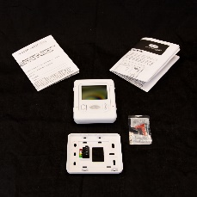 | Carrier® Infinity® - Smart Sensor for Zoning

Zone Sensors–
Device Address Follows Zone Number: 0x2301, 0x2401, 0x2501, 0x2601, 0x2701, 0x2801,

Device Address | Device Model | Photo | Description
0x2301, 0x2401, 0x2501, 0x2601, 0x2701, 0x2801, | UI/SS |  | Carrier® Infinity® - Smart Sensor for Zoning

Furnace Models
Device Address: 0x4001

Device Address | Device Model | Photo | Description
0x4001 | 355CAV042080  355CAV060120  “355CA” 3-stage heat | 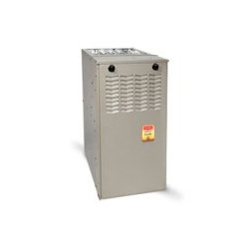 | 80,000 BTU, 95% Efficiency Evolution Multipurpose Gas Furnace, 3-1/2 Ton  120,000 BTU, 95% Efficiency Evolution Multipurpose Gas Furnace
0x4001 | 58MVC100-F-1--20  “58MVC” variable speed | 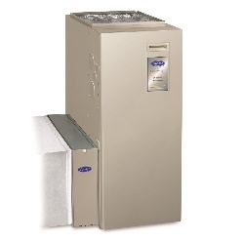 | Carrier® Infinity™ 95% AFUE 100,000 Btuh Deluxe 4-Way Multipurpose Variable-Speed Multi-Stage Condensing Gas Furnace

Furnace Fan Coil – Device Address: 0x4101, 0x4201
Device Address | Device Model | Photo | Description
0x4101, 0x4201 | FE4ANF002T000 |  | FE4ANF002T000 10kW Electric Heat Package
Heat Pump Heat Pump – Device Address: 0x5001, 0x5101
Device Address | Device Model | Photo | Description
0x5001 | 25HNB530A003 (2.5 ton)  25HNB624A003 (2 ton)  25HNB5 | 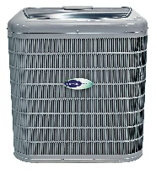 | Carrier® Infinity™ - 2.5 Ton, 15 SEER, Residential Heat Pump Condensing Unit
0x5101 | 25VNA0 | 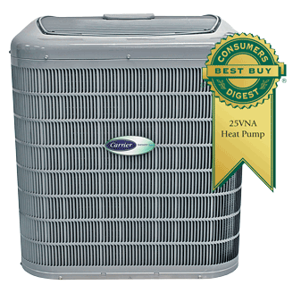 | 25VNA infinity® 20 Heat Pump With Greenspeed® Intelligence  20.5 seer; 13.0 hspf  Variable speed compressor
Damper Controls – Device Address: 0x6001, 0x6101, 0x6501
Device Address | Device Model | Photo | Description
0x6001, 0x6101, | SYSTXCC4ZC01 | 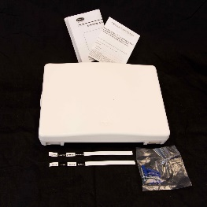 | Carrier® Infinity™ Damper Control Module
0x6501 |  |  | Carrier® Infinity™ Damper Control Module – room sensor
Other Devices: 0x8001, 0x9201, 0xA001
Device Address | Device Model | Photo | Description
0x6001, 0x6101, | SYSTXCCRCT01  SYSTX = Infinity System Product Type  CC = Carrier Brand  RCT = CAT5 (Wired) Broadband Connection  01 = Package Qty | 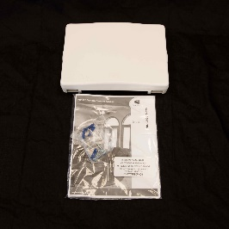 | Carrier Infinity System Access Module SAM/RAMCarrier® Infinity™ Ethernet (CAT-5 Wired) Broadband Remote Access Module
0x9601 |  |  | Carrier® Infinity™ Damper Control Module – room sensor

The following thermostat models have been observed in the wild and generally would be expected to work with this protocol. These models vary principally on the wi-fi features and for the low end devices, the number of zones managed.
Thermostats – Device Address: 0x2001
Index | Thermostat Model | Photo | Description
1 | SYSTXCCITW01-A | 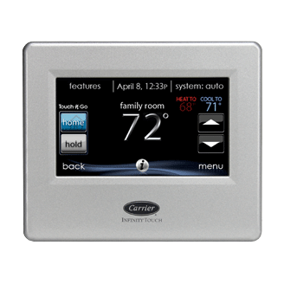 | Carrier INFINITY® REMOTE ACCESS TOUCH CONTROL WITH WIRELESS ROUTER
2 | SYSTXCCITC01-A |  | Carrier INFINITY® REMOTE ACCESS TOUCH CONTROL
3 | SYSTXBBECC01-A | 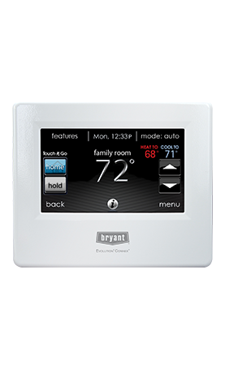 | Bryant Evolution® Connex™ Control
4 | SYSTXBBECW01-A | 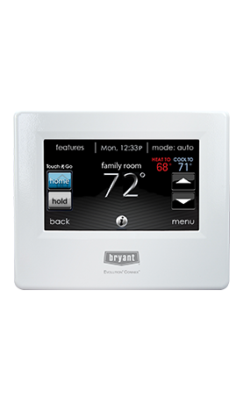 | Bryant Evolution® Connex™ Control
5 | SYSTXBBECN01-A | 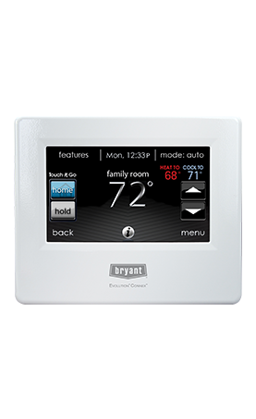 | Bryant Evolution® Connex™ Control
6 | TP-WEM01 | 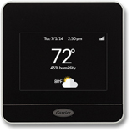 | Carrier CÔR® WI-FI® THERMOSTAT
7 | SYSTXCCUIZ01-B | 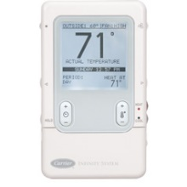 | Carrier SYSTXCCUIZ01-B Infinity® Control
8 | TC-WHS01 | 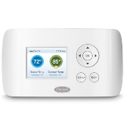 | CARRIER® WI-FI® THERMOSTAT
9 | SYSTXBBUID01-B  SYSTXBBUIZ01-B (8 zones) | 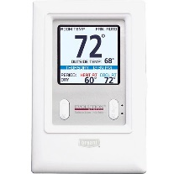 | Bryant Evolution SYSTXBBUID01-B Thermostat
10 | SYSTXBBUID01-B | 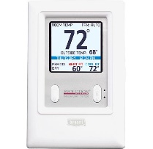 | Bryant Evolution SYSTXBBUID01-B Thermostat

Acknowledgements:
Clearly a lot of highly professional work went into this to date.
github.com/acd/infinitive Andrew Danforth (adanforth@gmail.com)
github.com/nebulous/infinitude John Lifsey

