***Salary Calculator***



* Click the ***Employee Salary*** button to go to the ***Employee Salary*** page. A table with all employees is invited to do so.

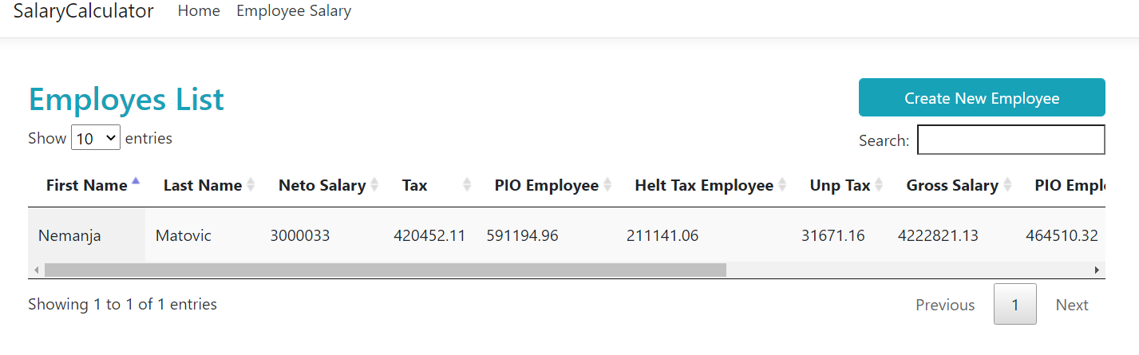

* By clicking on the ***Create New Employee*** button, we move to the page (form) for entering a new employee and calculating salary.
* By clicking on the ***Edit*** button, we move to the page (form) for changing employee data.
* Click on the ***Delete*** button to delete the employee.

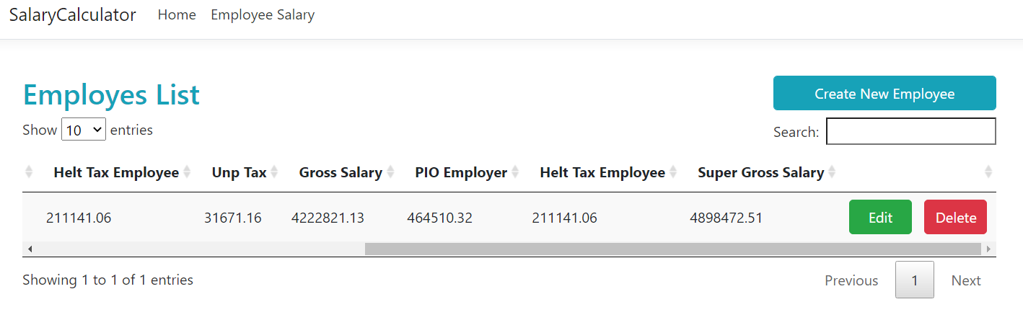

* Click on the ***Create/Update*** button to create/update a employee.
* By clicking on the ***Back To List*** button, we return to the list of all employees.
* By clicking on the ***Calculate button***, we calculate earnings with the calculation of all taxes.

