Main title of the paper – style "MAIN TITLE"
Research in Progress

Only once the paper is accepted, place the author information here for the final version using style "Author" as illustrated below (delete this text):
Smith, Ellen, University of Stockholm, Stockholm, Sweden, ellen.smith@su.se
Jönsson, Mikael, University of Uppsala, Uppsala, Sweden, mikael.jonsson@uu.se
The review process is double blind. Therefore papers submitted for review MUST NOT contain any author information – neither on the title page nor in the page header! This information will need be added only once the submission is ACCEPTED.

Abstract (format of this heading: “Subtitle”)
The paper should have an abstract of not more than 200 words. The abstract should be understandable by the general IS researcher who is not an expert in the topic area. The abstract should follow the “Abstract” style as presented here.
Keywords: One, Two, Three, Four.

The text above this point should appear on the title page, and all text below this point should follow on the succeeding pages only in the initial submission. The final copy should follow immediately after the keywords.
NOTE: The final papers should contain the authors' names, university and contact information, placed between the main title and the abstract.
NOTE: There can be at most seven (7) pages in a research-in-progress. These page limits include all text, figures, tables, and appendices. The cover page, abstract, keywords, and references are excluded from this page count.
NOTE: Submission files must be in PDF format.

This is a Heading 1 Style Paragraph
Normal text…
Another paragraph

This is a heading 2 style paragraph
Normal text…

Third level headings are strongly discouraged but look like this
This is a normal text paragraph; the style for it is "Basic text". This is a complementary sentence. Here is a footnote. References should use Harvard citation style. For example Markus and Robey (1988) is used often, for information systems development (Avison and Fitzgerald, 1995) is used more commonly. Kautz and McMaster (1994, p. 275) is an important paper, too.
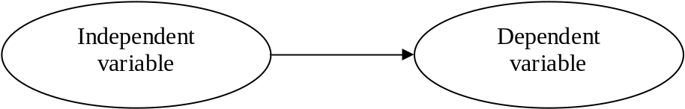
Figure 1. The style name for this kind of paragraph is "Figure title". The style for the figure is called "Figure". The title should always be placed below the figure.
Tables should be titled like the example shows below, the style "Figure title" is also used for the title here.
<One blank line of basic text is needed here!>
Question | Average 1992 | Average 1999
1 How do you regard... | 3.4 | 3.7
2 How do you... | 2.7 | 3.4
3 How do you... | 3.9 | 3.6
Table 1. The style name for this kind of paragraph is "Figure title". The title should always be placed below the table. The table may not extend the margins. The style for the text in table cells is called "Table". Some cells may need special alignment.
Here is an example of using the style "Bullet":
- The style "Bullet" should be used here. This is a complementary sentence. This is a complementary sentence. In the following you can find an example of a second level list:
  - The style "Bullet 2" should be used here. This is a complementary sentence. This is a complementary sentence. This is a complementary sentence. This is a complementary sentence. This is a complementary sentence. This is a complementary sentence.
  - This is a complementary sentence. This is a complementary sentence.
The references should look like below. The style is called "Reference". The heading style is “Subtitle”

References
Avison, D. E. and G. Fitzgerald (1995). Information Systems Development. Methodologies, Techniques and Tools. 2nd Edition. London: McGraw-Hill.
Delfmann, P. (2007). “Adaptive Referenzmodellierung. Methodische Konzepte zur Konstruktion und Anwendung wiederverwendungsorientierter Informationsmodelle.” PhD thesis. University of Münster.
Geron, T. (2013). Airbnb And The Unstoppable Rise Of The Share Economy. URL: http://www.forbes.com/sites/tomiogeron/2013/01/23/airbnb-and-the-unstoppable-rise-of-the-share-economy/ (visited on 07/30/2014).
Kautz, K. and T. McMaster (1994). “The failure to introduce systems development methods. A factorbased analysis.” In: Proceedings of the IFIP TC8 Working Conference on Diffusion, Transfer and Implementation of Information Technology. Ed. by L. Levine. IFIP Transactions A-45. Amsterdam: North-Holland, p. 275.
Markus, M. L. and D. Robey (1988). “Information technology and organizational change. Causal structure in theory and research.” Management Science 34 (5), 583–598.
Mendling, J. and M. Nüttgens (2005). EPC Markup Language (EPML) - An XML-Based Interchange Format for Event-Driven Process Chains (EPC). Technical Report JM-2005-03-10. Vienna University of Economics and Business Administration.

Footnotes are not recommended, but if used, look like this. The style is "Footnote text".

