Examining Mexican Migration by Age:

An Analysis Utilizing the Mexican Migration Project

Nancy Castellon

The University of Texas in San Antonio

Predicting Mexican Migration Through Age

Through the use of the Mexican Migration Project (MMP) dataset which collects data on migration patterns of Mexican nationals, the present analysis seeks to determine if frequency of U.S. migration trips and the year of illegal border crossing have a relationship on the age of 8,557 Mexican nationals. The participants surveyed range from ages 17 to 98. Two correlations were performed to determine the direction and relationship of these factors on age. Although the MMP began collecting data in 1982, the data available through MMP is pertinent to the political narratives surrounding immigration in the United States.

**Participant Age**

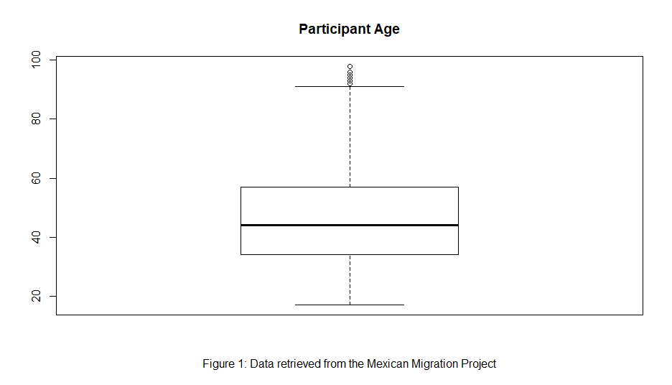 The dependent variable of age (*M* = 46.4, *SD* = 15.5) is studied due to the current increase of younger Mexican migrants in the United States. Figure 1 illustrates the variance of age within the participants, and it is important to note the weight of the outliers. We assume that the MMP recorded a variety of age in participants which included a participant aged 98. The variety of age reiterates that the MMP has recorded migration through a longitudinal process and continues to seek a better understanding of this phenomena. Although this outlier may affect the results of the analysis, the researcher chose only to omit unknown (*n* = 3) responses because it is possible that the oldest participant could display a pattern of relationship not yet known before the correlation test.

**Predicting Age by U.S. Migration Trips**

To understand the patterns of migration that Mexican nationals, the total amounts of entering the U.S. are important to examine. Thus, the MMP recoded the participant’s migration amount to the U.S. which range from 1 to 44 trips. U.S. documentation type had a mean of 3.4 trips to the U.S. illustrated in Table 1. The descriptive statistics of this variable informs us that most participants traveled less frequently than others. It is important to keep in mind that more frequent migration trips may skew data.

|  |  |  |  |  |  |
| --- | --- | --- | --- | --- | --- |
| **Table 1. Descriptive Statistics of Total U.S. Migration Trips** | | | | | |
| Variable | Mean | Median | Min | Max | SD |
| Total U.S. Migration Trips | 3.4 | 2 | 1 | 44 | 4.6 |
| Note: Data retrieved from Mexican Migration Project | | | | | |

A Pearson’s Correlation was conducted to understand if total amount of migration trips could predict the age of the participant. Obtaining information on the relationship between age and migration trips can give insight on age being connected to migrant age. There was a significant positive correlation between total U.S. migration trips and age (*r* (8549) = .11, p < .001). A Spearman Rank is in line with this correlation (.10). This would tell us that our hypothesis proved there was a relationship between age and total migration trips. However, upon closer examination of a scatterplot in Figure 2, the results of this correlation illustrate a weak relationship between the two variables which informs us that there is a less likelihood of the relationship. Our correlation tells us that as more U.S. migration trips are made, age also goes up. Finally, the scatterplot illustrates the descriptive statistics of most participants travelling less frequently.

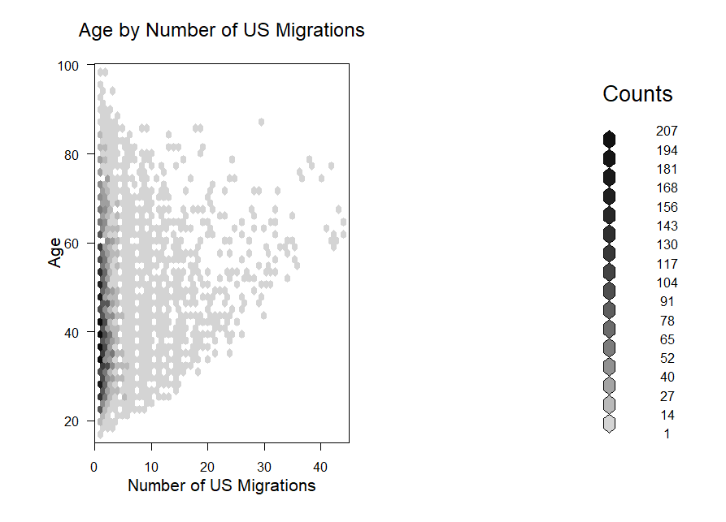

**Figure 2.**

**Age by First Illegal Crossing Year**

Participants first illegal crossing year will be examined in hopes of finding a relationship with the participant age. The hypothesis for this correlation is that the first illegal crossing year will predict the participant age. This could mean that those who have migrated to the U.S. undocumented tend to be younger. Therefore, it is important to explore if there is a relationship between illegal crossing year and age. A correlation was conducted. First illegal crossing ranged from years 1906 to 2014. Since the MMP recorded different types of documentations used to migrate into the U.S., unknown data and legal migration data was omitted for this analysis deeming 6,439 participants fit for the correlation. A median of 1982 is noted with a mode of 1981. Table 2 displays the central tendencies of the data. A histogram in Figure 4 shows the normally distributed data which permits a Pearson’s correlation analysis.

|  |  |  |  |  |  |  |
| --- | --- | --- | --- | --- | --- | --- |
| **Table 2. Descriptive Statistics of First Illegal Crossing Year** | | | | | | |
| Variable | Mean | Median | Mode | Min | Max | SD |
| First Illegal Crossing Year | 1981.22 | 1982 | 1981 | 1906 | 2014 | 14.03 |
| *Note:* Data from Mexican Migration Project | | | | | | |

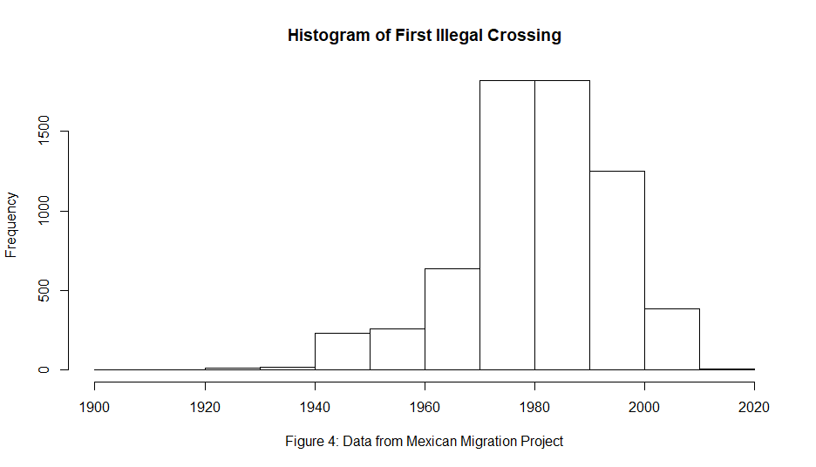

There was a significant negative correlation between age and first illegal crossing year (*r*(6437) = -.60, p< .01). Recent illegal crossing year tends to have younger Mexican nationals. This tells us that as the first crossing year goes up, age goes down. This reflects the recent trends of undocumented individuals crossing the southern border of the U.S. We can further infer that as years continue to pass, younger and younger Mexican nationals will cross the border illegally. A scatterplot in Figure 5 illustrates this relationship and shows the density of the data.

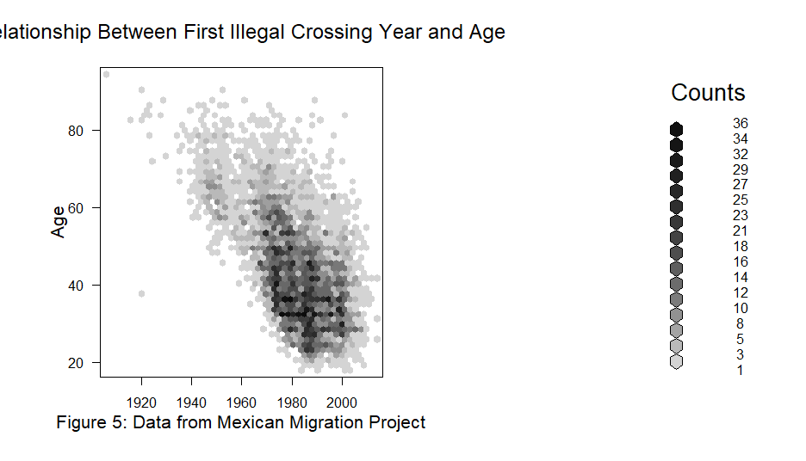

It is important to note that the most updated data of the MMP includes a small amount of data for the year 2014 which is cited to be one of the biggest influx years of unaccompanied children. The missing data could reflect the findings found in this analysis.