Assignment #4

**U.S. Department of Homeland Security Data**

Utilizing a dataset reported by the U.S. Department of Homeland Security on apprehensions of “aliens”, a subset of data was utilized to focus on the fiscal year 2014 (*m* = 3930.59), 2015 (*m* = 2785.40), and 2016 (*m* = 3175.10) apprehensions by nationality. Table 1 illustrates the descriptive statistics of the three groups as well as mention of variance. It is important to note that due to the current political climate and the need for asylum that is pushing migrants into the U.S., the descriptive analysis of the three years greatly vary due to a negative rhetoric around specific countries like El Salvador, Honduras, Guatemala, and Mexico. For instance, “aliens” apprehended from Guatemala (*n* = 84,649) were much more likely to be apprehended than those from Canada (*n* = 509) in the year 2016. In order to explore whether there has been a change of apprehensions of “aliens” since the new presidency, a t-test was conducted to determine whether or not there is a difference between the old presidency in 2014 to the current presidency of 2016. Results show there was not a statistically significant difference between the two groups (t = 0.27, p > 0.05) which can be visually

|  |  |  |  |  |
| --- | --- | --- | --- | --- |
| **Table 1. Descriptive Statistics of Alien Apprehensions by Year** | | | | |
| Year | Variables | Mean | Median | SD |
| 2014 | 175 | 3,930.59 | 57.0 | 29,255.65 |
| 2015 | 166 | 2,785.40 | 40.5 | 21,941.30 |
| 2016 | 167 | 3,175.10 | 35.0 | 22,784.35 |

**Data from the GSS**

When analyzing the General Social Survey, the variables of race and income were focused on. The dataset was coded in which race was divided into three levels (1 = White, 2 = Black, 3 = Other) meanwhile income was continuous. Further descriptive statistics can be found in Table 2. Not all participants reported an income which is present in the table data. Upon reviewing the box plot of the data, as shown in Figure 1, it was hard to determine if any difference between groups was significant. Thus a one-way ANOVA was conducted as three groups were being analyzed within one variable. The ANOVA reported a statistically significant difference within our data (F = 23.63, DF = 2, p < 0.001). For better clarification on where the difference lies, a TuckeyHSD test was conducted which resulted in between group difference between the White and Black group, as well as in the White and Other groups. See Table 3 and 4 for the results.

|  |  |  |  |
| --- | --- | --- | --- |
| **Table 2. Descriptive Statistics for Income and Race** | | | |
| Variables | Participants | Mean | Median |
| Income | 2,433 | - | $25,000 or more |
| Race | 2,867 | - | - |
| White | 1,784 | - | $25,000 or more |
| Black | 427 | - | $25,000 or more |
| Other | 222 | - | $25,000 or more |

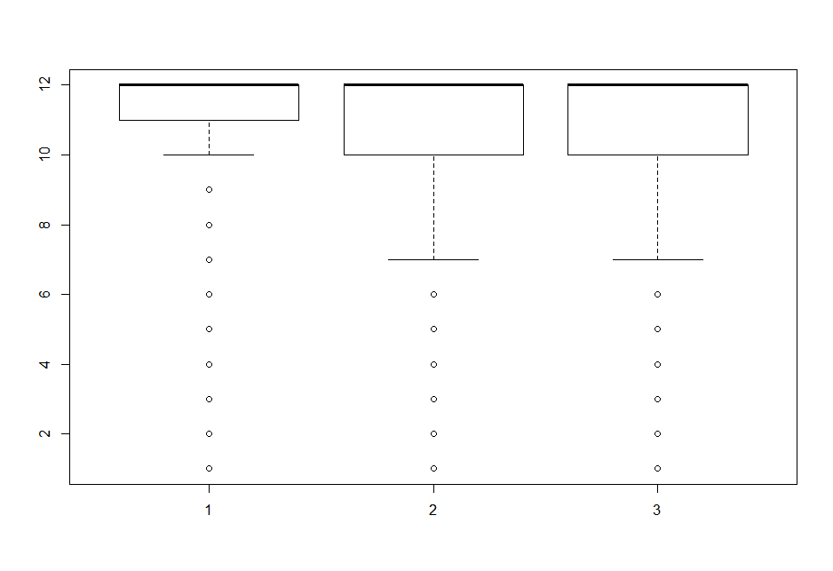

*Figure 1.* Boxplot of Income by Race (1 = White, 2 = Black, 3 = Other)

|  |  |  |  |  |  |
| --- | --- | --- | --- | --- | --- |
| **Table 3. One-Way Anova Results** | | | | | |
|  | DF | Sum. Sq. | Mean Sq. | F Value | P |
| Race | 2 | 258 | 129.17 | 23.63 | *** |
| Residuals | 2430 | 13281 | 5.47 |  |  |

*Notes*: *** = p < 0.001

|  |  |  |  |  |
| --- | --- | --- | --- | --- |
| **Table 4. TukeyHSD Test Results** | | | | |
| Groups | Difference | Lower | Upper | P |
| Black-White | -0.77 | -1.06 | -0.47 | *** |
| Other-White | -0.67 | -1.06 | -0.28 | *** |
| Other-Black | 0.09 | -0.36 | 0.55 | - |

*Notes*: *** = p < 0.001