2ST BENEDICT’S COLLEGE



|  |  |  |  |
| --- | --- | --- | --- |
| **SUBJECT** | Information Technology | **DATE** | November 2015 |
| **GRADE** | 11 | **MARKS** | 120 |
| **EXAMINER** | Mrs Nocton Smith, Mrs Kench and Mr Gill | **MODERATOR** | Mrs Gill |
| **NAME** |  | **DURATION** | 3 hours |
| **CLASS** |  |  |  |
|  |  |  |  |

|  |  |  |  |  |  |
| --- | --- | --- | --- | --- | --- |
| **COGNITIVE LEVELS** | | | | | |
| LOW ORDER | 36 % | **MIDDLE ORDER** | 42 % | HIGH ORDER | 23 % |

|  |  |
| --- | --- |
| STUDENT’S RESULT |  |
| COMMENT |  |
|  |  |
|  |  |
| TEACHER’S SIGNATURE |  |
| PARENT’S SIGNATURE |  |

SECTION A: SQL 40 marks

SCENARIO

Syria Is The Worst Refugee Crisis Of Our Generation

from Niall McCarthy, July 13th, 2015

Last week, the United Nations reported that the number of people fleeing the war in Syria had surpassed 4 million, making it the worst refugee crisis of our generation. The sheer scale of the Syrian exodus becomes evident through a comparison with several other conflicts that have taken place since 1991.

Even though the chart below focuses on selected conflicts since 1991, Afghanistan has been in turmoil far longer than that. Since the Soviet invasion in 1979, an estimated 2.6 million Afghans have been forced to flee their homeland while the genocide in Rwanda resulted in 2.3 million people being displaced.

This chart shows refugees displaced by war in selected conflicts since 1991.

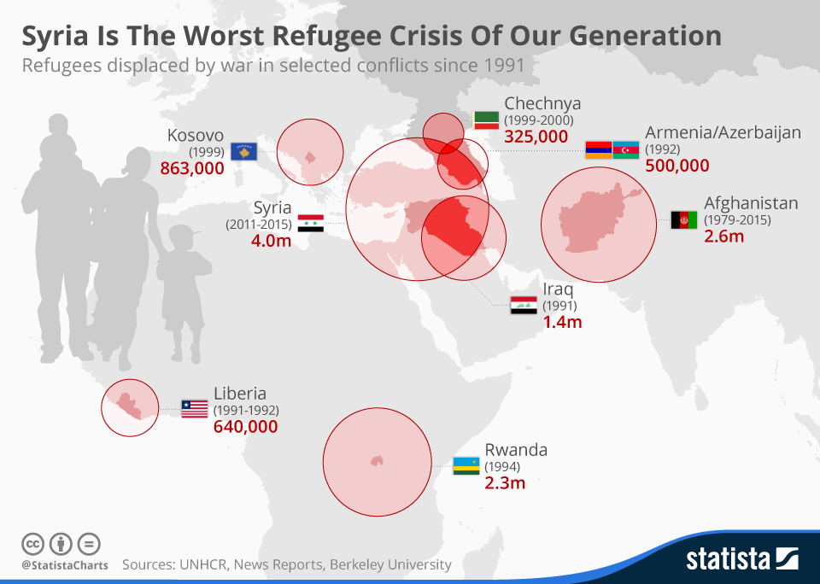

QUESTION 1

Examine the tables and then create SQL statements to solve the following queries.

The database **Asylum.accdb,** has been created to track the Syrian refugees applications for

Asylum in the neighbouring countries.

For each country the following statistics are saved:

Applications – the number of applications for Asylum received

Decisions – the number of applications waiting on a decision

Acceptances – the number of applications that have been accepted by the country.

The data structures and sample data are as follows:

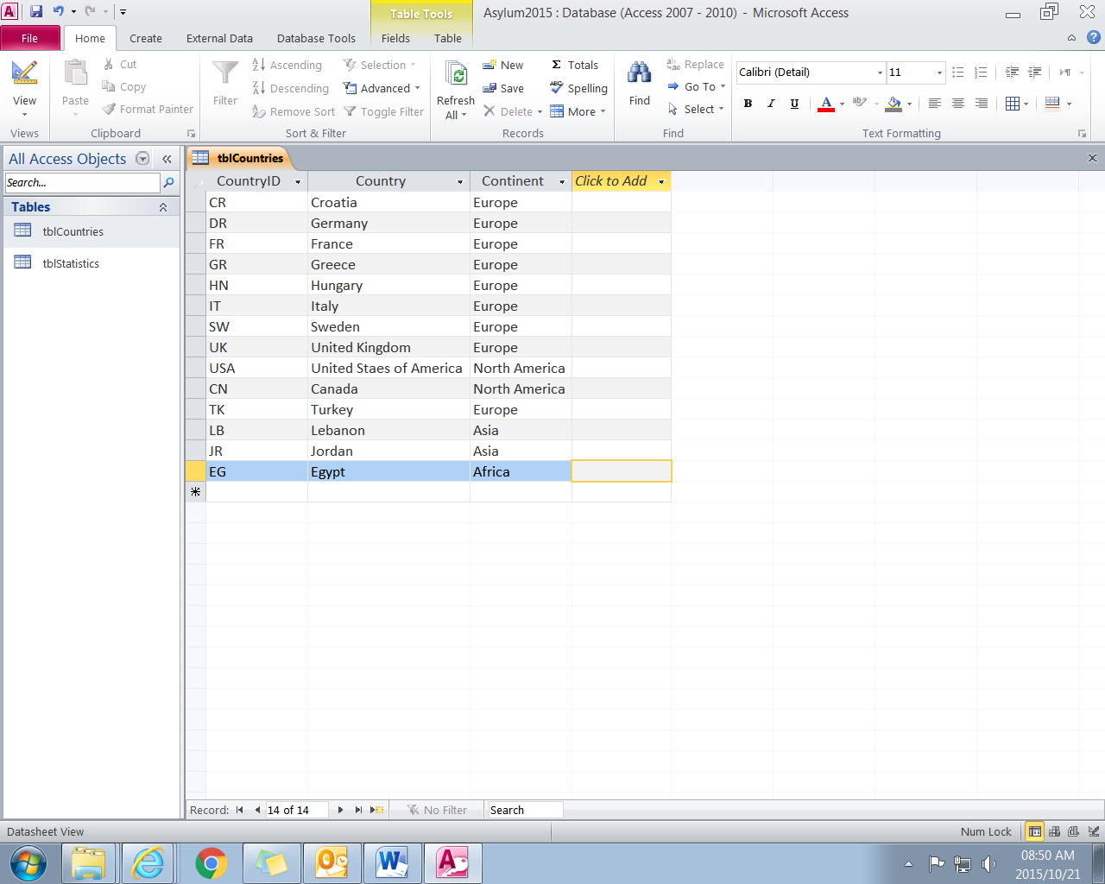

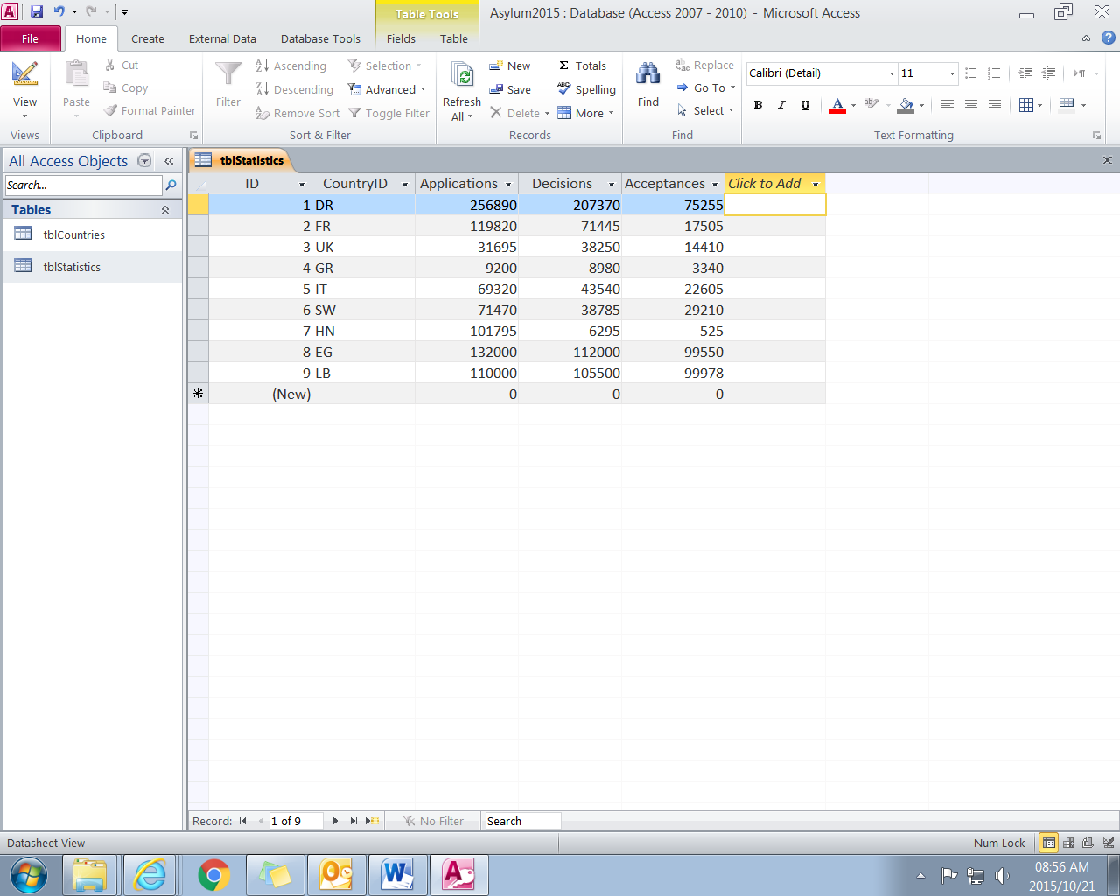

Copy your queries into the word document AM IT Q1 Ans.doc which is located in your exam folder. Don’t forget to add your name!

1.1 Provide a list of all continents and countries, sorted alphabetically by country within continent.

(2)

1.2 Display the 3 countries with the most applications. List the Country name and Application data.

(4)

1.3 Canada has removed their support of the program. Delete the record for Canada from tblCountries.

(3)

1.4 Insert the country Norway, with a code of NW and continent Europe into tblCountries.

(3)

1.5 Increase the number of acceptances for Germany and France by 500 (you may hardcode their IDs)

(4)

1.6 Create a table showing the Total Number of applications per Continent

(5)

1.8 Which country has the highest number of rejections? (5)

(Rejections = Decisions – Acceptances)

SECTION B oop 80 MARKS

question 26 marks

There are a number of relief organisations partnering with the refugee centres to provide services in the various locations. The services offered fall into the following categories:

* Education
* Health
* Child protection
* Food
* Shelter

You need to create an application to manage the information about the partner organisations.

The data for the organisations is stored in the file **partners.txt** in the following format.

name#category#website#location#

Data:

UNHCR#shelter#http://www.unhcr.org/#Turkey#

WHO#health#http://www.who.tk/#Turkey#

WFP#food#http://www.wfp.org/#Turkey#

CARITAS#education#http://www.wfp.org/#Egypt#

CRH#education#http://ww.crh.org/#Egypt#

UNICEF#child protection#http://www.unicef.org#Egypt#

Questscope#education#http://www.questscope.org#Jordan#

Medair#health#http://www.MEDAIR.org#Jordan#

JHAS#health#http://www.jordanhealthaid.jo/#Jordan#

ACTED#food#http://ww.acted.org#Jordan#

You are provided with the following class structure:

|  |
| --- |
| **Partners** |
| - organisation: String  - category: String  - website : String  - location : String |
| + Partners(name: String, category: String, website: String, location: String)  + getOrganisation(): String  + getCategory(): String  + getWebsite():String  + getLocation():String  + void correctWebsite()  toString() : String |

2.1 Create a class called **Partners** with fields to store the organisation, category, website and location. Declare these fields with appropriate types and ensure that these fields are not accessible outside the package. (3)

2.2 Code a constructor which will accept values for the organisation, category, website and location. (3)

2.3 Code the accessor methods listed in the class table. (3)

2.4 Code a method to correct the website of an organisation according the following rules:

* All websites must end with “.org”. Replace any ending such as “.tk” with “.org”.
* All websites must start with “www”. Change any websites that start with “ww” to start with “www”.
* The name of the website must be the same as the name of the organisation. For example JHAS must not be abbreviated as the website is named jordanhealthaid. Change the organisation name to be jordanhealthaid. (12)

2.5 Code a toString method to display the organisation, category, website and location. Display the details of the organisation each on a new line. For example:

Organisation : UNHCR

Category : shelter

Website : http://www.unhcr.org/

Country : Turkey (5)

Question 3 38 marks

You are provided with the following class table, for your array class:

|  |
| --- |
| **PartnersArray** |
| - partArr: Array of Partners objects  - size: Integer |
| + PartnersArray()  + toString() : String  + sortName()  + search(category : String) : String  + checkPartners() |

3.1 Code an array class called **PartnersArray** which has instance fields to store an array of Partners, and the number of elements in the array. These must be of an appropriate type, and not be accessible outside of the class. (4)

3.2 Code a constructor that will read the data from the text file partners.txt and instantiate elements in the array. (10)

3.3 Code a **toString()** method to display all the partners information separated by a blank line. (5)

3.4 Code a **sortName()** method to sort the objects in the array in order of organisation names. (8)

3.5 Code a **search(String org)** method to find all the partners for a given organisation. The method must return the organisation name, together with the website separated by a tab. Each organisation must start on a new line. (6)

3.6 Code a method called **correctWebsites()** that will correct every website for a Partners object. (5)

3.7 Each of the partner organisation have made donations toward the refugees. Some organisations have made more than one donation. The donations are recoded in the text file called **donations.txt**. The file lists the name of the organisation followed by the amount separated by a space.

Note that some organisations have made more than one donation.

WHO 2000000

CRH 1000000

ACTED 3000000

UNHCR 100000

WFP 200000

WHO 500000

CRH 100000

CRH 100000

UNHCR 2000000

CARITAS 10000000

UNICEF 3300000

UNHCR 500000

CRH 100000

3.7.1 Add an integer field called **total** to the **Partners** class and set its value to 0. (2)

3.7.2 Add an accessor method to access this field. (1)

3.7.3 Add a method called **updateTotal(int amount)** to add the parameter amount to the **total** filed. (2)

3.7.4 Add a typed method called **calcDonations** in the **PartnersArray** class. The method will return a string with the name of the organisation and the total. If an organisation has not made a donation then their details must not be returned in the string.

In this method you will need to:

* + - read the data from the text file called donations.txt
    - search for the corresponding organisation
    - update the organisation’s total with the organisation’s donation
    - create a string with the names of the organisation and their total amount listed one below the other and the heading “Donations”. Eliminate any organisations that have not made any donations. Your output should appear as below:

Donations

ACTED 3000000

WFP 200000

CRH 1300000

UNHCR 2600000

UNICEF 3300000

WHO 2500000