Fruit for My Father

Date | 2011-08-07
Preacher | Stephen Wong
Reading scripture | John 15 1-15
Sermon topic | Fruit for My Father
Presider | Rachel He
Worship Leader | Jordan Wendt
Website link | http://english.hdchurch.org/html/news/2011/0808/237.html

Scripture Reading: John 15:1-15

1 I am the true vine and my Father is the gardener.
2 He takes away every branch in me which has no fruit, and every branch which has fruit he makes clean, so that it may have more fruit.
3 You are clean, even now, through the teaching which I have given you.
4 Be in me at all times as I am in you. As the branch is not able to give fruit of itself, if it is not still on the vine, so you are not able to do so if you are not in me.
5 I am the vine, you are the branches: he who is in me at all times as I am in him, gives much fruit, because without me you are able to do nothing.
6 If a man does not keep himself in me, he becomes dead and is cut off like a dry branch; such branches are taken up and put in the fire and burned.
7 If you are in me at all times, and my words are in you, then anything for which you make a request will be done for you.
8 Here is my Father's glory, in that you give much fruit and so are my true disciples.
9 Even as the Father has given me his love, so I have given my love to you: be ever in my love.
10 If you keep my laws, you will be ever in my love, even as I have kept my Father's laws, and am ever in his love.
11 I have said these things to you so that I may have joy in you and so that your joy may be complete.
12 This is the law I give you: Have love one for another, even as I have love for you.
13 Greater love has no man than this that a man gives up his life for his friends.
14 You are my friends, if you do what I give you orders to do.
15 No longer do I give you the name of servants; because a servant is without knowledge of what his master is doing: I give you the name of friends, because I have given you knowledge of all the things which my Father has said to me

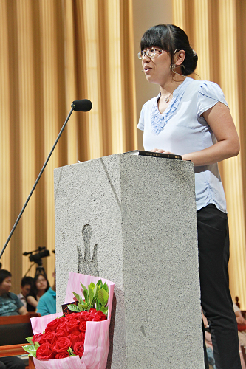

Fruit for My Father
by Stephen Wong
07 Aug, 2011

Sermon Transcription

Let us pray. “God, our Father, you are the gardener, and our Lord Jesus Christ, you are the vine; the true beautiful life-given vine. Father, we’ve come this morning to empty ourselves so that you may fill us with your life. Empty ourselves of everything that is not of you because you alone are worthy to occupy the throne of our hearts. So, Father, speak to us today with your beautiful Word by Your Spirit. May we be transformed into fruitful branches that bear forever lasting life. We pray in Jesus’ name, Amen.”

Good morning, everyone. The sharing that I have is for those people who have a great life and for those people who are not having a great life; for those people who are going through difficulties and for those people who are just soaring on the wings of an eagle and just enjoying God’s presence. Today’s story is about grapes. Grapes! Actually grapes are a big business.
Grapes
World Vineyards | 25 million acres
World Productions | 72 million tons
U.S. Economy | $162 billion

When we look at the world production, it is about 72 million tons of grapes. When we take a look at what the economic impact is in just one country, the United States, grapes have 162 billion dollars’ impact. So grapes are fairly significant. Grapes, as we know, are good for our health; they are good for our heart and for our cardiovascular system; and they are also good with antioxidants for healthy cells.

Last week when we were studying together in the Gospel of John, Chapter 14, we said that there were three divisions that we looked at together. We looked at the heart, the heaven, and the highway. Jesus said “I am the way, the truth, and the life.” We concluded that if Jesus is not valued at all if Jesus is not valued above all. Jesus has to be above all.
Chapter 14:1-6
Jesus is not valued at all until He is valued above all
Verse 1 | Heart
Verses 2-3 | Heaven
Verses 4, 6 | Highway

In Chapter 15 which we are going to study right now, we are going to look at the key words. It will not come as a surprise to you that the word “will” appears 12 times, the word “remain” 11 times, “father” and “love” each 10 times, and then “fruit” 9 times.

Key Words in John 15
Will | 12 times
Remain | 11 times
Father | 10 times
Love | 10 times
Fruit | 9 times

Look at the word “will”. Remember the context: Jesus is in his last hours before his betrayal, before he is handed over to those wicked men, and before he is crucified. He is in his last hours of this very dark time, and he is saying to his disciples: Hang in there because I have some beautiful promises for you. Just hang in there. It’s really dark but I will fulfill my promises to you. No matter how distant the fulfillment of those promises is, I will fulfill them to you.

The other key word that you’ve seen is of course the word “remain”. We will talk a little about remaining and what that means. Doesn’t it come as a surprise that “father” is very frequent? It is because Jesus wants to tell them, “You may see me suffer and you may see me die, and you may think ‘I thought he said he was God’, but I tell you that I am God; the heavenly Father and I are one.”

As we turn to Chapter 15, we have three divisions.
Divisions 15
Verses 1-6 | Fruit
Verses 7-14 | Friends
Verses 15-31 | Foes

It is very easy for you to follow: fruit, friends, and foes. He says, “I want you to remain in me and bear fruit. I want you to love one another and be friends to the end, because it’s going to be hard and it’s going to be persecution. You are going to meet many foes but do not worry. My Holy Spirit is with you.”

Chapter 15:1-8 Divisions
Verses 1-3 | A Pure Life
Verses 4-7 | A Productive Life
Verse 8 | A Purposeful Life

Our chapter with the passage we are going to look at is actually the first eight verses. We are going to divide them up also into three divisions. A pure life is in verses 1-3. A productive life is in verses 4-7. A purposeful life is in the last verse, verse 8.

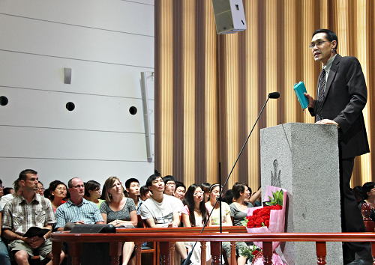

- A Pure Life – vv.1-3
Let’s look at the first verse in Chapter 15, it says, “I am the true vine and my Father is the gardener.” God chose Israel to be His light in the world. They were supposed to shine so that people would see their good works and praise God. Unfortunately they failed to bear any fruit because they wanted to do this through their own self effort; through their own will. And so Jesus says, “Yes, you have failed. Yes, you have not shone for my father so my father sent me to be the true vine; the one who really bore that fruit that God was speaking; and the one who would give the true life that every single human being needs - eternal life.” So He is the true and final and ultimate vine that pleases God in every single way. He says that my father is the gardener. He owns this world. He is the one that is in charge. He is the one that sets our boundaries. And he is the one that we are to come forward to.

Now what does the father do? He says in Verse 2: “He cuts off every branch in me that bears no fruit.” So as a creator, as the owner of this vineyard, as the owner of this land, and as the owner of us, He expects fruit. He invests His time, energy, love, and every effort into you and me so that we can bear fruit. His expectation is very clear. We cannot just live life and say, “I can just live life and be under-performing. No. God expects you to bear fruit as much as a clock maker expects his clock to tell the time, as much as light is supposed to shine, and as much as life like yours is supposed to bear fruit to glorify God. That is the expectation. He cuts off those that bear no fruit.

But then what about those that are bearing fruit? Maybe we get a break, may be life is going to be just easy for us, because we are bearing fruit and we are doing something. Let us see what Verse 2 tells us. It says, “While every branch that does bear fruit”, he rewards? And he gets rest? No. “He prunes so that it will be even more fruitful.” He prunes; He cuts off and he cleanses. “What? Isn’t it just sufficient enough to bear a little bit of fruit. Why do you have to cut off? Why do you have to prune? It is so painful. You don’t know how painful it is to lose a loved one. You don’t know how painful it is to lose a loved one. You don’t know how painful it is to lose everything. You don’t know how painful it is. Why do I have to be pruned and bearing a little bit of fruit? Is that not sufficient?”

God is removing the good so that you will have room for the better. God is removing the better so that you can have the best. He is removing the best for the most excellent. “Ouch! It hurts, but it’s for the excellent; it’s for the most infinitely excellent. Okay! I will trust you.” He prunes, so that we can have infinitely most excellent life; nothing less, because the person who loves you infinitely says, “You are the one on whom I desire infinite excellence, the best of everything that I can give.” Now you see that pruning has a purpose. Now you see that the person that’s given you difficulties in your life has a purpose. Now you see the trials that are testing you have a purpose. Now you see those inexplicable pains have a purpose. Nothing is by accident. Our Father has your excellent best in mind for you.

“Okay, if that’s so, Lord, let’s carry on.” He says, in the next verse: “You are already clean because of the word I have spoken to you”. (John 15:3) All of us who believe in Jesus as our savior, we are forgiven; and we are forgiven not just yesterday’s sins, but we are forgiven today’s sins and tomorrow’s sins. We are no longer enemies. We are no longer lovers of darkness. We’re no longer children of disobedience. We’re no longer children of wrath. We are friends of God. I have no friends. I have the best friend: a friend who will stick with me forever; a friend who will be there always; a friend who is forever faithful; a friend whose opinion of me is very accurate and true; a friend who knows me better than myself; a friend of God; a friend who can speak heart to heart without condemnation, without guilt, without shame, without judgment; a friend - a true friend at last. That friend’s name is Jesus. His name is Jesus and He cleanses you from every stain of sin when you confess your sins to Him, and receive Him as your personal savior.

Principle – It is not great talents or great learning or great preachers that God needs, but men great in holiness.

Before we go into our next verse, let me share with you the principle for our section here: It is not great talents, it’s not great learning, and it’s not great preachers that God needs. What God is looking for is men, women, and children great in holiness. Holiness!

Application Question – How can you keep your life holy?

The questions that I have for you and for myself are then, “Holiness, what is that?”, “How can I make holiness a priority of my life?”, “How can holiness be more and more important in my life?”, “How can I keep my life holy?”

Application Answer
Confession | Recognize | Mind
Contrition | Remorse | Emotions
Conviction | Resolve | Will
Conversion | Repentance | Life

Well, there are a few things.
- Confession - There is confession. When you agree with God and you say, “Lord, I have sinned and I know that I have sinned.”
- Contrition – There is contrition. “I really feel sorry that I’ve hurt you,.” Not only do I acknowledge in my mind, but I acknowledge in my heart and in my feelings. “Yes, I feel really sorry that I’ve grieved you so much.”
- Conviction – There is conviction. I know, without a doubt in my will, that I don’t want to sin any more.
- Conversion - And then there is conversion. “I am going to change my life right, one hundred percent, three hundred and sixty degrees. I want my life to be wholly yours.”

The big challenge that we have, I believe, is what’s in our heart. The Bible tells us when Jesus was being tempted, He said to the devil, “It is written ‘Worship the Lord your God and serve Him only.’” (Luke 4:8) Worship Him alone and serve Him alone. Our biggest problem is not our circumstances, not our hurts, nor our pains. Our biggest challenge is the idols in our heart. God created us to worship Him and Him alone; to serve Him and Him alone. It has been said that our hearts are an idol factory. We love ourselves too much at the expense of God. We fix that one thing, then we’ll see everything else clear up and resolve very beautifully.

If you want to start a new life, a pure life, and a holy life, then deal with this issue. That’s what Jesus did. Remember that He went to the temple. He saw what was going on in the temple and then He came back in, made a whip, and He just cleared that temple out. He said, “God is here, and I have come to dwell with you. I’ve come to dwell in your heart, but your heart is not worthy until I have cleansed it to make it a temple holy onto me. You are a holy priesthood. You are God’s holy people.” The next time that you’re tempted to sin, or to do anything impure, I beg you, please remember that your heart is God’s holy temple. Holy almighty God is your friend and He desires to live in you in a holy place. Set apart just for Him. After all, He is your bridegroom, and He deserves the very best.

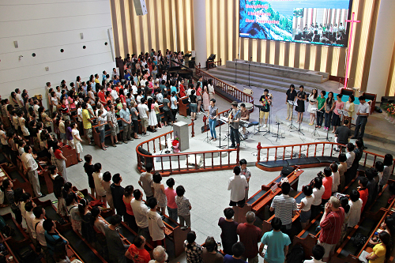

- A Productive Life – vv. 4-7
Our next division that we are going to be taking a look at is a productive life. This is where the word “remains” appears very often. We are going to jump to Verse 5 where it says, “I am the vine; you are the branches. If a man remains in me and I in him, he will bear much fruit; apart from me you can do nothing.” (John 15:5)

The essential picture here is that God is saying, “If you are going to live a life - a real life, and if you are going to have a life of infinite value, of divine value, a life that’s going to please me, you must be connected to me. Just like a lamp has to be connected; its electrical cord has to be connected to shine, you must be connected to me. Just like a branch, it has to be connected to the vine for the life sap to live through the branch and produce fruit.”

God is saying that we cannot do anything without Him. But if I just gave a million dollars, surely that’s okay. You know, wouldn’t God accept that? I just sacrificed all my time, surely that’s okay, isn’t it? I give to God; I serve God; I do everything possible under the sun. Is that okay? Yes, if you’re doing it for His glory. If you’re doing it for yourself, then it counts for nothing. If you’re doing it to please Him and by His strength, and if you’re doing it for His pleasure and for His glory, then, yes, it will count for eternity.

This whole thing of abiding is living. I have been trying to figure out how I can picture that for you. Well, maybe it’s like a fish in water. It’s living. That’s where it lives. That’s where it thrives. That is where it belongs. It’s in its element, right? It can’t live outside of the water, right?

Breath! I can’t live too long without breath, without oxygen, without breathing. I’m getting old so my lungs don’t keep me under the water as long as it used to. I can’t live; I can’t take an extra step or any step without the life of God in me. I can’t think for myself without His help. I can’t do anything of value or worth without His help. I can’t exist without Him. He is just an absolute necessity, a vital part of me and of you.

The Bible tells us “in Him we live, we move, and have our being”. Does this describe you? It should, because God wants you. He wants to be your life. He wants to be everything for you. “Nothing less than excellent,” He says, “Nothing less than the best.” He wants the totally, upmost, infinitely, excellent best for you. Why settle for anything other than the life of God in you? Why, when you are destined for that? God loves you so much, doesn’t He? God loves us.

When we take a look at the next verse, it says “Anyone that does not remain in me, he is like a branch that is thrown away and withers. Such branches are picked up, thrown into the fire, and burned.” This is a quick warning. He says, “You know, you have been coming to church a lot, you’ve been saying a lot of prayers, you’ve been fellowshipping with a lot of Christians, but it’s time to make that commitment.”

Proximity to Christ does not guarantee salvation. Remember Judas? He spent a lot of time with Jesus. He said the right things, he looked the right part, but God is warning all of us who are pretenders, all those who may pretend. He’s saying, “I have a warning for you. And the time is now to change; the time is now to connect with me. Connect with me and have real life. Otherwise, you’re dry and withered up, and lifeless. And I don’t want that for you. Okay?” When I take a look at this particular verse, it reminds me of the passage that says, “Make the most of every opportunity.” And the time is now to make that opportunity golden for you.

Principle – Without Jesus, fruit is impossible. With Jesus, fruit is inevitable.

What is this principle for this particular division? Without Jesus, fruit is impossible. With Jesus, fruit is inevitable. If you want a new life, if you want a pure life, and a productive life, connect with Jesus.

Application question – How can you be more like Jesus?

Matthew 4:4 Jesus answered, “It is written: ‘Man does not live on bread alone, but on every word that comes from the mouth of God’” How can we do that? How can we be more like Jesus? How do we become more like Christ? Well, I just have one suggestion - Abide in His Word. And I will give you few suggestions about abiding in His Word.

Abide in His Word
Read & Study | Capture thoughts
Memorize & Pray | Change ways
Treasure & Delight | Connect feelings
Submit & Obey | Center life in Christ

- Read and Study – Capture thoughts.
The first thing that I’ll like you to do is to read and study, to read and study his Word. So that is can capture your thoughts so you can think more like him.
- Memorize and Pray – Change ways
Then I want you to memorize and pray his Word. So that it can change you ways and your habits.
- Treasure and Delight – Connect feelings
Then I want you to treasure and delight in his Word, so that your feelings can be one with your feelings. The things that break His heart, the things that rejoice His heart, will also break your heart and rejoice your heart.
- Submit and Obey – Center life in Christ
And then, I’ll like you to submit and obey, so your life will always be centered upon Jesus. And that’s going to help you a little bit, I believe. In abiding in Him, and experiencing the true life he has for you.

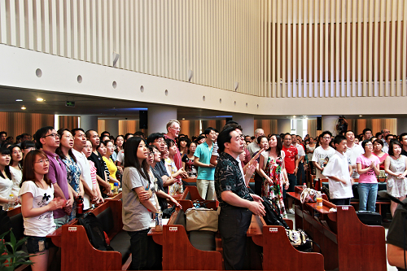

- A Purposeful Life – v. 8
Our final division is a purposeful life. We are going to read the passage here that says, “This is to my Father’s glory, that you bear much fruit, so yourselves to be my disciples.” This is to my Father’s glory.

Principle – A servant of God has only one Master and one Master passion.

The principle here, very quickly and easily, is the servant of God has only one master and one passion - one master passion. Our master is God, and no one else. And my passion is for Him and Him alone. My master is the Lord Jesus Christ, and I’m willing to die for Him. That’s what you say, that’s what we say, and that’s what I say, when we go to the throne. We say, “God, there is none like you, there is no one to compare to you, and there is no one I desire more than you. You are the only true God in my life. And I’ll do everything and anything to please you because that’s my passion, for you; nothing less for the most excellent God; for the infinitely beautiful Lord Jesus Christ.”

Application Question – How will your life glorify God?

How do I change the way that I live to glorify God? How can I start glorifying God? He mentioned a few things here: Be fruitful, and not just fruitful but abundantly fruitful. Then He says “Be my disciples. Follow me. Follow me to the ends of the earth.

There are a few things He mentions in the remainder of the passage. I’m going to read you those verses that tell you how to glorify him. The next verse says, “If you obey my commands, you will remain in my love. Just as I have remained in my Father’s command and remain in his love.” So obey and that will glorify God. Not what I feel or what I think or when I want to, but just obey. Just obey. When you hear God say “Don’t do it,” don’t do it. When you here God say “Do it,” do it. Just obey even when you don’t feel like and even when it’s very costly.

The second verse that I want to share with you is, “Greater Love has no other than this: that he laid down his life for his friends.” He says, not only “obey me”, but “love me.” Love me. Now we know that’s greater love, but we did know that Jesus showed us the greatest love, because He died for His enemies. “FATHER, forgive them, for they do not know what they are doing.” He died for His enemies. So He is calling us, “love one another and then love me, even onto death. Love me in life, love me in death. Love me when it’s great; love me when it’s not so great. Love me, love me, love me, because I have so much more for you.”

The final verse here, that I would like to share with you, which I wish I had more time to talk to you about is, “When the councilor comes, whom I will send to you from the Father, the Spirit of truth.” How can we live a pure life? How can we live a productive life? How can we live a purposeful life? It can only happen if we are joined to Jesus by His Holy Spirit living in us. When the Holy Spirit, His Holy Spirit, has absolute control, absolute access to every area of your life: absolute access, absolute surrender, and absolute yieldedness in every area of your life.

Chapter 15:1-8 Divisions
1-3 Pure Life | Purify & Prune
4-7 Productive Life | Presence & Prayer
8 Purposeful Life | Pleasure & Passion

Principle – Our chief end is to glorify God and to enjoy Him

When I think of our Lord Jesus Christ, and what He has done for us, how He made an enemy a friend, and how He made a friend into a bride, I can’t help but say, “Lord, my chief goal in life is to glorify you and to enjoy you, here on earth, and in eternity.” We know that there are many, many people who have given their life to the gospel, for this nation of China, because they loved you. They came to this land to die, to stay away from the comforts of home, from the comforts of their friendships, because God put a passion in their heart, a love in their heart for each and every one of you. And they died here in this land for the gospel to reach you. We also know that Jesus also left a far place; He left the comforts of His home and glory, because He chose you, He appointed you to be His bride. He knew all ahead of your failures, your weaknesses; He knew ahead all the times that you would hurt Him, but He said, “I choose you still to be my bride. I choose you still, to be the object of my love. Now I ask you, ‘Come to me. Follow me. And make me your life.’” Jesus is the way, the truth, and the life. Glory to God in the highest.

Transcript: Shirley, Esther and YuYu.

