Ben-Gurion University of the Negev
Faculty of Engineering Sciences
Department of Software and Information systems Engineering

Deep Learning
Assignment 2
Name | ID
Nechi Berhe Weldu | 850164070
Noga Klein | 326364007

2. Dataset

We used the aligned LFW-a (Labeled Faces in the Wild-a) dataset. The dataset contains face images collected under unconstrained real-world conditions, including variations in pose, illumination, facial expression, occlusion, background, and image quality. The aligned version reduces geometric variability while preserving the natural difficulty of the face-verification task.
Training and evaluation followed the provided pairsDevTrain and pairsDevTest protocols. Importantly, identities appearing in the test split were excluded from training, ensuring evaluation on previously unseen individuals rather than memorization of training identities.
The dataset was used:
• in pair-based form for verification experiments
• in episodic N-way form for one-shot evaluation

Positive pairs contain two images of the same identity, while negative pairs contain images belonging to different identities.
To ensure fair comparison across all experiments:
• the same train/validation/test splits were used for every model
• the same one-shot evaluation episodes were reused across configurations
• the same preprocessing and augmentation pipeline was applied throughout all experiments
The distribution of images per identity is highly imbalanced. Some individuals appear many more times than others, while many identities contain only a small number of images. This long-tail distribution increases the difficulty of metric learning because some identities provide limited intra-class variation during training.

Dataset Statistics and Split Summary
Dataset statistic | Value
Total images | 13,233
Total identities | 5,749
Min images per identity | 1
Max images per identity | 530
Mean images per identity | 2.30
pairsDevTrain pairs | 2,200
pairsDevTest pairs | 1,000

- Compute Budget and Fairness Constraints
To ensure fair comparison between configurations, all experiments were conducted under a shared compute budget and consistent evaluation protocol
All configurations in Experiments 1 and 2 used:
• the same train, validation, and test splits
• the same aligned LFW-a preprocessing pipeline
• the same optimizer (Adam)
• the same batch size
• the same number of training epochs (30) with the same early stopping configuration
• the same one-shot evaluation episodes
• the same verification evaluation procedure and threshold-selection protocol
Hyperparameter tuning was intentionally limited to a small number of validation-based trials per configuration to maintain comparable search effort across models. Margin selection for contrastive and triplet losses was performed using validation accuracy while keeping all other training conditions fixed.
For Experiment 2, additional fairness constraints were applied to isolate the effect of backbone architecture rather than raw model capacity. The original Koch-style network was modified by reducing the size of its large fully connected layer, resulting in parameter counts within the required 20% range relative to ResNet-18.
All models were trained and evaluated on the same hardware environment.
Each configuration was allowed a maximum of K=3 hyperparameter trials for margin selection and learning-rate adjustment.

One-shot Evaluation Protocol
One-shot evaluation followed the episodic protocol introduced by Koch et al. For each evaluation episode, a query image was sampled together with a support set containing one candidate image from each identity. Exactly one support image belonged to the same identity as the query, while the remaining support images belonged to different identities.
Episodes were generated for:
- $N=2$
- $N=5$
- $N=20$
using the same fixed set of evaluation episodes across all models to ensure fair comparison.
A fixed random seed was used during episode generation to guarantee reproducibility. Episodes were generated once and stored to disk, then reused unchanged across Experiments 1–3.
For each value of $N$:
- 200 evaluation episodes were generated
- one query image was sampled per episode
- one support image was sampled for each candidate identity
- identities were sampled exclusively from the held-out test identities
Model predictions were produced by selecting the support embedding with the highest similarity (or lowest embedding distance) to the query embedding.

4. Experiment 1 – Loss Function Comparison
We compare three loss functions while keeping the backbone fixed using a Koch-style Siamese CNN with 128-dimensional L2-normalized embeddings:
- Koch-style BCE baseline:
shared CNN → element-wise L1 distance → sigmoid → binary cross-entropy
- Contrastive loss:
Euclidean (L2) distance in embedding space with margin-based supervision
- Triplet loss:
anchor-positive-negative optimization using semi-hard negative mining, with random triplet sampling reported as an ablation baseline
All configurations used:
- the same train/validation/test splits
- the same backbone architecture
- the same optimizer and batch size
- the same maximum training budget (30 epochs)
- identical validation-based early stopping (patience = 5, min_delta = 1e-4)
- the same one-shot evaluation episodes (N=2, N=5, N=20)
Validation was created using a fixed-seed 80/20 pair-level split of pairsDevTrain. Validation was used only for threshold selection, margin selection, and checkpoint selection. Final evaluation used pairsDevTest, whose identities are disjoint from training identities.
Verification Accuracy (validation-selected threshold)
Method | Margin | Best Epoch | Validation Accuracy | Test Accuracy
BCE_L1 | – | 10 | 0.673 | 0.606
Contrastive | 1.0 | 12 | 0.802 | 0.737
Triplet Random | 0.2 | 16 | 0.884 | 0.801
Triplet Semi-hard | 0.2 | 29 | 0.966 | 0.781

ROC / AUC
Method | AUC
BCE_L1 | 0.612
Contrastive | 0.820
Triplet Random | 0.772
Triplet Semi-hard | 0.747
ROC curves are shown in Figure 1.

One-shot Accuracy (same evaluation episodes)
Method | N=2 | N=5 | N=20
BCE_L1 | 0.740 | 0.380 | 0.115
Contrastive | 0.845 | 0.545 | 0.235
Triplet Random | 0.820 | 0.490 | 0.220
Triplet Semi-hard | 0.855 | 0.545 | 0.310

Analysis
Effect of loss function
The BCE baseline performs worst across all evaluation settings. Although it learns a pairwise decision function, it does not directly optimize global embedding geometry. As training progresses, BCE increasingly overfits pair-level discrimination while generalization to unseen identities deteriorates.
Contrastive loss substantially improves both ROC-AUC and one-shot accuracy. By directly optimizing Euclidean distances in embedding space, it produces tighter intra-class clustering and improved inter-class separation compared to BCE supervision.
Triplet loss further improves difficult one-shot retrieval tasks. Unlike contrastive loss, triplet loss enforces a relative ordering constraint:
$$d(a,p)+m<d(a,n)$$
which encourages anchor-positive pairs to remain closer than anchor-negative pairs by at least a margin $m$. This ranking-based objective appears especially beneficial for harder one-shot matching scenarios.

Role of margin
Margins were tuned using validation accuracy.
For contrastive loss, margins $\left\{0.5 , 1.0 , 1.5\right\}$were evaluated, with $m=1.0$achieving the strongest validation performance.
For semi-hard triplet loss, margins $\left\{0.1 , 0.2 , 0.5\right\}$were evaluated.
Observed trends:
- small margins produced insufficient inter-class separation
- large margins increased optimization difficulty and reduced test generalization
- aggressive margins improved validation separation but sometimes harmed performance on unseen identities
Interestingly, the highest validation accuracy did not always correspond to the best test accuracy. Semi-hard triplet loss with margin $0.2$achieved the highest validation accuracy (0.966), but margin $0.1$generalized better to the test set. This suggests that highly constrained embedding geometry can over-specialize to training identities.

Why mining matters
Triplet mining strongly affected training behavior.
Random triplet sampling achieved competitive performance but frequently generated easy negatives that contributed weak gradients once coarse separation had already been learned.
Semi-hard negative mining instead selected negatives satisfying:
$$d(a,p)<d(a,n)<d(a,p)+m$$
These negatives remain informative because they are difficult enough to violate the margin constraint while still being solvable.
Semi-hard mining substantially increased validation embedding separability and improved performance on harder one-shot tasks (N=20). During later training epochs, the number of skipped batches increased because fewer valid semi-hard negatives remained, indicating that the embedding space became progressively more structured over training.

Key Insights
Several important trends emerge from the experiments:
- Metric-learning objectives significantly outperform the original BCE Siamese formulation.
- Contrastive loss provides strong and stable embedding geometry.
- Triplet objectives improve ranking-based retrieval behavior, particularly for difficult one-shot matching tasks.
- Semi-hard mining improves training signal quality, but aggressive margins can reduce generalization to unseen identities.
- Validation accuracy alone is not always a reliable indicator of generalization quality in metric-learning systems.

Conclusions
Experiment 1 demonstrates that modern metric-learning losses substantially outperform the original Koch-style BCE verification framework.
The BCE baseline achieved the weakest verification and one-shot performance, supporting the limitation discussed in the original Siamese network paper: pairwise binary supervision alone does not necessarily produce globally structured embeddings.
Contrastive loss produced the most balanced overall performance and the highest ROC-AUC, while triplet-based methods achieved the strongest performance on difficult one-shot retrieval tasks.
Semi-hard mining improved embedding discrimination substantially during training, although larger margins sometimes reduced transferability to unseen identities.
Overall, the experiment shows that:
- loss formulation
- margin selection
- sampling strategy
all strongly influence the quality and generalization behavior of learned face embeddings.

4. Experiment 2 – Backbone Comparison

Setup
In this experiment, the loss function was fixed to the best validation-selected configuration from Experiment 1: triplet loss with semi-hard negative mining using margin $m=0.2$.
Two backbone architectures were compared:
- Modified Koch-style CNN
- ResNet-18 trained from scratch
To isolate the effect of architecture rather than raw model capacity, the parameter counts of both backbones were matched within the assignment’s required ±20% range.
The original Koch architecture contains approximately 38M parameters, dominated by its large fully connected layer. Following the assignment recommendation, the first fully connected layer was reduced from 4096 to 1024 units, reducing the model size to approximately 10.8M parameters.
Both backbones used:
- the same 128-dimensional L2-normalized embedding output
- the same triplet-loss objective
- the same margin ($m=0.2$)
- the same train/validation/test splits
- the same balanced identity batch sampler
- the same optimizer (Adam) and learning rate
- the same maximum training budget (30 epochs)
- the same validation-based checkpoint selection procedure
- the same one-shot evaluation episodes
ResNet-18 was trained entirely from scratch using weights=None, ensuring that no ImageNet pretraining influenced the comparison.

Model Complexity and Efficiency
Backbone | Parameters | MACs | Approx. FLOPs | Training Time
Koch CNN | 10.78M | 998.4M | 1.997B | 1188.8 s
ResNet-18 | 11.24M | 476.1M | 0.952B | 810.0 s
The parameter difference between the two backbones is approximately 4.1%, satisfying the assignment’s ±20% matching requirement.
Although the parameter counts are similar, ResNet-18 requires less than half the FLOPs of the Koch CNN and trains substantially faster.

Results

Verification Accuracy
Backbone | Best Epoch | Validation Accuracy | Test Accuracy
Koch CNN | 30 | 0.955 | 0.757
ResNet-18 | 27 | 0.925 | 0.692

ROC / AUC
Backbone | AUC
Koch CNN | 0.892
ResNet-18 | 0.830
ROC curves are shown in Figure X.

One-shot Accuracy
Backbone | N=2 | N=5 | N=20
Koch CNN | 0.885 | 0.760 | 0.515
ResNet-18 | 0.925 | 0.675 | 0.330

Discussion

What residual connectivity buys you
Residual connections are expected to improve optimization in deeper architectures by:
- improving gradient flow
- reducing vanishing-gradient effects
- enabling deeper feature hierarchies
From lecture material and modern deep-learning practice, one would normally expect a residual architecture such as ResNet-18 to outperform a plain stacked CNN.
However, the results on LFW-a do not support that expectation under the current training conditions.
Despite having nearly identical parameter counts, the modified Koch CNN consistently outperformed ResNet-18 on:
- verification accuracy
- ROC-AUC
- difficult one-shot retrieval tasks
The difference becomes especially large for harder one-shot evaluation (N=20), where Koch CNN achieved 0.515 accuracy compared to 0.330 for ResNet-18.

Why the Koch CNN outperformed ResNet-18
Several factors likely contributed to this outcome.

Small dataset regime
LFW-a is relatively small for training a deep residual architecture entirely from scratch. ResNet-18 typically benefits from:
- larger-scale datasets
- longer optimization schedules
- pretraining initialization
Under limited data conditions, the simpler Koch architecture appears easier to optimize.

Optimization difficulty
Although residual connections improve optimization stability, deeper architectures often require:
- more epochs
- learning-rate scheduling
- larger training diversity
to realize their full representational advantage.
The identical optimization protocol used for fairness may therefore disadvantage the deeper residual architecture.

Input resolution and task specialization
The original Siamese CNN was specifically designed for low-resolution pairwise image comparison tasks similar to this setup.
The 105×105 aligned face images used in this assignment may favor:
- shallow local feature extraction
- aggressive spatial reduction
- simpler metric-learning pipelines
over deeper residual hierarchies.

Efficiency versus performance trade-off
ResNet-18 was significantly more computationally efficient:
- approximately 2× lower FLOPs
- approximately 32% faster training time
However, this efficiency came at the cost of lower verification and retrieval performance.
This highlights an important practical trade-off:
architectural efficiency alone does not guarantee stronger embedding quality when training data and optimization budget are limited.

Does the ranking match expectations?
Not entirely.
A naive expectation based on modern architectures would predict:
$$\text{ResNet-18}>\text{Plain CNN}$$
However, the observed ranking was:
$$\text{Koch CNN}>\text{ResNet-18}$$
under from-scratch training on LFW-a.
This does not necessarily contradict the theoretical advantages of residual networks. Instead, it suggests that:
- residual architectures require sufficient scale to demonstrate their strengths
- shallow task-specific architectures may remain competitive under constrained training conditions
Thus, the results are consistent with the broader theory once dataset scale and optimization constraints are taken into account.

Conclusions
Experiment 2 isolated architectural effects by closely matching parameter counts between a modified Koch CNN and ResNet-18.
Under identical metric-learning supervision and training conditions:
- the Koch CNN achieved stronger verification and one-shot performance
- ResNet-18 achieved substantially lower computational cost
The experiment suggests that residual connectivity alone does not guarantee superior performance in small-data metric-learning settings trained entirely from scratch.
At this scale, the simpler Siamese architecture appears:
- easier to optimize
- more task-specialized
- better suited to the limited-data regime
while ResNet-18 likely requires either:
- larger datasets
- longer training
- stronger optimization strategies
- or pretraining
to realize its full representational advantage.

. Experiment 3 – Frozen Pretrained Features Baseline
As a sanity-check baseline, a frozen ImageNet-pretrained ResNet-18 was evaluated without any training or fine-tuning on LFW-a. The network was used purely as a fixed feature extractor.
The goal of this experiment was to measure how far generic pretrained visual representations can transfer to face verification without any task-specific metric learning.
Key properties of the setup:
- ResNet-18 pretrained on ImageNet
- all parameters frozen (requires_grad=False)
- no optimization or fine-tuning on LFW-a
- cosine similarity used for verification
- ImageNet normalization and 224×224 inputs
- same aligned LFW-a crops used in previous experiments
- same test pairs and one-shot episodes used across all models
The final embedding consisted of the 512-dimensional feature vector extracted before the ResNet classification layer, followed by L2 normalization.

Results

Verification Performance
Metric | Value
Best threshold | 0.809
Test accuracy | 0.701
Threshold selection was performed using the same validation-based protocol used in Experiments 1 and 2.

ROC / AUC
Model | AUC
Frozen ImageNet ResNet-18 | 0.774
ROC curves are shown in Figure X.

One-shot Accuracy
N-way Task | Accuracy
N = 2 | 0.720
N = 5 | 0.590
N = 20 | 0.275

Discussion

Effectiveness of pretrained visual features
The frozen pretrained ResNet-18 performed surprisingly well despite:
- no fine-tuning
- no metric-learning objective
- no exposure to the LFW-a dataset during optimization
This demonstrates that ImageNet-pretrained convolutional representations already encode substantial semantic and structural information that transfers effectively to similarity-based face recognition tasks.
Even generic pretrained features provide meaningful facial discrimination when combined with cosine similarity.

Comparison with trained models
The pretrained baseline produced several important findings.

Comparison against the BCE baseline
The frozen pretrained model substantially outperformed the original Koch-style BCE baseline from Experiment 1.
Model | Test Accuracy | AUC
BCE_L1 | 0.606 | 0.612
Frozen pretrained ResNet-18 | 0.701 | 0.774
This is an important result because it shows that generic pretrained visual features can outperform task-specific Siamese training when the metric-learning objective is weak.
In particular, the BCE baseline failed to learn embeddings that generalized better than fixed pretrained representations.

Comparison against ResNet-18 trained from scratch
The pretrained baseline also slightly outperformed the scratch-trained ResNet-18 from Experiment 2.
Model | Test Accuracy | AUC
ResNet18Scratch | 0.692 | 0.830
Frozen pretrained ResNet-18 | 0.701 | 0.774
Although the scratch-trained model achieved higher ROC-AUC, the frozen pretrained model achieved slightly higher thresholded verification accuracy and substantially stronger one-shot performance at N=5.
This suggests that pretrained representations provide strong initialization priors and transfer effectively under limited-data conditions.

Why pretraining helps
ImageNet pretraining provides:
- generic edge and texture detectors
- hierarchical semantic representations
- strong low-level visual priors
- stable feature organization learned from large-scale data
These representations transfer surprisingly well even to domains not explicitly seen during pretraining.
By contrast, training deep architectures entirely from scratch on LFW-a is difficult because:
- the dataset is relatively small
- optimization budgets are limited
- metric-learning supervision is comparatively sparse
As a result, pretrained representations may generalize more robustly than randomly initialized deep features under constrained training conditions.

Comparison with the best metric-learning model
Although the pretrained baseline is strong, it does not outperform the best task-specific metric-learning systems.
The strongest overall model remained:
- Koch CNN + semi-hard triplet loss
- Test accuracy = 0.757
- ROC-AUC = 0.892
- One-shot N=20 accuracy = 0.515
This indicates that:
- task-specific metric learning still provides substantial gains
- mining strategies improve embedding discrimination
- learned face-specific geometry remains more effective than generic pretrained representations alone
Thus, pretraining provides a strong baseline, but carefully optimized metric-learning systems still achieve superior verification and retrieval performance.

Conclusions
The frozen pretrained ResNet-18 established a strong and informative baseline for the assignment.
Key findings include:
- pretrained visual representations transfer effectively to face verification
- generic pretrained features can outperform weakly trained metric-learning systems
- pretraining is highly valuable under limited-data conditions
- task-specific metric learning still provides the strongest overall embeddings when optimized carefully
Experiment 3 highlights the importance of both:
- representation initialization
- metric-learning supervision
in determining the final quality and generalization behavior of face embeddings.
Verification thresholds were selected using a held-out validation split derived from pairsDevTrain. For each model, similarity scores were computed on the validation pairs and the threshold maximizing validation verification accuracy was selected. This threshold was then fixed and applied unchanged during evaluation on pairsDevTest. Using validation-based threshold selection prevents information leakage from the test set and ensures fair comparison across models.

Embedding Analysis (Updated)
The best overall model was the Koch CNN trained with semi-hard triplet loss.
A 2D t-SNE projection of embeddings from the best-performing model (Koch CNN with semi-hard triplet loss) is shown in Figure X. Twenty-five identities from the test split were sampled for visualization.
The embedding space exhibits several compact identity-specific clusters, indicating that the model learned meaningful facial similarity structure. Many identities occupy relatively distinct regions of the embedding space, suggesting effective inter-class separation induced by the triplet objective.
However, the clusters are not perfectly separated. Several identities remain partially mixed, particularly in denser central regions of the projection. This indicates that some identities are still difficult to separate under variations in pose, illumination, facial expression, age, and image quality. The remaining overlap is expected given the relatively small scale of LFW-a and the constrained training budget used in this assignment.
Overall, the embedding geometry demonstrates the intended effects of metric learning:
- reduced intra-class distance,
- increased inter-class separation,
- semantically meaningful neighborhood structure.
- Shown in figure 7
Distance Analysis
- The intra-class distance distribution is shifted left relative to the inter-class distribution. The mean intra-class distance was 0.9117 (σ = 0.2160), while the mean inter-class distance was 1.3915 (σ = 0.2057). This indicates that the model generally maps images of the same identity closer together than images of different identities.
- Nevertheless, the two distributions still overlap. This overlap explains the remaining verification errors: some different-identity pairs are embedded closer together than certain same-identity pairs. Likely causes include visually similar identities, pose variation, illumination changes, expression changes, and limited dataset scale.
- Overall, the learned embedding space demonstrates the desired metric-learning structure: improved intra-class compactness and stronger inter-class separation, though not perfect class separability.

Distance table
Distance type | Mean | Std
Intra-class | 0.9117 | 0.2160
Inter-class | 1.3915 | 0.2057

False Accept Analysis: Figure 9
FA-1:
Hypothesis:
Both individuals exhibit similar frontal facial structure, grayscale contrast, and low-frequency facial appearance. The limited facial detail and similar lighting conditions likely caused the embeddings to become artificially close despite different identities.
FA-2
Hypothesis:
The two faces share similar head shape, short hairstyle, and frontal pose. Background blur and relatively low-resolution facial texture may have reduced discriminative identity cues.
FA-3
Hypothesis:
This pair contains substantial image-quality degradation and partial occlusion (helmet/hat regions). The loss of detailed facial structure likely caused the model to rely on coarse appearance statistics rather than identity-specific features.
False Reject Analysis: Figures is displayed in Figure 10.
FR-1
Hypothesis:
The two images contain differences in illumination, facial expression, and background clutter. The glasses, beard texture, and slight pose variation may have altered local facial features sufficiently to increase intra-class embedding distance beyond the threshold.
FR-2
Hypothesis:
Although both images are frontal, the lighting direction and facial appearance differ noticeably. One image exhibits stronger shadowing and lower contrast, likely reducing embedding consistency for the same identity.
FR-3
Hypothesis:
The pair shows substantial variation in pose, illumination, and facial presentation. One image is taken in a formal setting with harsher directional lighting, while the other appears more casual and evenly illuminated. These differences have likely increased intra-class distance despite belonging to the same individual.

Threats to Validity
Several limitations may affect the conclusions drawn from these experiments.
First, all models were trained under relatively limited compute budgets and short training schedules. Some architectures, particularly deeper networks such as ResNet-18 trained from scratch, may not have fully converged within the shared training budget. Consequently, the reported comparisons partly reflect optimization efficiency under constrained resources rather than absolute representational capacity.
Second, only a limited number of random seeds were evaluated. Although mean ± standard deviation was reported for the best-performing configuration, additional seeds could reveal greater variability in performance and ranking stability across models.
Third, the experiments were conducted exclusively on aligned LFW-a face crops. Results may not generalize to more challenging unconstrained datasets with stronger pose variation, occlusion, illumination changes, or demographic diversity.
Additionally, hyperparameter search budgets were intentionally constrained for fairness. It is possible that some models would achieve stronger performance under more extensive tuning of learning rates, margins, embedding dimensions, or mining strategies.
The one-shot evaluation episodes were fixed across experiments to ensure fair comparison; however, different episode sampling strategies may produce slightly different absolute accuracies.
Finally, the embedding analysis used low-dimensional t-SNE projections, which can distort global geometry and should therefore be interpreted qualitatively rather than as exact representations of embedding-space structure.
Appendix A – Additional Figures and Detailed Results

Clean final summary table

Model | Backbone | Loss / setup | Test acc | AUC | N=2 | N=5 | N=20 | Params | FLOPs | Train time
BCE_L1 | KochCNN | BCE + L1 head | 0.606 | 0.612 | 0.740 | 0.380 | 0.115 | 10.78M | 1.997B | not recorded
Contrastive | KochCNN | Contrastive, m=1.0 | 0.737 | 0.820 | 0.845 | 0.545 | 0.235 | 10.78M | 1.997B | 251.93s
Triplet_Random | KochCNN | Random triplet, m=0.2 | 0.801 | 0.772 | 0.820 | 0.490 | 0.220 | 10.78M | 1.997B | not recorded
Triplet_Semihard | KochCNN | Semi-hard triplet, m=0.2 | 0.781 | 0.747 | 0.855 | 0.545 | 0.310 | 10.78M | 1.997B | not recorded
KochCNN_Exp2 | KochCNN | Semi-hard triplet, m=0.2 | 0.755 | 0.892 | 0.885 | 0.760 | 0.515 | 10.78M | 1.997B | 2356.20s
ResNet18_Scratch | ResNet-18 | Semi-hard triplet, m=0.2 | 0.725 | 0.830 | 0.925 | 0.675 | 0.330 | 11.24M | 0.952B | 4488.26s
ResNet18_Pretrained_Frozen | ResNet-18 | Frozen ImageNet + cosine | 0.701 | 0.774 | 0.720 | 0.590 | 0.275 | 11.69M | 0.952B | 0s
- The frozen pretrained baseline was not trained, so seed-based training variance is not applicable.

Experiment | Best model | Seeds | Test accuracy mean ± std
Exp1 | Contrastive | 42, 123, 999 | 0.740 ± 0.016
Exp2 | KochCNN_Exp2 | 42, 123, 999 | 0.759 ± 0.019
Exp3 | Frozen pretrained ResNet-18 | Deterministic | N/A

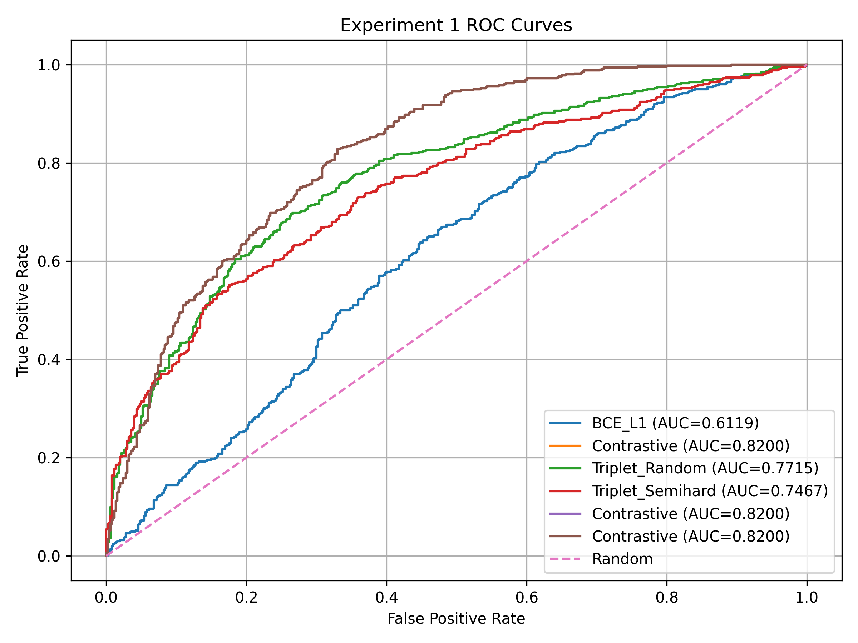
Figure 1: ROC curves for Experiment 1 comparing BCE, contrastive, and triplet objectives under the same backbone and evaluation protocol.

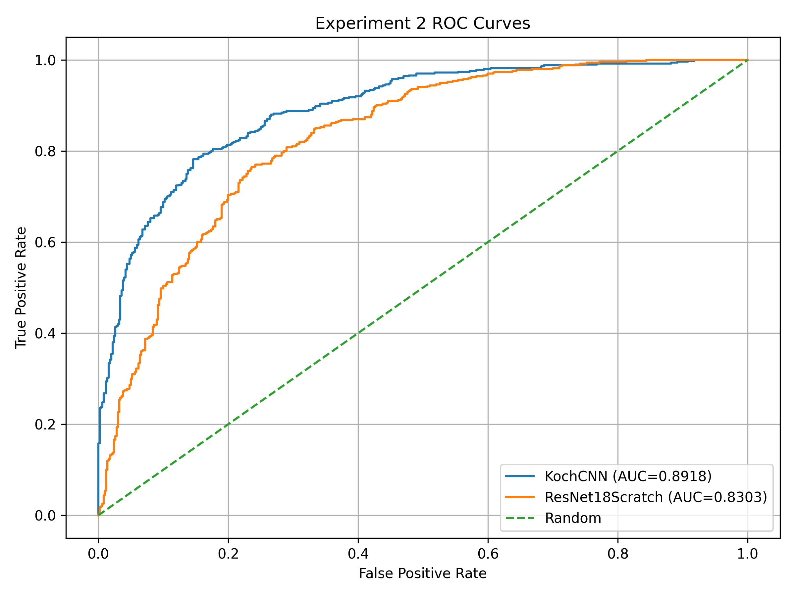
Figure 2: ROC curves for Experiment 2 backbone comparison under matched parameter counts and identical triplet-loss supervision. The modified Koch CNN achieves consistently stronger verification performance across decision thresholds than ResNet-18 tra

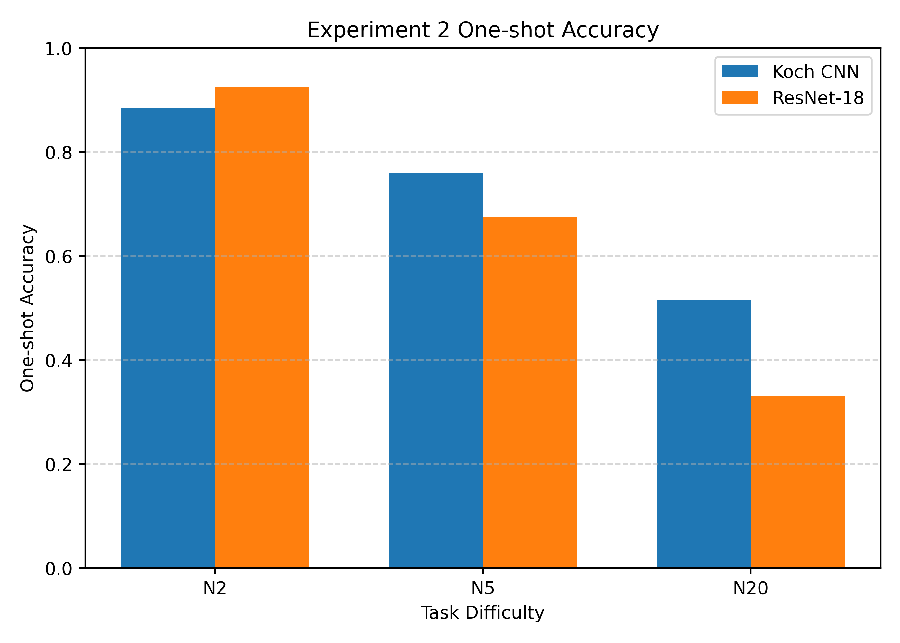
Figure 3: One-shot identification accuracy for Experiment 2 across increasing candidate-set sizes.

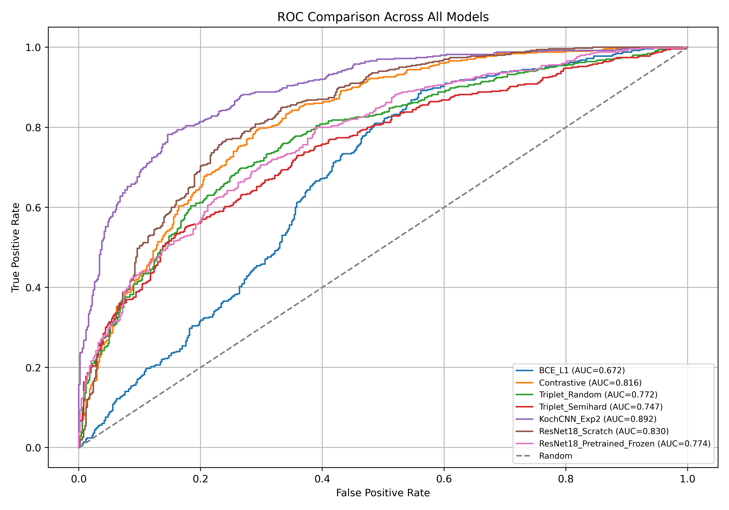Figure 4: ROC comparison across all models
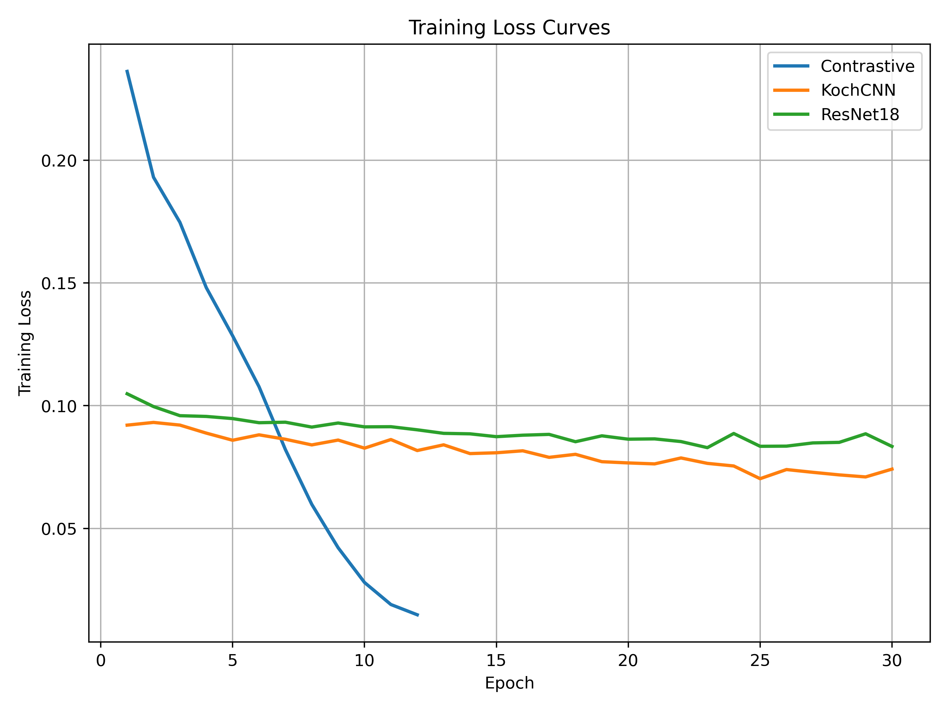
Figure 5: Training loss curve
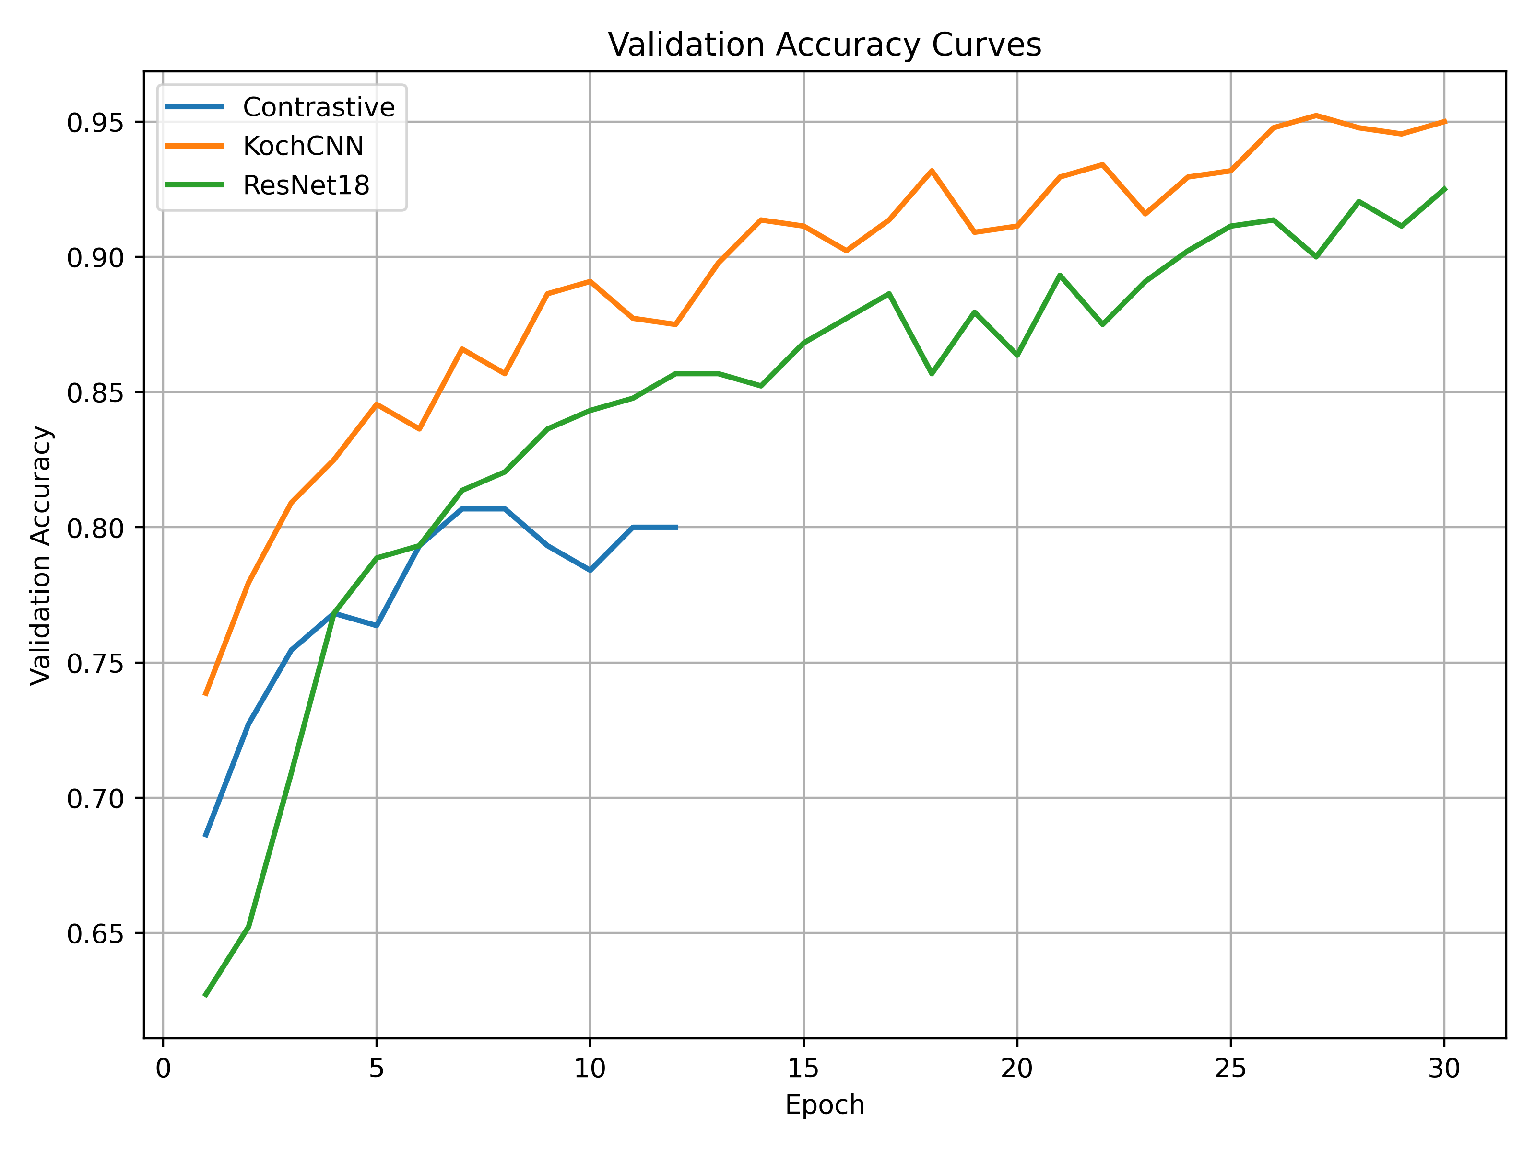
Figure 6: Validation accuracy curves across training epochs for the strongest configurations in Experiments 1 and 2.
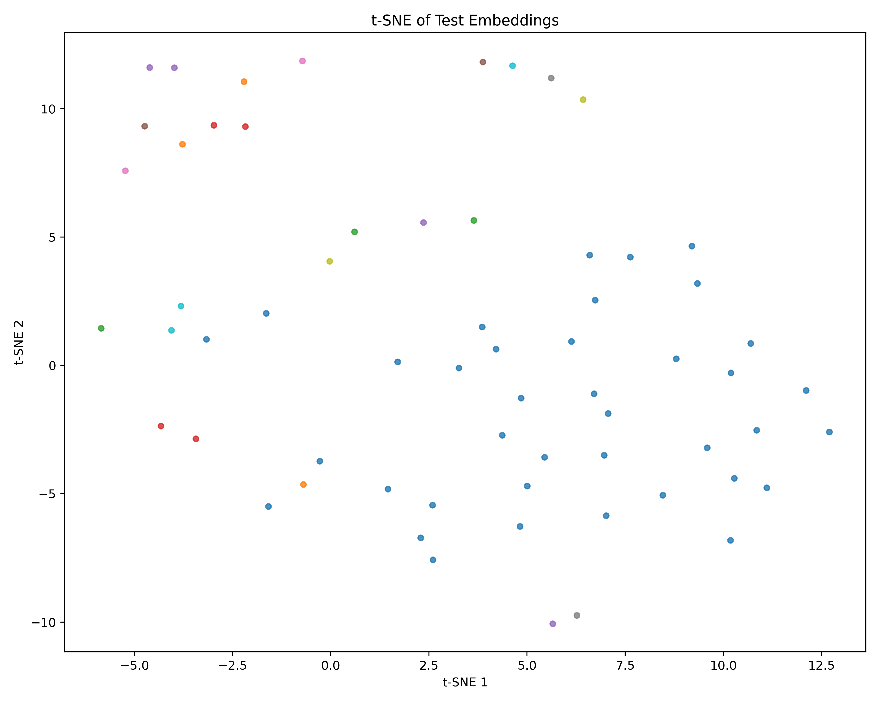
Figure 7: t-SNE projection of test-set embeddings produced by the best-performing model (Koch CNN with semi-hard triplet loss). Twenty-five identities from the test split were sampled for visualization. Several compact identity-specific clusters emerge, indicating meaningful metric structure in the learned embedding space.

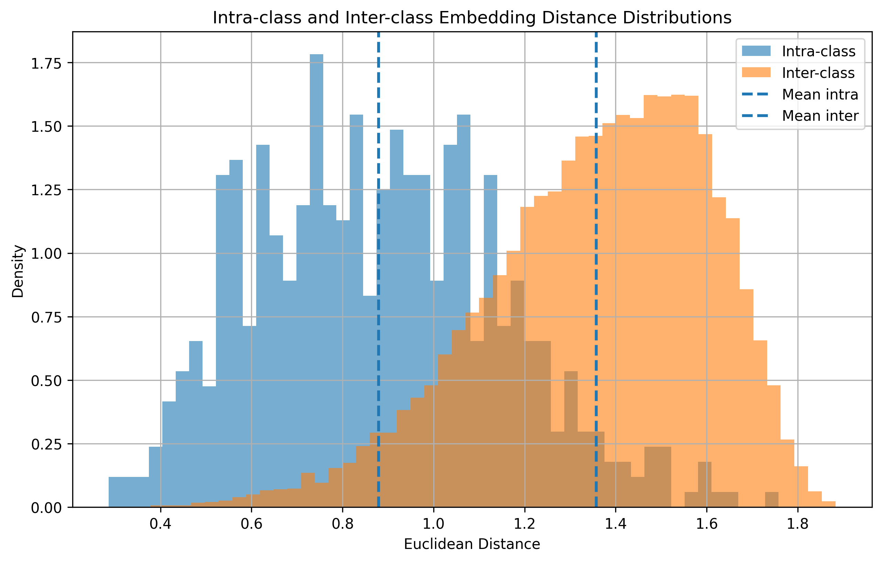
Figure 8: Intra-class and inter-class embedding distance distributions for the best-performing model (Koch CNN with semi-hard triplet loss). Intra-class distances are generally smaller than inter-class distances, indicating that the learned embedding space maps images of the same identity closer together. The overlap region between the two distributions explains the remaining verification errors.
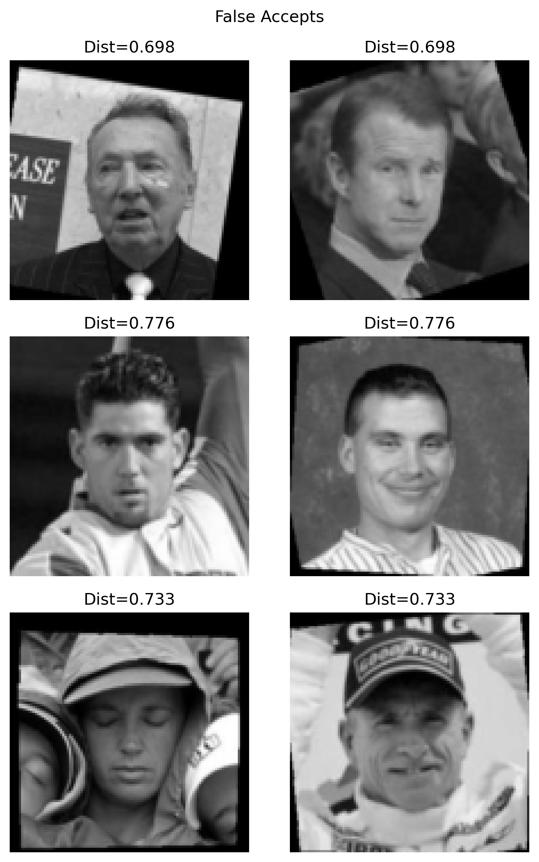
Figure 9: False accepts

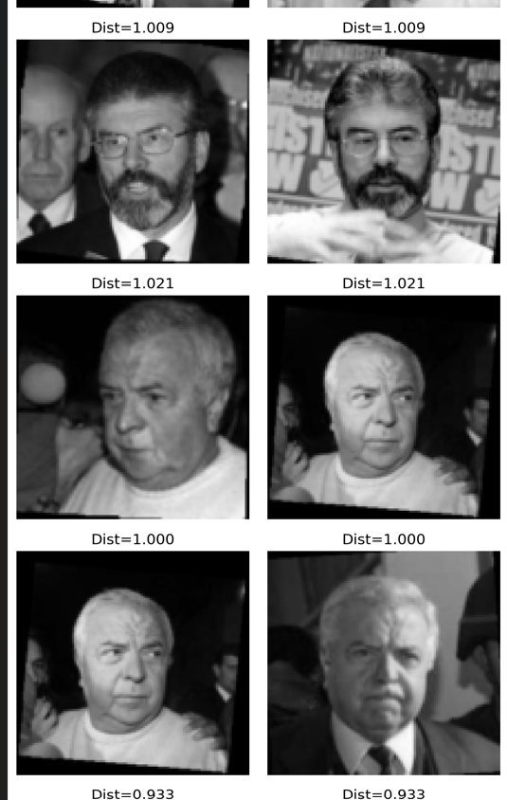
Figure 10: False rejections
2. Wall-clock convergence table

Model | Best Epoch | Training Time (s)
Contrastive | 7 | 410
KochCNN | 27 | 1299
ResNet18 | 13 | 460

