Theoretical Section

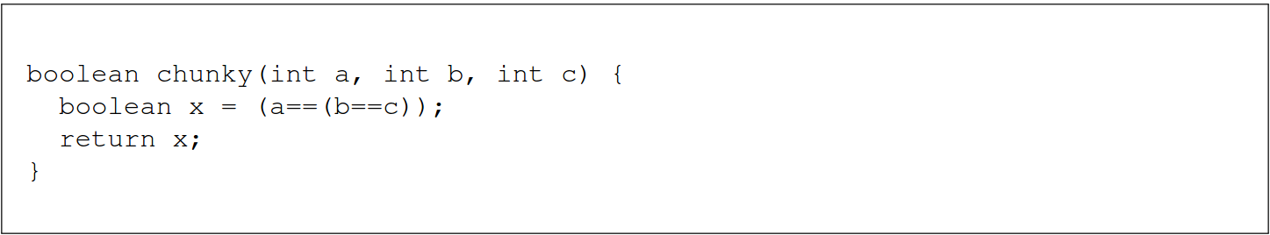

- chunky is not type-safe because the expression (a==(b==c)) violates the typing rules.
The parameters b and c are of the same type, so using the rule 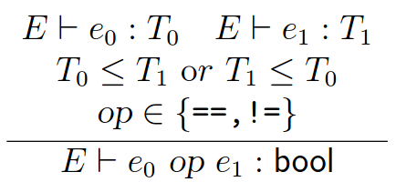, we infer that the expression (b==c) is of type boolean.
Since a is of type int, (b==c) is of type boolean, and since int and boolean are not subtypes of each other, then the inference rule above cannot be used to infer a boolean type for the expression (a==(b==c)). This means that the declaration “boolean x = (a==(b==c))” will fail.

- If we change the type of the parameter a from int to boolean, then chunky will be type-safe.
Proof:
Num. |  | Rule | Assumptions
1 | a : boolean | Assumption | 1
2 | b : int | Assumption | 2
3 | c : int | Assumption | 3
4 | ret : boolean | Assumption | 4
5 | int int | Subtype relation is reflexive | 5
6 | (b==c) : boolean | Based on 2, 3, 5 using the rule: | 2, 3
7 | boolean boolean | Subtype relation is reflexive | 7
8 | (a==(b==c)) : boolean | Based on 1, 6, 7 using the rule: | 1, 2, 3
9 | x : boolean | Assumption | 9
10 | return x; | Based on 4, 7, 9, using the rule:  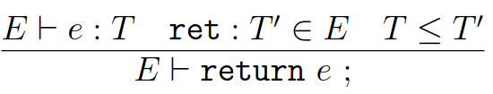 | 4, 9
11 | boolean x = (a==(b==c)); return x; | Based on 8, 7, 10, using the rule (Decl 1):  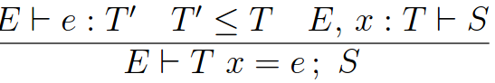 | 1, 2, 3, 4, 9
12 | boolean chunky (boolean a, int b, int c) { boolean x = (a==(b==c)); return x; } | Based on 11, using the rule (Method):  