НАЦІОНАЛЬНИЙ ТЕХНІЧНИЙ УНІВЕРСИТЕТ УКРАЇНИ
“КИЇВСЬКИЙ ПОЛІТЕХНІЧНИЙ ІНСТИТУТ ІМЕНІ ІГОРЯ СІКОРСЬКОГО”
Факультет інформатики та обчислювальної техніки
Кафедра обчислювальної техніки

Лабораторна робота №4
з дисципліни
“Програмування мобільних систем”

Виконав:
студент групи ІВ-82
ЗК ІВ-8218
Пінчук Микита

Київ 2021
Скріншоти роботи додатка (Варіант 8218 % 2 + 1 = 1)
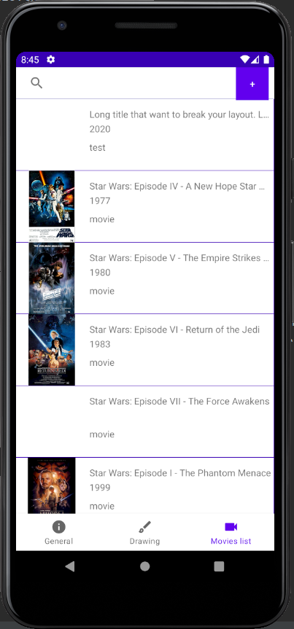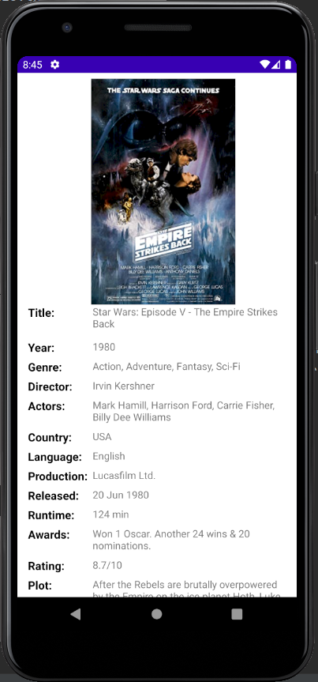
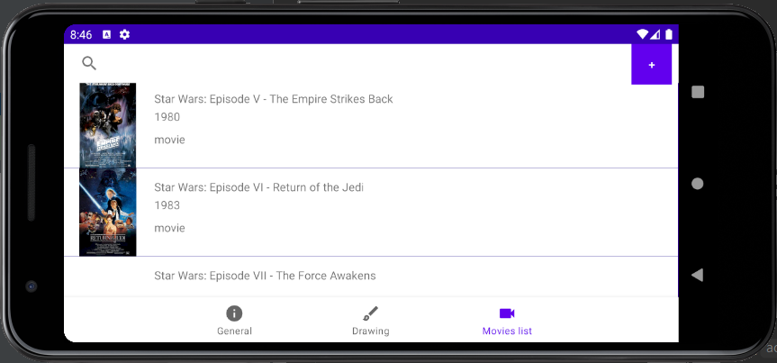

Лістинг коду
MainActivity.java
package ua.kpi.comsys.iv8218.third;
import android.os.Bundle;
import androidx.appcompat.app.AppCompatActivity;
import androidx.navigation.NavController;
import androidx.navigation.Navigation;
import androidx.navigation.ui.AppBarConfiguration;
import androidx.navigation.ui.NavigationUI;
import com.google.android.material.bottomnavigation.BottomNavigationView;
public class MainActivity extends AppCompatActivity {
@Override
protected void onCreate(Bundle savedInstanceState) {
super.onCreate(savedInstanceState);
setContentView(R.layout.activity_main);
BottomNavigationView navView = findViewById(R.id.nav_view);
// Passing each menu ID as a set of Ids because each
// menu should be considered as top level destinations.
AppBarConfiguration appBarConfiguration = new AppBarConfiguration.Builder(
R.id.navigation_info, R.id.navigation_dashboard, R.id.navigation_videocam).build();
NavController navController = Navigation.findNavController(this, R.id.nav_host_fragment);
NavigationUI.setupActionBarWithNavController(this, navController, appBarConfiguration);
NavigationUI.setupWithNavController(navView, navController);
if (getSupportActionBar() != null) {
getSupportActionBar().hide();
}
}
}

Movie.java
package ua.kpi.comsys.iv8218.third.lab3;
public class Movie {
private final String title;
private final String year;
private String rated;
private String released;
private String runtime;
private String genre;
private String director;
private String writer;
private String actors;
private String plot;
private String language;
private String country;
private String awards;
private String imdbRating;
private String imdbVotes;
private String production;
private final String imdbID;
private final String type;
private final String posterPath;
public Movie(String title, String year, String type) {
this.title = title;
this.year = year;
this.imdbID = "noid";
this.type = type;
this.posterPath = "";
}
public Movie(String title, String year, String imdbID, String type, String posterPath){
this.title = title;
this.year = year;
this.imdbID = imdbID;
this.type = type;
this.posterPath = posterPath;
}
public void setRated(String rated) {this.rated = rated;}
public void setReleased(String released) {this.released = released;}
public void setRuntime(String runtime) {this.runtime = runtime;}
public void setGenre(String genre) {this.genre = genre;}
public void setDirector(String director) {this.director = director;}
public void setWriter(String writer) {this.writer = writer;}
public void setActors(String actors) {this.actors = actors;}
public void setPlot(String plot) {this.plot = plot;}
public void setLanguage(String language) {this.language = language;}
public void setCountry(String country) {this.country = country;}
public void setAwards(String awards) {this.awards = awards;}
public void setImdbRating(String imdbRating) {this.imdbRating = imdbRating;}
public void setImdbVotes(String imdbVotes) {this.imdbVotes = imdbVotes;}
public void setProduction(String production) {this.production = production;}
public String getRated() {return rated;}
public String getReleased() {return released;}
public String getRuntime() {return runtime;}
public String getGenre() {return genre;}
public String getDirector() {return director;}
public String getWriter() {return writer;}
public String getActors() {return actors;}
public String getPlot() {return plot;}
public String getLanguage() {return language;}
public String getCountry() {return country;}
public String getAwards() {return awards;}
public String getImdbRating() {return imdbRating;}
public String getImdbVotes() {return imdbVotes;}
public String getProduction() {return production;}
public String getTitle() {return title;}
public String getYear() {return year;}
public String getImdbID() {return imdbID;}
public String getType() {return type;}
public String getPosterPath() {return posterPath;}
}

}
MovieAdd.java
package ua.kpi.comsys.iv8218.third.lab3;
import ua.kpi.comsys.iv8218.third.R;
import android.annotation.SuppressLint;
import android.content.Context;
import android.os.Build;
import android.view.Gravity;
import android.view.LayoutInflater;
import android.view.View;
import android.widget.LinearLayout;
import android.widget.PopupWindow;
import androidx.annotation.RequiresApi;
public class MovieAdd {
@RequiresApi(api = Build.VERSION_CODES.M)
@SuppressLint("ClickableViewAccessibility")
public Object[] showPopupWindow(final View view) {
view.getContext();
LayoutInflater inflater = (LayoutInflater) view.getContext().getSystemService(Context.LAYOUT_INFLATER_SERVICE);
@SuppressLint("InflateParams")
View popupView = inflater.inflate(R.layout.movie_add, null);
int width = LinearLayout.LayoutParams.MATCH_PARENT;
int height = LinearLayout.LayoutParams.MATCH_PARENT;
boolean focusable = true;
final PopupWindow popupWindow = new PopupWindow(popupView, width, height, focusable);
popupWindow.showAtLocation(view, Gravity.CENTER, 0, 0);
popupView.setOnTouchListener((v, event) -> {
return true;
});
return new Object[] {popupView, popupWindow};
}
}

MovieInfo.java
package ua.kpi.comsys.iv8218.third.lab3;
import android.annotation.SuppressLint;
import android.content.Context;
import android.view.Gravity;
import android.view.LayoutInflater;
import android.view.View;
import android.widget.ImageView;
import android.widget.LinearLayout;
import android.widget.PopupWindow;
import android.widget.TextView;
import androidx.annotation.RawRes;
import org.json.simple.JSONObject;
import org.json.simple.parser.JSONParser;
import org.json.simple.parser.ParseException;
import java.io.ByteArrayOutputStream;
import java.io.IOException;
import java.io.InputStream;
import java.lang.reflect.Field;
import ua.kpi.comsys.iv8218.third.R;
public class MovieInfo {
@SuppressLint("ClickableViewAccessibility")
public void showPopupWindow(final View view, Movie movie) {
view.getContext();
LayoutInflater inflater = (LayoutInflater) view.getContext().getSystemService(Context.LAYOUT_INFLATER_SERVICE);
@SuppressLint("InflateParams")
View popupView = inflater.inflate(R.layout.movie_info, null);
try {
parseMovieInfo(readTextFile(popupView.getContext(),
getResId(movie.getImdbID(), R.raw.class)), movie);
} catch (ParseException e) {
System.err.println("Incorrect content of JSON file!");
e.printStackTrace();
}
int width = LinearLayout.LayoutParams.MATCH_PARENT;
int height = LinearLayout.LayoutParams.MATCH_PARENT;
boolean focusable = true;
final PopupWindow popupWindow = new PopupWindow(popupView, width, height, focusable);
popupWindow.showAtLocation(view, Gravity.CENTER, 0, 0);
if (movie.getPosterPath().length() != 0){
((ImageView) popupView.findViewById(R.id.movie_info_image)).setImageResource(
getResId(movie.getPosterPath().toLowerCase()
.split("\\.")[0], R.drawable.class));
}
((TextView) popupView.findViewById(R.id.movie_info_title)).setText(movie.getTitle());
((TextView) popupView.findViewById(R.id.movie_info_year)).setText(movie.getYear());
((TextView) popupView.findViewById(R.id.movie_info_genre)).setText(movie.getGenre());
((TextView) popupView.findViewById(R.id.movie_info_director)).setText(movie.getDirector());
((TextView) popupView.findViewById(R.id.movie_info_actors)).setText(movie.getActors());
((TextView) popupView.findViewById(R.id.movie_info_country)).setText(movie.getCountry());
((TextView) popupView.findViewById(R.id.movie_info_language)).setText(movie.getLanguage());
((TextView) popupView.findViewById(R.id.movie_info_production)).setText(movie.getProduction());
((TextView) popupView.findViewById(R.id.movie_info_released)).setText(movie.getReleased());
((TextView) popupView.findViewById(R.id.movie_info_runtime)).setText(movie.getRuntime());
((TextView) popupView.findViewById(R.id.movie_info_awards)).setText(movie.getAwards());
((TextView) popupView.findViewById(R.id.movie_info_rating)).setText(movie.getImdbRating());
((TextView) popupView.findViewById(R.id.movie_info_plot)).setText(movie.getPlot());
}
private void parseMovieInfo(String jsonText, Movie movie) throws ParseException {
JSONObject jsonObject = (JSONObject) new JSONParser().parse(jsonText);
movie.setGenre((String) jsonObject.get("Genre"));
movie.setDirector((String) jsonObject.get("Director"));
movie.setActors((String) jsonObject.get("Actors"));
movie.setCountry((String) jsonObject.get("Country"));
movie.setLanguage((String) jsonObject.get("Language"));
movie.setProduction((String) jsonObject.get("Production"));
movie.setReleased((String) jsonObject.get("Released"));
movie.setRuntime((String) jsonObject.get("Runtime"));
movie.setAwards((String) jsonObject.get("Awards"));
movie.setImdbRating(jsonObject.get("imdbRating") + "/10");
movie.setPlot((String) jsonObject.get("Plot"));
}
private static int getResId(String resName, Class<?> c) {
try {
Field idField = c.getDeclaredField(resName);
return idField.getInt(idField);
} catch (Exception e) {
e.printStackTrace();
return -1;
}
}
private static String readTextFile(Context context, @RawRes int id){
InputStream inputStream = context.getResources().openRawResource(id);
ByteArrayOutputStream outputStream = new ByteArrayOutputStream();
byte[] buffer = new byte[1024];
int size;
try {
while ((size = inputStream.read(buffer)) != -1) {
outputStream.write(buffer, 0, size);
}
outputStream.close();
inputStream.close();
} catch (IOException e) {
System.err.println("File cannot be reading!");
e.printStackTrace();
}
return outputStream.toString();
}
}

MovieList.java
package ua.kpi.comsys.iv8218.third.lab3;
import android.content.Context;
import android.graphics.Color;
import android.text.TextUtils;
import android.view.Gravity;
import android.view.ViewGroup;
import android.widget.ImageButton;
import android.widget.ImageView;
import android.widget.LinearLayout;
import android.widget.TextView;
import androidx.constraintlayout.widget.ConstraintLayout;
import androidx.constraintlayout.widget.ConstraintSet;
import com.daimajia.swipe.SwipeLayout;
import java.lang.reflect.Field;
import ua.kpi.comsys.iv8218.third.R;
public class MovieList {
public Object[] moviePack;
public MovieList(Context context, LinearLayout movieList, Movie movie){
moviePack = newMovieList(context, movieList, movie);
}
private Object[] newMovieList(Context context, LinearLayout movieList, Movie movie){
SwipeLayout swipeLayout = new SwipeLayout(context);
swipeLayout.setShowMode(SwipeLayout.ShowMode.PullOut);
swipeLayout.setLayoutParams(
new LinearLayout.LayoutParams(ViewGroup.LayoutParams.MATCH_PARENT,
ViewGroup.LayoutParams.WRAP_CONTENT));
movieList.addView(swipeLayout);
ImageButton deleteButton = new ImageButton(context);
deleteButton.setImageResource(R.drawable.ic_delete_sweep_black_24dp);
deleteButton.setBackgroundColor(Color.RED);
deleteButton.setPadding(50, 0, 50, 0);
LinearLayout.LayoutParams btnBinParams =
new LinearLayout.LayoutParams(ViewGroup.LayoutParams.WRAP_CONTENT,
ViewGroup.LayoutParams.MATCH_PARENT);
btnBinParams.gravity = Gravity.RIGHT;
swipeLayout.setShowMode(SwipeLayout.ShowMode.PullOut);
swipeLayout.addView(deleteButton, 0, btnBinParams);
ConstraintLayout movieLayTmp = new ConstraintLayout(context);
movieLayTmp.setBackgroundResource(R.drawable.movielist);
movieLayTmp.setLayoutParams(
new LinearLayout.LayoutParams(ViewGroup.LayoutParams.MATCH_PARENT,
ViewGroup.LayoutParams.WRAP_CONTENT));
swipeLayout.addView(movieLayTmp, 1);
deleteButton.setOnClickListener(v -> Lab3.binClicked(swipeLayout));
movieLayTmp.setOnClickListener(v -> {
if (movie.getImdbID().length() != 0 && !movie.getImdbID().equals("noid")) {
MovieInfo popUpClass = new MovieInfo();
popUpClass.showPopupWindow(v, movie);
}
});
ImageView imageTmp = new ImageView(context);
imageTmp.setId(imageTmp.hashCode());
if (movie.getPosterPath().length() != 0)
imageTmp.setImageResource(
getResId(movie.getPosterPath().toLowerCase().split("\\.")[0], R.drawable.class));
ConstraintLayout.LayoutParams imgParams =
new ConstraintLayout.LayoutParams(300, 300);
movieLayTmp.addView(imageTmp, imgParams);
TextView textTitle = new TextView(context);
textTitle.setText(movie.getTitle());
textTitle.setEllipsize(TextUtils.TruncateAt.END);
textTitle.setMaxLines(1);
textTitle.setId(textTitle.hashCode());
movieLayTmp.addView(textTitle, new ConstraintLayout.LayoutParams(
ConstraintLayout.LayoutParams.MATCH_CONSTRAINT,
ConstraintLayout.LayoutParams.WRAP_CONTENT));
TextView textYear = new TextView(context);
textYear.setText(movie.getYear());
textYear.setEllipsize(TextUtils.TruncateAt.END);
textYear.setMaxLines(4);
textYear.setId(textYear.hashCode());
movieLayTmp.addView(textYear, new ConstraintLayout.LayoutParams(
ConstraintLayout.LayoutParams.MATCH_CONSTRAINT,
ConstraintLayout.LayoutParams.WRAP_CONTENT));
TextView textType = new TextView(context);
textType.setText(movie.getType());
textType.setId(textType.hashCode());
movieLayTmp.addView(textType, new ConstraintLayout.LayoutParams(
ConstraintLayout.LayoutParams.MATCH_CONSTRAINT,
ConstraintLayout.LayoutParams.WRAP_CONTENT));
ConstraintSet textConstraintSet = new ConstraintSet();
textConstraintSet.clone(movieLayTmp);
textConstraintSet.connect(imageTmp.getId(), ConstraintSet.START,
ConstraintSet.PARENT_ID, ConstraintSet.START);
textConstraintSet.connect(imageTmp.getId(), ConstraintSet.TOP,
ConstraintSet.PARENT_ID, ConstraintSet.TOP);
textConstraintSet.connect(imageTmp.getId(), ConstraintSet.BOTTOM,
ConstraintSet.PARENT_ID, ConstraintSet.BOTTOM);
textConstraintSet.connect(textTitle.getId(), ConstraintSet.START,
imageTmp.getId(), ConstraintSet.END);
textConstraintSet.connect(textTitle.getId(), ConstraintSet.TOP,
imageTmp.getId(), ConstraintSet.TOP);
textConstraintSet.connect(textTitle.getId(), ConstraintSet.END,
ConstraintSet.PARENT_ID, ConstraintSet.END);
textConstraintSet.connect(textTitle.getId(), ConstraintSet.BOTTOM,
imageTmp.getId(), ConstraintSet.BOTTOM);
textConstraintSet.connect(textYear.getId(), ConstraintSet.START,
textTitle.getId(), ConstraintSet.START);
textConstraintSet.connect(textYear.getId(), ConstraintSet.TOP,
textTitle.getId(), ConstraintSet.BOTTOM);
textConstraintSet.connect(textYear.getId(), ConstraintSet.END,
textTitle.getId(), ConstraintSet.END);
textConstraintSet.connect(textType.getId(), ConstraintSet.START,
textYear.getId(), ConstraintSet.START);
textConstraintSet.connect(textType.getId(), ConstraintSet.TOP,
textYear.getId(), ConstraintSet.BOTTOM);
textConstraintSet.connect(textType.getId(), ConstraintSet.END,
textYear.getId(), ConstraintSet.END);
textConstraintSet.setMargin(textTitle.getId(), ConstraintSet.START, 8);
textConstraintSet.setMargin(textTitle.getId(), ConstraintSet.END, 8);
textConstraintSet.setVerticalBias(textTitle.getId(), 0.15f);
textConstraintSet.setMargin(textYear.getId(), ConstraintSet.TOP, 8);
textConstraintSet.setMargin(textType.getId(), ConstraintSet.TOP, 24);
textConstraintSet.applyTo(movieLayTmp);
return new Object[] {swipeLayout, movie};
}
public static int getResId(String resName, Class<?> c) {
try {
Field idField = c.getDeclaredField(resName);
return idField.getInt(idField);
} catch (Exception e) {
e.printStackTrace();
return -1;
}
}
}

Висновок

В даній лабораторній роботі було удосконалено мобільний додаток, а саме:
- пошук зі списку сутностей
- додавання своїх фільмів у бібліотеку
- новий екран, на якому відображається повна інформація про сутність
Програма працює коректно. Кінцева мета досягнута.

