Vishnu Remesh
11327223
DRL 5

- Display the oldest employee in the deptno 30.

ANS: select ename
from emp
where hiredate=(select min(hiredate) from emp where deptno=30)

- Display the records of employees who earn salary less than the average salary of job SALESMAN. The records of SALESMAN should be excluded from the report.

ANS: select * from emp
where sal<ALL(select avg(sal) from emp where job='SALESMAN')
AND job<>'SALESMAN'

- Display the top earner’s records from the job CLERK.

ANS: select * from emp
where sal=(select max(sal) from emp where job='CLERK')

- Display the records of lowest earners who joined in the year 81.

ANS: select *
from emp
where sal=(select min(sal) from emp where to_char(hiredate,'yy')=81)

- Display the records of employees who are earning above the average salary in their own deptno.

ANS: select *
from emp
where sal>ANY(select avg(sal) from emp group by deptno)

- Display the name, hire date, and salary for all employees who have both the same salary and commission as Scott.
Note: Do not display SCOTT in the result set.

ANS: select ename,hiredate,sal
from emp
where (sal=(select sal from emp where ename='SCOTT')
OR comm=(select comm from emp where ename='SCOTT'))
AND ename<>'SCOTT'

- Display the department names of employees who have their salary greater than Martin’s salary.

ANS: select d.dname
from dept d
inner join emp e
on (d.deptno=e.deptno)
where sal>ALL(select sal from emp where ename='MARTIN')

8) Produce the following output—

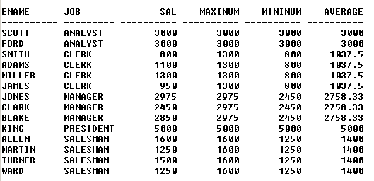

ANS: select a.ename,a.job,a.sal,b.MAXIMUM,c.MINIMUM,d.AVERAGE
from emp a,(select job,max(sal) MAXIMUM from emp group by job)b,(select job,min(sal) MINIMUM from emp group by job)c,(select job,avg(sal) AVERAGE from emp group by job)d
where a.job=b.job
and a.job=c.job
and a.job=d.job

9. Display the records of employees who earn salary above the average salary of SALESMAN job excluding the MANAGER jobs.

ANS: select * from emp
where sal>ALL(select avg(sal) from emp where job='SALESMAN')
AND job<>'MANAGER'

10. Display the deptno which has the lowest number of employees.

ANS: select deptno
from (select deptno,count(empno) from emp group by deptno order by count(empno) desc)
where rownum<=1

11. Display the employee name which the highest number of alphabets.

ANS: select ename
from (select ename,count(ename) from emp group by ename order by count(ename) desc)
where rownum<=1

12. Produce the following output

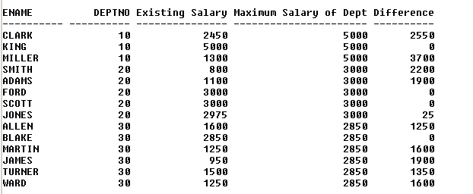

ANS: select a.ename,a.deptno, a.sal EXISTING_SALARY,b.MAXIMUM_SALARY_OF_DEP,b.MAXIMUM_SALARY_OF_DEP-sal DIFFERENCE
from emp a,(select deptno,max(sal) MAXIMUM_SALARY_OF_DEP from emp group by deptno)b
where a.deptno=b.deptno

13. Display the department name that has the highest salary record.

ANS: select b.dname
from emp a
inner join dept b
on(a.deptno=b.deptno)
where sal=(select max(sal) from emp)

