Vishnu Remesh
11327223

DRL 7

- Create the following type of Deptno-wise Sub Total report.

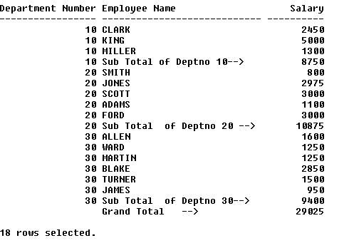

ANS: select deptno,ename,sal
from emp
where deptno=10
union
select deptno,'Sub total of deptno 10',sum(sal)
from emp
where deptno=10
group by deptno
union
select deptno,ename,sal
from emp
where deptno=20
union
select deptno,'Sub total of deptno 20',sum(sal)
from emp
where deptno=20
group by deptno
union
select deptno,ename,sal
from emp
where deptno=30
union
select deptno,'Sub total of deptno 30',sum(sal)
from emp
where deptno=30
group by deptno

2) Create the following type of Department-Job Sub Total report –

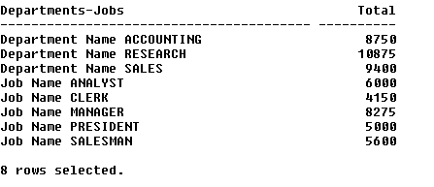

ANS: select 'Department Name '||d.dname DEPARTMENT_JOBS,sum(e.sal) total
from emp e
inner join dept d
on e.deptno=d.deptno
group by d.dname
UNION
select 'JOB Name '||job DEPARTMENT_JOBS,sum(sal) total
from emp e
group by job
3) Create the following sub-totals of year-wise salary details.

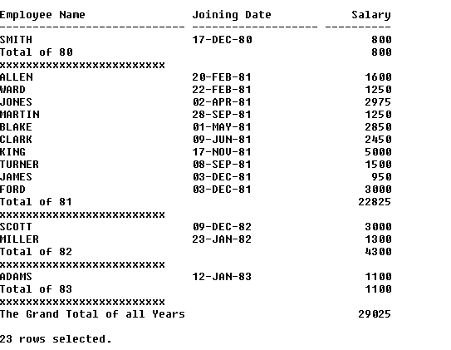

ANS: select ename employee_name,to_char(hiredate,'dd-mm-yy') joining_date,to_char(sal) salary
from emp
where to_char(hiredate,'yy')=80
union
select 'total of 80' employee_name,' ' joining_date,to_char(sum(sal)) salary
from emp
where to_char(hiredate,'yy')=80
group by ename
union
select '******' employee_name,' ' joining_date,' ' salary
from emp
union
select ename employee_name,to_char(hiredate,'dd-mm-yy') joining_date,to_char(sal) salary
from emp
where to_char(hiredate,'yy')=81
union
select 'total of 81' employee_name,' ' joining_date,to_char(sum(sal)) salary
from emp
where to_char(hiredate,'yy')=81
group by ename
union
select '******' employee_name,' ' joining_date,' ' salary
from emp
UNION
select ename employee_name,to_char(hiredate,'dd-mm-yy') joining_date,to_char(sal) salary
from emp
where to_char(hiredate,'yy')=82
union
select 'total of 82' employee_name,' ' joining_date,to_char(sum(sal)) salary
from emp
where to_char(hiredate,'yy')=82
group by ename
union
select '******' employee_name,' ' joining_date,' ' salary
from emp
union
select ename employee_name,to_char(hiredate,'dd-mm-yy') joining_date,to_char(sal) salary
from emp
where to_char(hiredate,'yy')=83
union
select 'total of 83' employee_name,' ' joining_date,to_char(sum(sal)) salary
from emp
where to_char(hiredate,'yy')=83
group by ename
union
select '******' employee_name,' ' joining_date,' ' salary
from emp

4) Display the deptno-wise employees with the record of the lowest earner in each deptno as shown below.

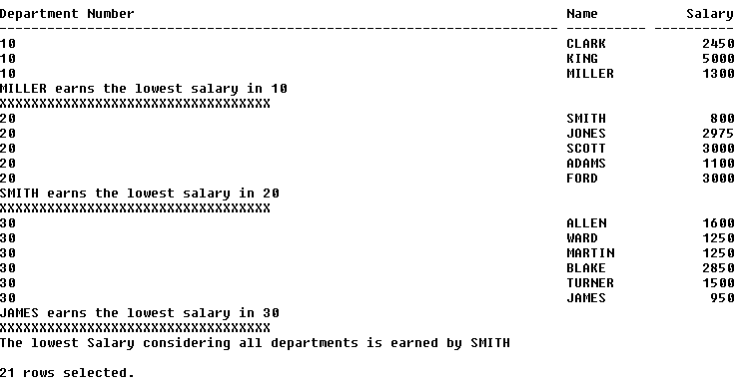

ANS: select to_char(deptno) deptno,ename,to_char(min(sal)) min_sal
from emp
where deptno=10
group by deptno,ename
union all
select ename||' has minimum salary' deptno,' ' ename,' ' min_sal
from emp
where sal=(select min(sal) from emp where deptno=10)
UNION ALL
select to_char(deptno) deptno,ename,to_char(min(sal)) min_sal
from emp
where deptno=20
group by deptno,ename
union all
select ename||' has minimum salary' deptno,' ' ename,' ' min_sal
from emp
where sal=(select min(sal) from emp where deptno=20)
UNION ALL
select to_char(deptno) deptno,ename,to_char(min(sal)) min_sal
from emp
where deptno=30
group by deptno,ename
union all
select ename||' has minimum salary' deptno,' ' ename,' ' min_sal
from emp
where sal=(select min(sal) from emp where deptno=30)
union all
select to_char(deptno) deptno,ename,to_char(min(sal)) min_sal
from emp
where deptno=40
group by deptno,ename
union all
select ename||' has minimum salary' deptno,' ' ename,' ' min_sal
from emp
where sal=(select min(sal) from emp where deptno=40)

5) Display the highest two salary records within each job as shown below --

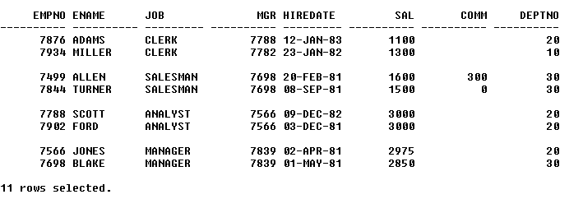

ANS: select empno,ename,mgr,job,deptno,sal
from (select empno,ename,mgr,job,deptno,sal sal from emp order by sal desc)
where rownum<=2
and job='CLERK'
union all
select empno,ename,mgr,job,deptno,sal
from (select empno,ename,mgr,job,deptno,sal sal from emp order by sal desc)
where rownum<=2
and job='SALESMAN'
union all
select empno,ename,mgr,job,deptno,sal
from (select empno,ename,mgr,job,deptno,sal sal from emp order by sal desc)
where rownum<=2
and job='ANALYST'
union all
select empno,ename,mgr,job,deptno,sal
from (select empno,ename,mgr,job,deptno,sal sal from emp order by sal desc)
where rownum<=2
and job='MANAGER'
order by job

6) Display the records sorted as per deptno along –with the record of the oldest employee within that deptno as shown below --

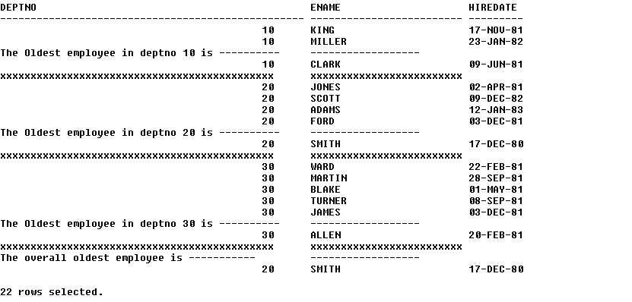

ANS: select to_char(deptno),ename,to_char(hiredate,'dd-mm-yy')
from emp
where deptno=10
union all all
select 'OLDEST EMPLOYEE OF DEPT 10 is' deptno,'-----',' '
from emp
union all
select to_char(deptno),ename,to_char(hiredate,'dd-mm-yy')
from (select deptno,ename,hiredate from emp where deptno=10 order by hiredate desc)
where rownum<=1
union all all
select to_char(deptno),ename,to_char(hiredate,'dd-mm-yy')
from emp
where deptno=20
union all all
select 'OLDEST EMPLOYEE OF DEPT 20 is' deptno,'-----',' '
from emp
union all all
select to_char(deptno),ename,to_char(hiredate,'dd-mm-yy')
from (select deptno,ename,hiredate from emp where deptno=20 order by hiredate desc)
where rownum<=1
union all all
select to_char(deptno),ename,to_char(hiredate,'dd-mm-yy')
from emp
where deptno=30
union all all
select 'OLDEST EMPLOYEE OF DEPT 30 is' deptno,'-----',' '
from emp
union all all
select to_char(deptno),ename,to_char(hiredate,'dd-mm-yy')
from (select deptno,ename,hiredate from emp where deptno=40 order by hiredate desc)
where rownum<=1
union all all
select to_char(deptno),ename,to_char(hiredate,'dd-mm-yy')
from emp
where deptno=40
union all all
select 'OLDEST EMPLOYEE OF DEPT 10 is' deptno,'-----',' '
from emp
union all all
select to_char(deptno),ename,to_char(hiredate,'dd-mm-yy')
from (select deptno,ename,hiredate from emp where deptno=40 order by hiredate desc)
where rownum<=1

7) Display the employees earning less than the average salary of their own jobs as shown below --

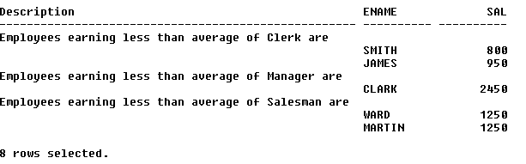

ANS: select 'EMPLOYEES EARNING LESS THAN CLERK ARE' description,sal,ename
from emp
where sal<ALL(select avg(sal) from emp where job='CLERK')
and job='CLERK'
union all
select 'EMPLOYEES EARNING LESS THAN MANAGER ARE' description,sal,ename
from emp
where sal<ALL(select avg(sal) from emp where job='MANAGER')
and job='MANAGER'
union all
select 'EMPLOYEES EARNING LESS THAN SALESMAN ARE' description,sal,ename
from emp
where sal<ALL(select avg(sal) from emp where job='SALESMAN')
and job='SALESMAN'

8) Create the following Master-Detail type of report

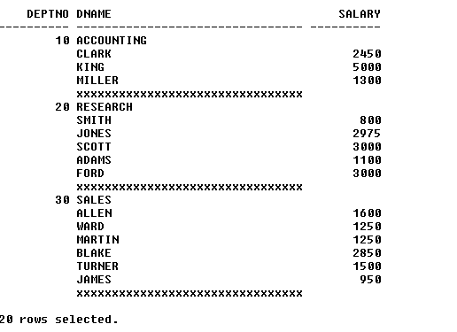

ANS: select to_char(emp.deptno),d.dname department,' ' salary
from emp
inner join dept d
on emp.deptno=d.deptno
where emp.deptno=10
union all
select ' ',ename,to_char(sal)
from emp
where emp.deptno=10
union all
select to_char(emp.deptno),d.dname department,' ' salary
from emp
inner join dept d
on emp.deptno=d.deptno
where emp.deptno=20
union all
select ' ',ename,to_char(sal)
from emp
where emp.deptno=20
union all
select to_char(emp.deptno),d.dname department,' ' salary
from emp
inner join dept d
on emp.deptno=d.deptno
where emp.deptno=30
union all
select ' ',ename,to_char(sal)
from emp
where emp.deptno=30
union all
select to_char(emp.deptno),d.dname department,' ' salary
from emp
inner join dept d
on emp.deptno=d.deptno
where emp.deptno=40
union all
select ' ',ename,to_char(sal)
from emp
where emp.deptno=40

9) Create the following Master-Detail Summary type of report.

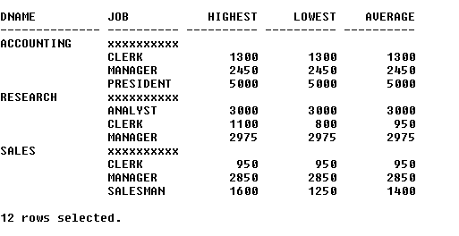

ANS: select dname,'*****' job,' ' highest,' ' lowest,' ' average
from dept
where dname='ACCOUNTING'
union all all
select ' ',job,to_char(max(sal)),to_char(min(sal)),to_char(avg(sal))
from emp
group by job
UNION ALL all
select dname,'*****' job,' ' highest,' ' lowest,' ' average
from dept
where dname='RESEARCH'
union all all
select ' ',job,to_char(max(sal)),to_char(min(sal)),to_char(avg(sal))
from emp
group by job
union all all
select dname,'*****' job,' ' highest,' ' lowest,' ' average
from dept
where dname='SALES'
union all all
select ' ',job,to_char(max(sal)),to_char(min(sal)),to_char(avg(sal))
from emp
group by job
10) Create the Organization hierarchy report as shown below –

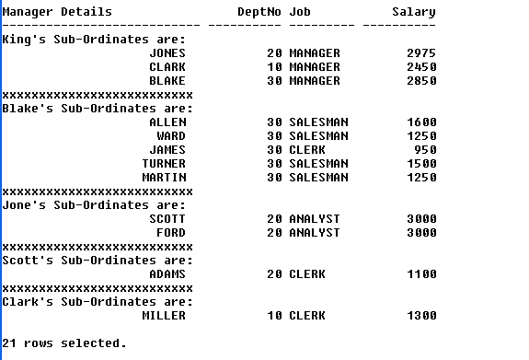

ANS:

