ADVANCED AMIGA SOUNDCARD

User Manual

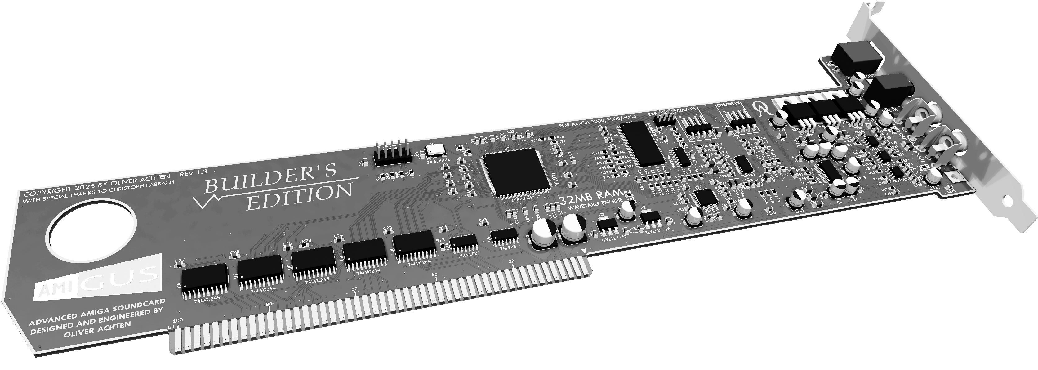

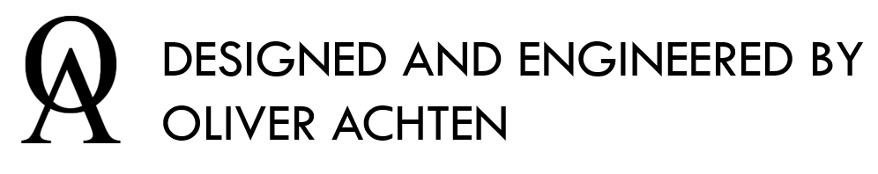

1 Overview 3

2 Installation 7

3 Software Tools 12

4 AHI Driver Framework 21

5 MHI Driver Framework 27

6 Driver Framework troubleshooting 32

7 Appendices 34

1. Overview
   1. Introduction

Thank you very much for purchasing the AmiGUS soundcard. The AmiGUS was designed to enable high-resolution audio playback on your Amiga computer. All audio processing makes extensive use of hardware acceleration in order to provide this quality even on low-end Amiga configurations.

* 1. AmiGUS Key Features
* Zorro II bus interface for Amiga 2000,3000,4000 computers and compatible bus boards
* 24-bit, 192kHz stereo sample DAC and ADC
  + 1 analogue audio stereo output
  + 3 analogue audio stereo inputs
* TOSLINK optical output, supporting 48, 96 and 192kHz @ 24-bit resolution
* MP3 / OGG Vorbis hardware codec chip (VLSI VS1063)
* Digital sound processing accelerator chip
  + 3 separate software interfaces (AHI, MHI, MIDI/Wave)
  + 32 hardware voices
    - 8 / 16-bit playback
    - Stereo panning
    - Per-voice linear sample interpolation
    - Hardware ADSR envelope
  + Full 24-bit 192kHz processing and mixing paths
  + Hardware accelerated data transfers to / from DAC, ADC & MP3 chips
* 32 MB wavetable RAM
  1. Hardware Overview

In the following picture you can see an overview of the AmiGUS card, its interfaces and the main hardware components which provide the card’s functionality.

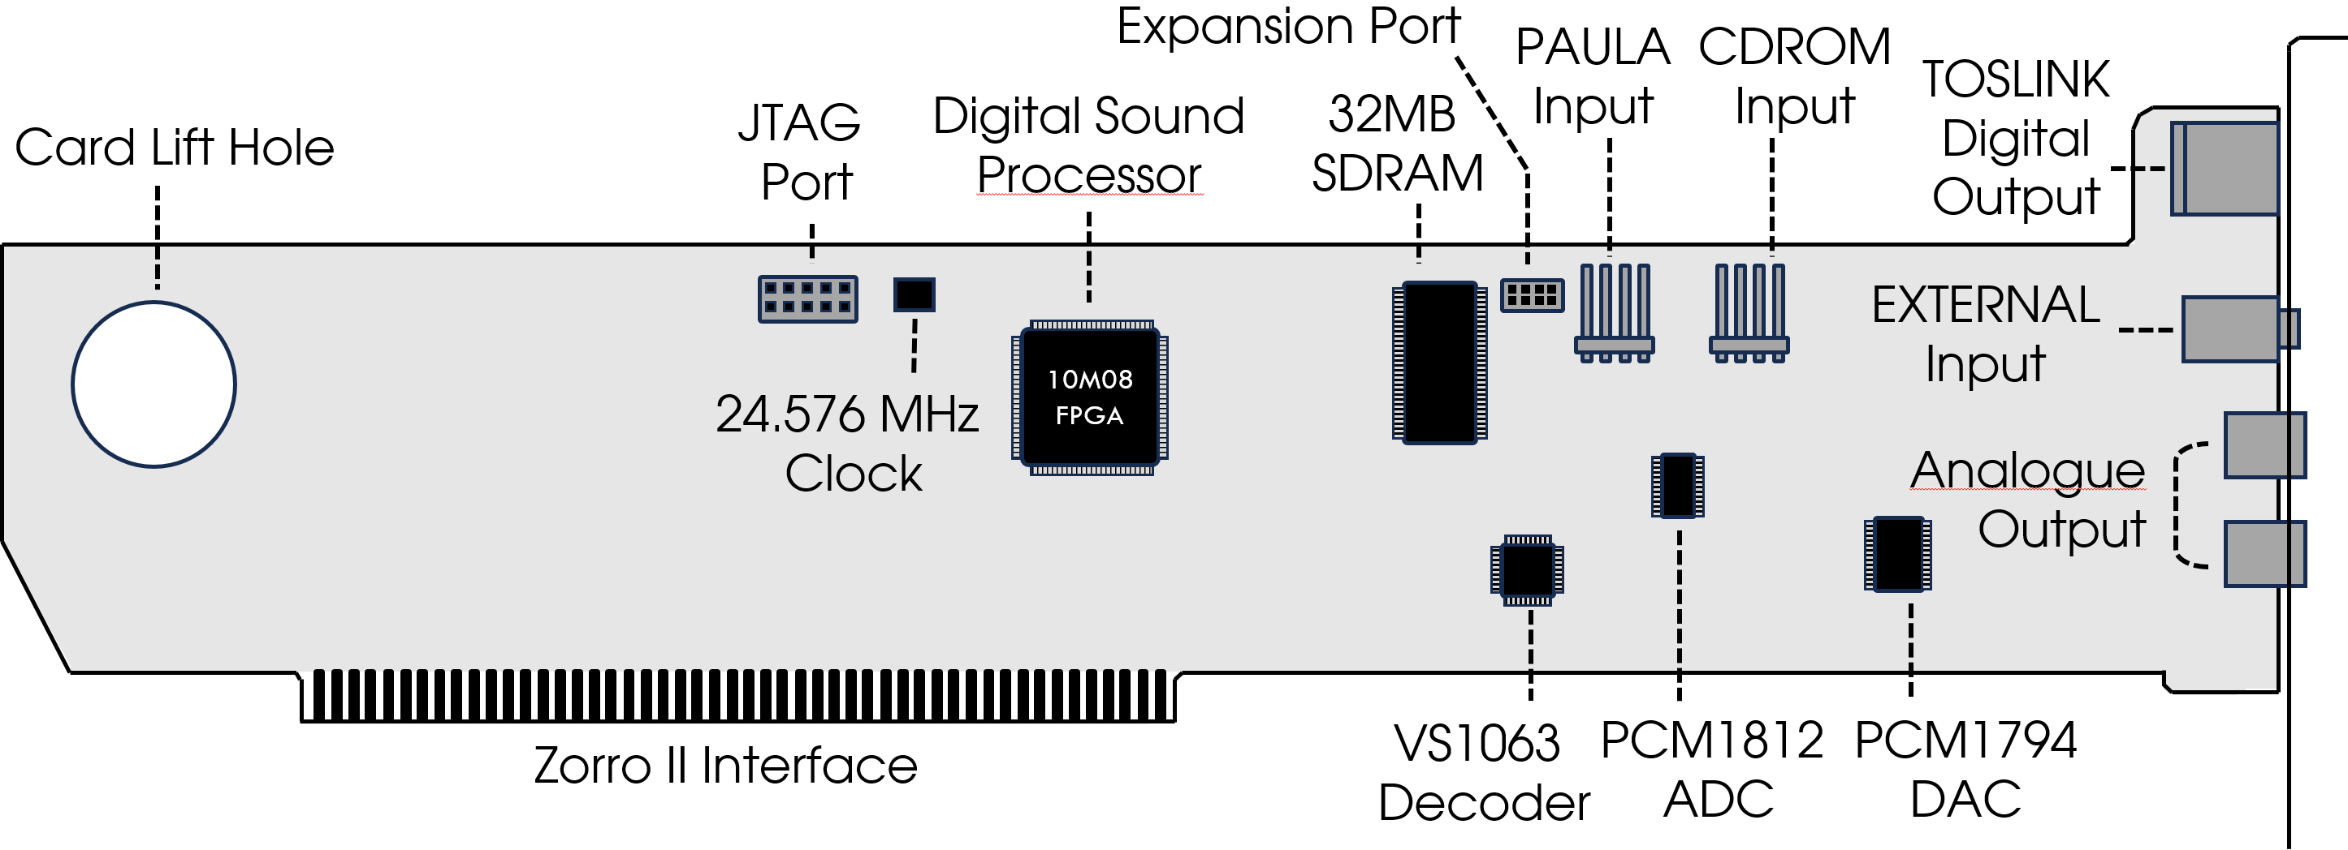

* + 1. Hardware Ports

|  |  |
| --- | --- |
| **Port Name** | **Function** |
| **JTAG Port** | Connects to an Altera FPGA programmer to flash and debug the FPGA. Should only be used for initial programming or servicing the card. |
| **Expansion Port** | Direct digital audio signal which can be provided to other cards to process the AmiGUS final mixer output. |
| **TOSLINK Digital Output** | TOSLINK output which connects to an optical interface. AmiGUS supports up to 192kHz, 24-bit audio data rates over this link. |
| **Analogue Output** | Standard RCA jacks which connect to an analogue stereo line-level input. |
| **PAULA Input** | This port can directly connect to the AMIGA’s native PAULA audio signal, which is mixed and output with the AmiGUS final output. |
| **CDROM Input** | You can directly connect an internal CDROM audio cable to this port, which allows mixing the CD audio coming from the drive with the AmiGUS final output. |
| **External Input** | Line-level input to connect and mix an external audio stereo source via 3.5 mm audio jack. |

* + 1. Hardware components

|  |  |
| --- | --- |
| **Component** | **Function** |
| **Digital Sound Processor (HAGEN)** | The Digital Sound Processor (HAGEN) is responsible for most of the digital sample processing and mixing. It directly connects to the Amiga’s Zorro bus and provides all necessary interfaces to the memory and audio support chips. |
| **32MB SDRAM** | This SDRAM memory chip can store up to 32MB of audio sample data for digital playback and mixing. |
| **VS1063 Hardware Codec** | The VS1063 is a hardware codec made by VLSI which supports hardware accelerated decoding of compressed audio streams such as MP3 or Ogg Vorbis. |
| **PCM1812 ADC** | The PCM1812 ADC made by Texas Instruments is responsible for converting all external audio inputs to a digital stream which is processed and mixed by the Digital Sound Processor. |
| **PCM1794 DAC** | The PCM1794 DAC made by Texas Instruments receives the final mixed digital audio stream and converts it to a line-level analogue audio signal. The audio data rate is always 24-bit, 192kHz. |
| **Zorro II Interface** | AmiGUS implements a Zorro II bus interface which supports full AutoConfig and interrupt handling. |

* 1. System Requirements

In order to make full use of AmiGUS features, the following range of system configurations is recommended.

* + 1. Minimum Configuration
* Amiga 2000 computer
* 1 MB Chip, 4 MB Fast-Ram
* 68000 CPU, 7MHz
* Kickstart 1.3
  + 1. Recommended Configuration
* Amiga 2000, 3000, 4000 computer
* 2 MB Chip, 16 MB Fast-Ram
* 68030 CPU, 25MHz
* Kickstart 2.x / 3.x

Even though we ensure that the most essential Tools required to configure the card do work on all revisions of the Amiga operating system, using Kick 2.x / 3.x is strongly recommended to yield maximum application compatibility.

1. Installation
   1. Card Installation

Turn off your Amiga computer and remove the case cover after removing the necessary screws according to your Amiga’s User Manual. Find an empty Zorro slot, remove the place-holder bracket after unscrewing it and gently insert the AmiGUS card in the slot socket, while carefully aligning the card on both ends to the support bracket and slot opening of the case. When done, re-use the bracket screw to mount the card’s bracket to the case.

If you have an internal CD-ROM, connect the CD-ROM’s analogue output located on the back of the drive with the CD-ROM input of your AmiGUS card.

In order to loop-through the native Amiga audio signal, you can either use the AUDIOT board delivered with your card, or, depending on your configuration, use the audio output which might be present on one of your expansion cards.

Please refer to chapter 2.2 for a more detailed description of the AmiGUS internal audio ports and use-cases.

When everything is set up, place the cover on your Amiga and re-tighten all screws according to your Amiga’s User Manual.

* 1. Internal Audio Set-Up
     1. Internal CD-ROM

You can directly connect an internal CD-ROM drive to the AmiGUS CDROM Input via the supplied audio cable of your drive.

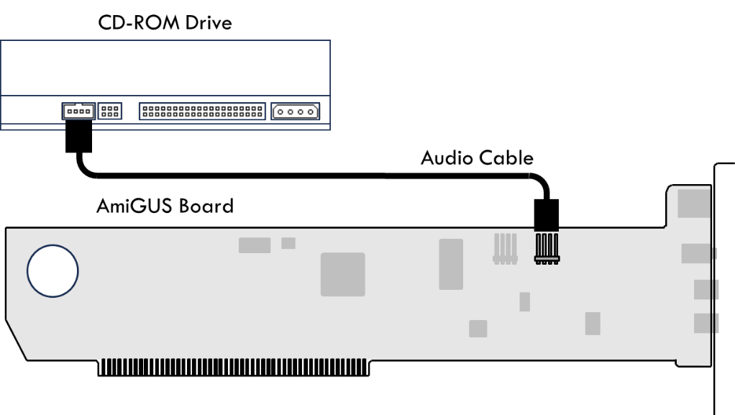

* + 1. Paula loop-through via AUDIOT board

The AUDIOT board needs to be inserted into the video slot and connected to the AmiGUS via the supplied audio cable.

This option is feasible for configurations where the video slot is not used by any card such as a flickerfixer or genlock.

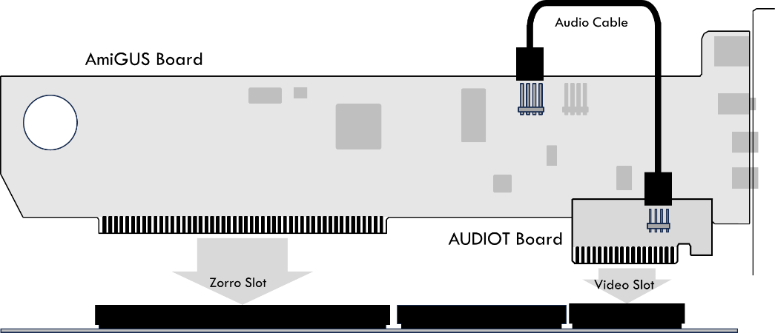

Please note that the AmiGUS and AUDIOT board must be placed in different slot lanes in order to physically fit.

* + 1. List of known hardware extensions with PAULA audio output

For configurations which already use the video slot, there are options available to loop the internal PAULA signal to the AmiGUS without using the AUDIOT board.

Below you a list of boards which supply PAULA audio output.

|  |  |
| --- | --- |
| **Hardware** | **Description** |
| **Multifix AGA Flickerfixer** | The card provides the Amiga audio and ground signals on JP1 & JP3. |
| **ZZ9000 GFX Board** | The card provides the Amiga audio signal on J6. |

* + 1. Digital Audio Expansion Port

The digital audio expansion port provides the final mixed audio signal as a 192kHz, 24-bit I2S digital audio stream.

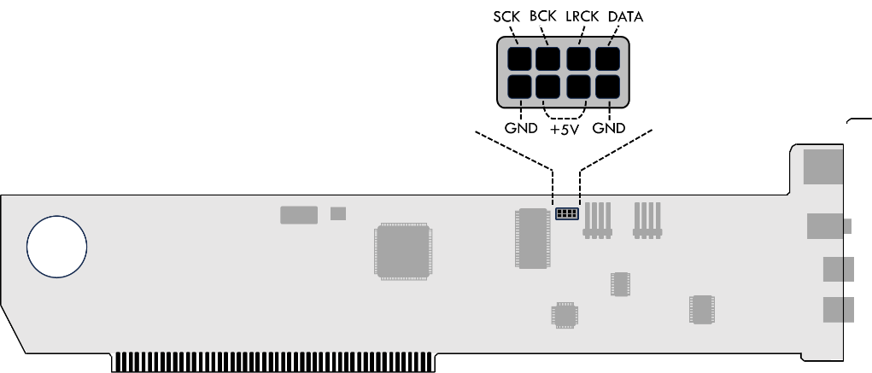

* 1. External Audio Setup

Pictured below are the different external audio output ports of the AmiGUS.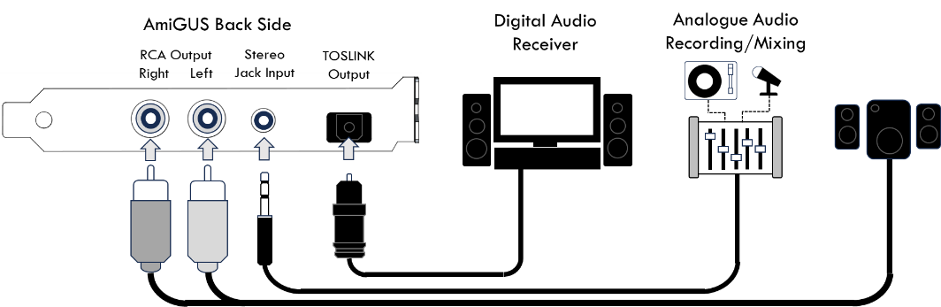

The AmiGUS card provides both a line-level RCA stereo output and a TOSLINK optical output to connect to a household stereo receiver equipment.

The TOSLINK output is very flexible and supports multiple sampling rates accommodating your output devices capabilities. The default output sampling rate is 48kHz, which should be compatible with all equipment providing a TOSLINK interface. Output rate can be adjusted in the mixer settings.

The external input can be used to either loop-through the Amiga’s external audio output by using a Cinch-to-3.5mm adaptor cable, or to connect any other analogue sound source which supports line-level audio output.

1. Software Tools
   1. Installation

The AmiGUS software comes in the following packages:

* Two LHA archives for **OS1.3** and **OS2.x/3.x**
* Three sets of ADF files
  + For **OS1.3**
  + For **OS2.x/3.x**
  + One shared **Manual Disk**

We don’t recommend useing the OS1.3 versions for installation on newer AmigaOS revisions.

Some features present in the OS2.x/3.x package, such as AHI support, are not available on OS1.3.

* + 1. OS1.3 Installation

The AmigaOS 1.3 disk provides installers in different languages as simple shell scripts.

They open a window expecting the user to provide input via keyboard. Positive acknowledgements are triggered by pressing the **<Y>** key, negative or rejection can be expressed by pushing the **<N>** key, followed by the **<RETURN>** or **<ENTER>** key.

You may be asked to enter target installation paths, e.g. for the AmiGUS base tools.

The default installation path of AmiUS tools and manual is **Sys:Expansion/AmiGUS** – which may collide with some versions of Commodore’s Janus bridgeboard software.

If you experience any issues, please delete the AmiGUS software installed in that location, reinstall and select another path.

**Installation procedure - AmiGUS base tools**.

These are the service tools described in sections **3.1 Mixer Tool** and **3.2 FPGA Flash Tool** and the basic functionality tools **PlayMIDI,** **PlayMP3**, **PlayWav** and **Record**. The recommendation is to install them to the default path.

**Installation procedure - AmiGUS debug tools.**

These are described in the manual section **6 Driver troubleshooting.** They are meant to provide developers with additional debug information in case an AmiGUS user experiences issues, helping to diagnose whether these are related to the card, the drivers or other software.

For OS1.3, these are only available for the MHI driver so far. For non-developers, the recommendation is to skip installing them. If you experience trouble, you can still install them later.

**Installation procedure – MHI driver**

The third installation category installs the MHI driver, described in section **5 MHI Driver Framework**. Since it only works reliably from the default path, there is no option to change the installation path.

**You are being offered the following choices for installation:**

* If you are running **OS1.3** with a **68020** or **68030** CPU only, please use the **68020** version.
* If you are using AmiGUS with an **68000**, choose that library variant, instead.
* There is no support for **68040/060** in OS1.3.

For developers, or users helping us to troubleshoot issues, we do offer various debug versions of the MHI drivers here. Otherwise, our recommendation is to just use the default RELEASE versions.

The final choice in this category is putting all available drivers, without renaming them, to disk, so you can use them later for testing purposes. The general recommendation is to skip this option.

**Installation procedure – Additional libraries**

As part of the OS 1.3 installation, additional libraries are required such as **reqtools.library 38.390, Copyright © 1991-1994 Nico François**. The installation script will check for a previously installed version and ask before overwriting anything. Recommendation is to do so, as the library is needed for selecting firmware update files in the FlashGUI.

The last step is to optionally install the AmigaGuide manual. To use any AmigaGuide on AmigaOS versions earlier than 3.0, you will need to install the "AmigaGuide Development" version from:

<https://aminet.net/text/hyper/aguide34.lha>

To enable display of images as well, you need to copy **iffparse.library** from OS2.0 to your OS1.3 installation.

* + 1. OS2.x / 3.x Installation

On OS2.0 and later, the AmiGUS software installation relies on the Amiga Installer being available, which is part of the AmigaOS installation since OS2.1

Therefore, if you are installing the AmiGUS software on OS2.0, you may need to install the Installer from:

<https://aminet.net/util/misc/Installer-43_3.lha>

While we successfully tested the installation with an early Installer from OS2.1, Installer 43.3 is recommended in case you experience any kind of issues..

Similarly, to read the provided documentation in AmigaGuide format on OS2.0 and OS2.1, you will need to install the "AmigaGuide Development" version from:

<https://aminet.net/text/hyper/aguide34.lha>

The AmiGUS AmigaGuide manual has been designed to look best using OS3.2 and above, but you can at least conveniently read it using an older version.

The installation comes in multiple languages, but if you would like to see the installation procedure or the manual translated to other languages, feel free to reach out to us via our github presence.

**The following installations are available:**

**Novice User**

Installs all recommended parts without further modifications to the recommended file destinations. This should work fine for most users

**Please Note:**

* If you change your CPU after installation and experience issues running any AmiGUS software, you may need to reinstall the drivers.
* The default installation path of AmiGUS tools and manual is **Sys:Expansion/AmiGUS**. This path may collide with some versions of Commodore's Janus bridgeboard software. If you experience any issues, please delete the AmiGUS software installed to that location, reinstall and select another path.

**Intermediate User**

Here, you may pick and choose a lot of options. For more details, please refer to the help texts embedded into the Installer when pushing the **"Help"** buttons when available.

**Expert User**

In addition to the above, only "Expert User" level installations allow for placing all CPU or debug versions of AHI and MHI drivers next to the activated ones.

Please keep in mind, using AHI and MHI requires additional software. Refer to sections **4 AHI Driver Framework** and **5 MHI Driver Framework** for a detailed description.

* 1. Mixer Tool

The AmiGUS Mixer Tool provides individual volume control over the various sound sources being processed and mixed by the digital sound processor.

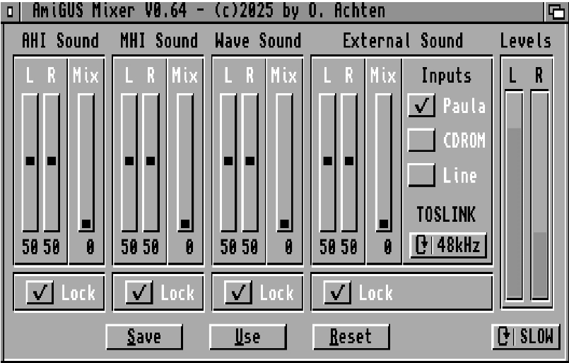

Across the panels, you can adjust the volume using the **Left / Right** volume sliders for channel-independent control. When the **Lock** button is enabled, Left /Right are always set to equal values when the sliders are changed.

By using the **Mix** slider, it is possible to cross-mix the stereo audio signal, thus lessening the amount of channel separation.

* + 1. Mixer Panel Descriptions

Below you will find a description of each panel’s functionality and configuration options.

|  |  |
| --- | --- |
| **Panel** | **Description** |
| **AHI Sound** | This panel provides volume control over all sounds which are played back using the AHI driver framework. |
| **MHI Sound** | This panel provides volume control over all sounds which are played back using the MHI driver framework, output by the VS1063 audio codec. |
| **Wave Sound** | This panel provides volume control over all sounds which are played using the 32 voice wavetable engine. |
| **External Sound** | **General**  This panel provides volume control over all external sounds such as the PAULA, CDROM and Line Input.  **Inputs**  You can enable or disable each of the external audio inputs by clicking on the individual boxes.  **TOSLINK**  By clicking on the cycle-gadget, you can set the audio sample rate of the TOSLINK output. Available options are 48kHz, 96kHz and 192kHz. |
| **Levels** | Realtime display of the stereo audio signal levels. By clicking on the cycle gadget below, you can control the display’s update rate. |
| **Save / Use / Reset** | Save, Use or Reset the Mixer settings to their default values. The settings are automatically loaded when the Amiga is started or reset. |

* 1. AmiGUS Flash Tool

The AmiGUS Flash Tool provides full control over the AmiGUS FPGA firmware settings.

This includes updating the firmware, displaying the card’s hardware status or initialising the configuration data used for the mixer settings.

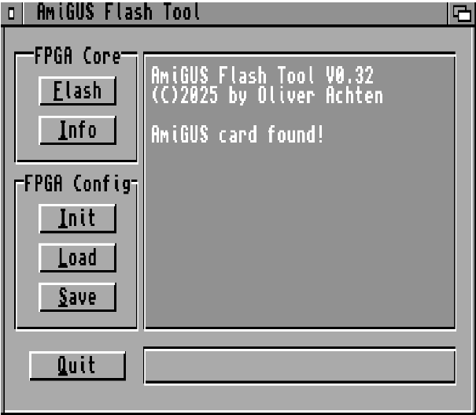

* + 1. Available Options

|  |  |
| --- | --- |
| **Panel** | **Description** |
| **FPGA Core** | **Flash**  You can directly update the AmiGUS firmware by clicking on this button and selecting the appropriate FPGA .upd file. Once an update file is selected, you can follow the update progress on the status bar below, which can take up to 30 seconds. The firmware update becomes effective after power-cycling the Amiga.  **Info**  Displays information about the FPGA revision, serial number and the state of the card’s configuration, containing the mixer settings. |
| **FPGA Config** | **Init**  Initializes the card’s mixer settings to their default values. This should be selected in case the card’s sound output is not correct. The settings become effective after a reset.  **Load**  Loads the card’s mixer settings from file, and flashes them to the internal configuration flash. The loaded settings become effective after a reset.  **Save**  Saves the card’s mixer settings to a file, which can be re-flashed by using the Load option. |

1. AHI Driver Framework

AHI is a retargetable audio subsystem for Amiga-like operating systems, originally developed by Martin Blom.   
Not only have major audio applications, like SoundFX and DigiBooster adapted this standard, but many PC/Windows ports, Mac emulators, and even some exclusive software titles have implemented their audio functionality employing AHI to allow use of sound cards for playback and recording.

Although AHI 6.0[1] is available for download, AHI 4.18[2] is assumed to be faster and therefore strongly recommended for use on 68k-based systems. You need choose one of them and install it following their respective own manuals.

Before configuring AHI for use with AmiGUS, please verify that AHI is working correctly. AHI comes with a Paula driver which is sufficient for that purpose.

**Please note:**

* AHI 4 requires AmigaOS 2.0 or later to work.
* The AHI 4 preferences editor shown below uses MUI 3.8[3],  
  the non-MUI version works in a similar fashion.
* AHI 6 **(not recommended)** requires a 68020 processor or better.
* Due to limitations of the AHI framework, AmiGUS’ AHI driver is limited to a 64000Hz mixing rate.
  1. Using AHI with AmiGUS

AHI shall be your last resort for making software use your AmiGUS.

* For playback of encoded music like MP3, FLAC, or OGG, please use MHI and let AmiGUS Hardware Codec do the heavy lifting,
* For tracker music, use a player with native support for the AmiGUS wavetable engine, e.g. HippoPlayer or EaglePlayer.
* If none of the above works for your application – here comes AHI. And only here.
  1. Selecting AHI modes

AHI modes need to be carefully selected to fit the purpose.

**Example: Quake (clickboom) mixes audio in 16bit, 11025 Hz.**

* If you select an **8-bit** audio mode, you **lose playback quality.**
* If you select a **24-bit** audio mode, you **waste precious CPU time.**
* If you select a sample rate less than 11025 Hz…   
  well, you will not want to hear it anyway.
* If you select more than 11025 Hz, you waste resources again.
* If you do not at least select a multiple of 11025 Hz (like 1x, 2x, 4x), you force AHI to re-render the audio stream,   
  wasting even more CPU time.

But how do you determine the right AHI settings?

AmiGUS comes with an overwhelming number of choices.

**Here are some guidelines:**

* If your game or application displays resolution (“…16-bit…”) and sample rate (“…44.1kHz… ” or “…11025Hz…”) information, please use that information to adapt the AHI mode accordingly.
* Otherwise, for PC ports, **16-bit** resolution and **44100 Hz** are usually fine.
* **“Mono”** modes do not save a lot of CPU time, avoid them.
* **“Stereo”** modes know “left” and “right” and nothing inbetween. This is fine for PC ports, as they will apply their own mixing.
* **“Stereo++”** modes allow positioning instruments between the “left” and “right” extremes, but these are useful only if the client software can use it. PC ports usually cannot, and you may waste resources here. DigiBooster for example can benefit from it.
* **“Fast…”** modes take a bunch of shortcuts, saving a lot of CPU time, but potentially harming the audio quality, if you do not hit the correct resolution and sample rate – really recommended if you are sure about both settings!
* **“HiFi…”** modes are optimized for best possible quality and slower.   
  Avoid them for games, if you are short on CPU time, but recommended for enjoying music as good as possible!
  1. Configuring AHI for AmiGUS

After all that theoretical foundation, you are ready to select AmiGUS modes using the AHI preferences editor usually installed to **Sys:Prefs/AHI**. Please start it from there by double-clicking on its icon.

**Recommendations:**

* **Define a dedicated music mode**, using all AmiGUS can deliver,   
  “HiFi 24 bit stereo++” in 48000 Hz, and **use it only for music.**
* **Define some game modes**, “Fast 16 bit stereo” in 11025 Hz, 22050 Hz, and 44100 Hz each and **use them for your favourite PC ports.**

Ein Bild, das Text, Screenshot, Display, Software enthält.

* + 1. Available Options

|  |  |
| --- | --- |
| **Panel** | **Description** |
| **Left** | **AHI unit toggle (Music unit / Unit 0 / … 1 / … 2 / …3)**  AHI supports defining up to five preset modes, the default “Music unit” and the units 0, 1, 2, and 3.  **AHI Mode list**  We love Paula, but this is about AmiGUS. So AmiGUS should be selected as the default input/output device from the list.  **Mode details**  Informational display only, but if the text looks broken or is empty, you know something is very wrong. |
| **Right (Options)** | **Frequency**  Select the desired sample rate using the slider.  **Volume**  Recommendation is to move the slider to the far right, +0.0dB and use the AmiGUS Mixer to adapt the volume to your needs.    **Gain**  Sets the input gain – recommended to set to +0.0dB, too.  **Input**  Selects the audio sources to record.  AmiGUS AHI driver allows recording Wave, MHI / Codec, external sound, and “what you hear” / all sources for the time being. |

|  |  |
| --- | --- |
| **Buttons** | **Save**  Applies all changes, stores them permanently, so they survive a reboot and closes the AHI preferences editor.  **Use**  Applies all changes and closes the AHI preferences editor, without saving the settings permanently. Can be used for testing.  **Cancel**  Discards all changes and closes the AHI preferences editor. |

1. MHI Driver Framework

MHI is a standard for retargetable encoded audio for classic Amigas.

AmiGUS comes with the VLSI VS1063a audio codec chip supporting

* MP3 (MPEG 1 & 2 audio layer III, with CBR, VBR, and ABR)
* MP2 (layer II)
* MPEG4 / 2 AAC-LC (with PNS), HE-AAC v2 (Level 3) (SBR + PS)
* Ogg Vorbis
* FLAC
* WMA 4.0/4.1/7/8/9 all profiles (5-384 kbps)
* WAV (PCM, IMA ADPCM, G.711 (µ-law/A-law), G.722 ADPCM)

Unlike AHI, MHI comes without separate system-wide preferences. Each application implements their own way of setting and selecting the desired MHI compatible library for the installed hardware.

Per default, AmiGUS’s MHI driver is installed to **Libs:mhi/mhiamigus.library** on AmigaOS 2.0 or later.

On AmigaOS 1.3, there are problems loading libraries from locations other than Libs:, hence it will be installed to **Libs:mhiamigus.library** to ensure hassle-free usage.

* 1. Example: MHI in AmigaAmp

As Thomas Wenzel not only created AmigaAMP[4] but has also been co-authoring MHI, integration of both works almost perfectly, including equalizer functionality.

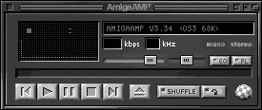

After starting AmigaAMP, open the **Preferences** via the Project menu entry.

Ein Bild, das Text, Schrift, Screenshot, Zahl enthält.

In the **Preferences**, navigate to the Decoder tab, select the **“MHI Support”** checkbox and click the file symbol next to the **“MHI Driver:”** label.

Ein Bild, das Text, Screenshot, Display, Zahl enthält.

Navigate to **Libs:MHI** and select the **mhiamigus.library**. Library names are case-sensitive.

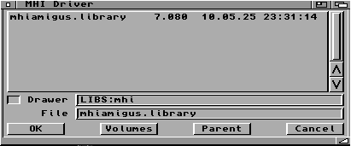

Confirm with the **“OK”** button, then close and confirm the preferences dialog with the **“Save”** button. You may need to restart AmigaAMP immediately.

Add a few mp3 files to your playlist and enjoy!

* 1. Example: MHI in HippoPlayer

HippoPlayer[5][6] by K-P Koljonen not only works from AmigaOS 1.2 upwards but has also been successfully tested with MHI on AmigaOS 1.3 on 68000 CPUs. Even better, it also supports AmiGUS the wave table engine natively for tracker module playback starting with version 2.62 or later.

Ein Bild, das Text, Screenshot, Schrift, Zahl enthält.

Click the **“Pr”** button to open the HippoPrefs window.

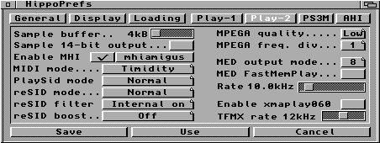

Navigate to the **“Play-2”** tab, select the **“Enable MHI”** checkbox and push the **“mhiamigus”** button right next to it shown above.

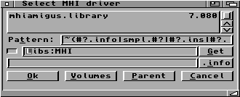

Navigate to the **mhiamigus.library** in AmigaOS 1.3 that will be in **Libs:**, in AmigaOS 2.0 and above it will be in **Libs:MHI**. Select it, push the **“OK”** button, save the preferences using the “**Save”** button.

Add a few mp3 files to your playlist and enjoy!

1. Driver Framework troubleshooting

AHI and MHI drivers come with release and debug versions. Never use the debug versions for normal operations – they may introduce more crashes and are slower.

* **“…-SER_LOG”** versions of the drivers log to the serial port of the Amiga. You may use Sashimi to redirect the output back into a Workbench window, but the speed of that debug output is limited, and therefore the level of detail as well. A real null-modem cable can be used to get the output to another computer. Please find a link to a tested wiring at [7].
* **“…-FILE_LOG”** versions of the drivers log to a file on the Amiga. By default, this is **“RAM:AmiGUS-?.log”,** but can be adapted on AmigaOS 2.0 and above using   
  **“setenv AmiGUS-AHI-LOG-FILEPATH SYS:my_AHI_log.txt”** or   
  **“setenv AmiGUS-MHI-LOG-FILEPATH SYS:another-Log-MHI.txt”** respectively. Please be careful to not overwrite important files and be prepared in the event your drive may want to validate for a long time in case of crashes!
* **“…-MEM_LOG“** debug versions of the drivers allocate a chunk of memory and leave their messages in there. This is as fast as it can be and as noisy as it can get, survives crashes well and will be requested in case of bug reports. **“setenv AmiGUS-AHI-LOG-ADDRESS 1234560”** or   
  **“setenv AmiGUS-MHI-LOG-ADDRESS 1234560”** sets the log address in case the automatic methods fail. Beware, the addresses are noted in decimal. The memory size can be adapted to fit your machine using   
  **“setenv AmiGUS-AHI-LOG-SIZE 512”** or

**“setenv AmiGUS-MHI-LOG-SIZE 512”** with a decimal memory size.

**Beware:** this is just for allocation and protecting the resulting logs. The drivers do not stop producing more logs behind the end of that memory slab.  
Even after a crash, the GetMem#?Log tools can retrieve the respective log files.

We hope you will never need this information - please be patient, we did our best!

1. Appendices
   1. Credits

**AmiGUS concept & hardware design**

Oliver Achten

**AmiGUS drivers**

Christoph Faßbach

**Special thanks to**

Simon Neumann

Torsten Hees

Thomas Ziegert

Kari-Pekka Koljonen

Henryk Richter

Greg Donner

* 1. References

1. <https://aminet.net/driver/audio/m68k-amigaos-ahiusr.lha>

  
2. <https://aminet.net/driver/audio/ahiusr_4.18.lha>
3. <https://aminet.net/util/libs/mui38usr.lha>
4. <http://www.amigaamp.de/Binaries/AmigaAMP3-68k.lha>
5. <https://aminet.net/mus/play/hippoplayer.lha>
6. <https://aminet.net/mus/play/hippoplayerupdate.lha>
7. <https://www.amigaforever.com/kb/13-105>