ADVANCED AMIGA SOUNDCARD

User Manual

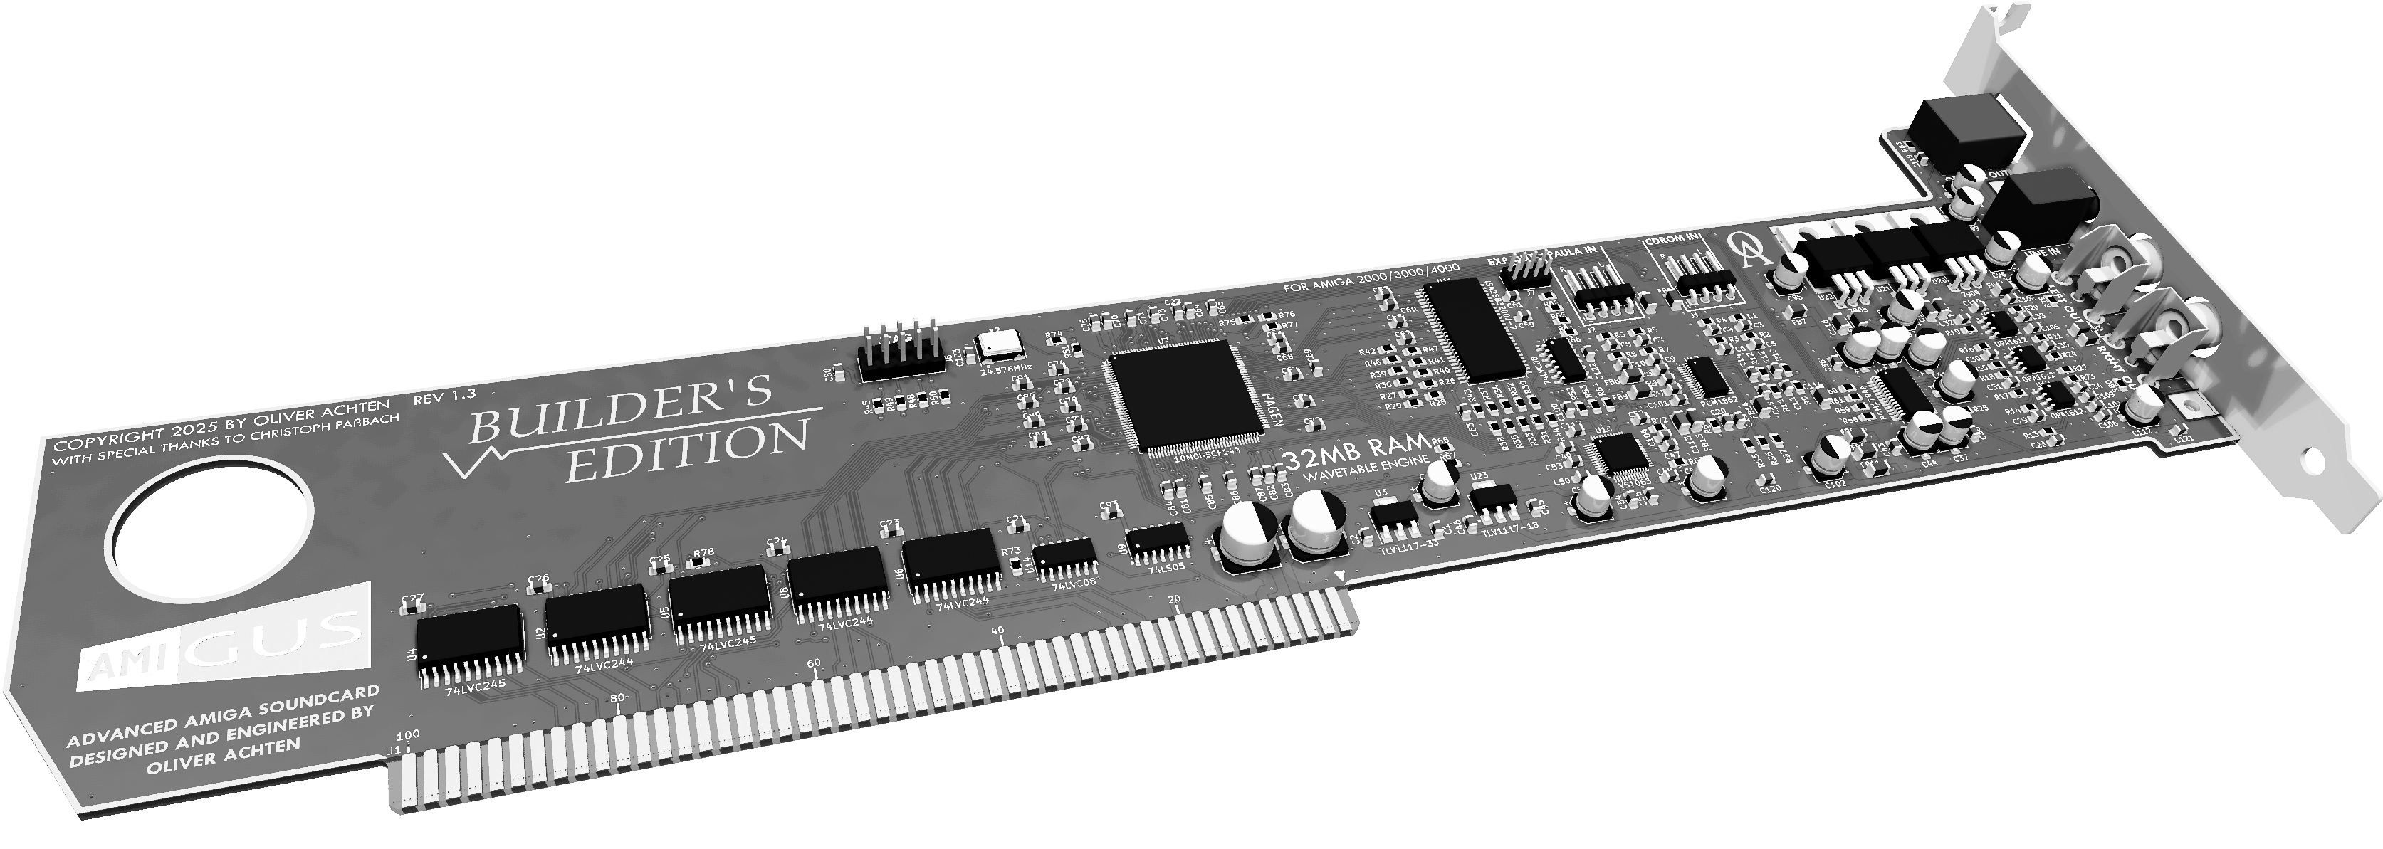

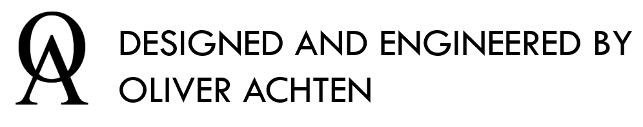

1. Overview
   1. Introduction

Thank you very much for purchasing the AmiGUS soundcard. The AmiGUS was designed to enable high-resolution audio playback on your Amiga computer. All audio processing is making extensive use of hardware acceleration in order to provide this quality even on low-end Amiga configurations.

* 1. AmiGUS Key Features
* Zorro II bus interface for Amiga 2000,3000,4000 computers and compatible bus boards
* 24-bit, 192kHz stereo sample DAC and ADC
  + 1 analogue audio stereo output
  + 3 analogue audio stereo inputs
* TOSLINK optical output, supporting 48, 96 & 192kHz @ 24-bit resolution
* MP3 / OGG Vorbis hardware codec chip (VLSI VS1063)
* Digital sound processing accelerator chip
  + 3 separate software interfaces (AHI, MHI, MIDI/Wave)
  + 32 hardware voices
    - 8 / 16-bit playback
    - Stereo panning
    - Per-voice linear sample interpolation
    - Hardware ADSR envelope
  + Full 24-bit 192kHz processing & mixing paths
  + Hardware accelerated data transfers to / from DAC, ADC & MP3 chips
* 32 MB wavetable RAM
  1. Hardware Overview

In the following picture you can see an overview of the AmiGUS card, its interfaces and the main hardware components which provide the card’s functionality.

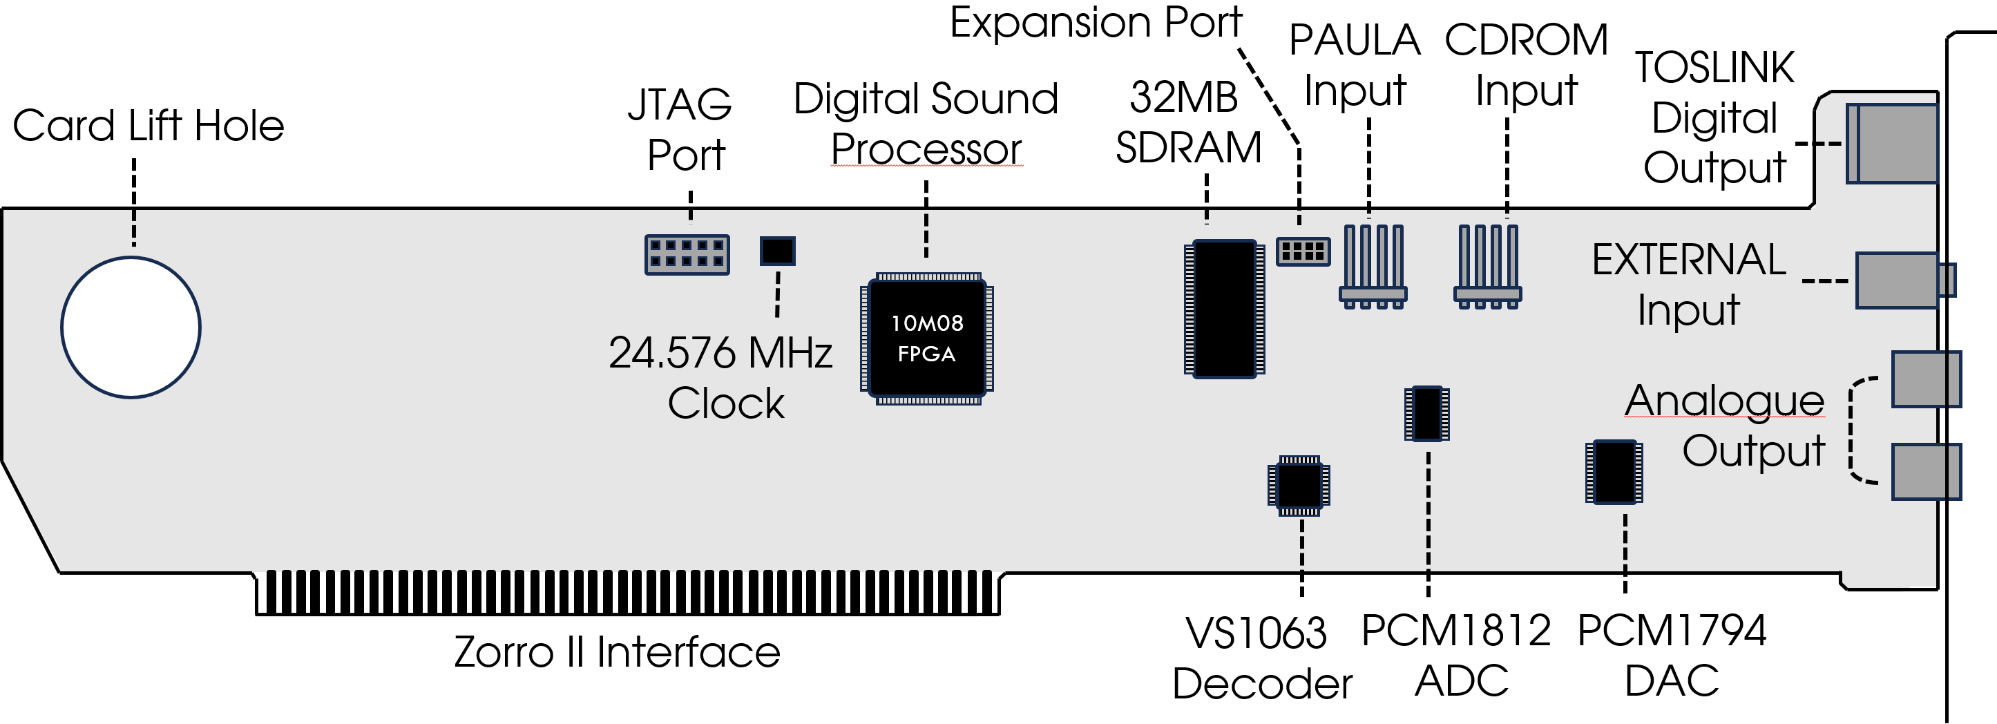

* + 1. Hardware Ports

|  |  |
| --- | --- |
| **Port Name** | **Function** |
| **JTAG Port** | Connects to an Altera FPGA programmer to flash and debug the FPGA. Should only be used for initial programming or servicing the card. |
| **Expansion Port** | Direct digital audio signal which can be provided to other cards to process the AmiGUS final mixer output. |
| **TOSLINK Digital Output** | TOSLINK output which connects to an optical interface. AmiGUS supports up to 192kHz, 24-bit audio data rates over this link. |
| **Analogue Output** | Standard RCA jacks which connect to an analogue stereo line-level input. |
| **PAULA Input** | This port can directly connect to the AMIGA’s native PAULA audio signal, which is mixed and output with the AmiGUS final output. |
| **CDROM Input** | You can directly connect an internal CDROM audio cable to this port, which allows mixing the CD audio coming from the drive with the AmiGUS final output. |
| **External Input** | Line-level input to connect and mix an external audio stereo source via 3.5 mm audio jack. |

* + 1. Hardware components

|  |  |
| --- | --- |
| **Component** | **Function** |
| **Digital Sound Processor (HAGEN)** | The Digital Sound Processor (HAGEN) is responsible for most of the digital sample processing and mixing. It directly connects to the Amiga’s Zorro bus and provides all necessary interfaces to the memory and audio support chips. |
| **32MB SDRAM** | This SDRAM memory chip can store up to 32MB of audio sample data for digital playback and mixing. |
| **VS1063 Hardware Codec** | The VS1063 is a hardware codec made by VLSI which supports hardware accelerated decoding of compressed audio streams such as MP3 or Ogg Vorbis. |
| **PCM1812 ADC** | The PCM1812 ADC made by Texas Instruments is responsible for converting all external audio inputs to a digital stream which is processed and mixed by the Digital Sound Processor. |
| **PCM1794 DAC** | The PCM1794 DAC made by Texas Instruments receives the final mixed digital audio stream and converts it to a line-level analogue audio signal. The audio data rate is always 24-bit, 192kHz. |
| **Zorro II Interface** | AmiGUS implements a Zorro II bus interface which supports full autoconfig and interrupt handling. |

* 1. System Requirements

In order to make full use of AmiGUS features, the following range of system configurations is recommended.

* + 1. Minimum Configuration
* Amiga 2000 computer
* 1 MB Chip, 4 MB Fast-Ram
* 68000 CPU, 7MHz
* Kickstart 1.3
  + 1. Recommended Configuration
* Amiga 2000, 3000, 4000 computer
* 2 MB Chip, 16 MB Fast-Ram
* 68030 CPU, 25MHz
* Kickstart 2.x / 3.x

1. Installation
   1. Card Installation

Turn off your Amiga computer and lift up the case cover after removing the necessary screws according to your Amiga’s User Manual. Find an empty Zorro slot, remove the place-holder bracket after unscrewing it and gently insert the AmiGUS card in the slot socket, while carefully aligning the card on both ends to the support bracket and slot opening of the case. When done, re-use the bracket screw to mount the card’s bracket to the case.

If you have an internal CD-ROM, connect the CD-ROM’s analogue output located on the back of the drive with the CD-ROM input of your AmiGUS card.

In order to loop-through the native Amiga audio signal, you can either use the AUDIOT board delivered with your card, or, depending on your configuration, use the audio output which might be present on one of your extension cards.

Please refer to chapter 2.2 for a more detailed description of the AmiGUS internal audio ports and use-cases.

When everything is set-up, place the cover back on your Amiga and re-tighten all screws back according to your Amiga’s User Manual.

* 1. Internal Audio Set-Up
     1. Internal CD-ROM

You can directly connect an internal CD-ROM drive to the AmiGUS CDROM Input via the supplied audio cable of your drive.

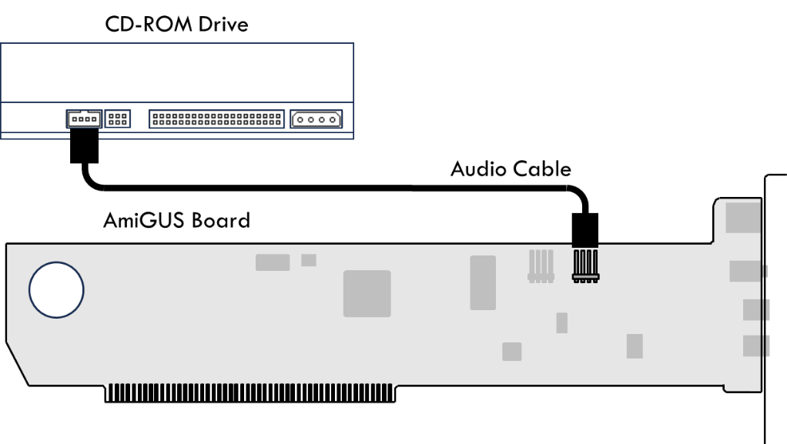

* + 1. Paula loop-through via AUDIOT board

The AUDIOT board needs to be inserted into the video slot and connected to the AmiGUS via the supplied audio cable.

This option is feasible for configurations where the video slot is not used by any card such as a flickerfixer or genlock.

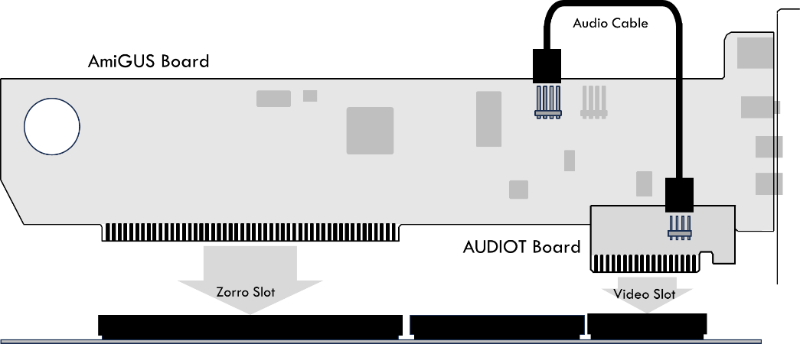

Please note that the AmiGUS and AUDIOT board must be placed in different slot lanes in order to physically fit.

* + 1. List of known hardware extensions with PAULA audio output

For configurations which already use the video slot, there are options available to loop the internal PAULA signal to the AmiGUS without using the AUDIOT board.

Below you will find a list of boards which do supply PAULA audio output.

|  |  |
| --- | --- |
| **Hardware** | **Description** |
| **Multifix AGA Flickerfixer** | The card provides the Amiga audio and ground signals on JP1 & JP3. |
| **ZZ9000 GFX Board** | The card provides the Amiga audio signal on J6. |

* + 1. Digital Audio Expansion Port

The digital audio expansion port provides the final mixed audio signal as a 192kHz, 24-bit I2S digital audio stream.

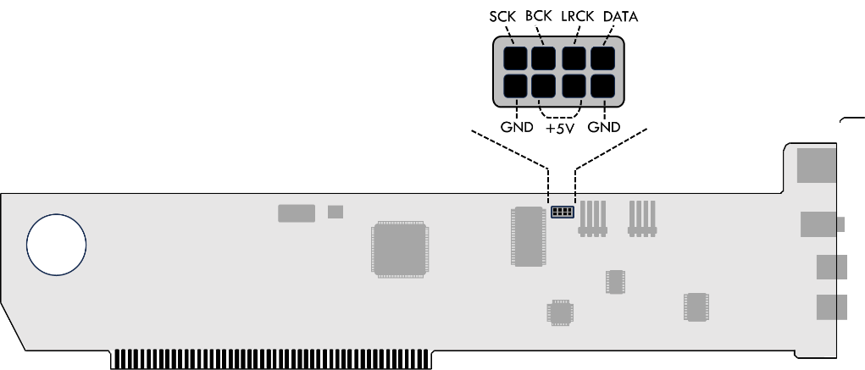

* 1. External Audio Set-Up

Pictured below are the different external audio output ports of the AmiGUS.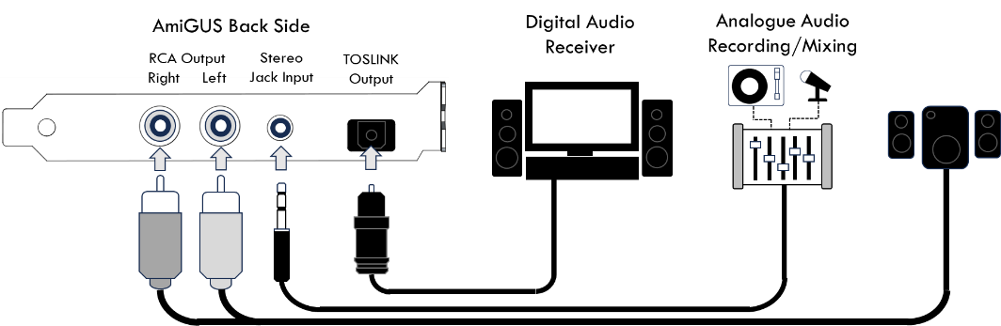

The AmiGUS card provides both a line-level RCA stereo output and a TOSLINK optical output to connect to a household stereo receiver equipment.

The TOSLINK output is very flexible and supports multiple sampling rates accommodating your output devices capabilities. The default output sampling rate is 48kHz, which should be compatible with all equipment providing a TOSLINK interface. Output rate can be adjusted in the mixer settings.

The external input can be used to either loop-through the Amiga’s external audio output by using a Chinch-to-3.5mm adaptor cable, or to connect any other analogue sound source which supports line-level audio output.

1. Software Tools
   1. Installation

TBD

* 1. Mixer Tool

The AmiGUS Mixer Tool provides individual volume control over the various sound sources which are being processed and mixed by the digital sound processor.

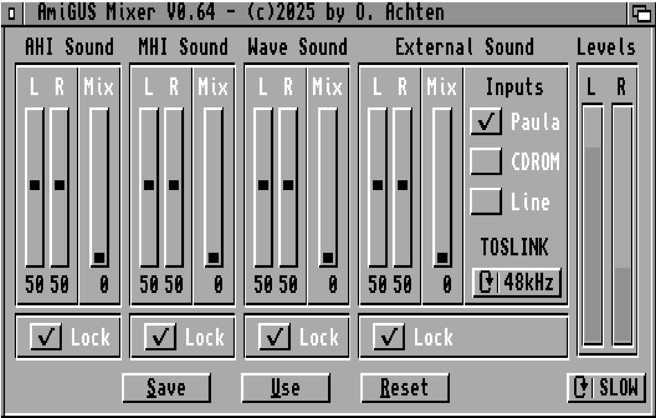

Across the panels, you can adjust the volume using the **Left / Right** volume sliders for channel-independent control. When the **Lock** button is enabled, Left /Right are always set to equal values when the sliders are changed.

By using the **Mix** slider, it is possible to cross-mix the stereo audio signal, thus lessening the amount of channel separation.

* + 1. Mixer Panel Descriptions

Below you will find a description of each panel’s functionality and configuration options.

|  |  |
| --- | --- |
| **Panel** | **Description** |
| **AHI Sound** | This panel provides volume control over all sounds which are played back using the AHI driver framework. |
| **MHI Sound** | This panel provides volume control over all sounds which are played back using the MHI driver framework, output by the VS1063 audio codec. |
| **Wave Sound** | This panel provides volume control over all sounds which are played using the 32 voice wavetable engine. |
| **External Sound** | **General**  This panel provides volume control over all external sounds such as the PAULA, CDROM and Line Input.  **Inputs**  You can enable or disable each of the external audio inputs by clicking on the individual boxes.  **TOSLINK**  By clicking on the cycle-gadget, you can set the audio sample rate of the TOSLINK output. Available options are 48kHz, 96kHz and 192kHz. |
| **Levels** | Realtime display of the stereo audio signal levels. By clicking on the cycle gadget below, you can control the display’s update rate. |
| **Save / Use / Reset** | Save, Use or Reset the Mixer settings to their default values. The settings are automatically loaded when the Amiga is started or reset. |

* 1. FPGA Flash Tool

The FPGA Flash Tool provides detailed control over the AmiGUS FPGA firmware settings.

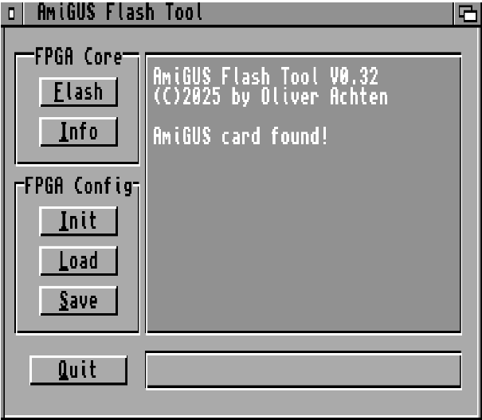

* + 1. Available Options

|  |  |
| --- | --- |
| **Panel** | **Description** |
| **FPGA Core** | **Flash**  You can directly update the AmiGUS firmware by clicking on this button and selecting the appropriate FPGA .upd file. Once an update file is selected, you can follow the update progress on the status bar below, which can take up to 30 seconds. The firmware update becomes effective after power-cycling the Amiga.  **Info**  Displays information about the FPGA revision, serial number and the state of the card’s configuration, containing the mixer settings. |
| **FPGA Config** | **Init**  Initializes the card’s mixer settings to their default values. This should be selected in case the card’s sound output is not correct. The settings become effective after a reset.  **Load**  Loads the card’s mixer settings from file, and flashes them to the internal configuration flash. The loaded settings become effective after a reset.  **Save**  Saves the card’s mixer settings to a file, which can be re-flashed by using the Load option. |

1. AHI Driver Framework
2. MHI Driver Framework
3. Appendices
   1. Credits