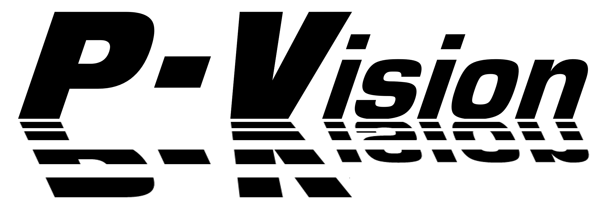

User Manual

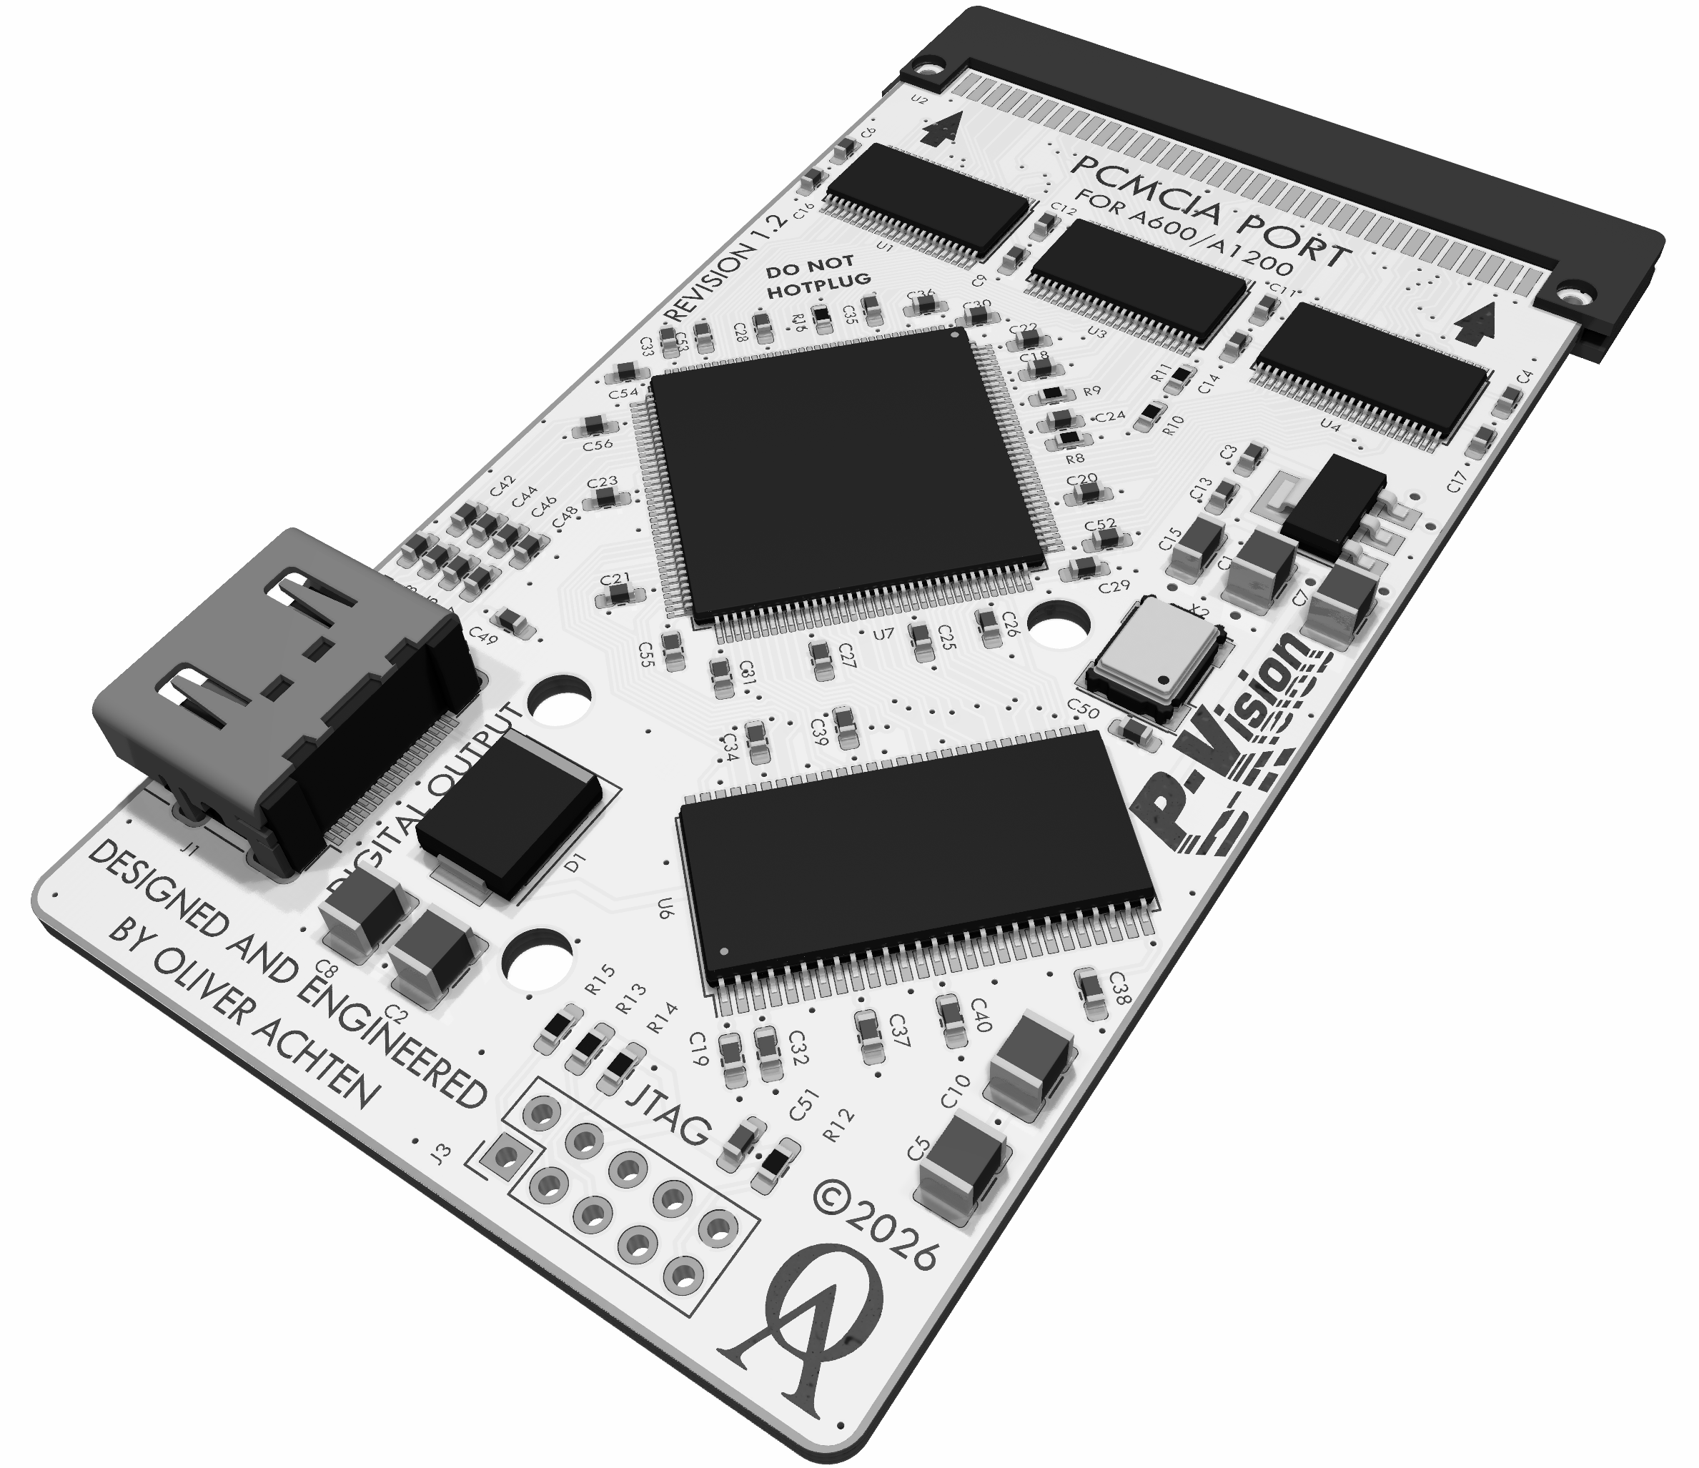

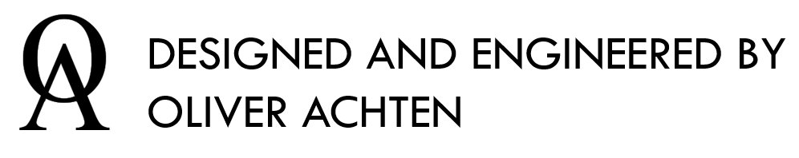
1 Overview 3
2 Installation 6
3 Software Tools 7
4 P-Vision Troubleshooting Guide 13
5 Appendices 15

- Overview
  - Introduction

Thank you very much for purchasing the P-Vision RTG graphics card. The P-Vision was designed to provide a fast, high-resolution video output interface for all PCMCIA equipped Amigas such as the Amiga 600 & 1200. All video processing makes extensive use of hardware acceleration in order to enable these features even on low-end Amiga configurations.

  - P-Vision Key Features

- Fast 16-bit PCMCIA interface
  - 3.5 MB/s on Amiga 600
  - Up to 9.5 MB/s on Amiga 1200
- Digital video output interface
  - 8, 16 and 32-bit color modes
  - Wide range of supported display resolutions (12-85MHz clock), supporting Full-HD resolution
  - 64x64 hardware sprite and smooth scrolling
  - Programmable display processor for flexible display synchronisation and palette context management
- 32 MB video memory
  - 200MHz, up to 360 MB/s total memory bandwidth
  - Hardware memory paging for MMU equipped Amigas
  - 4 MB VRAM for non-MMU equipped Amigas
- 64-bit Hardware BitBlt engine
  - 90MHz, up to 360 Mio pix/s
  - Fast rectangular blits - up to 32768x32768 size
  - Logical function unit with pixel/color bit masking support
  - 16x16 Mono pattern with color expansion & direct host interface for dithering & fast text rendering
  - Hardware Overview

In the following picture you can see an overview of the P-Vision card including its interfaces and the main hardware components which provide the card’s functionality.

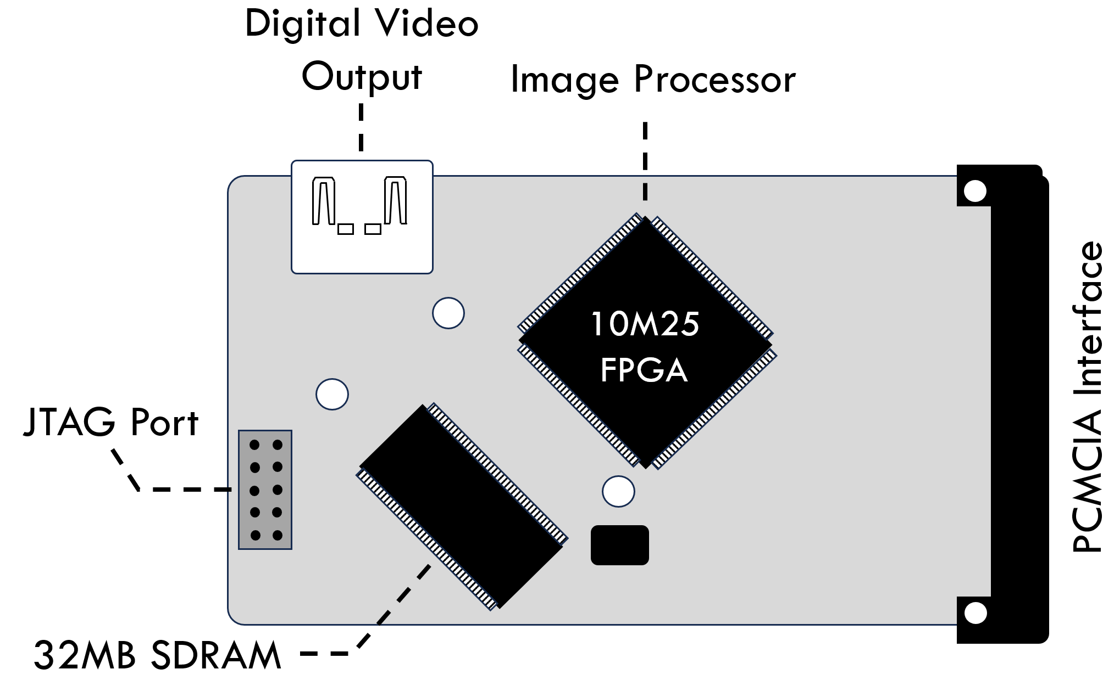
    - Hardware Ports

Port Name | Function
JTAG Port | Connects to an Altera USB Blaster FPGA programmer to flash and debug the FPGA. Should only be used for initial programming or servicing the card.
Digital Video Output | Connects to a modern digital monitor or television providing a high resolution, true color video output.
PCMCIA Interface | The P-Vision PCMCIA interface connects to either an Amiga 600 or Amiga 1200 computer. Please do note that this card does not support hot-plugging.

    - Hardware components

Component | Function
Image Processor | All image processing functions are implemented in the Image Processor using an Altera MAX10 10M25 FPGA device.
32MB SDRAM | This SDRAM memory chip is providing the video memory for all display output and graphics processing.

  - System Requirements

In order to make full use of P-Vision features, the following range of system configurations is supported.

    - Minimum Configuration
- Amiga 600 computer
- 1 MB Chip, 4 MB Fast-Ram
- 68020 CPU, 14MHz
- Kickstart 3.1
- P96 V3.3.0

    - Recommended Configuration
- Amiga 1200 computer
- 2 MB Chip, 16 MB Fast-Ram
- 68030 CPU, 25MHz
- Kickstart 3.2.x
- P96 V3.6.2

- Installation
  - Card Installation

Turn off your Amiga computer and make sure that there is enough space on the left hand side to accommodate the P-Vision.

Insert the P-Vision into the PCMCIA slot of your Amiga and connect your digital monitor or television with a matching cable.

When your Amiga is turned on, the P-Vision will initially not output any video signa on the digital portl, unless you install the RTG graphics software package with the appropriate driver for the P-Vision card.

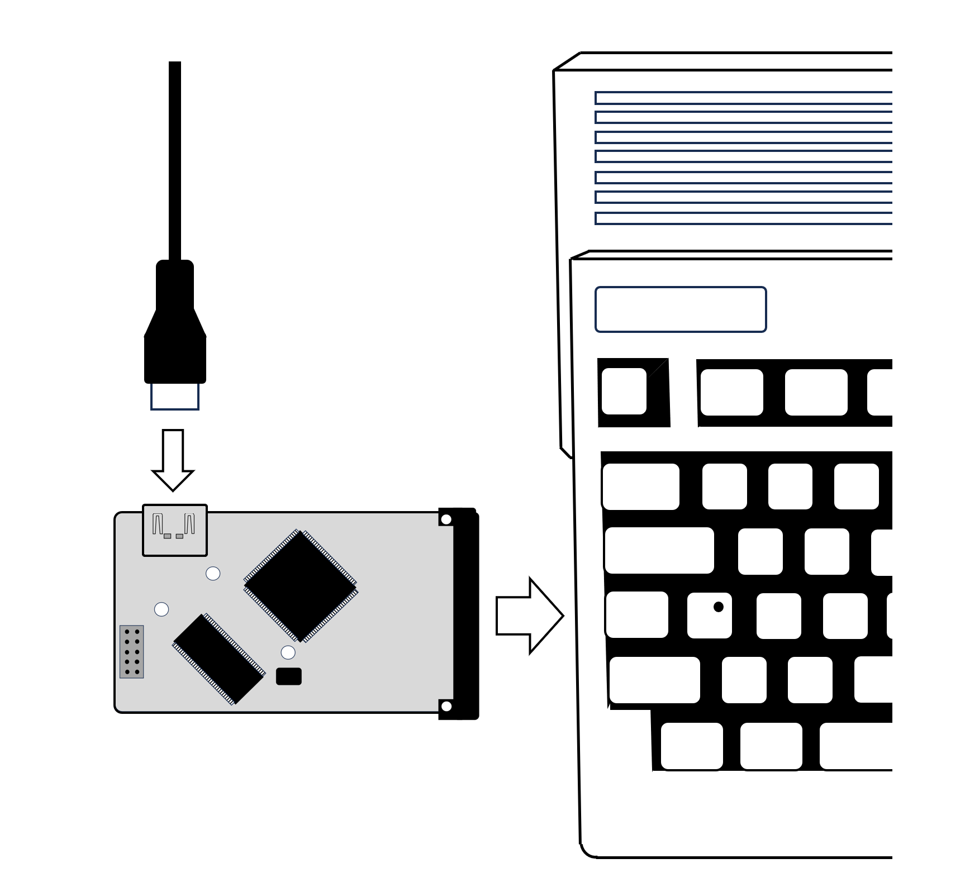

- Software Tools
  - Installation

The P-Vision is a retargetable graphics card (RTG), meaning that all Amiga graphics operations provided by the Amiga OS using the native chipset need to be redirected in order to make use of the hardware functions of the P-Vision Image Processor.
This is, unfortunately, not supported out of the box by the Amiga OS, which is why you need to install an additional software package, which provides the necessary interfaces to use graphics cards on the Amiga.
As a consequence, at the time of writing, the P-Vision requires the following software in order to be fully operational:
- P96 RTG system from Individual Computers
- P-Vision driver for P96 from Thomas Richter
- MMU Library from Thomas Richter to make full use of 32MB VRAM

    - P96 Installation
The first step of installing your P-Vision is to purchase P96 from www.icomp.de using their shop system, or, in case you require further support, writing an e-mail directly to shop@icomp.de
You should be receiving a downloadable archive, which needs to be uncompressed using LHA. Once done, click on the “Install” Icon and follow the installation instructions.

    - P-Vision Driver Installation
At the time of writing of this document (May 2026), the P-Vision driver is not yet part of the P96 installation package, which is planned for the next release of the software (3.6.3 and later).
Therefore, after having installed P96, you need to manually install the driver using the following procedure:
- Download and decompress the archive pVision.lha from www.aminet.net. You can find it in the category driver/video
- Copy the file pVision.card to your SYS:Libs/Picasso96 folder.
- Copy the files pVision and pVision.info to your SYS:Devs/Monitors folder.
- As a recommendation, you can download a set of pre-defined Resolutions from https://github.com/necronomfive/P-Vision_pub. Uncompress the file P96Settings.lha to your SYS:Devs folder, overwriting the already existing file.
The P-Vision driver provides special configuration options, which can be controlled via the ToolTypes of the SYS:Devs/Monitors/pVision.info file.
Tooltype | Function
OVERCLOCK=YES/NO | If you set this tooltype to YES, the extended range of display resolutions from 65-85MHz is enabled. Default setting is YES.
MEMORYCLOCK=166/200 | You can select the memory speed of the P-Vision via this tooltype, affecting the performance of the BitBlt engine and range of supported display resolutions.  P-Vision cards equipped with Winbond SDRAM memory can use a setting of 200MHz, every other vendor requires a setting of 166MHz.
PCMCIASPEED=150/100 | Using this tooltype, you can select the speed of your Amiga’s PCMCIA Interface. This is an option which is only supported on Amiga 1200 computers, therefore the default setting is 150ns for maximum compatibility.  By setting this to 100ns, you enable full-speed access to the PCMCIA port, gaining a significant performance boost which, however, is not supported equally well by all CPU accelerators.  At the time of writing, we have tested this setting successfully on a standard Amiga 1200 configuration with fast ram, Blizzard 1230/40/60, Terriblefire TF1230/60 and the upcoming Demon D1260 card.
MMU=Yes/No | On configurations with native MMUs, you can manually enable or disable the MMU using this setting. The default setting is Yes, which is automatically ignored on non-MMU equipped configurations

    - MMU Library Installation
In order to use the full 32MB video memory, the P-Vision implements an elaborate bankswitching scheme through the 4MB PCMCIA addressing window on Amigas featuring a CPU with a hardware MMU.

If your set-up matches these requirements by having a “full” 68030/040/060 CPU, then you need to download and install the MMU Library from Thomas Richter from https://www.aminet.net/util/libs/MMULib.lha.
After decompressing the archive, please click on the Install icon and follow the installation instructions.

    - Final Steps
Having installed all components, you can now reset your Amiga.

As a next step, you can now select a suitable screenmode for display on your monitor by opening the Prefs/ScreenMode application on your Workbench partition.

If everything has been installed correctly, you can now choose from many new resolutions and color depths, beginning with the pVision: designator.

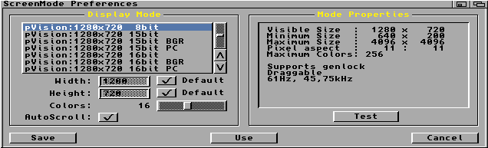

It is recommended to perform a quick “Test” of your selected screenmode before saving your selection, to make sure that your monitor is able to display it correctly.

If you have a working display then, congratulations, your P-Vision has been installed successfully, ready to be used with a broad variety of different applications and games!

  - P-Vision Flash Tool

The P-Vision Flash Tool provides full control over the P-Vision FPGA firmware settings, which includes updating the firmware and displaying the card’s hardware status.

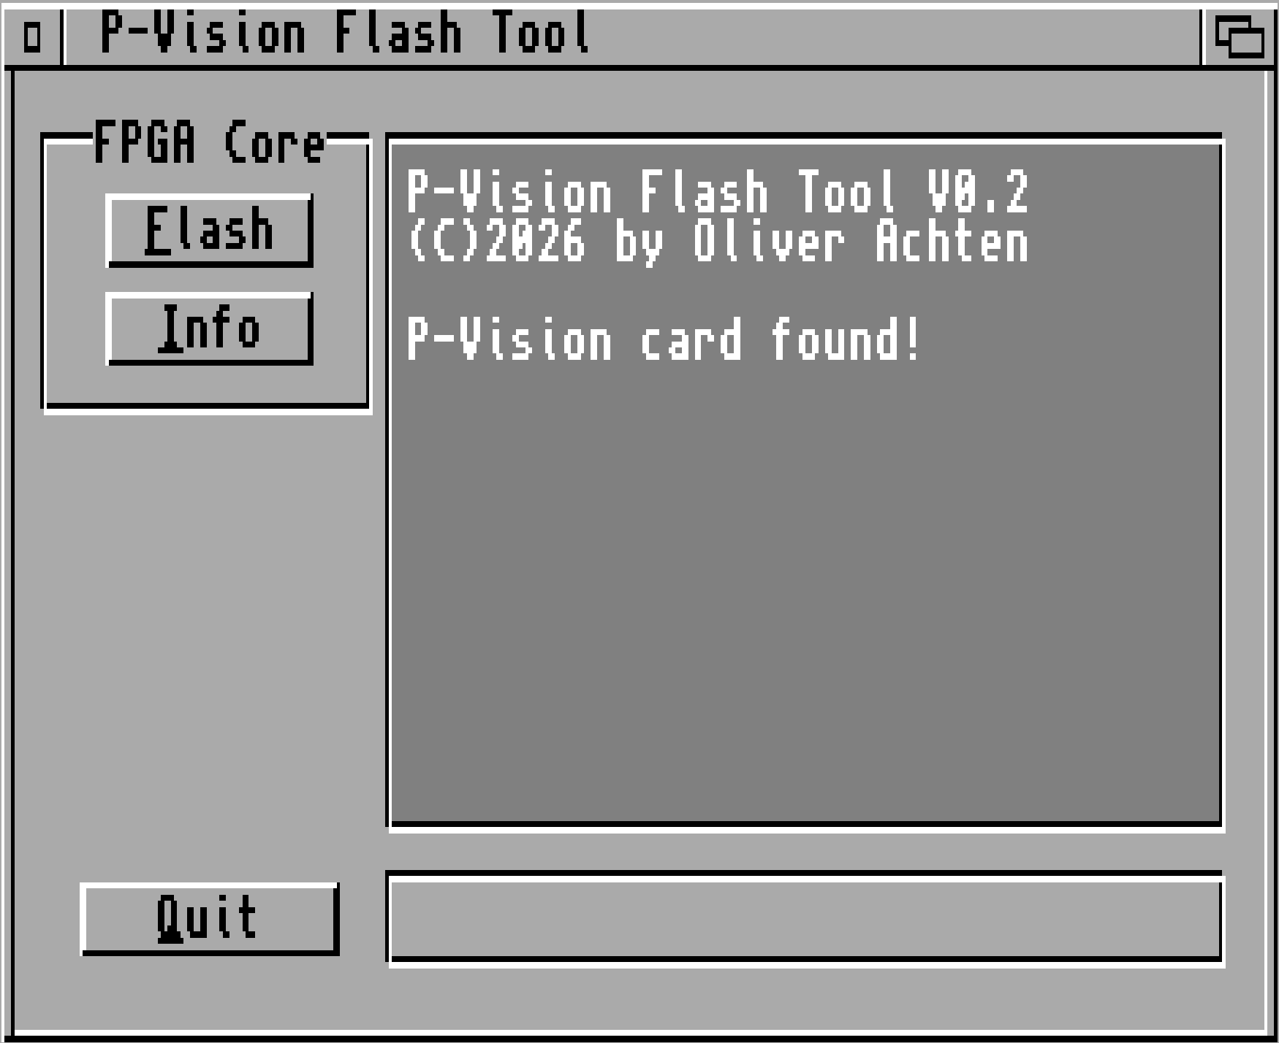

    - Available Options

Panel | Description
FPGA Core | Flash  You can directly update the P-Vision firmware by clicking on this button and selecting the appropriate FPGA .upd file. Once an update file is selected, you can follow the update progress on the status bar below, which can take up to 30-60 seconds. The firmware update becomes effective after power-cycling the Amiga.  Info  Displays information about the FPGA revision, serial number and the state of the card’s configuration, containing the memory and bus clock settings.

- P-Vision Troubleshooting Guide
- Random coloured pixels appear when something is drawn on screen
- My Amiga computer locks up when attempting to open a screen on the P-Vision
Your accelerator card might not be able to support the fast PCMCIA bus mode. As a workaround, try to set the following tooltype in your pVision monitor file
  - PCMCIASPEED=150

- The P-Vision is not recognized when the Amiga is booted
Run the utility Tools/PrepCard located on your Workbench partition and see if the following text appears correctly:
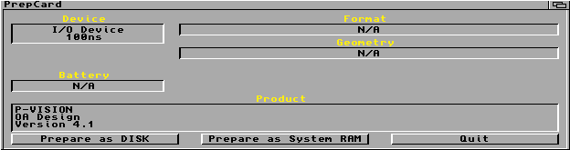
If it’s not displayed correctly, try to gently reseat the card, as it can happen that some PCMCIA ports might be worn due to extensive usage over the years.
Please also note that the P-Vision only works with CPU accelerators which map their local memory in a “PCMCIA friendly” manner, such as the Blizzard, ACA, TerribleFire and the upcoming Demon D1260 accelerators.
- Some resolutions produce an “Out of Range” message on my monitor, although they are supposed to be within the supported range of resolutions and refresh rates
Even though we provide a set of pre-defined screenmode settings for the P-Vision, we can not exclude the possibility that some monitors are less tolerant to variances in the display settings than other monitors.
This is why the P-Vision allows the creation of user-definable display settings via the P96Prefs tool, which is part of the P96 installation package. This includes the ability to modify, or “tweak” the provided display timing settings to increase the chance of hitting a valid operating range which is supported by your particular monitor.
- The P-Vision screen output always freezes when I perform a warm reset on my Amiga 1200
This is a bug in the Amiga OS PCMCIA driver (card.resource), which incorrectly implements the PCMCIA software reset procedure for Amiga 1200 computers.
We have given all required information to the Amiga OS developer team to fix this bug in subsequent releases. In the meantime, we recommend to download the small tool pvision_reset.lha from https://github.com/necronomfive/P-Vision_pub, copy it to your C: directory, and add the following line to the beginning of your s:startup-sequence:
C:pvision_reset >NIL:

- Some resolutions are instable and begin to flicker, when I move objects on the screen, like windows
What you see are problems which occur due to lack of available memory bandwidth to perform the display output and the hardware accelerated BitBlt functions at the same time. This typically occurs at high pixel clock rates (>75MHz) and 32-bit true color depths. We recommend to choose a lower color depth, or tweaking the settings of the affected screenmode in P96Prefs to use a lower pixel clock setting.
- Appendices
  - Credits

P-Vision concept & hardware design

Oliver Achten

P-Vision P96 driver & MMU library

Thomas Richter

Special thanks to

Simon Neumann

Torsten Hees

Kymon Zonias

José Manuel Menéndez

Oliver Renz de Font

