I Declare that This project is all my own work and has not been copied in part or in whole from any other source except where duly acknowledged. As such, all use of previously published work (from books, journals, magazines, internet etc.) has been acknowledged by citation within the main report to an item in the References or Bibliography lists. I also agree that an electronic copy of this project may be stored and used for the purposes of plagiarism prevention and detection.
Statement of copyright
I acknowledge that the copyright of this project report, and any product developed as part of the project, belong to Coventry University. Support, including funding, is available to commercialize products and services developed by staff and students. Any revenue that is generated is split with the inventor/s of the product or service. For further information, please see www.coventry.ac.uk/ipr or contact ipr@coventry.ac.uk.
Statement of ethical engagement
I declare that a proposal for this project has been submitted to the Coventry University ethics monitoring website (https://ethics.coventry.ac.uk/) and that the application number is listed below (Note: Projects without an ethical application number will be rejected for marking).
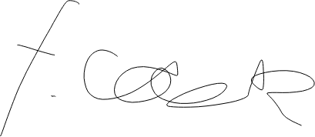
Signed:
Date:
Please complete all fields.
First Name: | Fred
Last Name: | Cook
Student ID number | 8463955
Ethics Application Number | P130390
Supervisor | Carey Pridgeon

