Homework5
Neda Safari
2025-12-01
Selected the Second Choice
homicides<- read.csv("data-homicides-master/homicide-data.csv")
Freddie_Gray<- homicides%>%
filter(str_detect(victim_last, "GREY") & str_detect(victim_first, "^FREDDIE"))%>%
pull(reported_date)
Freddie_Gray<- ymd(paste(substr(Freddie_Gray, 1, 4), substr(Freddie_Gray,5,6),"01", sep="-"))
Freddie_Gray
## [1] "2015-04-01"
baltimore_data<- homicides%>%
filter(city == "Baltimore")%>%
mutate(date_r= ymd(reported_date),
year_month= paste(year(date_r), month(date_r), "01", sep = "-"),
date=ymd(year_month),
month= month (date),
season= ifelse(month %in% c(11,12,1,2,3,4),"Winter", "Summer"))%>%
group_by(date, season)%>%
summarise(homicides=n(), .groups = "drop")
baltimore_data
## # A tibble: 132 × 3
## date season homicides
## <date> <chr> <int>
## 1 2007-01-01 Winter 28
## 2 2007-02-01 Winter 17
## 3 2007-03-01 Winter 26
## 4 2007-04-01 Winter 19
## 5 2007-05-01 Summer 32
## 6 2007-06-01 Summer 31
## 7 2007-07-01 Summer 30
## 8 2007-08-01 Summer 25
## 9 2007-09-01 Summer 22
## 10 2007-10-01 Summer 19
## # ℹ 122 more rows
baltimore_data%>%
ggplot(aes(date, homicides))+
geom_col(aes(fill=season), width= 26)+
geom_smooth(color= "royalblue", se= FALSE, method = 'loess', span = 0.12, linewidth= 1.5)+
geom_vline(aes(xintercept= Freddie_Gray), linetype= "dashed", color= "red", linewidth= 1.5)+
annotate("text", Freddie_Gray, 40, label= "Arrest of \nFreddie Gray", color= "cornsilk2", hjust=1)+
labs(title= "Homicides in Baltimore, MD", x= "Date", y="Monthly homicides")+
scale_fill_manual(values= c("Summer"="cornsilk3", "Winter"="lightcyan3"), name=NULL)+
theme_dark()+
theme(legend.position = "bottom")
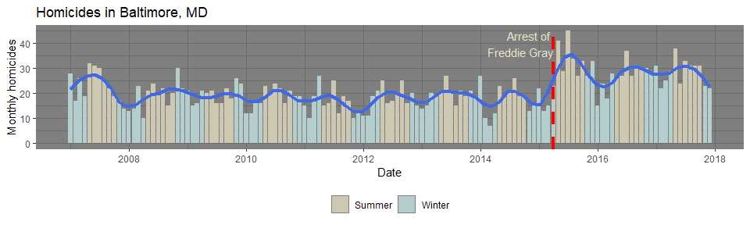
ggsave("Baltimore.png", width= 10, height= 3)

