Coding_Exercises

Neda Safari

2025-10-17

1.Create a new column in the bison dataset that calculates the individual’s age at the time of observation.

knz_bison%>%  
 head(5)

## # A tibble: 5 × 8  
## data_code rec_year rec_month rec_day animal_code animal_sex animal_weight  
## <chr> <dbl> <dbl> <dbl> <chr> <chr> <dbl>  
## 1 CBH01 1994 11 8 813 F 890  
## 2 CBH01 1994 11 8 834 F 1074  
## 3 CBH01 1994 11 8 B-301 F 1060  
## 4 CBH01 1994 11 8 B-402 F 989  
## 5 CBH01 1994 11 8 B-403 F 1062  
## # ℹ 1 more variable: animal_yob <dbl>

bison2<- knz_bison%>%  
 mutate(indiv_age= rec_year- animal_yob)  
bison2%>%  
 head(5)

## # A tibble: 5 × 9  
## data_code rec_year rec_month rec_day animal_code animal_sex animal_weight  
## <chr> <dbl> <dbl> <dbl> <chr> <chr> <dbl>  
## 1 CBH01 1994 11 8 813 F 890  
## 2 CBH01 1994 11 8 834 F 1074  
## 3 CBH01 1994 11 8 B-301 F 1060  
## 4 CBH01 1994 11 8 B-402 F 989  
## 5 CBH01 1994 11 8 B-403 F 1062  
## # ℹ 2 more variables: animal_yob <dbl>, indiv_age <dbl>

2.Write a function that will first filter the bison dataset based on any user-specified weight threshold (returning the filtered dataset).

bisonWeight<- function(knz_bison, x) {  
 knz_bison%>%  
 filter(animal_weight>= x)  
}

3.Create a boxplot showing weight distribution between male and female bison, and then conduct a t-test to see if weight is significantly difference between males and females.

We have p-value = 0.000961 < 0.05 so this means that the wieght is significantly difference between males and females.

bison_test<-bison2%>%  
 drop_na()  
  
bison_test%>%  
 ggplot(aes(animal_sex, animal_weight))+  
 geom_boxplot()

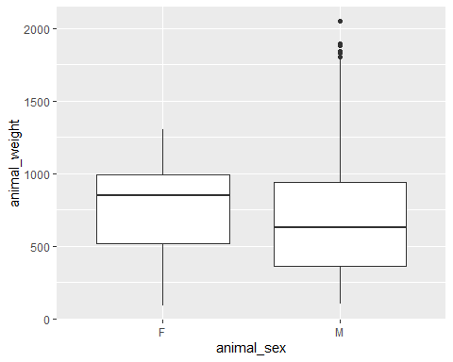

t.test(animal_weight ~ animal_sex, data= bison_test)

##   
## Welch Two Sample t-test  
##   
## data: animal_weight by animal_sex  
## t = 3.3038, df = 4722.2, p-value = 0.000961  
## alternative hypothesis: true difference in means between group F and group M is not equal to 0  
## 95 percent confidence interval:  
## 11.54392 45.23867  
## sample estimates:  
## mean in group F mean in group M   
## 752.9115 724.5202