Contents

Question Issue Log
Project Steps
Project Plan
Project Log
Nice-to-Haves Dump
Steps to Build Humidity Control Circuit
C++ Learning / Key Takeaways
Question/ Issue | Answer | Complete?
At what points do I need to reboot? |  | Outstanding
What does VCC mean? | Voltage Common Controller | Done
Should sensors and VCCs use busbars and all go to/ from Arduino | Sensors use VCCs, relays should use seperate, busbars are a good idea | Done
Platformio for vscode
What is machine code? | .hex
Power supply for 8 relays
Overall box design and layout

Project steps

Project Plan for Mushroom Growing Chamber Controller
0. Research as and when required and log research
- Initial Spike / talk to hackspace group
- Arduino Specific
- C++

1. Define Requirements and Source Hardware:
- Identify environmental parameters to monitor; humidity, temperature, CO2, etc.
- Select appropriate sensors (e.g., DHT22, MH-Z19B, BH1750)
- Choose relays compatible with loads (fans, heaters, humidifiers, lights)
- Source Arduino board (e.g., Arduino Uno, Mega) and Ethernet shield/module
- Obtain power supply and any additional hardware (breadboards, connectors)

2. Hello World Examples:
- Hash together
3. Set Up Development Environment:
- Install Arduino IDE and/or PlatformIO extension for VS Code
- Install necessary libraries (Ethernet, sensor-specific libraries)
- Verify basic toolchain setup by compiling a simple C++ “Hello World” program on Arduino
- Write a basic sensor read example to verify sensor connectivity and data acquisition
4. Design Software Architecture
- Define modular components
- Sensor management (reading, calibration)
- Relay control (logic, safety checks)
- Networking (Ethernet initialization, communication protocols)
- Logging (serial output, network logging)
- Scheduler/Timers (task management and timing)
- Define configuration settings (pin mappings, thresholds, network settings)
- Plan communication with Home Assistant (MQTT or HTTP)
5. Set Up Version Control:
- Initialize a Git repository for source code management:
- Create .gitignore and branching strategy (e.g., main and development branches)
- Commit initial codebase structure and early prototypes
6. Implement Core Functionality:
- Develop sensor drivers and test readings
- Implement relay control logic with safety conditions
- Build scheduler for timed tasks
- Integrate Ethernet connection and implement Home Assistant data sync
- Implement logging (serial + network)
7. Testing and Validation:
Test each module individually (unit testing where feasible):
-Validate sensor readings and control outputs in controlled environment
-Stress test network communication and logging
-Perform integration testing (full system operation)
8 Documentation:
- Write detailed README with:
- Project overview
- Hardware list and wiring diagrams
- Software setup and build instructions
- Usage instructions and troubleshooting tips
- Document code with comments and, if possible, generate API docs
- Maintain changelog for version tracking
9. Deployment
- Upload final firmware to Arduino
-Setup Home Assistant integration
-Monitor and log environmental conditions
-Iterate based on feedback and performance
10. Maintenance and Future Enhancements
Plan for over-the-air updates if feasible:
-Add support for additional sensors or actuators
-Implement advanced control algorithms (PID, fuzzy logic)
-Improve UI/UX for Home Assistant dashboard

Project Log
30/05/2025 3hrs
- Talked to Hackspace group, they suggested
- Used ChatGPT to look at pros and cons of ESP32 Vs Arduino, to complete
- decided on Arduino Mega for followring reasons:

  - to allow for scaling project, quality, and chance to learn C++
- Ordered componants

31/05/2025
- Project Steps complete, used chatgpt and sensed checked, made own edits.
- Hello world example for humidity sensor, can print this up and use when components come.
- Set up IDE:
  - Followed this tutoral: https://code.visualstudio.com/docs/cpp/config-mingw
  - Installed C/C++ extension
  - Installed MinGW-w64 toolchain using MSYS2 installer & pacman
  - Added to path
  - Selected compiler in Vscode and run
- Started C++ learning with hello world example
- Found edube C++ institute, good idea to do that and get a qualification
- Arduino came, downloaded arduino IDE
- Thought it good idea to create more detailed requirements and table

03/06/2025
- Got up and running with “hello world” equiv for board. Humidity relay powers on a 12v light when humidity is below 97%
04/06/2025
- Had thoughts about current sensing when power to items “on/off”
- Ordered some SCT013-000 non-intrusive sensors.
- Updated code to include start stop levels – 97% high and 80% low for humidity relay to kick in.
- Considering relay board dedicated power supply. Board will draw more current than arduino can handle.
- Ordered 5v 2a adapter for relay board.
- Updated arduino code to include temperature sensing via DHT22

Nice-to-Haves Dump / Backlog
- Multiple temperature sensors. Will temp sense “kick off” in high airflow?

System | Sensing | Sensor Type | Control | Control Type | Pin | Range | Timing | Start Delay | Cooldown Time | Startup Conditions | Notify | Logging? | Critical? | Control Logic | Integration
Humidity Control | Humidity | DHT22 | Humidifier | Relay | D2 | 89–97% | Controlled | 30s | 5 min | If < 89% | Yes | Yes | Yes | On/Off | MQTT: chamber/humidity
Temperature Control | Internal Temperature | DHT22 | Heater / Cooling Fans | Relay | D3 | 20–23°C | Controlled | 15s | 5 min | If outside range | Yes | Yes | Yes | On/Off | MQTT: chamber/temp
Water Level Monitor | Humidifier Water Level | Float Switch | None | N/A | D4 | Low/High | Passive |  |  | Always monitor | Yes | Yes | Yes | Alert Only | MQTT: chamber/waterlevel
CO₂ Control | CO₂ Level | MH-Z19B | FAE Fans | Relay | D5 | TBD (e.g., < 1000 ppm) | Controlled | 10s | 3 min | If CO₂ too high | Yes | Yes | Yes | On/Off | MQTT: chamber/co2
Lighting Control | None | N/A | LED Lights | Relay | D6 | 12 hrs/day | Scheduled |  |  | Time-based | No | Optional | No | Timed | MQTT: chamber/lights
Room Temperature | Ambient Room Temp | DS18B20 | None | N/A | D7 | Monitor only | Passive |  |  | Always monitor | No | Yes | No | Monitor Only | MQTT: environment/roomtemp

Confirmation Sensing
Light
Humidifier
Main Fan
Heating
Cooling

Mains
Relay Supply

Steps to Build Humidity Control Circuit
- Prerequisits
Component | Present?
Hardware
Arduino Mega
DHT22 sensor
5V relay module
Power supply
Jumper wires
Breadboard
USB Cable
Software
Code Editor
Debugger
Compiler
Arduino IDE

- Wire the Sensor
  - Connect DHT22 VCC to 5V on Arduino
  - Connect GND to GND
  - Connect Data pin to Arduino digital input (e.g., pin 2) with a 10k pull-up resistor if needed
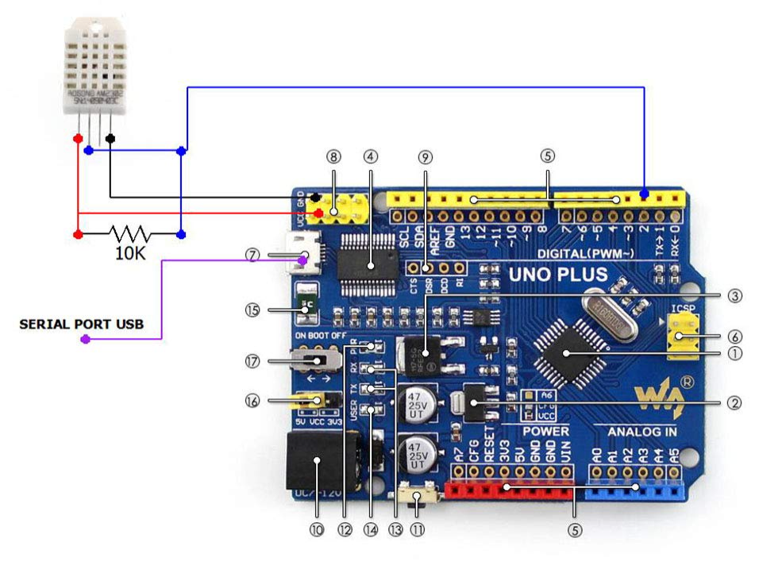
- Wire the Relay Module
  - Keep JD-VCC jumper installed or check in
  - Connect relay VCC to 5V Arduino 5v
  - Connect GND to GND
  - Connect IN1–IN8 to Arduino digital pins (e.g., D8–D15).
  - Connect humidifier power through relay contacts (NO & COM)
- Write Arduino Code
  - Include DHT library
  - Read humidity values periodically
  - If humidity below lower threshold, turn relay ON (activate humidifier)
  - If humidity above upper threshold, turn relay OFF
- Upload and Test
  - Connect Arduino via USB
  - Select the correct board and COM port.
  - Upload the code
  - Click Upload (Arduino IDE) or Build & Upload (PlatformIO).
  - Verify humidifier turns on/off as expected
- Power Setup
  - Use your 9V 2A adapter for Arduino power
  - Use separate power source for humidifier through relay, ensuring safety
- Safety Check
  - Double-check all wiring and insulation before powering mains devices
  - Use proper enclosures to avoid accidental contact

C++
Key Learnings and Takeaways

#include <iostream>

using namespace std;
int main(void)
{
cout << "It's working\n"
<< endl;
}
Vs
#include <iostream>

//this is a single line comment

int main() {
std::cout << "Hello World!" << std::endl;
return 0;
}

Namespace std okay for small but not big
main(void) >> more like C
Readme

Arduino Mega
Sensors

Softwares

Languages
C++
yaml

Tools + Extensions
VSCode
PlatformIO

