6 August 2015
Guide for using the Photo Monitoring Plugins

Overview
This guide explains how to use the photo monitoring plugins written to work with ImageJ and a variant of ImageJ called Fiji. Since Fiji has most of the plugins accessed by the Photo Monitoring plugins bundled with the distribution it is easier to work with Fiji but the plugins should work equally as well in ImageJ if the installation instructions below are followed.

There are six plugins. Two are designed to create NDVI or DVI and false color images using image pairs acquired from two cameras. One of the dual-camera plugins creates a text file of matched image pairs acquired using two different cameras and another that uses the image pair file and geometrically registers one of the images to overlay over the other and also calculates NDVI or DVI and related image products if one of the cameras records a near-infrared (NIR) image. There are two plugins are designed to create NDVI images from a single camera with a filter that allows one waveband of visible light (usually blue or red) and also near-infrared light to pass and be recored by the camera sensor. One of these single-camera plugins processes all of the images in a directory and the other processes an image that is displayed in ImageJ or Fiji. There are two plugins for calibrating images, one to calculate calibration coefficients and other information related to calibrating images and the other is to apply the calibration coefficients to a directory of images that were acquired under the same conditions as the image used to calculate the calibration coefficients.

Output color index images will be created as JPEG images and the EXIF metadata including GPS data will be copied from the original photograph to the output JPEG image. The raw NDVI values will be saved as a single band floating-point TIFF file but as of now the EXIF metadata is not copied to the TIFF file. If I can figure out how to do that I'll copy EXIF metadata to TIFF images.

An attempt has been made to create some processing messages that will be output to the ImageJ/Fiji “Log” window. When an error occurs an informative message should be displayed. Please keep in mind that the plugins are still in a beta state so you should maintain a backup copy of all of your images in case the input images are altered. Some troubleshooting tops are provided at the end of this document.

This guide and the plugins are works in progress and comments are welcome. I work primarily with the Ubuntu operating system so these instructions are based on my experience with Ubuntu. If you notice something that should be altered to accommodate other operating systems please let me (Ned Horning - horning@amnh.org) know.

Installing the plugins
The first step is to download and install ImageJ or Fiji (recommenced) which is a distribution of ImageJ – a powerful image processing package designed to support the biomedical research community. Fiji can be downloaded from http://Fiji.sc/wiki/index.php/Fiji. It is Java based and runs on all computers that support Java. After Fiji is installed you should launch it then click on the menu “Help => Update ImageJ” to get the most recent version of the ij.jar file. If the update does not work you can do the update manually by downloading the most recent version from here: rsb.info.nih.gov/ij/upgrade/ij.jar. Next, replace the old ij.jar file the new one in the “jars” directory which is located under the Fiji root directory. You must use a version that is more recent than 1.46r.

You will also need to get a copy of the plugin which is available on GitHub at https://github.com/nedhorning/PhotoMonitoringPlugin. In addition to the photo monitoring plugin you will also need to download the metadata-extractor-2.6.2.jar, xmpcore.jar and sanselan-0.97-incubator.jar files. A copy of these files are available on the GitHub site in the downloads directory or you can get the files from: http://code.google.com/p/metadata-extractor/downloads/list and http://www.docjar.com/jar_detail/sanselan-0.97-incubator-javadoc.jar.html. For metadata-extractor-2.6.2.jar, xmpcore.jar you need to download the metadata-extractor-2.6.2.zip file and then unzip that file to get the metadata-extractor-2.6.2.jar and xmpcore.jar files.

You can install the plugins either by copying the “.jar” files into the plugins directory which is in the Fiji or ImageJ root directory or by dragging the file from your file browser onto the Fiji menu. If you drap the file to the Fiji menu a “Save Plugin, Macro or Script...” window will open and you can click the “Save” button to copy the plugins. Y ou should now see a listing labeled “PhotoMonitoring” under the Plugins menu. Clicking on that will reveal the plugins described in this guide. More information about installing plugins can be found here: http://fiji.sc/wiki/index.php/Installing_3rd_party_plugins.

If the plugins are used with ImageJ then the following additional .jar files from the Fiji project need to be also copied to the plugins directory: jars/mpicbg.jar, plugins/mpicbg_.jar, and plugins/bUnwarpJ_.jar. Also, the metadata-extractor-2.6.2.jar and xmpcore.jar files must be copied to the plugins directory.

Using and creating custom lookup tables
A lookup table (LUT) is used to define which colors will be used to represent different NDVI values when a color NDVI image is output. ImageJ and Fiji have several dozen LUTs but none dedicated specifically for NDVI. A set of LUTs have been created to render NDVI images in color. The custom LUTs can be found on the GitHub site: https://github.com/nedhorning/PhotoMonitoringPlugin. The human readable CSV files used to create the LUTs using the ImageJ “LUT Importer” plugin (http://rsbweb.nih.gov/ij/plugins/lut-importer.html) are located in the main GitHub page and the binary LUTs for direct use with ImageJ or Fiji are in the downloads directory.

To install the LUT you need to copy the .lut file (from the downloads directory of the GitHub site) to the “luts” directory which is in the Fiji or ImageJ root directory. The next time you start ImageJ or Fiji the LUT should appear in the list of LUTs. To see what the LUT looks like you can use a ImageJ/Fiji utility. Go to Image => Lookup Tables then click on the LUT you'd like to see and a color bar will open. The color on the left side of the bar represents an NDVI value of 0 and the color on the right side represents a value of 255.

If you want to create your own LUT you need to create a CSV file with the first column containing the pixels value (0 to 255) and the next three columns are the intensity values for Red, Green, and Blue respectively. A CSV file can be created using a spreadsheet such as Excel or Calc. The lowest valid value for these three columns is 0 and the highest is 255. You can use the CSV file in the GitHub site as an example. Once the CSV file is finished you need to use the “LUT Importer” plugin to convert the values to a format that can be used by ImageJ/Fiji. After running the “LUT Importer” plugin with the color bar displayed and active you can save the LUT by clicking on Image => Color => Edit LUT... then when the LUT Editor opens click save. Save the LUT in the “luts” directory which is in the Fiji or ImageJ root directory. The LUT will appear in the list of LUTs next time you open ImageJ/Fiji.

Here is a brief description of the different custom LUTs:
- ndviClasses_0_1.lut: 11 different colors ranging from reddish brown for low NDVI to dark green for high NDVI. This is designed to work with scaling NDVI values from 0 to 1.
- ndviClasses_-1_1.lut: 11 different colors ranging from reddish brown for low NDVI to dark green for high NDVI. This is designed to work with scaling NDVI values from -1 to 1.
- ndviClassesCB_0_1.lut: Designed for people with color blindness. It has 11 different colors ranging from purple for low NDVI to dark green for high NDVI. This is designed to work with scaling NDVI values from 0 to 1.
- ndviClassesCB_-1_1.lut: Designed for people with color blindness. It has 11 different colors ranging from purple for low NDVI to dark green for high NDVI. This is designed to work with scaling NDVI values from -1 to 1.
- colorRampNDVI.lut: A gradient from light beige for low NDVI to very dark green for high NDVI. This will work with scaling ranging from -1 to 1 and 0 to 1 but the results will be very different.
- NDVIBlue2Red.lut: A gradient from blue to red.
- NDVIBlue2RedWB: TSimilar to the NDVIBlue2Red but color pixels with a value of 0 to white and pixels with a value of 255 to black.

Remove low quality photos
Before you use the plugins it's a good idea to review your photos and remove any that are of low quality or have no image on them. The current version of the plugin is known to freeze when an all black image (like one you would get if you had the lens cap on) is encountered.

Plugin to create file of image pairs
The “Create dual image list” plugin is designed to facilitate the process of matching two digital photographs that were acquired at roughly the same time. The plugin outputs a text file with the path and file names for image pairs (e.g., images acquired from two cameras) that can be input into the “Reg images” plugin. The image matching is done by synchronizing the times stored in the image EXIF DateTimeOriginal tag from each of two cameras. If for some reason the EXIF DateTimeOriginal tag is not set then the files last modified time will be used.

Before running the plugin the images from each camera should be stored in different directories. If this is not convenient please let me know of your preferred method for differentiating between the images acquired from each camera and I will consider adding alternative methods.

Synchronization of the image pairs is done by calculating or reading a user defined offset between the imaging time recorded by one camera with the image time from another camera and then using the offset to find which images were acquired at roughly the same time.

When the plugin starts a dialog window is opened with the following options:

Select offset calculation method: There are three options for calculating the time:
- Assume already synched: Assumes the camera clocks were synchronized to the same time before photo were acquired so an offset of 0 seconds will be used.
- Enter offset: Allows you to enter the offset in seconds. The offset should be calculated using this equation: time of visible image – time of NIR image. It the result is negative it is important to include the negative sign (“-”) before the number of seconds.
- Calculate offset from pair: Uses two images from a pair (one visible one NIR) to calculate the offset. If this option is selected then you will have to specify the visible and NIR images that were acquired at the same time and will be used as the reference pair.

Max difference in seconds between offset-corrected image pairs: This is the maximum time difference in seconds, after the calibration has been applied, that is allowable between each image pair. This compensates for slight variations in the camera clock and shutter release mechanism.
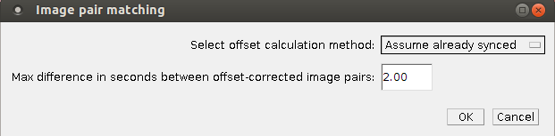
If the “Enter offset” option is selected you will need to enter the offset (calculated as: time of visible image – time of NIR image) in seconds.

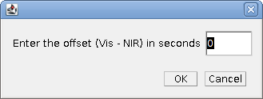

If the “Assume synched” or “Enter offset” options are selected you will need to select the location for the visible and NIR images.

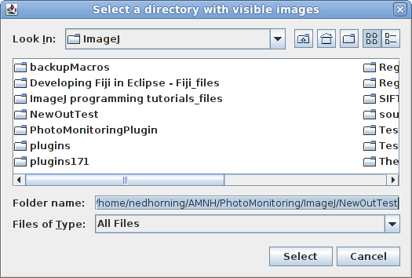

If the “Calculate from pair” option is selected then you will need to select the visible image that will be used as a reference to synchronize the times to select image pairs. After clicking “OK” a window will open so you can select the NIR image that will be used as a reference. For both of these windows the assumption is made that all of the visible images that will be processed are in the same directory as the visible reference image and all of the NIR images are in the same directory as the NIR reference image.

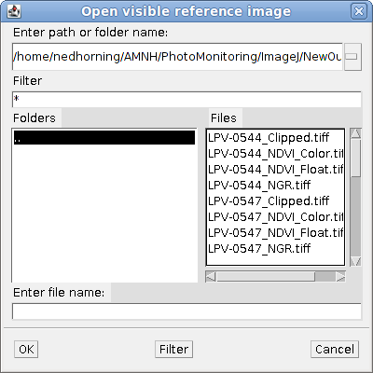

Regardless of the other options the last window is where you select the output file location and name. After selecting the directory path and entering the output file name click on “Save” to run the program. It should complete in seconds.
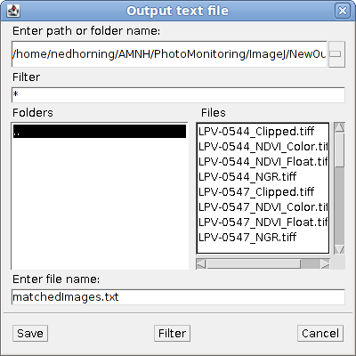

Image registration and index image plugin
The “Dual image index processing” plugin is designed to co-register two images, one using a NIR camera and the other a “normal” visible camera. The plugin will work best if the images were acquired from two cameras mounted with their lenses close to each other, acquired at nearly the same time (so the scene hasn't changed), and it's best if the two cameras have similar characteristics such as image size and resolution.

The plugin can output the following images:
NRG image (false-color image with R=NIR, G=red from visible, and B=green from visible)
NDVI or DVI image with a user-selected color table applied
Floating point NDVI or DVI image with actual NDVI values (data range -1 to +1 for NDVI or -255 to 255 for DVI)
A visible image clipped to the common area between the registered NIR and visible image
A log file documenting the registration method used for each image pair

The parameters used to run SIFT, Landmark correspondences, and bUnwarpJ are coded into the plugin and at this point can not (at this time) be modified by the parameter window displayed by this plugin.

Instructions
Before running the plugin you will need to prepare a text file that directs the plugin to process specific image pairs. This can be accomplished by running the “Create dual image list” plugin described above or by creating your own file.

If you create your own file you need to ensure the following format is followed. Each line in the file must have the directory path and file name for the two images that form a pair with a comma separating the two. The first image is the near_IR image (the source image that will be warped) and the second image is the visible image (the target image used as a reference but not altered). Make sure there is no whitespace (space, tab, or new line) after the last line of text.
Here is an example of what the text file looks like for two image paris (4 images):
ned/InputImages/nir/LPV-0001.JPG, ned/InputImages/visible/LPV-1324.JPG
ned/InputImages/nir/LPV-0003.JPG, ned/InputImages/visible/LPV-1325.JPG

The plugin will work with any image format that can be read by ImageJ/Fiji. Your first (test) run should probably include just a couple image pairs to make sure it's working.

To run the plugin go to Plugins => Photo Monitoring => Dual image index processing. When the plugin starts a dialog window opens that lets you specify processing options.

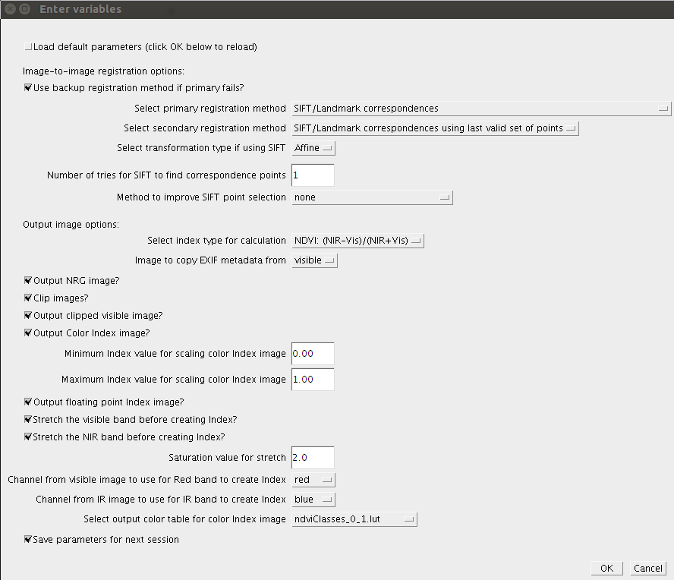

Modify the following options to specify the output that you want to create.
- Load default parameters: If you check this checkbox and then click on the “OK” button at the bottom of the window the default parameters will be entered. This is helpful if you modify some of the parameters and forget what the default settings were.
- Use backup registration method if primary fails: This option allow you to specify if you want to try a backup registration method if the primary method fails.
- Select primary registration method: This is the first registration method that will be tried for the image pair. Three registration methods are available. The first, “SIFT/Landmark correspondences”, uses a scale-invariant feature transform (SIFT) to select matching points in image pairs. After points are selected a transformation is applied that will modify the NIR image. Unfortunately SIFT often does not always select points that correspond with both images in landscape photos since there are ofter not enough distinct features that can be detected and match. A second registration option, “SIFT/Landmark correspondences using reference points from first valid image pair” will use the reference points from the previous set of correspondence points calculated using SIFT. This option is fast since new correspondence point do not need to be calculated but the results will only be good if there is no relative movement between the two cameras that acquired the image pairs. The third option is “bUnwarpJ” which uses the bUnwarpJ plugin in Fiji. This algorithm is able to register most image pairs and is able to deal with more severe types of image mismatches. The downside is that this algorithm take more time (~4 minutes vs 15 seconds for the SIFT approach) and it can introduce distortions if the corresponding reference points in the image pair are not very accurate and well distributed throughout the image. More information about bUnwarpJ can be found at http://biocomp.cnb.uam.es/~iarganda/bUnwarpJ/.
- Select secondary registration method: These options, similar to the primary registration options described above, are applied if a backup registration method is requested using the checkbox at the top of the parameter window.
- Select transformation type if using SIFT: The transformation type option only has an effect if you use the SIFT registration method selected. The affine transformation adjusts the image using translation, rotation and scaling and the rigid transformation only uses translation and rotation. The rigid transformation sometimes produces a better image-to-image fit when few corresponding points are selected using SIFT.
- Number of tries for SIFT to find correspondence points: This specifies the number of times the SIFT algorithm will run to find corresponding reference points on the two images. The results differ each time the SITF algorithm runs so for difficult to match image pairs running multiple time will sometime result in a match. If you do not want to use multiple runs set this to “1”.
- Method to improve point selection: This option presents different pre-processing methods that can be used to improve the ability of the SIFT algorithm to find corresponding points. This is experimental and the only option at this time is "target (g-b) source (g+b)" which subtracts the blue channel from the green channel of the target (visible) image and adds the green channel to the blue channel of the source (NIR) image to create input images for the SIFT algorithm. This approach seems to work well for the camera pairs made using the information on the PLOTS web site. Other approaches can be added for camera pairs if this algorithm isn't effective.
- Select index type for calculation: This dropdown menu lets you choose the type of index you want to create (e.g., NDVI or DVI).
- Image to copy EXIF metadata from: Specify if the EXIF metadata should be copied from the visible or near-infrared camera.
- Output NRG image?: Output a false-color composite image with the following RGB color channel assignments: R=NIR, G=red from visible, and B=green from visible.
- Clip images?: Clip the images so that only the common area dimensions are used in the output images. In most cases this is desirable but if you needed to have all of the output images to maintain their original dimensions you would want to un-check this box.
- Output clipped visible image?: If “Clip images” is checked then output a copy of the visible image that is clipped to match the dimensions of the other output images.
- Output Color index image?: Output a color NDVI image using the look-up table specified below.
- Minimum index value for scaling color index images: When the color index image is created it is necessary to scale from actual floating point NDVI values (possible values range from -1.0 to +1.0 for NDVI and -255 to 255 for DVI) to a range of integers (possible values range from 0 to 255) allowed for the color image. This parameter allows you to set the minimum index value that will be assigned to a value of 0 in the output color image. NDVI values between the minimum and maximum (next parameter) are scaled linearly from 0 to 255.
- Maximum index value for scaling color index images: Same principle as the previous variable but value you enter here will be assigned to a value of 255 in the output color image.
- Output floating point index image?: Output a floating point index image with actual values – not scaled from 0 to 255.
- Stretch the visible band before creating index?: This option will stretch the visible band used to calculate NDVI. This can be used to normalize images if the features in each image are similar. If some images are mostly vegetation and some are mostly urban environments using this technique to normalize images might not work well.
- Stretch the NIR band before creating index?: Similar to the previous parameter but for the NIR band used to calculate NDVI.
- Saturation value for stretch: The saturation value determines a threshold for extreme values in the image. In other words it defines which of the lowest values will be set to 0 and which of the highest values will be set to 255. If the default value of 2.0 is used then 1 percent of the lowest values will be set to zero and 1 percent of the highest values will be set to 255 and the remaining values will be linearly scaled to a range of 0 to 255.
- Channel from visible image to use for Red band to create index: Select the channel number from the visible image that will be used as the red band in the NDVI formula. The default selection seems to work well with most color digital cameras.
- Channel from IR image to use for NIR band to create index: Select the channel number from the near-infrared image that will be used as the NIR band in the NDVI formula. The default selection seems to work well with the PLOTs nearIR cameras.
- Select output color table for color index image: The color lookup table to be used if a color NDVI image is being output. You can add new color lookup tables to Fiji/ImageJ by following the instructions in the ImageJ manual.
- Save parameters for next session: Save the parameters entered in this window and displayed them the next time the plugin is run.

After you select the options you want click on “OK”. The next window allows you to select the file containing the path and image names of each image pair is located. Select the file (possibly the output from the Create list plugin) and click “OK”.
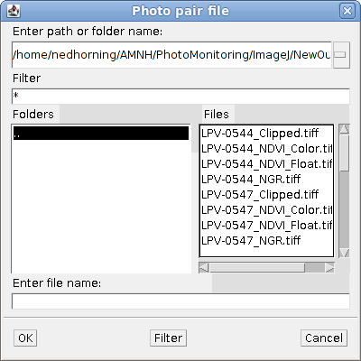

The last window allows you to select the directory where the images and log file will be output. You can also change the name of the log file that is output when the plugin is run. The log file will be output to the same directory as the output images. After you specifying the directory and log file click on “Save” to start processing.

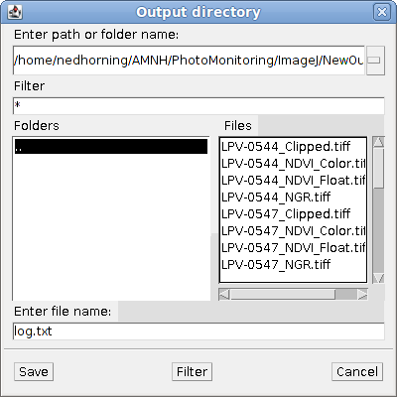

If the SIFT registration method is selected and an image pair fails to register after 5 tries that pair will be skipped and processing of the remaining image pairs will continue.

Index images from a directory of images plugin
The “Single image index from directory” plugin is designed to create color and floating point index images from a directory containing images that recorded visible light in one band and near-infrared light in another. These images can be captured using the SuperBlue filter available from LifePixel (http://www.lifepixel.com/) or from Public Labs: (http://www.kickstarter.com/projects/publiclab/infragram-the-infrared-photography-project). The plugin processing images faster than the dual-camera images since no image warping is necessary.

Instructions
Before running the plugin you will need to ensure that all of the images that you want to process are in a single directory with no other files. To run the plugin go to Plugins => Photo Monitoring =>Single image NDVI from directory. When the plugin starts a dialog window opens that lets you specify processing options.

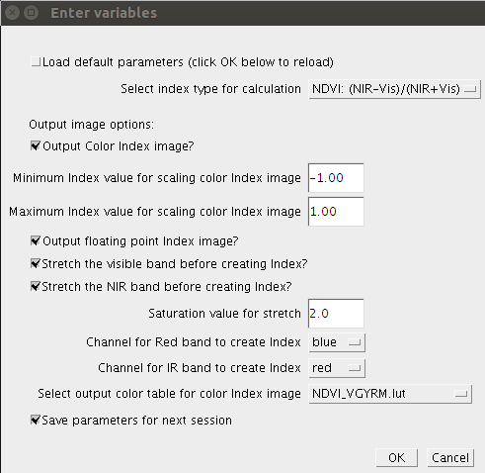

Modify the following options to specify the output that you want to create.
- Load default parameters: If you check this checkbox and then click on the “OK” button at the bottom of the window the default parameters will be entered. This is helpful if you modify some of the parameters and forget what the default settings were.
- Select index type for calculation: This dropdown menu lets you choose the type of index you want to create (e.g., NDVI or DVI).
- Output Color index image?: Output a color NDVI image using the look-up table specified below.
- Minimum index value for scaling color index images: When the color index image is created it is necessary to scale from actual floating point NDVI values (possible values range from -1.0 to +1.0 for NDVI and -255 to 255 for DVI) to a range of integers (possible values range from 0 to 255) allowed for the color image. This parameter allows you to set the minimum index value that will be assigned to a value of 0 in the output color image. NDVI values between the minimum and maximum (next parameter) are scaled linearly from 0 to 255.
- Maximum index value for scaling color index images: Same principle as the previous variable but value you enter here will be assigned to a value of 255 in the output color image.
- Output floating point index image?: Output a floating point NDVI image with actual NDVI values that range from -1 to +1.
- Stretch the visible band before creating index?: This option will stretch the visible band used to calculate NDVI. This can be used to normalize images if the features in each image are similar. If some images are mostly vegetation and some are mostly urban environments using this technique to normalize images might not work well.
- Stretch the NIR band before creating index?: Similar to the previous parameter but for the NIR band used to calculate NDVI.
- Saturation value for stretch: The saturation value determines a threshold for extreme values in the image. In other words it defines which of the lowest values will be set to 0 and which of the highest values will be set to 255. If the default value of 2.0 is used then 1 percent of the lowest values will be set to zero and 1 percent of the highest values will be set to 255 and the remaining values will be linearly scaled to a range of 0 to 255.
- Channel from visible image to use for Red band to create index: Select the channel number from the visible image that will be used as the red band in the NDVI formula. The default selection seems to work well with most color digital cameras.
- Channel from IR image to use for NIR band to create index: Select the channel number from the near-infrared image that will be used as the NIR band in the NDVI formula. The default selection seems to work well with the PLOTs nearIR cameras.
- Select output color table for color index image: The color lookup table to be used if a color NDVI image is being output. You can add new color lookup tables to Fiji/ImageJ by following the instructions in the ImageJ manual.
- Save parameters for next session: Save the parameters entered in this window and displayed them the next time the plugin is run.

After you select the options you want click on “OK”. The next window allows you to select the directory with the input images and click “OK”.
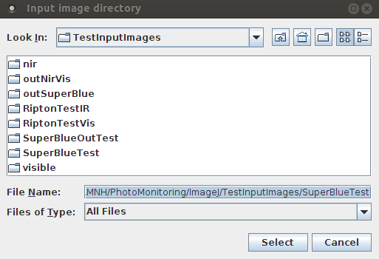

The next window allows you to select the directory for the output images and the name of the log file containing all of your parameter settings. Click “OK” after selecting the directory.

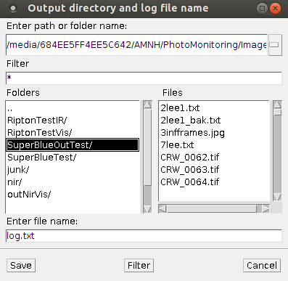

After selecting the output directory and log file name the images will be opened one-by-one and processed.

NDVI from an opened image plugin
The "Single image NDVI from displayed image" plugin is designed to create color and floating point NDVI images from an image displayed in ImageJ/Fiji that recorded visible light in one band and near-infrared light in another. These images can be captured using the SuperBlue filter available from LifePixel (http://www.lifepixel.com/) or from Public Labs: (http://www.kickstarter.com/projects/publiclab/infragram-the-infrared-photography-project). The plugin processing images faster than the dual-camera images since no image warping is necessary. This plugin displays the output images on the screen but does not save them to disk. If you want to save the images you can do so using the ImageJ/Fiji save feature.

Instructions
Before running the plugin you will need to ensure that all of the images that you want to process are in a single directory with no other files. To run the plugin go to Plugins => Photo Monitoring =>Single image NDVI from displayed image. When the plugin starts a dialog window opens that lets you specify processing options.

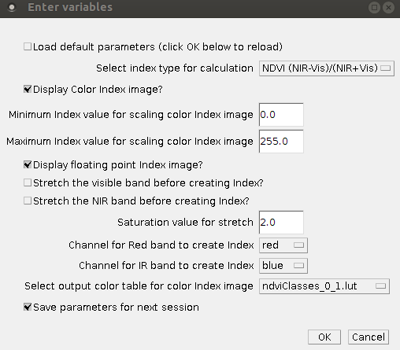

Modify the following options to specify the output that you want to create.
- Load default parameters: If you check this checkbox and then click on the “OK” button at the bottom of the window the default parameters will be entered. This is helpful if you modify some of the parameters and forget what the default settings were.
- Select index type for calculation: This dropdown menu lets you choose the type of index you want to create (e.g., NDVI or DVI).
- Display Color index image?: Output a color NDVI image using the look-up table specified below.
- Minimum index value for scaling color index images: When the color index image is created it is necessary to scale from actual floating point NDVI values (possible values range from -1.0 to +1.0 for NDVI and -255 to 255 for DVI) to a range of integers (possible values range from 0 to 255) allowed for the color image. This parameter allows you to set the minimum index value that will be assigned to a value of 0 in the output color image. NDVI values between the minimum and maximum (next parameter) are scaled linearly from 0 to 255.
- Maximum index value for scaling color index images: Same principle as the previous variable but value you enter here will be assigned to a value of 255 in the output color image.
- Display floating point index image?: Output a floating point NDVI image with actual NDVI values that range from -1 to +1.
- Stretch the visible band before creating index?: This option will stretch the visible band used to calculate NDVI. This can be used to normalize images if the features in each image are similar. If some images are mostly vegetation and some are mostly urban environments using this technique to normalize images might not work well.
- Stretch the NIR band before creating index?: Similar to the previous parameter but for the NIR band used to calculate NDVI.
- Saturation value for stretch: The saturation value determines a threshold for extreme values in the image. In other words it defines which of the lowest values will be set to 0 and which of the highest values will be set to 255. If the default value of 2.0 is used then 1 percent of the lowest values will be set to zero and 1 percent of the highest values will be set to 255 and the remaining values will be linearly scaled to a range of 0 to 255.
- Channel from visible image to use for Red band to create index: Select the channel number from the visible image that will be used as the red band in the NDVI formula. The default selection seems to work well with most color digital cameras.
- Channel from IR image to use for NIR band to create index: Select the channel number from the near-infrared image that will be used as the NIR band in the NDVI formula. The default selection seems to work well with the PLOTs nearIR cameras.
- Select output color table for color index image: The color lookup table to be used if a color NDVI image is being output. You can add new color lookup tables to Fiji/ImageJ by following the instructions in the ImageJ manual.
- Save parameters for next session: Save the parameters entered in this window and displayed them the next time the plugin is run.

After you select the options you want click on “OK” and the image will be processed with the results displayed on the screen.

Calculate image calibration coefficients plugin
The “Calculate image calibration coefficients” plugin is designed to calibrate digital photograph acquired with a single NIR-modified camera and calibrate a visible bands and NIR band to reflectance values to facilitate the creation of NDVI and DVI images.

The plugin assumes there is a calibration target in the image that will be used to calculate calibration coefficients and that the reflectance properties of target are known. It is recommended that at the very least a bright and dark reference calibration target be in the image but additional targets can be used.

Before running the plugin you must create a comma-separated variable (CSV) file with the reflectance values for each of the reference targets in the image that you want to use to calculate the calibration coefficients. The rows of the CSV file correspond to the targets and the columns are the target reflectance values for the visible and near-infrared wavelengths that correspond with the camera filter being used. For example, the following values are for two targets (first line is the bright target and second line is the dark target):
0.86696300, 0.90032700
0.04748605, 0.05665055

The first line is the bright target reflectance values corresponding to the visible band wavelengths and the near-infrared wavelengths respectively. The second line is for the dark target. There is no limit to the number of targets that can be used but at least two are required. The reflectance values in the CSV file will be used to calculate a linear regression between the target reflectance values and the pixels values in the image representing the calibration targets.

When you are ready to do the calibration you must first open the image in ImageJ/Fiji and select a region of interest (ROI) for each of your reference targets using the ROI Manger in ImageJ (Analyze=>Tools=>ROI Manager). The ROIs will be used to select pixels from the image and the average pixel value will be used to calculate the linear regression with the target reflectance values saved in the CSV file. The order of the ROIs in the ROI Manager list (the left panel in the ROI Manager window) is important. The first (top) ROI corresponds to the first line in the CSV file, the second ROI is for the second line in the CSV file and so on. The ROI selection tools are the left-most icon on the ImageJ menu bar. I usually use the rectangle selection tool but any of the tools can be used.

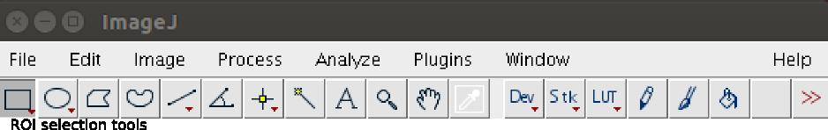
To add ROIs to the ROI Manager draw an ROI on the image and then click on the “Add” button in the ROI manager. You should see a reference number appear on the left panel in the ROI Manager window. Do the same for the remainder of the targets. When you draw a new ROI the previous one will disappear from the image but the reference will remain in the ROI Manager window. To see a previously defined ROI click on the reference number in theROI Manager and the corresponding ROI should appear in the image. The ROI Manager has a lot of flexibility and more information can be found here: http://rsbweb.nih.gov/ij/docs/guide/146-30.html#sub:ROI-Manager...

Keep the image and ROI manager open before starting the calibration plugin.

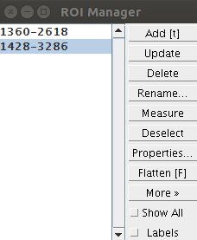

Once the ROIs are selected you can launch the calibration plugin by going to Plugins => Photo Monitoring =>Calculate image calibration coefficients. When the plugin starts a dialog window opens that lets you specify processing options.

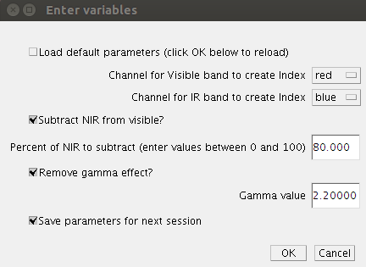

Modify the following options to specify the output that you want to create.
- Load default parameters: If you check this checkbox and then click on the “OK” button at the bottom of the window the default parameters will be entered. This is helpful if you modify some of the parameters and forget what the default settings were.
- Channel for visible band to create index: Select the channel number from the visible image that will be used as the visible band in the NDVI formula.
- Channel for IR band to create index: Select the channel number from the near-infrared image that will be used as the NIR band in the NDVI formula.
- Subtract NIR from visible?: Check this box if you want to subtract a percentage of the NIR pixel value from the visible pixel values. This is used to reduce the effect caused by the camera's visible channels recording visible and nir light
- Percent of NIR to subtract (enter values between 0 and 100): Enter the percentage of the NIR pixel value that should be subtracted from the visible pixel. This values is only used if the “Subtract NIR from visible?” checkbox is checked.
- Remove gamma effect?: This provides an option to remove the gamma effect in JPEM image pixel values. A common value for gamma is 2.2 but different cameras might use different values.
- Gamma value: The gamma value that will be used to correct the image.
- Save parameters for next session: Save the parameters entered in this window and displayed them the next time the plugin is run.

After clicking “OK” the “Output calibration file name and directory” dialog window will open. Enter the name and path for the calibration file that will be created by this plugin. The calibration file will be required to apply the correction to a directory of images. Clcik “Save” when ready to proceed.

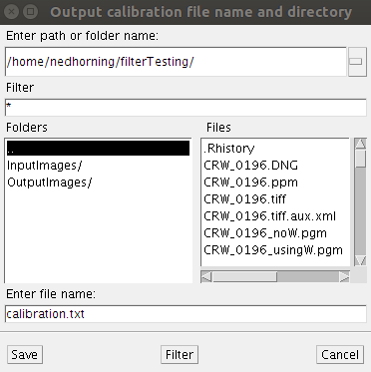

Next, the “Target reference data” dialog window opens. Select the CSV file with the target reflectance data. Clcik “OK” and the plugin will begin calculating the calibration coefficients. The original image is closed and the NDVI image is displayed. The LUT tools in ImageJ can be used to color the image: Image => Lookup Tables.

In addition to the output index image (NDVI or DVI) graphs showing the relationship between the normalized original pixel values and the calibrated values is displayed. The linear regression line used to calibrate the image pixels is also displayed along with the R² value of the fit.
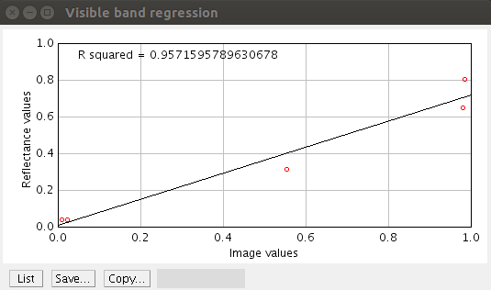

Apply calibration coefficients to directory of images plugin
The “Apply calibration coefficients to directory of images” plugin is used to apply the calibration coefficients calculated in the “Calculate image calibration coefficients” plugin to a directory of images and to save the resulting color (JPEG) and or floating point NDVI image (TIFF).

Start the apply calibration plugin by going to Plugins => Photo Monitoring =>Apply calibration coefficients to directory of images . When the plugin starts a dialog window opens that lets you specify processing options.

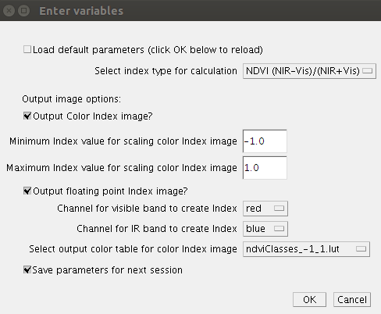

Modify the following options to specify the output that you want to create.
- Load default parameters: If you check this checkbox and then click on the “OK” button at the bottom of the window the default parameters will be entered. This is helpful if you modify some of the parameters and forget what the default settings were.
- Select index type for calculation: This dropdown menu lets you choose the type of index you want to create (e.g., NDVI or DVI).
- Output Color index image?: Output a color NDVI image using the look-up table specified below.
- Minimum index value for scaling color index images: When the color index image is created it is necessary to scale from actual floating point NDVI values (possible values range from -1.0 to +1.0 for NDVI and -255 to 255 for DVI) to a range of integers (possible values range from 0 to 255) allowed for the color image. This parameter allows you to set the minimum index value that will be assigned to a value of 0 in the output color image. NDVI values between the minimum and maximum (next parameter) are scaled linearly from 0 to 255.
- Maximum index value for scaling color index images: Same principle as the previous variable but value you enter here will be assigned to a value of 255 in the output color image.
- Output floating point index image?: Output a floating point NDVI image with actual NDVI values that range from -1 to +1.
- Channel for visible band to create index: Select the channel number from the visible image that will be used as the visible band in the NDVI formula.
- Channel for IR band to create index: Select the channel number from the near-infrared image that will be used as the NIR band in the NDVI formula.
- Select output color table for color index image: The color lookup table to be used if a color NDVI image is being output. You can add new color lookup tables to Fiji/ImageJ by following the instructions in the ImageJ manual.
- Save parameters for next session: Save the parameters entered in this window and displayed them the next time the plugin is run.

After you select the options you want click on “OK” and the “Select calibration file” dialog window will open.

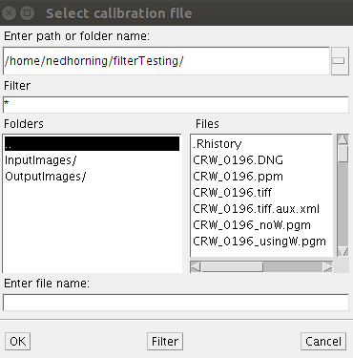

Select the calibration file created by the “Calculate image calibration coefficients” plugin then click “OK”. Next the “Input image directory” dialog window will open. Select the directory with the images you want to process then click on “Select”. Next the “Output directory and log file name” dialog will open.

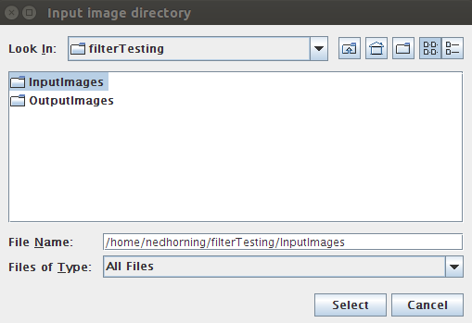

Select the directory where the output images and the processing log file will be written and then click “Save”.

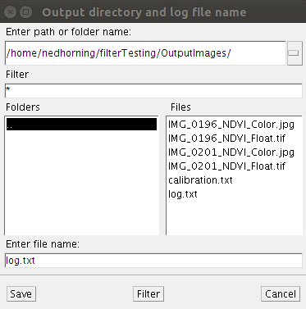

The processing will start. As images are processed they are opened and you can monitor the progress.

Error messages
Here are a few error messages and the recommended solutions. If you are not able to fix your error with this information please contact Ned Horning (horning@amnh.org).

Error:
first line of the exception message is:
java.lang.NoSuchMethodError: ij.process.ColorProcessor.getChannel(I)[B

Explanation and solution:
You are using a version of ij.jar that is older than 1.46r. You need to update the ij.jar file using the instructions in the “Installing the Plugins” sections above.
–

Error:
Plugin Register_Images did not find required class: com/drew/imaging/ImageProcesssingException

Explanation and solution:
This can due to two possible problems. Check to make sure the metadata-extractor-2.6.2.jar file is in the Fiji “jars” directory as explained in the “Installing the Plugins” sections above.

Another possible reason for this error is that there is a conflict with another plugin that uses some of the classes in the metadata-extractor-2.6.2.jar file. There is an ImageJ plugin called Exif_Reader installed that has some of the same of the metadata-extractor classes in its jar file and this can cause a conflict with the photo monitoring plugins. To fix this problem you will need to remove the Exif_Reader.jar file from the “plugins” directory.
–

Error:
When running the “Dual image NDVI processing” plugin a small window with the number “1” is displayed after entering the location of the log and output files. Clicking on “OK” closes the window and processing continues just fine.

Explanation and solution:
This will happen if there is one or more blank lines after the last line of text in the paired image file. To prevent this from happening be sure to remove all white space after the last line of text in the paired image file. If this file is created using the “Create dual image list” plugin this error should not occur.

