Guide for using the RegisterNIR_Vis macro.

Overview
This is a guide to explain how to use the RegisterNIR_Vis macro that is written to work with the Fiji version of ImageJ. I work primarily with the Ubuntu operating system so these instructions are based on my experience with Ubuntu. If you notice something that should be altered to accommodate other operating systems please let me (Ned Horning - horning@amnh.org) know.

The macro is designed to co-register two images, one using a near-infrared camera and the other a “normal” visible camera. The macro will work best if the images were acquired from two cameras mounted with their lenses close to each other, acquired at nearly the same time (so the scene hasn't changed), and the two cameras should have similar characteristics such as image size and resolution.

The macro can output the following images:
NGR image (false-color image with r=near-IR, g=green from visible, and r=red from visible)
NDVI image with a user-selected color table applied
Floating point NDVI image with actual NDVI values (data range -1 to +1)
A visible image clipped to the common area between the registered near-IR and visible image
A log file documenting the registration method used for each image pair

Three image-to-image registration methods are available. The first, “SIFT”, uses a scale-invariant feature transform (SIFT) to select matching points in image pairs. After points are selected an affine transformation is applied that will modify the near-IR image using translation, rotation and scaling. Unfortunately SIFT often does not work well with all landscape photos since there are ofter not enough distinct features that can be detected. A second registration option, “bUnwarpJ”, is uses the bUnwarpJ plugin in Fiji. This algorithm is able to register most image pairs and is able to deal with more severe types of image mismatches. The downside is that this algorithm take more time (~4 minutes vs 15 seconds for the SIFT approach). More information about bUnwarpJ can be found at http://biocomp.cnb.uam.es/~iarganda/bUnwarpJ/. The third option, “Try SIFT”, will try the SIFT approach and if that fails because no correspondence points are created then the macro will automatically try bUnwarpJ.

The parameters used to run SIFT, Landmark correspondences, and bUnwarpJ are coded into the marco and at this point can not be modified by the parameter window displayed by this script. If you want to change any of these parameters it will require editing the macro which is actually quite easy. If you want to experiment with there parameters you can run the following scripts that are accessible from the Plugins menu:
- Feature Extraction => Extract SIFT correspondences
- Transform => Landmark Correspondences
- Registration => bUnwarpJ

To fine the line in the macro search for the name of the plugin (Extract SIFT correspondences, Landmark Correspondences, or bUnwarpJ) preceeded by “run(“. It should be fairly obvious how to modify the parameters since they have the same name as what appears in the plugin dialog window when you run the plugin.

Instructions
The first step is to download and install Fiji which is a distribution of ImageJ – a powerful image processing package designed to support the biomedical research community. Fiji can be downloaded from http://Fiji.sc/wiki/index.php/Fiji. It is Java based and runs on all computers that support Java. Information about writing macros can be found on the ImageJ documentation page: http://rsbweb.nih.gov/ij/docs/index.html.

You will also need to get a copy of the macro which is available on GitHub: https://github.com/nedhorning/RegisterPhotos. The file name extension is “.ijm” which is commonly used to ImageJ macros.

Before running the macro you will need to prepare a text file that directs the macro to process specific image pairs. All of the input images must reside in the same directory. Each line in the file must have the file names for image pairs with a comma separating the two file names. The first image is the near_IR image (the source image tht will be warped) and the second image is the visible image (the target image used as a reference but not altered). The last line must be "end" (not case sensitive and no quotes) to mark the end of the file.
Here is an example:
IR_image1.tif, vis_image1.tif
IR_image2.tif , vis_image2.tif
IR_image3.jpg, vis_image3.jpg
end

I added spaces in the example just to show that the macro ignores white space on the lines with file names. You should be able to format it however you like as long as a comma separates the two file names. Also note that the macro will work with any image format that can be read by ImageJ/Fiji. Your first run should probably include just a couple image pairs to make sure it's working.

There are different ways to run the macro. One option is to start Fiji and then go to Plugins => Macros => Run... Select the macro file and it should start. Another option is to run it from a text editor window so you can easily make changes to the macro. You can open the macro editor by going to Plugins => New => Macro. You can also run the macro from a command line as a macro (opens Fiji and displays all the images) or a batch file (doesn't open Fiji or display images). Information on how to do that is available in the “ImageJ Macro Language Programmer's Reference Guide” that is available from the ImageJ documentation web page noted above.
When the macro starts a dialog window opens that lets you specify processing options.

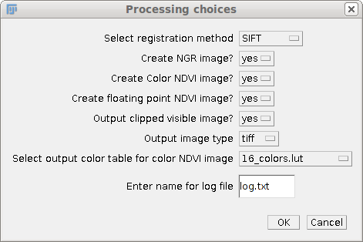

Most options are self-explanatory (if they aren't please let me know). The registration methods are explained in the introduction. The log file name is the name of a text file that will be created in the output directory to document the registration method used for each image pair. After you select the options you want click on “OK”.

The next window allows you to select the input directory where the input images can be found.
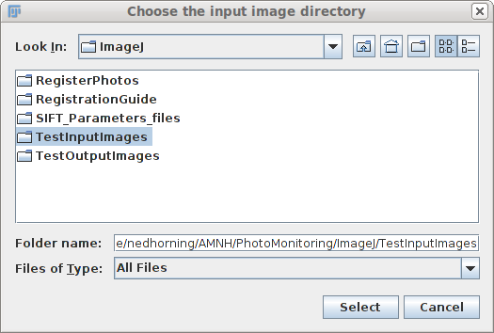

Next, the output directory where the new images will be written must be selected. Click on “Select” when the directory is selected.

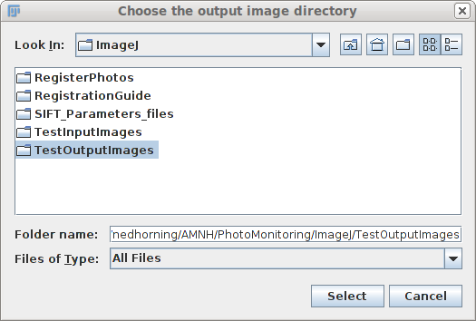

The last window lets you select the text file that has file names of the image pairs you want to process. When you click “Select” the macro will begin processing the images.

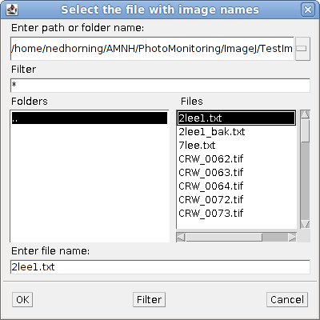

If the SIFT registration method is selected and an image pair fails to register that pair will be skipped and processing of the remaining image pairs will continue.

An attempt has been made to create some processing messages that will be output on the ImageJ/Fiji “Log” window. When an error occurs an informative message should be displayed.

When the macro is running it is best not to interact with your computer since the macro processes the active window and if another window become active it might cause the macro to generate an error. This can be avoided using the “batch” option mentioned above but then you can not see what is happening to the images.

This guide and the macro are works in progress and comments are welcome.

