Downloading documents using an exported Colandr CSV file using the Scopus Document Download Manager

This guide illustrates how to download documents that are flagged as "citation_screening_status" = "included" in an exported Colandr CSV file. The process involves three steps; setting up a Zotero collection (Endnote would likely work as well), running an R script and using the Scopus “Advanced” search interface. This process requires access to Scopus and authorization to download documents from publisher web sites. Without proper authorization only open licensed documents can be downloaded.

Download the Colandr CSV file
In Colandr, after the “Citation Screening” stage you can export a CSV file showing the included/excluded status of all of your documents. Use the “EXPORT” button to output the CSV file.

Edit and run the R script to output search strings
Once the CSV file is created you can edit the ColandrScopusParser.R script to specify the path and file name for the CSV file and the path and filename for the output ASCII text file. Due to a constraint in Scopus that limits the length of a search string the script subsets the full search string into sets with a user-defined number of titles. For example, if you had 95 citations and wanted ten titles in a single search string you would set the “numPapers” variable to 10. The output ASCII text file would have nine search strings with 10 titles and a tenth with five titles. When the script is ready you can run it and the text file including your search strings will be output.

Create a Zotero collection to store documents
Before downloading documents it is necessary to have a place to store them. Documents can be downloaded to a directory but a better choice is to use document management software such as Zotero to store the documents as well as citation information and other metadata. In my case I set up a new Zotero collection to store the documents I was downloading.

Run the search in Scopus
Next, open Scopus in a browser and click on the “Advanced” search link. Copy the first search string from the text file you created with the R script and paste it into the Scopus Advanced search string interface (see figure below) then click on the “Search” button.
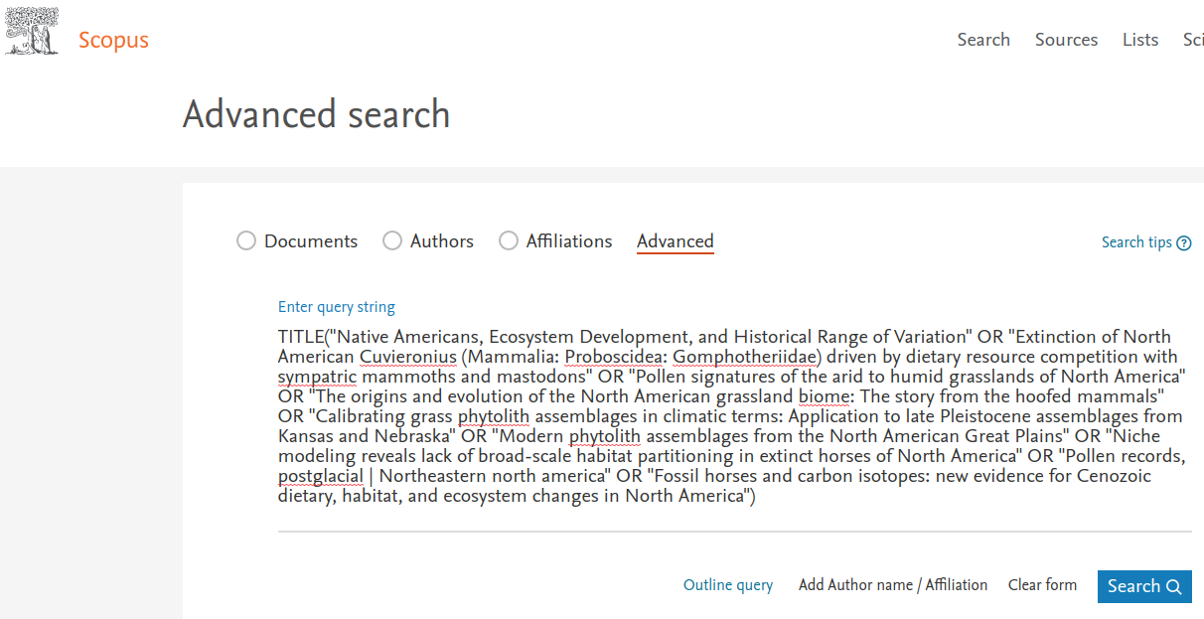
After the search is complete the results are displayed with a checkbox to the left of each title that is found (see figure below). If the results look appropriate you can click on the “All” checkbox to select all of the documents. Otherwise, you can select documents one at a time. In some cases you might be expecting a certain number of titles but the results return many additional titles. In my experience that is likely due to overly simplistic titles. For example if the search string included a book titled “Grasslands” that would likely return hundreds of titles. In that case it is probably easier to manually edit the search string and run the search again. When you have the appropriate titles selected using the checkboxes click on the “Download” link near the top of the list of documents.

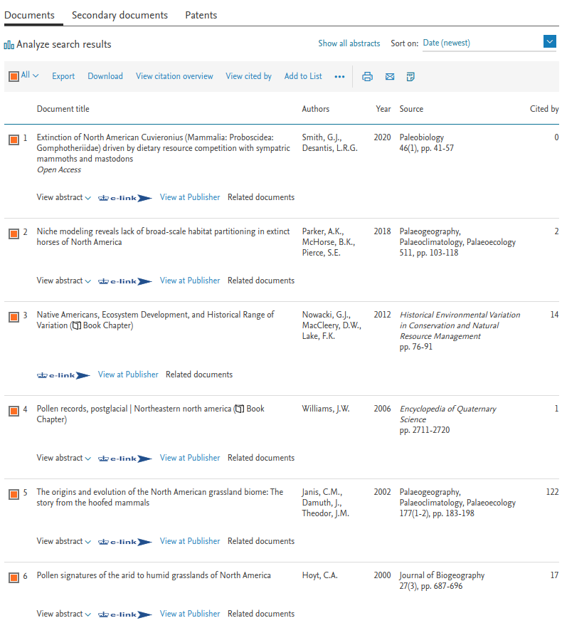

After a few seconds you will see the download results displayed in the “Scopus Document Download Manager”. Click on the “Download” box to initiate the download to initiate the download process (see figure below). If there are any open licensed documents in the search they will be downloaded automatically to your default download directory, not Zotero. Those files, noted in the interface as “Downloaded”, will need to be manually transferred to Zotero.

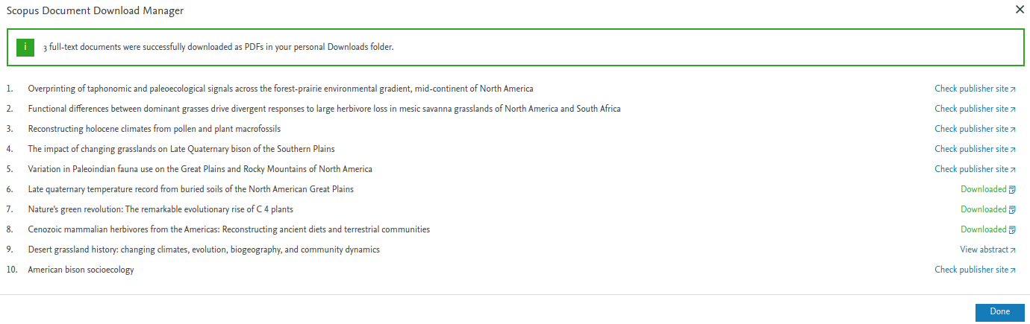
Titles that have a “Check publisher site” link to the right can be downloaded by clicking on the link and then clicking on your browser’s Zotero icon you can download that document and metadata to Zotero. In some cases the link for a title will be “View abstract”. From my experience that is often associated with books, book chapters, or other documents that Scopus can not access. Clicking on the link will display the abstract and in some cases you can download the document from that page although in many cases you’ll need to manually search for the document. It’s quite possible that you will not have free access to those documents.

