Counting 8-Puzzle Solutions
This document describes initial results leading to a conjecture regarding the number of equivalent optimal solutions to Markov decision problems with deep solutions. The conjecture is expanded to cover the number and quality of near-optimal solutions to the same problems.
These conjectures, if true, are potentially important to the scouting processing technique that I have developed for implementing practical hardware acceleration for solving various NP-complete problems. The primary drawback of scouting is that it must experiment within an exponentially enlarging solution space as it is applied to problems that are more complex.
This is a skeletal document outlining only the major thought process.

A Sample Problem: 8-Puzzle
The standard 8-puzzle, in which eight tiles are placed in a 3x3 grid and manipulated by sliding one tile at a time is considered. The following goal state is used, but the choice is largely arbitrary.

1 | 2 | 3
8 |  | 4
7 | 6 | 5

Counting Initial States
It is obvious that there are possible initial states. However, since each tile movement is really a swap of a numbered tile and the blank space, there is a parity argument that suggests that any goal state is only reachable from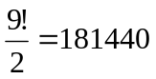states (including itself). To verify this, I built two simulations. The first simply takes an 8-puzzle in the goal state and makes random movements, building an insertion sorted list of every possible state that the puzzle can be manipulated into. This simulation eventually finds a total of 181440 initial states, and never finds any more in spite of additional runtime.
This verifies that the parity argument is in fact correct, and any state can be reached from exactly ½ of the possible number of initial states.
The second simulation that verifies this is also useful in the next section, and so is discussed below.

Tabulating All Solution Depths
The next issue is the depth of solutions. Much of my research was conducted only with a gut feel for typical solution depth based on the solution results of thousands of randomly generated test problems. These problems were generated by performing a large number of random manipulations on a puzzle initially in the goal state.
My newer simulation uses dynamic programming to work backwards from the goal state into every possible initial state while tabulating how many states can be reached from each number of backward moves. In this way, we construct an optimal solution path from every possible initial state to the goal state.
These simulations were added by using a hashing function that encodes each puzzle as a single 32-bit integer. For example, the goal state is expressed as 123804765.
These results are summarized in graphical form below. The average solution depth is 21.5 moves. It is interesting to note the dramatic dropoff in the number of puzzle requiring more than 25 moves to solve.
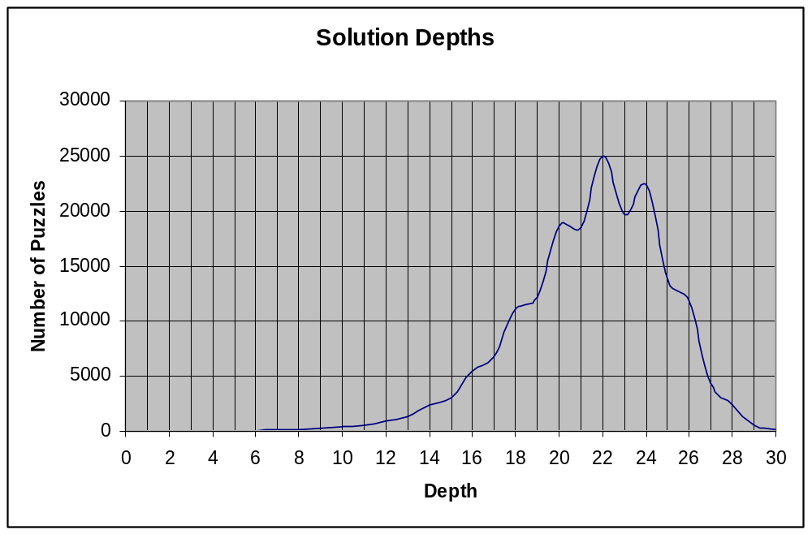
The graph below is the integral of the solution depth graph expressed in percent. This is effectively a probability density function representing the probability of an arbitrary puzzle having a particular solution depth
Half of all puzzles have solutions of 22 moves or fewer. 90% HAVE SOLUTIONS OF 25 MOVES OR FEWER.
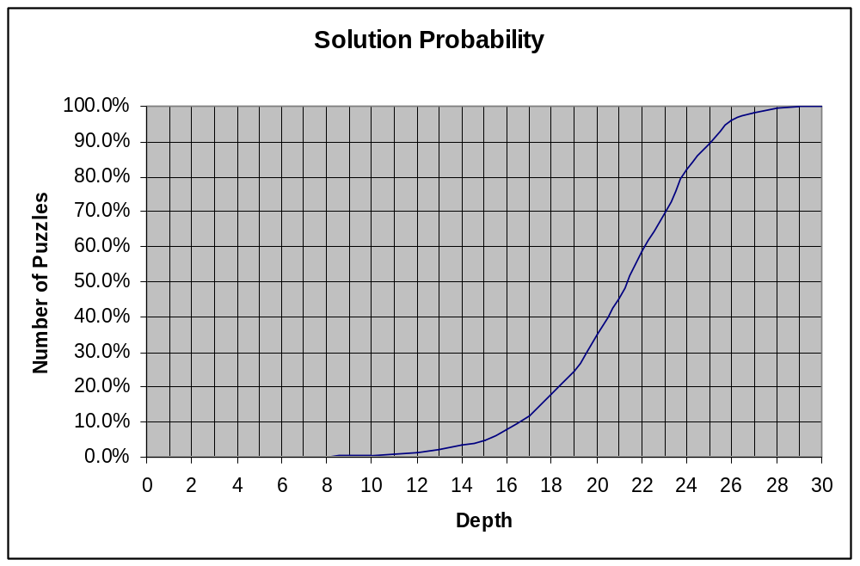
This result leads to my first conjecture:
CONJECTURE #1
In many decision problems, the worst case scenarios are rare. The pathologically difficult problems are almost nonexistent.

Counting the Number of Equivalent Optimal Solutions
Having alternate optimal solutions improves the odds of finding at least one of them. I don’t have a complete way of tabulating these at this time, although I think a simple modification to what I’m about to describe will work.
Presently, during the dynamic programming run, I count duplicate paths if I encounter the same state more than once at one iteration. That is, if I’m four moves back from the goal, and in propagating all of the four-deep puzzles back to five-deep I encounter the same state twice, I would tag that particular state as a puzzle with a solution 5 deep and a count of 2.
The average values are tabulated below:
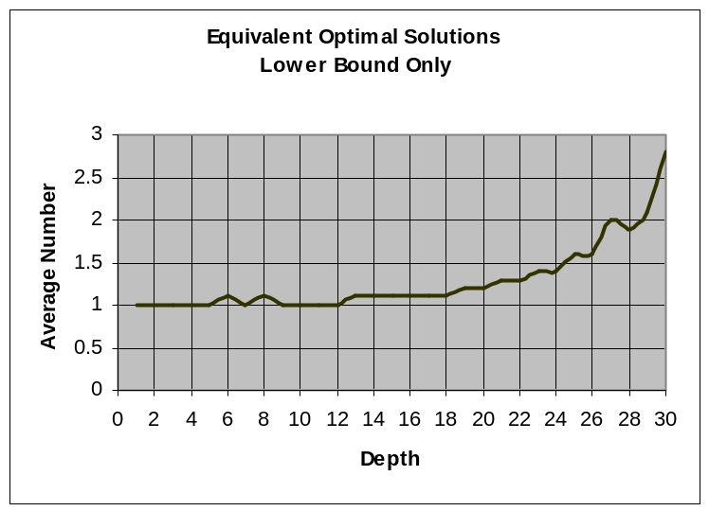
This is only a (poor) lower bound on the actual number of alternate optimal solutions for each puzzle because the information isn’t propagated deeper into the tree. For example, the solution tree:
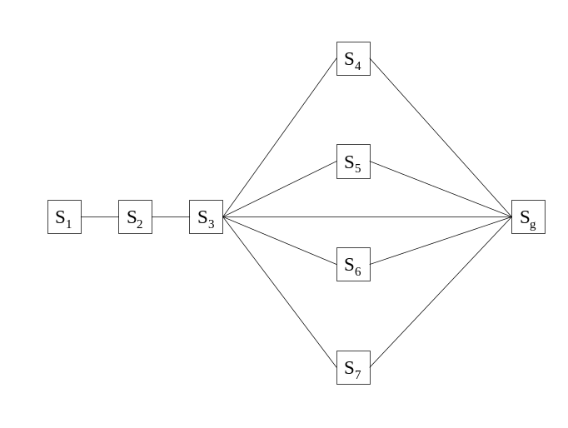
State 3 would be credited with an optimal solution of one move to get to state g. It would also be credited with four suboptimal paths of length two moves. But I must also tabulate 4 suboptimal solutions from state 2 of length 3, and 4 suboptimal solutions from state 1 of length 4.
For this reason, the number of equivalent optimal solutions in the 8-puzzle is likely vastly understated by the graph above.

Counting Suboptimal Solutions
It would be interesting to know the quality and number of suboptimal solutions for various puzzles. These are harder to tabulate, but I have used the following definition to collect some initial results.
Let a trajectory 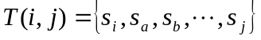be a set whose elements contain the ordered sequence of states in a trajectory from state to state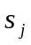.
Let 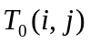be an optimal trajectory from to in the sense that there is no trajectory from to containing fewer steps than .
Define a first-order suboptimal trajectory 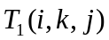as an optimal trajectory to a state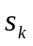NOT a part of followed by an optimal trajectory to. That is,
where the plus operator is used to signify concatenation. This allows us to construct suboptimal solutions from tabulated sets of optimal solutions that can be built using the dynamic programming technique discussed earlier.
CONJECTURE #2
If tabulated for all, the complete set of solutions include all of the best suboptimal solutions.
I have built a simulator that counts the number of first-order suboptimal solutions for specific puzzles. The simulator first tabulates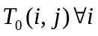given our chosen goal state. Then, for initial states with varying depths of solutions, the simulator computes 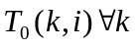. Now, it is possible to count all of the first order suboptimal solutions by trying every puzzle state as. This process appears as follows diagrammatically, where the straight lines represent optimal trajectories from one state to the next, possibly through many other states.
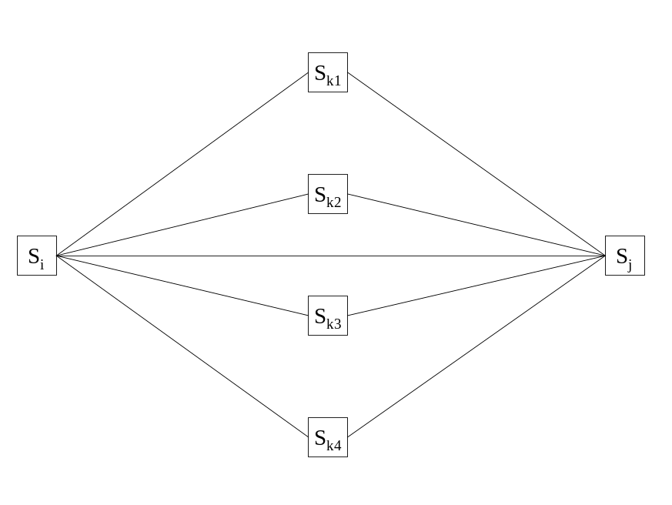
The results of this tabulation for a randomly chosen puzzle with solutions of 5, 10, 15, 20, 25, and 30 moves are graphed below. Note that the frequency axis on these plots is logarithmic.
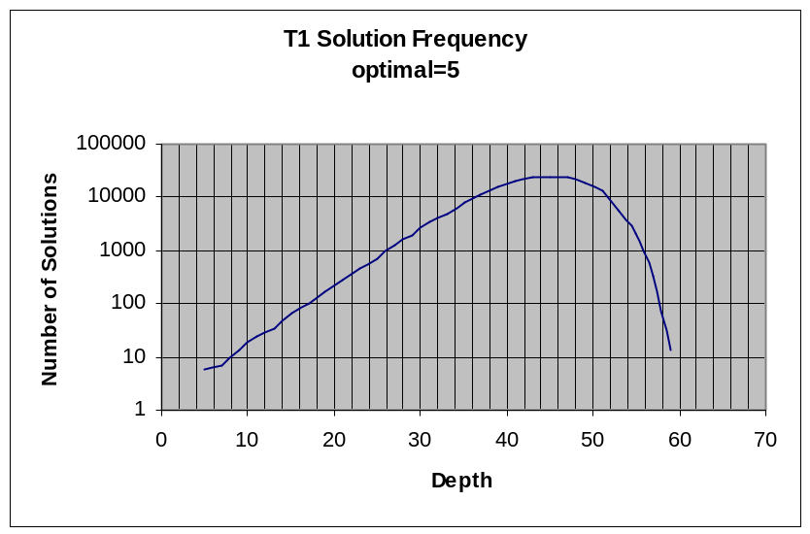
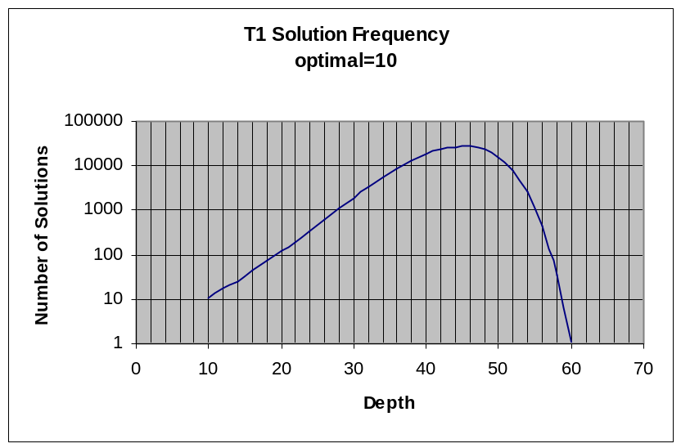
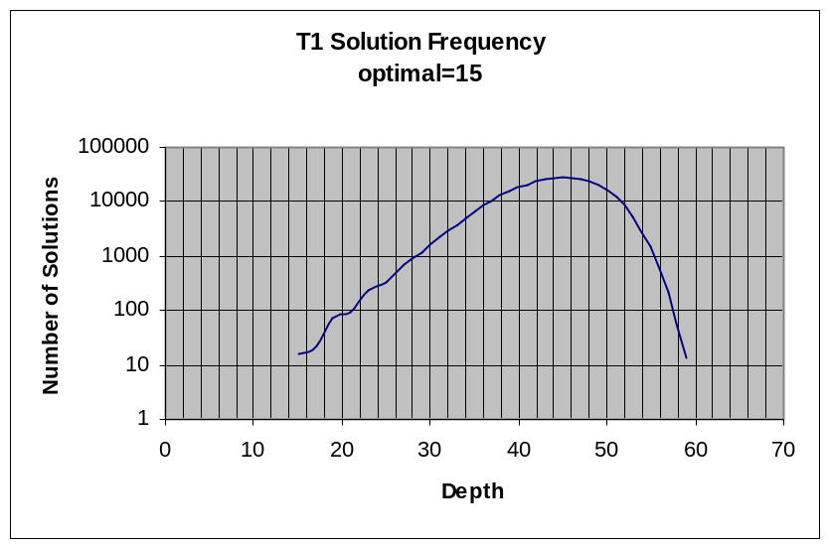
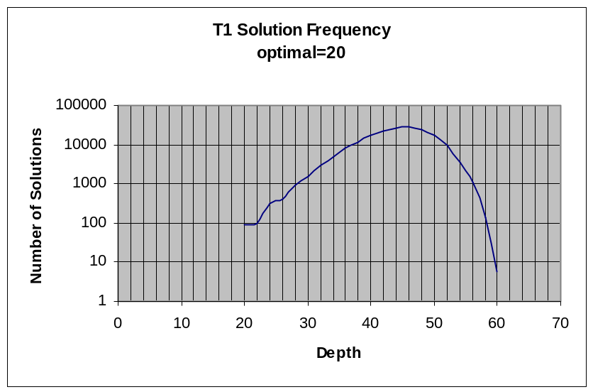
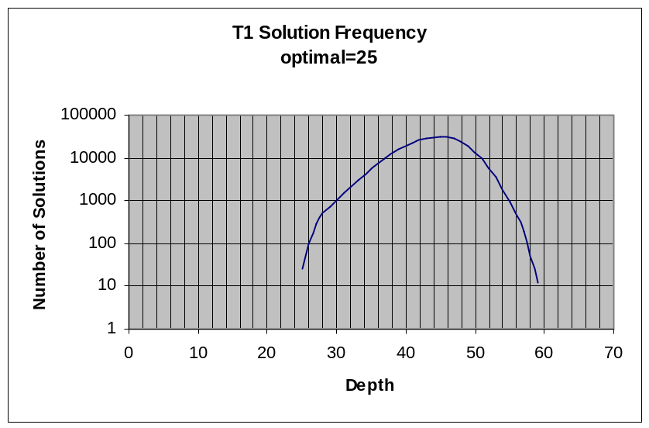
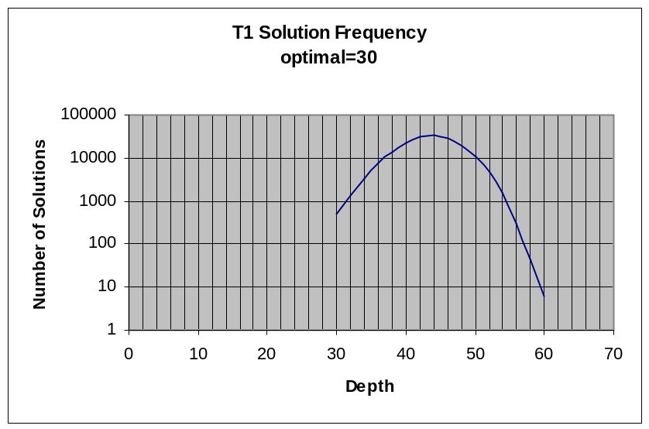
There is a problem with these plots. The first-order solutions are summed for all states, including those on the optimal path. This explains why, for example, there seem to be 6 optimal solutions for the puzzle with a single optimal solution of length 5. This just represents one optimal solution that touches 6 states.
What is significant, however, is the enormous number of suboptimal solutions. This population is centered on a depth of about 42 moves, regardless of the degree of difficulty of the puzzle. The quantity of solutions at this level is also problem-independent.
What this seems to say is that the character of the optimal solution varies from problem instance to problem instance, but that in general one can get from any state to any state in 40 moves, so there are always plenty of 40 move solutions regardless of whether your particular problem is easy or hard.
The nice consequence of this uniform depth of the bulk of the suboptimal solutions is that they get closer and closer to the optimal solution size as the problems get harder and harder. That is,
CONJECTURE #3
The harder the problem gets, the better the suboptimal solutions begin to look.
OR
As the probability of discovering an optimal solution goes down, the probability of discovering a near-optimal solution goes up.

