Counting 8-Puzzle Solutions
2/9/00

This document describes initial results leading to a set of conjectures regarding the number of equivalent optimal solutions to Markov decision problems with deep solutions. The conjectures also cover the number and quality of near-optimal solutions to the same problems.
These conjectures, if true, are potentially important to the scouting processing technique that I have developed for implementing practical hardware acceleration for solving various NP-complete problems. The primary drawback to scouting is that it must experiment within an exponentially growing solution space as it is applied to problems that are more complex.
My latest research with scouting involves using evolutionary or learning systems (such as neural nets) to build heuristic estimators for cost-to-goal for these problems. For example, Manhattan Distance is a poor but classic cost-to-goal estimator used for directing 8-puzzle searches. A much more informed estimators can be trained using the actual solutions developed by an undirected scouting approach, and these estimators can then be used in a directed search scheme to improve the efficiency of scouting on subsequent problems. I call this advanced process directed scouting.
This step is designed to show that undirected scouting doesn’t fall apart as quickly as one might fear as the solution depths increase. This is a skeletal document outlining only the major thought process. This works suggests three conjectures, which are listed below for convenience.
CONJECTURE #1
In many decision problems, the worst case scenarios are rare. The pathologically difficult problems are almost nonexistent.
CONJECTURE #2
Problems requiring more complex solutions are more likely to have multiple optimal solutions, limiting the negative effects of exponential growth in the search tree.
CONJECTURE #3
The harder the problem gets, the better the suboptimal solutions begin to look. OR
As the probability of discovering an optimal solution goes down, the probability of discovering a near-optimal solution goes up.
The remainder of this document describes the thinking and experimentation leading to these conjectures.

A Sample Problem: 8-Puzzle
The standard 8-puzzle, in which eight tiles are placed in a 3x3 grid and manipulated by sliding one tile at a time is considered. The following goal state is used, but the choice is largely arbitrary.

1 | 2 | 3
8 |  | 4
7 | 6 | 5

Counting Initial States
It is obvious that there are possible initial states. However, since each tile movement is really a swap of a numbered tile and the blank space, there is a parity argument that suggests that any goal state is only reachable from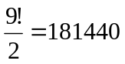states (including itself). To verify this, I built two simulations. The first simply takes an 8-puzzle in the goal state and makes random movements, building an insertion-sorted list of every possible state that the puzzle can be manipulated into. This simulation eventually finds a total of 181440 initial states, and never finds any more in spite of additional runtime.
This verifies that the parity argument is in fact correct, and any state can be reached from exactly ½ of the possible number of initial states.
The second simulation that verifies this is also useful in the next section, and so is discussed below.

Tabulating All Solution Depths
The next issue is the depth of solutions. Much of my research was conducted only with a gut feel for typical solution depth based on the solution results of thousands of randomly generated test problems. These problems were generated by performing a large number of random manipulations on a puzzle initially in the goal state.
My newer simulation uses dynamic programming to work backwards from the goal state into every possible initial state while tabulating how many states can be reached from each number of backward moves. In this way, we construct an optimal solution path from every possible initial state to the goal state.
These simulations were dramatically aided by using a hashing function that encodes each puzzle as a single 32-bit integer. For example, the goal state is expressed as the integer 123804765.
These results are summarized in graphical form below. The average solution depth is 21.5 moves. It is interesting to note the dramatic dropoff in the number of puzzles requiring more than 25 moves to solve.

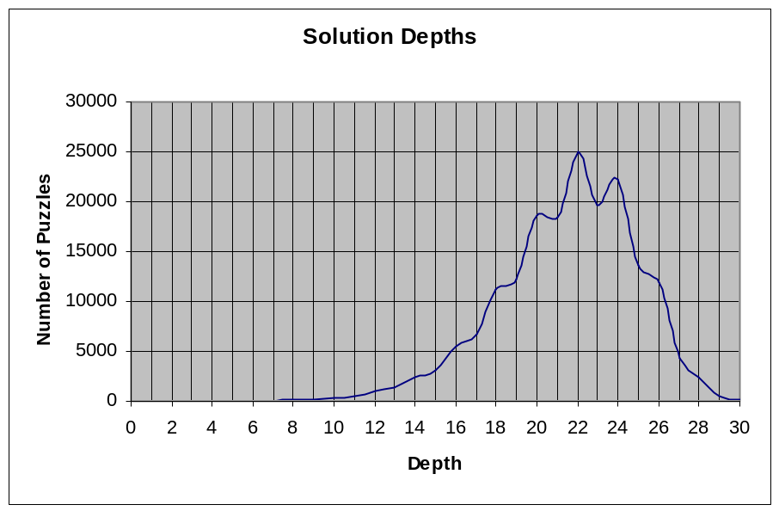
The graph below is the integral of the solution depth graph expressed in percent. This is effectively a probability density function representing the probability of an arbitrary puzzle having a solution less than a particular depth
Half of all puzzles have solutions of 22 moves or fewer. 90% have solutions of 25 moves or fewer.
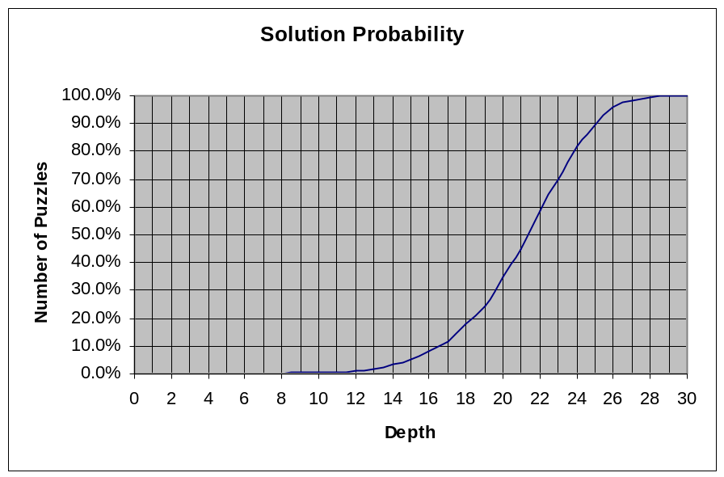
This result leads to my first conjecture:
CONJECTURE #1
In many decision problems, the worst case scenarios are rare. The pathologically difficult problems are almost nonexistent.

Counting the Number of Equivalent Optimal Solutions
Having alternate optimal solutions improves the odds of finding at least one of them. It is fairly easy to add this computation to the dynamic programming backpropagation as follows.
Consider that the goal state has a solution depth of 0 and only 1 way to achieve it (you have to start there!). When we backpropagate to puzzles reachable from one move, they are all marked with depths of 1 and counts of 1.
At some point, the same state is reachable from different puzzles with the same depth solution (4 in the example). This puzzle is marked with a corresponding solution count. As we backpropagate from this solution, all previous states are given a count of this parent count plus any other duplicities found along the way.
This technique is easily illustrated with a simple diagram:
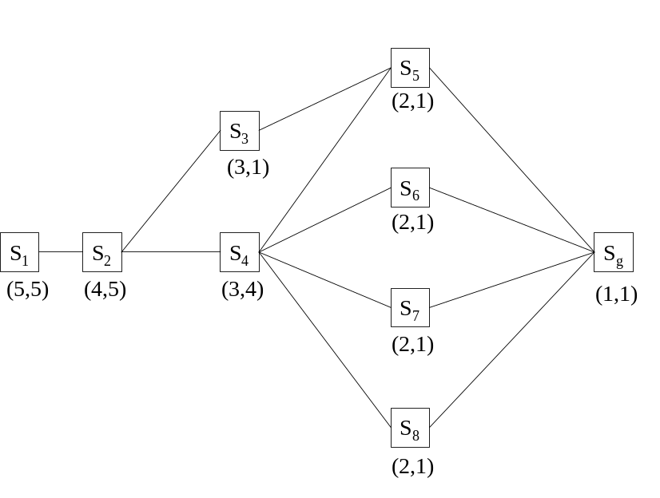
In the example, states 5-8 are found first, and have (depth,duplicity)=(1,1). Backpropagating from these states finds state 3 once, and state 4 four times. These states are marked (2,1) and (2,4), respectively. Backpropagating from states 3 and 4 find only state 2, but state 2 must receive the count of state 3 added to the count of state 4. Finally, state 2 backpropagates to state 1, which receives a copy of state 2s count.
The result of tabulating these counts during backpropagation for the 8-puzzle is shown below. For each solution depth, the minimum, maximum, and average number of equivalent optimal solutions is displayed.
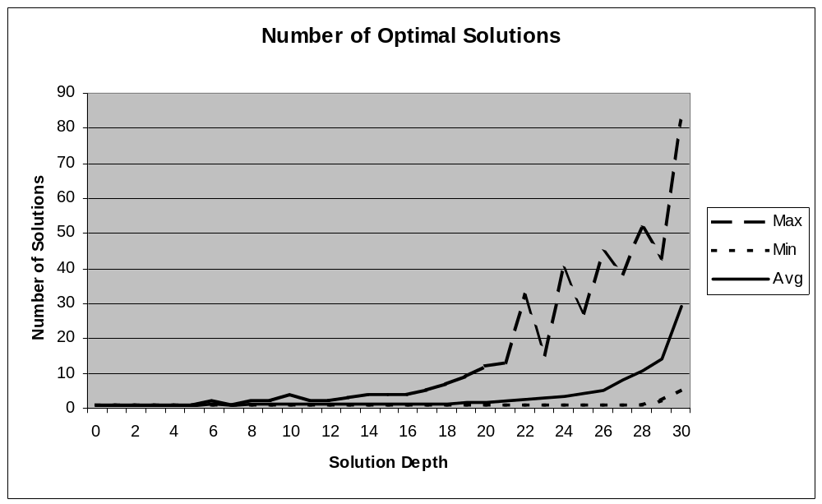

The importance of multiple equivalent optimal solutions is enormous. In my dissertation, I showed that the probability of discovering one of m optimal solutions by making n random excursions from the initial state for a problem with average branching factor b and solution depth d is:
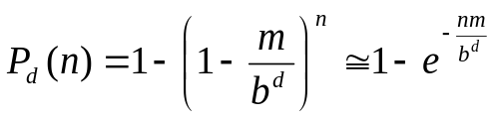
In the 8-puzzle, the average branching factor ignoring the branch back to where you just came from is 1.67. For a worst-case puzzle with d=30, running 100,000 scouting searches has only a 2.1% chance of finding an optimal solution for m=1. For m=30, which is the average value for puzzles with d=30, this probability increases to 46.5%. For the highest count m=82 at d=30, 100,000 search runs have an 81.1% chance of stumbling onto an optimal solution.
Thus, while a straightforward analysis shows bleak prospects for unstructured search on complex problems, this “gift of complexity” makes the problem much more tractable.
CONJECTURE #2
Problems requiring more complex solutions are more likely to have multiple optimal solutions, limiting the negative effects of exponential growth in the search tree.

Counting Suboptimal Solutions
It would be interesting to know the quality and number of suboptimal solutions for various puzzles. These are harder to tabulate, but I have used the following definition to collect some initial results.
Let a trajectory 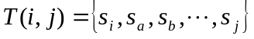be a set whose elements contain the ordered sequence of states in a trajectory from state to state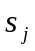.
Let 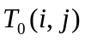be an optimal trajectory from to in the sense that there is no trajectory from to containing fewer steps than .
Define a first-order suboptimal trajectory 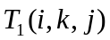as an optimal trajectory to a state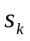NOT a part of followed by an optimal trajectory to. That is,
where the plus operator is used to signify concatenation. This allows us to construct suboptimal solutions from tabulated sets of optimal solutions that can be built using the dynamic programming technique discussed earlier.
THEOREM (proof needed)
If tabulated for all, the complete set of solutions includes all of the best suboptimal solutions to the problem of traversing from to .
I have built a simulator that counts the number of first-order suboptimal solutions for specific puzzles. The simulator first tabulates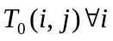given our chosen goal state. Then, for initial states with varying depths of solutions, the simulator computes 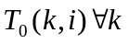. Now, it is possible to count all of the first order suboptimal solutions by trying every puzzle state as. This process appears as follows diagrammatically, where the straight lines represent optimal trajectories from one state to the next, possibly through many other states.
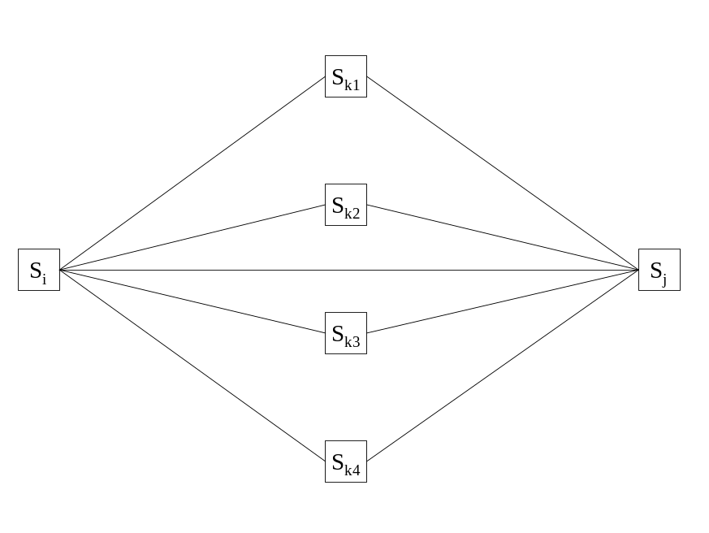
The results of this tabulation for a randomly chosen puzzle with solutions of 5, 10, 15, 20, 25, and 30 moves are graphed below. Note that the frequency axis on these plots is logarithmic.
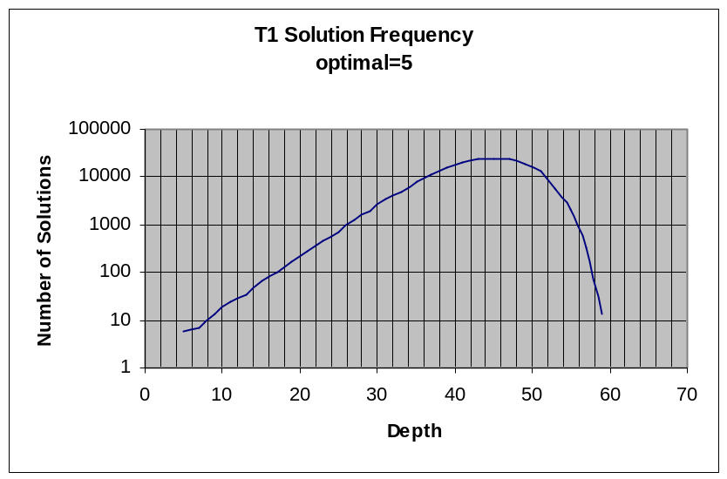
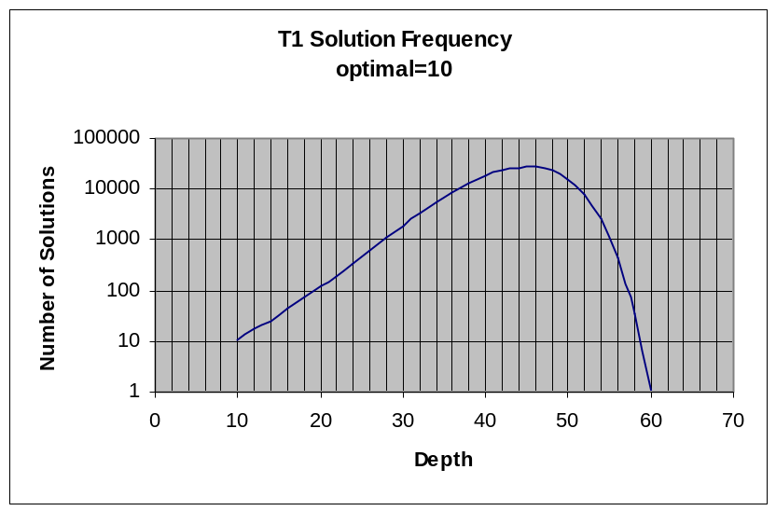
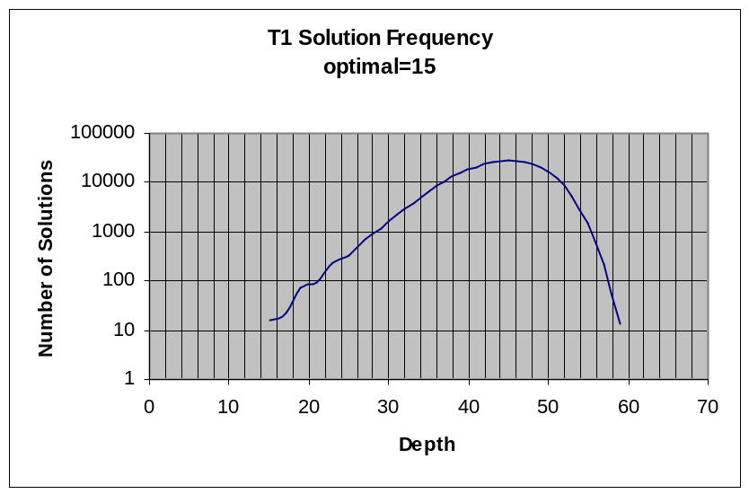
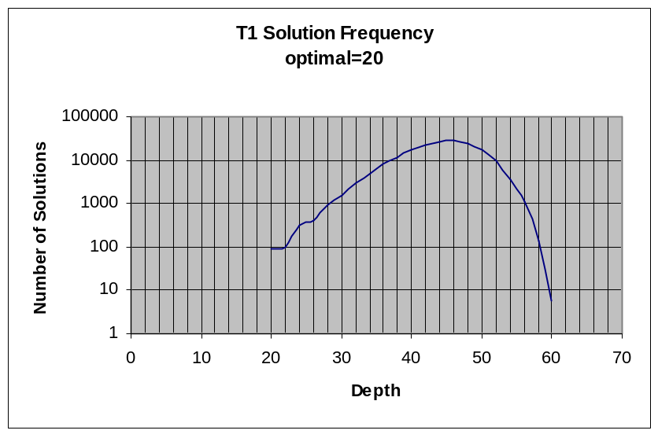
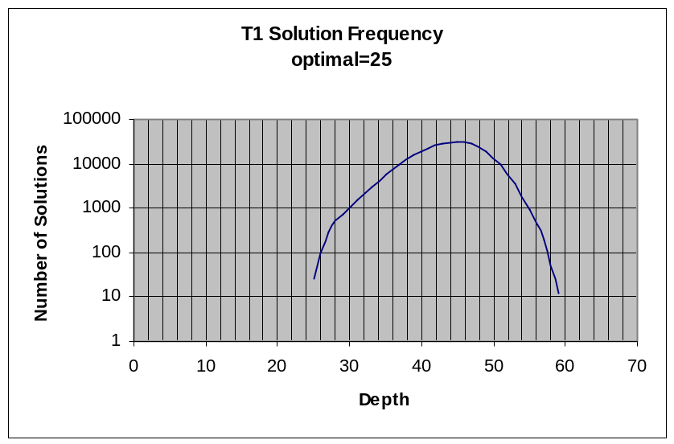
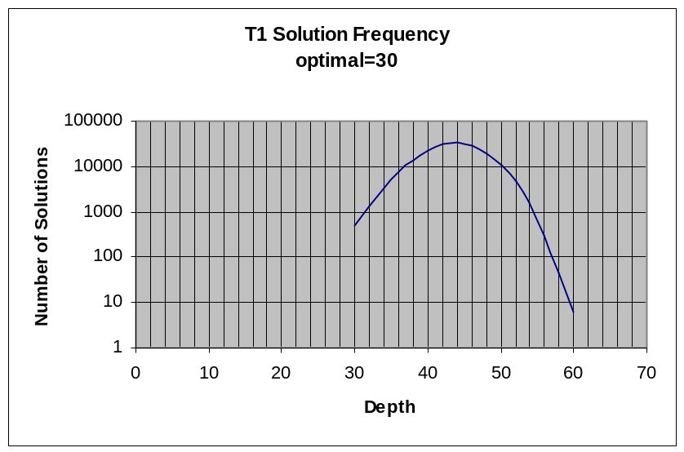
There is a problem with these plots. The first-order solutions are summed for all states, including those on the optimal path. This explains why, for example, there seem to be 6 optimal solutions for the puzzle with a single optimal solution of length 5. This just represents one optimal solution that touches 6 states.
What is significant, however, is the enormous number of suboptimal solutions. This population is centered on a depth of about 42 moves, regardless of the degree of difficulty of the puzzle. The quantity of solutions at this level is also problem-independent.
What this seems to say is that the character of the optimal solution varies from problem instance to problem instance, but that in general one can get from any state to any state in 40 moves, so there are always plenty of 40 move solutions regardless of whether your particular problem is easy or hard.
The nice consequence of this uniform depth of the bulk of the suboptimal solutions is that they get closer and closer to the optimal solution size as the problems get harder and harder. That is,
CONJECTURE #3
The harder the problem gets, the better the suboptimal solutions begin to look.
OR
As the probability of discovering an optimal solution goes down, the probability of discovering a near-optimal solution goes up.

