RhythmicTunes: Your Melodic Companion – Frontend Documentation

# 1. Project Title

RhythmicTunes: Your Melodic Companion – Frontend Module  
  
Team ID: NM2025TMID40787

Team Leader: Nedunthirumaran- nedunthirumaran17@gmail.com  
Team Members:

* Navin- navizzn20@gmail.com
* ponniglesh- [nikil.m6567@gmail.com](mailto:nikil.m6567@gmail.com)
* Paul Wesley - paulweslypaul@gmail.com

# 2. Project Overview

Purpose:  
Rhythmic Tunes is a music player web application frontend built with React and Vite. It provides a user-friendly interface to browse, search, and play songs, manage playlists, favorites, and wishlist.  
  
Frontend Features:  
- Landing page with navigation bar  
- Sidebar for navigation  
- Playlist management  
- Favorites and Wishlist functionality  
- Search bar for songs  
- Local MP3 file integration  
- Responsive design with React + Vite

# 3. Architecture (Frontend)

- Framework: React.js (with Vite bundler)  
- Styling: CSS (component-specific)  
- Assets: Local audio files and icons  
- No external UI libraries (custom CSS)

# 4. Setup Instructions

Prerequisites:  
- Node.js (latest LTS)  
- npm (comes with Node.js)  
- Code editor (VS Code)  
  
Installation Steps:  
# Clone the repository  
git clone <repository-url>  
cd code  
  
# Install dependencies  
npm install  
  
# Start development server  
npm run dev  
  
Access:  
Open http://localhost:5173 in browser

# 5. Folder Structure (Frontend Only)

code/  
 ├── index.html  
 ├── vite.config.js  
 ├── package.json  
 ├── src/  
 │ ├── main.jsx  
 │ ├── App.jsx  
 │ ├── App.css  
 │ ├── index.css  
 │ ├── Components/  
 │ │ ├── Unavbar.jsx  
 │ │ ├── Sidebar.jsx  
 │ │ ├── Uhome.jsx  
 │ │ ├── Songs.jsx  
 │ │ ├── Playlist.jsx  
 │ │ ├── Wishlist.jsx  
 │ │ ├── Favorities.jsx  
 │ │ ├── Search.jsx  
 │ │ ├── Uitem.jsx  
 │ │ ├── sidebar.css  
 │ │ ├── uhome.css  
 │ └── assets/  
 │ └── react.svg  
 ├── public/  
 │ ├── vite.svg  
 │ └── Songs/  
 │ ├── chaleya.mp3  
 │ ├── Bol Do Na Zara.mp3  
 │ ├── Humnava Mere.mp3  
 │ └── Saari Duniya Jalaa Denge.mp3  
 └── db/  
 └── db.json

# 6. Running the Application

- Start frontend:  
npm run dev  
  
- Default port: 5173  
- Open browser → http://localhost:5173

# 7. UI Components

- Unavbar.jsx – Navigation bar  
- Sidebar.jsx – Sidebar menu  
- Uhome.jsx – Home page  
- Songs.jsx – Song list component  
- Playlist.jsx – Playlist management  
- Wishlist.jsx – Wishlist system  
- Favorities.jsx – Favorites section  
- Search.jsx – Search functionality  
- Uitem.jsx – Single item card

# 8. User Interface (Frontend Pages)

- Landing Page  
- Sidebar Navigation  
- Music Player with Playlist  
- Favorites and Wishlist  
- Search bar for songs

**9. Screenshots**

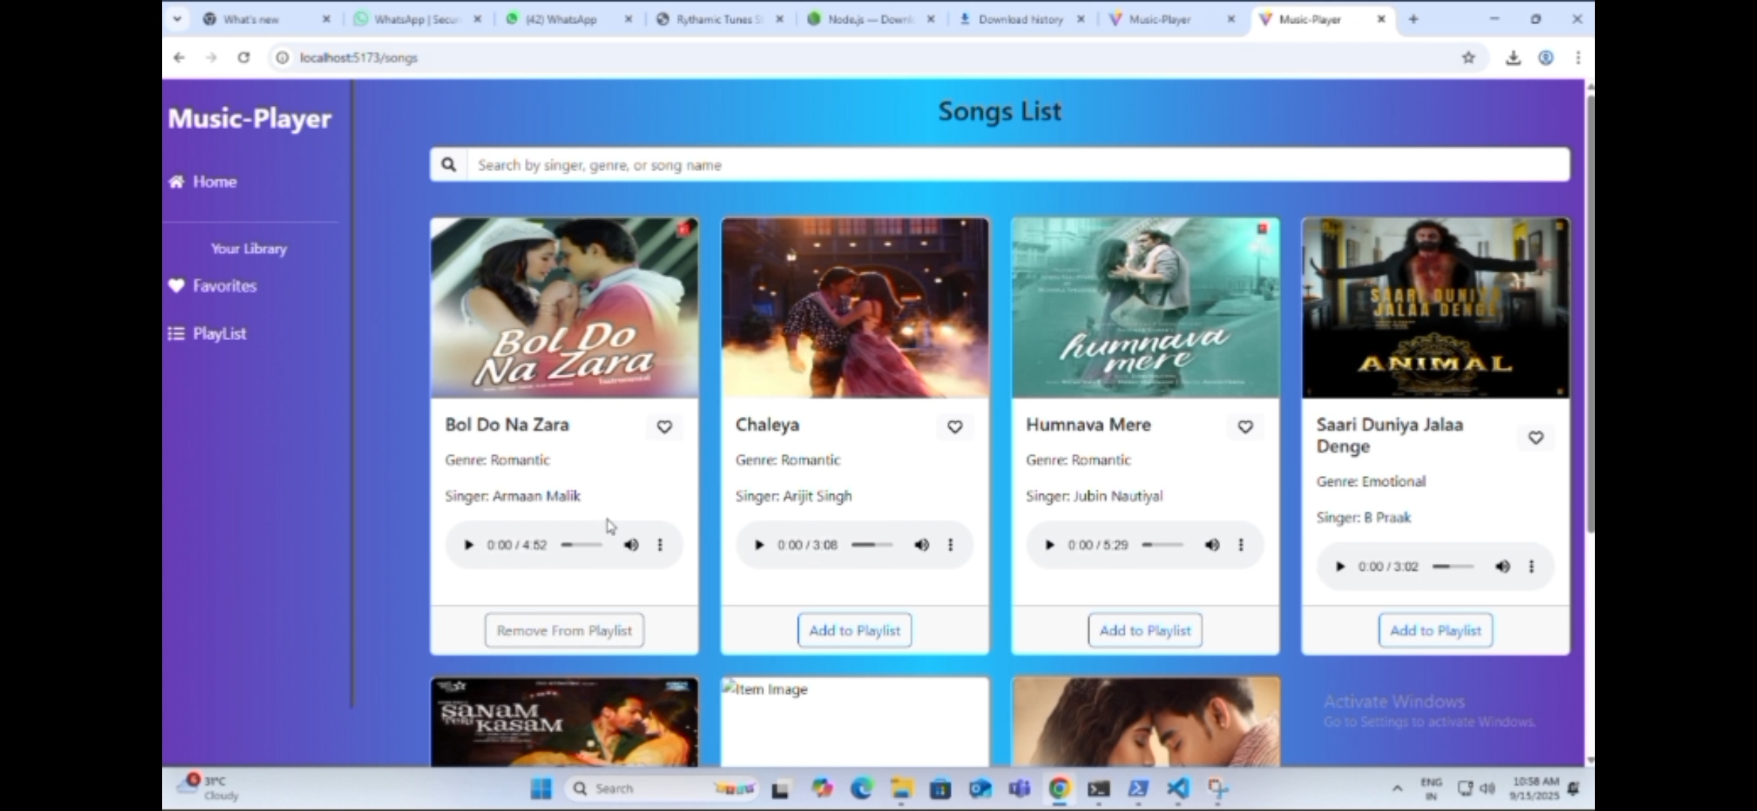

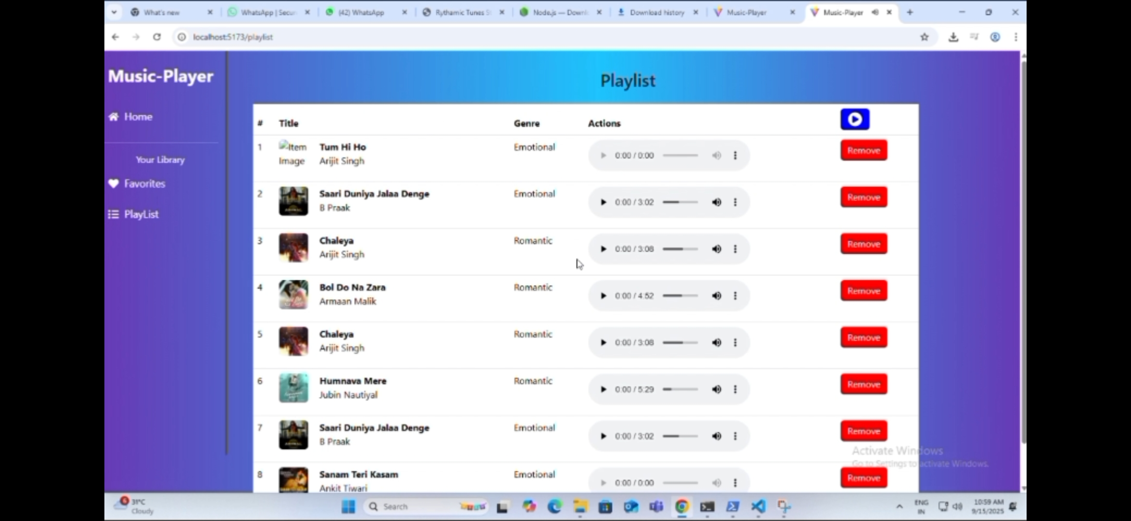

# 10. Testing (Frontend)

- Manual testing with browser dev tools  
- Verified playlist and favorites functionality  
- Debugging with Vite hot reload

# 11. Future Enhancements

- Add user login & authentication  
- Save playlists to backend  
- Improve responsive design and animations  
- Add volume control and audio visualizer