CHAPTER FOUR

SYSTEM IMPLEMENTATION AND DOCUMENTATION

4.0 Introduction
This chapter presents the implementation and documentation of the proposed Faculty Local Area Network (FacultyLAN) model. The implementation translates the network architecture, communication requirements and system design presented in Chapter Three into an executable network simulation. The implementation was carried out using OMNeT++ 6.0.1 and the INET Framework. OMNeT++ provides a modular and component-based environment for developing discrete-event simulation models, while INET provides reusable models for wired and wireless communication protocols and network components. (OMNeT++)
The implemented FacultyLAN consists of wired faculty workstations, a core network infrastructure, network servers, a wireless access point and three wireless users. The implementation supports communication through Ethernet and IEEE 802.11 wireless networking.
The chapter discusses the development environment, implementation architecture, program modules, input and output formats, data flow, testing procedures and documentation of the implemented system. It also presents the actual simulation results obtained from the FacultyLAN model. These results provide evidence that the configured network components were able to communicate through the implemented topology.

4.1 Choice of Development Environment
The choice of development environment was based on the requirements of the proposed FacultyLAN system. Since the project involves the modelling and simulation of a computer network containing both wired and wireless components, a discrete-event network simulation environment was required.
The major development tools used are presented in Table 4.1.

Table 4.1: Development Environment
Component | Selected Technology | Purpose
Simulation Environment | OMNeT++ 6.0.1 | Development and execution of the FacultyLAN simulation
Network Framework | INET Framework 4.5 | Provision of network protocols and reusable network modules
Modelling Language | NED | Definition of network structure, modules and connections
Simulation Configuration | omnetpp.ini | Configuration and execution parameters
Operating System | Windows | Development and simulation environment
Wired Technology | Ethernet | Communication between wired network nodes
Wireless Technology | IEEE 802.11 | Wireless communication between users and the access point
Connectivity Protocol | ICMP | Network connectivity testing
Transport Protocol | TCP | Reliable client-server communication
Transport Protocol | UDP | Connectionless packet communication
Simulation Interface | Qtenv | Interactive simulation execution and visualization

4.1.1 OMNeT++ 6.0.1
OMNeT++ 6.0.1 was selected as the primary simulation environment. OMNeT++ is an extensible, modular and component-based C++ simulation framework designed primarily for building network simulators and other discrete-event simulation systems. (OMNeT++)
The simulator provides facilities for defining network structures, configuring simulation parameters, executing communication events and examining simulation results. The NED language is used to describe the structure of the network by defining modules, compound modules, connections and channels. (OMNeT++ Documentation)
For this project, OMNeT++ provides the controlled environment required to instantiate the FacultyLAN design and evaluate whether the proposed wired and wireless components can communicate successfully.

4.1.2 INET Framework
The INET Framework was used together with OMNeT++. INET is an open-source model library for OMNeT++ that provides models for communication networks, including wired, wireless, Internet and mobile networks. It includes implementations and models for protocols such as TCP, UDP, IPv4 and IEEE 802.11, as well as Ethernet and other communication technologies. (INET Framework)
The use of INET reduced the need to implement basic networking protocols manually. Instead, appropriate existing INET modules were assembled and configured to represent the FacultyLAN environment.
The framework therefore provided the required building blocks for:
- wired hosts;
- servers;
- Ethernet interfaces;
- wireless hosts;
- wireless access points;
- IEEE 802.11 communication;
- IPv4 communication;
- TCP;
- UDP; and
- ICMP-based connectivity testing.

4.1.3 NED Modelling Language
The FacultyLAN topology was defined using the NED language. NED, which stands for Network Description, allows network modules to be declared, assembled and connected into compound network models. It supports hierarchical and component-based modelling, making it appropriate for representing a network containing multiple interacting components. (OMNeT++ Documentation)
The FacultyLAN NED model defines the network nodes and their communication relationships. The model includes the faculty departments, network infrastructure, servers, wireless access point and wireless users.
The project source follows the package structure:
package facultylan;
The NED source directory is configured so that the package is resolved as facultylan, allowing the FacultyLAN network to be selected correctly during simulation execution.

4.1.4 Qtenv Simulation Environment
The OMNeT++ Qtenv environment was used to execute and observe the simulation. Qtenv provides an interactive environment through which a simulation can be started, paused, inspected and analysed.
During simulation execution, packet transmissions and receptions can be observed as events occur in simulated time. This was particularly useful for examining communication between wireless users and the File Server and for observing the operation of TCP and UDP communication.

4.1.5 Development Configuration
The implementation environment was configured with OMNeT++ 6.0.1 and INET 4.5. The INET source directory was included in the NED search path together with the FacultyLAN project's src directory.
This configuration allowed the project to use INET modules while maintaining the FacultyLAN modules under the facultylan package.

4.2 Implementation Architecture
The implemented FacultyLAN follows the architecture designed in Chapter Three. The architecture combines wired and wireless network components into a single faculty-level network.
The major implementation sections are:
- Faculty user devices;
- network infrastructure;
- network service servers;
- wireless infrastructure;
- communication protocols; and
- simulation and result collection.
The overall implementation can be represented as follows:
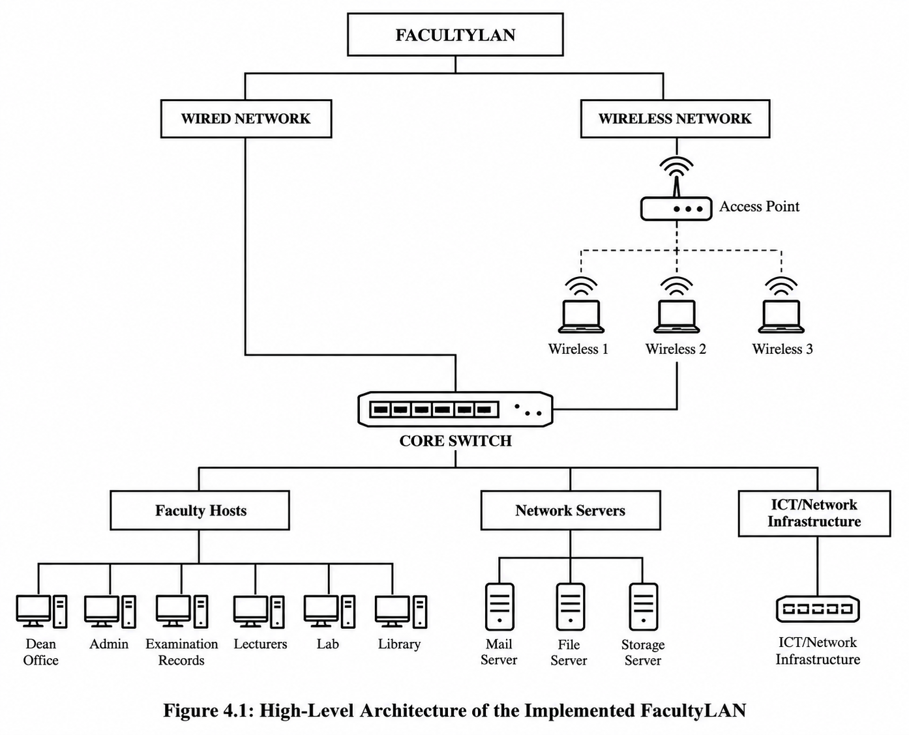

Figure 4.1: High-Level Architecture of the Implemented FacultyLAN

The architecture provides a communication path between faculty users and shared network resources. Wired users communicate through Ethernet connections to the network infrastructure, while wireless users communicate through the IEEE 802.11 access point.
The resulting model represents the four major layers identified during system design:
Users
↓
Network Access
↓
Network Infrastructure
↓
Network Services
The network services are represented by the Mail Server, File Server and Storage Server. This follows the design established in Chapter Three.

4.2.1 Program Modules
The FacultyLAN implementation is composed of several logical modules. Each module represents a physical or functional component of the proposed network.

4.2.1.1 Dean's Office Module
The Dean's Office represents an administrative workstation within the faculty network. It is implemented as a wired network host.
The module participates in:
- ICMP connectivity testing;
- TCP client-server communication with the File Server; and
- UDP communication with the File Server.
The Dean's Office therefore provides one of the major traffic sources used for evaluating the functionality of the network.

4.2.1.2 Administration Module
The Administration module represents computers used by administrative personnel. It is connected to the core network through a wired Ethernet connection.
The module demonstrates that administrative users can communicate through the common faculty network infrastructure.

4.2.1.3 Examination Records Module
The Examination Records module represents the networked computing resources used for examination and student record activities.
The module is connected to the wired network and forms part of the faculty's departmental communication structure.

4.2.1.4 Lecturers Module
The Lecturers module represents network-connected lecturer workstations. The module is connected through the wired network and can communicate with other network components and shared servers.

4.2.1.5 Computer Laboratory Module
The Computer Laboratory represents multiple computing resources used by students or faculty members for practical activities.
The module forms part of the wired portion of the FacultyLAN and provides additional network clients within the simulated environment.

4.2.1.6 Student Library Module
The Student Library represents network-connected computers or resources within the faculty library environment.
Its inclusion ensures that the model represents another important faculty unit requiring access to shared network services.

4.2.1.7 ICT Department Module
The ICT Department represents the technical unit responsible for network and computing resources.
It is connected to the core network and forms part of the faculty infrastructure represented in the simulation.

4.2.1.8 Core Network Infrastructure
The core network provides the central communication path between the wired faculty hosts and the servers.
The core infrastructure connects the different departments and provides the path through which packets move between clients and network services.
Ethernet communication is used for the wired portion of the model.

4.2.1.9 Mail Server
The Mail Server represents a shared network service that can be accessed by faculty network users.
Its inclusion demonstrates the ability of the FacultyLAN to support multiple network services within a common infrastructure.

4.2.1.10 File Server
The File Server is one of the principal network resources in the simulation.
It is particularly important because it is used in:
- wireless-to-wired connectivity tests;
- TCP communication with the Dean's Office; and
- UDP communication with the Dean's Office.
The three wireless users are configured to communicate with the File Server through the wireless access point and wired network infrastructure.

4.2.1.11 Storage Server
The Storage Server represents a shared storage resource within the faculty network.
It provides another network service accessible through the core network.

4.2.1.12 Wireless Access Point
The Access Point provides the wireless communication interface between the three wireless users and the wired portion of the FacultyLAN.
The wireless infrastructure uses IEEE 802.11 communication.
The Access Point therefore performs an important bridging role in the model:
Wireless User
│
│ IEEE 802.11
▼
Access Point
│
│ Wired Network
▼
Core Network
│
▼
File Server

Table 4.2: Simulation Input and Output Formats
File/Format | Function
.ned | Defines network structure and connections
.ini | Defines simulation configuration and execution parameters
.msg | Defines custom messages where required
.sca | Stores scalar simulation results
.vec | Stores vector/time-series simulation results
Event/Runtime Output | Displays simulation events and packet activity
Qtenv Visualization | Provides interactive observation of simulation behaviour

OMNeT++ uses NED for describing the structure of a simulation model, while simulation configuration specifies the network to be instantiated and the parameters under which the simulation executes. (OMNeT++ Documentation)

4.2.2.1 NED Input
The NED files constitute the primary structural input of the FacultyLAN model.
The network definition identifies:
- network modules;
- host modules;
- server modules;
- wireless components;
- network interfaces;
- connections;
- Ethernet links; and
- wireless communication components.
The FacultyLAN network is organized under the facultylan package.

4.2.2.2 Simulation Configuration Input
The simulation configuration provides the execution settings for the model.
The configuration identifies the network to be executed and controls parameters required for simulation runs.
The configuration also determines the simulation duration and the result-recording behaviour required for analysis.

4.2.2.3 Simulation Output
The simulation generates results based on events that occur during execution. These results include communication events, packet transmissions, packet receptions and application-level statistics.
OMNeT++ provides result files such as scalar and vector files that can be examined using its analysis tools. INET's documentation also identifies .vec and .sca results as standard outputs that can be viewed after simulation execution. (INET Framework)
The outputs obtained from the FacultyLAN model were used to determine whether the configured communication paths were functioning successfully.

4.2.3 Overall Data Flow Diagram
The overall data flow describes how information travels through the FacultyLAN.
For wired communication, the flow begins with a faculty workstation and passes through the network infrastructure before reaching the destination server.
For wireless communication, the wireless user first communicates with the Access Point before the packet enters the wired network.
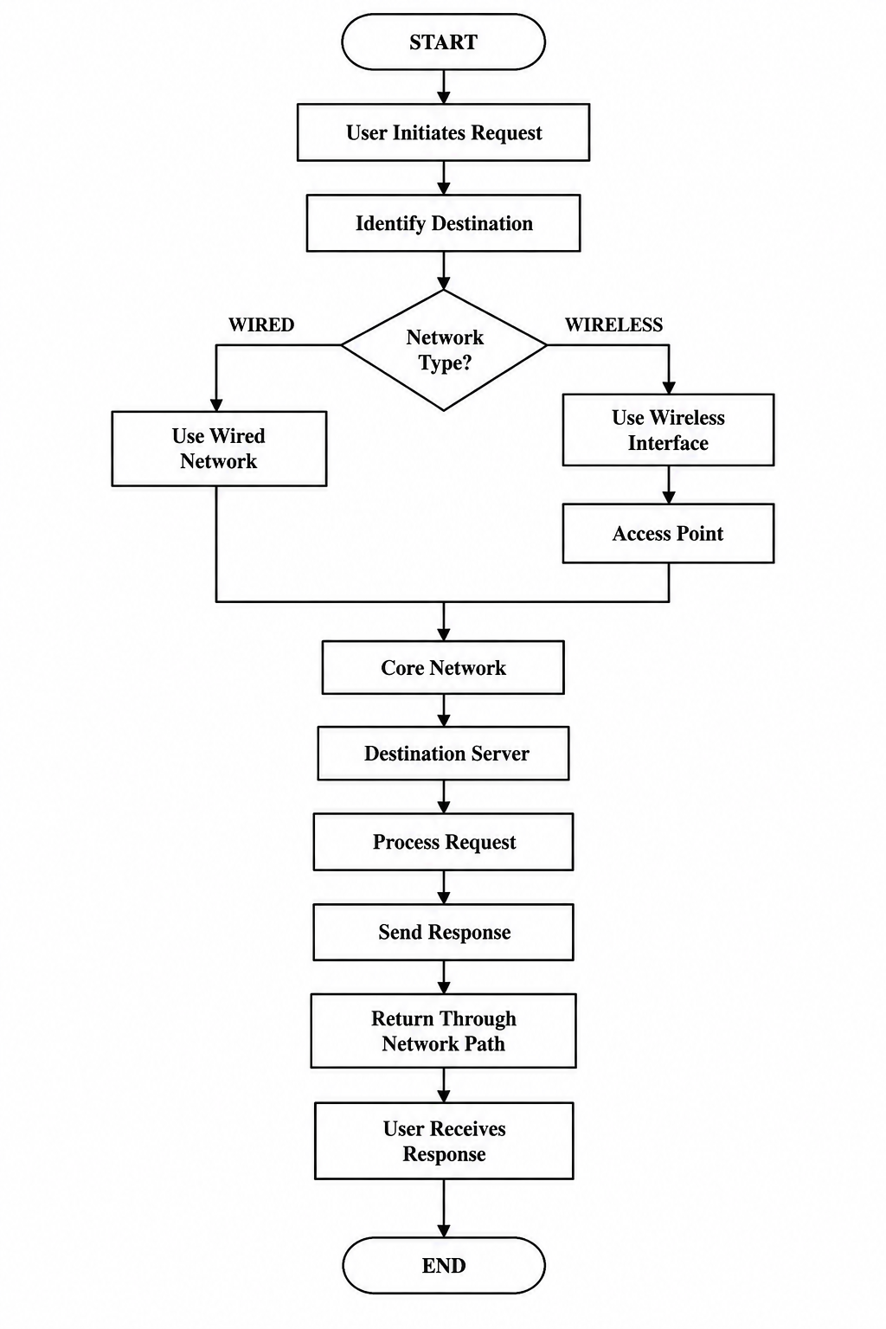

Figure 4.2: Overall Data Flow of the Implemented FacultyLAN
The communication sequence for wireless users follows the same logical process described in Chapter Three: the wireless user sends the request through the wireless interface, the Access Point receives and forwards it, the network infrastructure forwards it toward the File Server, and the response follows the reverse path.

4.2.4 Implementation of Network Communication
The FacultyLAN was implemented to support three principal communication mechanisms: ICMP, TCP and UDP.

4.2.4.1 ICMP Connectivity Testing
ICMP-based communication was used to determine whether selected network components could successfully reach one another.
The connectivity test involves:
Source Node
│
│ ICMP Echo Request
▼
Network Infrastructure
│
▼
Destination Node
│
│ ICMP Echo Reply
▼
Source Node
The ICMP tests were applied to selected wired components and to the wireless users communicating with the File Server.
The test provides information about:
- successful delivery;
- packet transmission;
- packet reception;
- packet loss; and
- round-trip time.
This approach directly supports the project's objective of evaluating connectivity using actual simulation responses rather than assuming that devices connected in the topology are automatically reachable.

4.2.4.2 TCP Communication
TCP communication was implemented between the Dean's Office and the File Server.
The Dean's Office functions as the client, while the File Server provides the server-side communication service.
The communication process can be represented as:
Dean's Office
│
│ TCP Connection
▼
Core Network
│
▼
File Server
│
│ TCP Response
▼
Dean's Office
The TCP scenario demonstrates reliable client-server communication within the FacultyLAN.
The simulation recorded a TCP session in which the Dean's Office transmitted data and the File Server received it.

4.2.4.3 UDP Communication
UDP communication was also implemented between the Dean's Office and the File Server.
Unlike TCP, UDP provides connectionless communication and does not establish a connection-oriented session before transmitting datagrams.
The implemented scenario provides an additional communication pattern for evaluating packet transmission through the FacultyLAN.
The UDP scenario was configured to allow packets to be transmitted from the Dean's Office toward the File Server and received by the destination.
The use of both TCP and UDP allows the simulation to represent different transport-layer communication behaviours.

4.2.5 Wireless Network Implementation
The wireless section of the FacultyLAN contains one Access Point and three wireless users.
The wireless network uses IEEE 802.11 communication through INET's wireless network models. INET provides models for IEEE 802.11 networking and wireless physical-layer behaviour. (OMNeT++ Documentation)
The wireless communication path is:
Wireless User 1 ─┐
Wireless User 2 ─┼──► Access Point ───► Core Network ───► File Server
Wireless User 3 ─┘
This configuration enables the study to examine communication between wireless clients and a server located within the wired portion of the FacultyLAN.
The implementation therefore demonstrates the integration of wired and wireless communication within one faculty network model.

4.2.6 Simulation Execution
After the network modules and connections were configured, the FacultyLAN model was compiled and executed using OMNeT++ 6.0.1.
The simulation was executed as a discrete-event simulation. Events such as packet transmission, packet reception and application activity are processed according to simulated time. The resulting behaviour is generated by the configured model rather than being manually produced.
The execution procedure followed these general stages:
- Create and configure the FacultyLAN NED model.
- Configure the simulation parameters.
- Load the INET Framework.
- Select the FacultyLAN network.
- Build the simulation model.
- Start the simulation in Qtenv.
- Observe network communication.
- Execute ICMP connectivity tests.
- Execute TCP communication.
- Execute UDP communication.
- Record simulation results.
- Analyse the generated results.

4.3 Software Testing
Software testing was performed to determine whether the implemented FacultyLAN satisfied its specified communication requirements.
The testing focused on functional communication rather than security attack scenarios. The principal objective was to establish whether the configured network components could communicate successfully through the proposed topology.
The testing activities covered:
- topology connectivity;
- wired connectivity;
- wireless connectivity;
- ICMP communication;
- TCP communication;
- UDP communication;
- packet delivery;
- packet loss; and
- round-trip time.

4.3.1 Test Strategy
The testing strategy was based on actual execution of the configured simulation model.
Each communication scenario was executed and the resulting simulation output was examined.

Table 4.3: Functional Testing Strategy
Test ID | Test Scenario | Expected Result
T01 | Dean's Office connectivity test | Successful communication
T02 | Wireless User 1 to File Server | Successful communication
T03 | Wireless User 2 to File Server | Successful communication
T04 | Wireless User 3 to File Server | Successful communication
T05 | TCP Dean's Office to File Server | TCP data successfully transmitted and received
T06 | UDP Dean's Office to File Server | UDP packets successfully transmitted and received

4.3.2 ICMP Testing Results
The ICMP connectivity tests were used to verify communication between selected nodes.

Table 4.4: Wireless Connectivity Test Results
Source | Destination | Result | Round-Trip Time
Wireless User 1 | File Server (10.0.0.9) | Successful | 2.061257336 ms
Wireless User 2 | File Server (10.0.0.9) | Successful | 3.875867960 ms
Wireless User 3 | File Server (10.0.0.9) | Successful | 1.813257336 ms

The results demonstrate that all three wireless users successfully communicated with the File Server.
Wireless User 2 recorded the highest round-trip time among the three tested wireless users, while Wireless User 3 recorded the lowest. The difference demonstrates that the communication path and wireless transmission conditions can produce different simulated delays even when users communicate with the same destination.
The important observation is that all three communication attempts produced successful responses, confirming the functional integration between the wireless and wired sections of the FacultyLAN.

4.3.3 Wired Connectivity Testing
Connectivity testing was also performed using the Dean's Office.
The recorded successful ICMP communication produced round-trip times in the approximate range of 0.00372 ms to 0.024456 ms for the tested destinations.

Table 4.5: Selected Wired Connectivity Results
Source | Communication Type | Result | Observed RTT
Dean's Office | ICMP | Successful | Approximately 0.00372–0.024456 ms
The successful responses indicate that the wired portion of the network was correctly configured for communication between the selected components.

4.3.4 TCP Testing
The TCP communication scenario was executed between the Dean's Office and the File Server.

Table 4.6: TCP Test Result
Parameter | Observed Result
TCP Sessions | 1
Data Sent | 200 bytes
Packets Sent | 1
Data Received | 512 bytes
Packets Received | 1
Communication Status | Successful

The simulation recorded one TCP session. The Dean's Office transmitted data and the File Server received the communication.
The TCP test therefore confirms that the network can support application-level client-server communication in addition to basic ICMP connectivity testing.

4.3.5 UDP Testing
The UDP scenario was executed between the Dean's Office and the File Server.

Table 4.7: UDP Test Result
Parameter | Observed Result
Packets Sent | 2
Data Sent | 2000 bytes
Packets Received | 2
Data Received | 2000 bytes
Communication Status | Successful
The UDP results show that the two configured UDP packets were transmitted and received successfully.
The result demonstrates that the FacultyLAN supports connectionless packet communication in addition to the reliable TCP communication scenario.

4.3.6 Overall Test Evaluation
The results from the three communication categories are summarized below.

Table 4.8: Overall FacultyLAN Testing Summary
Test Category | Result
Wired ICMP Connectivity | Successful
Wireless User 1 → File Server | Successful
Wireless User 2 → File Server | Successful
Wireless User 3 → File Server | Successful
TCP Dean's Office → File Server | Successful
UDP Dean's Office → File Server | Successful

The results demonstrate that the implemented FacultyLAN successfully supported the selected communication scenarios.
The testing therefore provides practical evidence for the objective of evaluating whether the proposed topology can support communication between selected wired and wireless network components.

4.3.7 Discussion of Simulation Results
The simulation results demonstrate that the proposed FacultyLAN topology was functionally executable.
The successful ICMP tests show that the configured network paths were capable of delivering connectivity requests and returning responses. The three wireless-to-File-Server tests are particularly important because they demonstrate communication across the wireless and wired portions of the network.
The observed wireless round-trip times were:
- 2.061257336 ms for Wireless User 1;
- 3.875867960 ms for Wireless User 2; and
- 1.813257336 ms for Wireless User 3.
The values are simulation measurements produced by the configured model and therefore represent the behaviour of the simulated network under the selected configuration.
The TCP test further demonstrates that the network was capable of supporting a client-server communication session. The UDP test demonstrated successful packet transmission and reception without relying on a connection-oriented transport session.
These findings correspond to the system objectives defined in Chapter One, particularly the objectives relating to wireless connectivity, TCP and UDP communication, ICMP testing and analysis of communication results.

4.3.8 Test Case Evaluation

Table 4.9: Detailed Test Case Evaluation
Test ID | Test Input | Expected Output | Actual Output | Status
T01 | Dean's Office ICMP request | ICMP reply | ICMP reply received | PASS
T02 | Wireless User 1 → 10.0.0.9 | Successful reply | 2.061257336 ms RTT | PASS
T03 | Wireless User 2 → 10.0.0.9 | Successful reply | 3.875867960 ms RTT | PASS
T04 | Wireless User 3 → 10.0.0.9 | Successful reply | 1.813257336 ms RTT | PASS
T05 | TCP data transfer | Data received | 200-byte transmission and TCP response recorded | PASS
T06 | UDP transmission | Packets received | 2 packets / 2000 bytes received | PASS

The test cases were evaluated against the communication requirements established during system analysis and design.

4.4 Documentation
Documentation was produced to provide a structured explanation of the implemented FacultyLAN model and to make the system understandable to users, supervisors and future researchers.
The documentation consists of:
- data dictionary;
- user manual;
- source code listing; and
- simulation output documentation.

4.4.1 User Manual
The user manual describes the basic procedure for executing and examining the FacultyLAN simulation.

4.4.2.1 Starting the Project
The user should first start the OMNeT++ IDE and open the FacultyLAN project.
The project should contain the FacultyLAN source files and the INET Framework should be available within the configured workspace.

4.4.2.2 Opening the Network Model
The user should navigate to the FacultyLAN NED file and open the network definition.
The network should display the configured faculty hosts, servers, core network infrastructure, Access Point and wireless users.
The NED model represents the actual executable network rather than only a conceptual drawing. The instantiated model processes communication events according to simulation time.

4.4.2.3 Running the Simulation
The user should select the appropriate FacultyLAN configuration and launch the simulation.
During execution, Qtenv displays the simulation environment and allows the user to observe communication events.
The user may:
- start the simulation;
- pause the simulation;
- observe packet activity;
- inspect network modules;
- examine communication events;
- allow the simulation to complete; and
- examine the generated results.

4.4.2.4 Observing Wireless Communication
To observe wireless communication, the user should monitor the Access Point and the three wireless users.

The communication path should follow:
Wireless User
↓
Access Point
↓
Core Network
↓
File Server
The user can observe the wireless users transmitting through the Access Point toward the File Server.

4.4.2.5 Examining ICMP Results
After the simulation, the user should examine the recorded ICMP results.
The results can be used to determine:
- whether communication succeeded;
- whether packets were delivered;
- the measured round-trip time;
- packet loss; and
- the relationship between source and destination.

4.4.2.6 Examining TCP Results
The TCP results should be examined to verify the session between the Dean's Office and File Server.
The user should check:
- number of sessions;
- transmitted bytes;
- received bytes;
- packets sent; and
- packets received.

4.4.2.7 Examining UDP Results
The UDP results should be examined to verify the configured datagram communication.
The user should check:
- packets transmitted;
- packets received;
- bytes transmitted; and
- bytes received.

4.4.2.8 Viewing Simulation Results
OMNeT++ provides result analysis facilities for examining generated scalar and vector data. INET documentation also describes viewing generated .vec and .sca result files after a simulation has been executed. (INET Framework)
The researcher can use these outputs to analyse the behaviour of the implemented network.

4.4.2 Source Code Listing
The source code of the FacultyLAN implementation is organized into the project source directory.

Table 4.11: Major Source Files
Source File | Purpose
FacultyLAN.ned | Main FacultyLAN network definition
omnetpp.ini | Simulation configuration
Package definitions | Organize FacultyLAN NED modules
INET modules | Provide standard network protocols and components
Result files | Store generated simulation measurements

4.4.2.1 FacultyLAN Network Definition
The main network definition is responsible for instantiating the major components of the FacultyLAN.
Conceptually, the network definition contains:
FacultyLAN
│
├── Faculty Wired Hosts
│ ├── Dean Office
│ ├── Administration
│ ├── Examination Records
│ ├── Lecturers
│ ├── Computer Lab
│ ├── Student Library
│ └── ICT Department
│
├── Servers
│ ├── Mail Server
│ ├── File Server
│ └── Storage Server
│
├── Wireless Infrastructure
│ └── Access Point
│
├── Wireless Users
│ ├── Wireless User 1
│ ├── Wireless User 2
│ └── Wireless User 3
│
└── Core Network
└── Core Switch

4.4.2.2 Ethernet Implementation
Ethernet interfaces are used for the wired portion of the network.
The Ethernet connections provide the communication path between:
- faculty hosts;
- core network infrastructure; and
- servers.
The use of Ethernet reflects the wired LAN design presented in the preceding chapters.

4.4.2.3 Wireless Implementation
The wireless portion uses an IEEE 802.11 radio medium together with the Access Point and wireless hosts.
The structure is:
Ieee80211ScalarRadioMedium
│
▼
Access Point
/ | \
/ | \
▼ ▼ ▼
Wireless Wireless Wireless
User 1 User 2 User 3
The implementation allows wireless users to participate in communication with resources located within the wired network.

4.4.3 Simulation Output Documentation
The simulation outputs provide evidence of the behaviour of the implemented FacultyLAN.
The principal outputs documented during implementation include:
- successful ICMP connectivity;
- wireless round-trip time;
- TCP session statistics;
- UDP packet statistics;
- packet transmission;
- packet reception; and
- simulation event activity.

4.4.4 Implementation Summary
The implementation successfully transformed the FacultyLAN design into an executable network simulation.
The implemented model contains:
- seven major faculty user/departmental sections;
- three network servers;
- one core network infrastructure;
- one wireless Access Point;
- three wireless users;
- wired Ethernet communication;
- IEEE 802.11 wireless communication;
- ICMP connectivity testing;
- TCP communication; and
- UDP communication.
The completed implementation corresponds to the system design presented in Chapter Three, where the FacultyLAN was defined as an integrated wired and wireless faculty network implemented with OMNeT++ and INET.
The testing results demonstrate successful communication across the selected wired and wireless paths. The wireless users were able to communicate with the File Server, while the Dean's Office successfully participated in the TCP and UDP communication scenarios.
The implementation therefore provides an executable and testable representation of the proposed FacultyLAN rather than a topology diagram alone.

References

Cisco. (2024). What is a LAN (Local Area Network)? Cisco Systems. https://www.cisco.com/site/us/en/learn/topics/networking/what-is-a-lan-local-area-network.html
Cisco. (2024). What is a wireless LAN (WLAN)? Cisco Systems. https://www.cisco.com/site/us/en/learn/topics/networking/what-is-a-wireless-lan.html
Cisco. (2024). What is an access point? Cisco Systems. https://www.cisco.com/site/us/en/learn/topics/small-business/what-is-an-access-point.html
INET Framework. (2025). INET Framework documentation: Introduction and developer guide. https://inet.omnetpp.org/docs/developers-guide/ch-introduction.html
INET Framework. (2025). INET Framework getting started guide. https://inet.omnetpp.org/GettingStarted.html
INET Framework. (2025). INET Framework API documentation. https://doc.omnetpp.org/inet/api-current/
Kurose, J. F., & Ross, K. W. (2021). Computer networking: A top-down approach (8th ed.). Pearson.
OMNeT++ Community. (2024). OMNeT++ simulation manual: Version 6.x. https://doc.omnetpp.org/omnetpp/SimulationManual.pdf
OMNeT++ Community. (2024). OMNeT++ 6.0.1 simulation environment. https://omnetpp.org/download-items/omnetpp/omnetpp-601.html
OMNeT++ Community. (2024). OMNeT++ documentation and user guides. https://omnetpp.org/documentation/
Pressman, R. S., & Maxim, B. R. (2020). Software engineering: A practitioner’s approach (9th ed.). McGraw-Hill Education.
Stallings, W. (2022). Data and computer communications (11th ed.). Pearson.
Tanenbaum, A. S., & Wetherall, D. J. (2021). Computer networks (6th ed.). Pearson.
IEEE. (2022). IEEE Standard for Information Technology—Telecommunications and Information Exchange Between Systems Local and Metropolitan Area Networks—Specific Requirements Part 11: Wireless LAN Medium Access Control (MAC) and Physical Layer (PHY) Specifications. IEEE Standards Association.
IEEE. (2020). IEEE Standard for Ethernet: IEEE 802.3 Ethernet Working Group. IEEE Standards Association. https://standards.ieee.org/
Huang, Y., Chen, X., & Zhang, J. (2021). Network simulation and performance evaluation approaches for modern communication systems. IEEE Access, 9, 112450–112462. https://doi.org/10.1109/ACCESS.2021.3102345
Park, H., & Kim, J. (2024). Network modelling and simulation using OMNeT++ and INET framework. Journal of Information and Communication Convergence Engineering, 22(1), 45–53.
Bredel, M., & Bergner, F. (2020). Validation and accuracy analysis of wireless network simulation models using OMNeT++. Simulation Modelling Practice and Theory, 102, 102052. https://doi.org/10.1016/j.simpat.2020.102052
Zand, M., & Keshavarz, M. (2023). Application of discrete-event simulation in communication network modelling and performance evaluation. IEEE Access, 11, 76543–76555. https://doi.org/10.1109/ACCESS.2023.3298765

