CHAPTER ONE

1.0 GENERAL INTRODUCTION TO SIWES AND INDUSTRIAL TRAINING FUND (ITF)

1.1 INTRODUCTION
The Student Industrial Work Experience Scheme (SIWES) is a practical-oriented training programme designed to complement the theoretical knowledge acquired by students in tertiary institutions. It serves as a bridge between classroom learning and real-life industrial practice by exposing students to actual work environments related to their fields of study. SIWES is a compulsory requirement for students in science, engineering, technology, and management-related disciplines in Nigerian tertiary institutions.
The scheme is coordinated and funded by the Industrial Training Fund (ITF), a federal government agency established to promote skill acquisition and manpower development in Nigeria. Through SIWES, students gain hands-on experience, improve their technical competence, develop professional work ethics, and become better prepared for future employment or self-reliance
This report documents my Student Industrial Work Experience Scheme (SIWES) carried out at Algorithmic Explorers, where I was trained in information technology–related skills, software development concepts, and practical problem-solving. The report covers an overview of SIWES and ITF, the organization of my place of attachment, the systems analyzed and designed, the training experience and projects undertaken, as well as the skills acquired and challenges encountered during the training period.

1.2 OVERVIEW OF THE INDUSTRIAL TRAINING FUND (ITF)
The Industrial Training Fund (ITF) was established in 1971 by the Federal Government of Nigeria with the primary objective of promoting and encouraging the acquisition of industrial and commercial skills required for national economic development. The establishment of the ITF was necessitated by the growing demand for skilled manpower capable of meeting the technological and industrial needs of the country.

The ITF operates under the supervision of the Federal Ministry of Industry, Trade and Investment. Since its inception, the Fund has been actively involved in human capital development through the implementation of various training programmes and policies aimed at improving the quality and relevance of skills possessed by Nigerian workers and students.
Over the years, the ITF has played a significant role in reducing the gap between academic knowledge and industrial requirements by supporting structured training schemes such as SIWES. Its contributions have enhanced productivity, improved employability of graduates, and strengthened the overall workforce capacity of the nation.

1.3 MANDATE OF THE INDUSTRIAL TRAINING FUND
The Industrial Training Fund operates based on a well-defined mandate aimed at developing Nigeria’s human resources. The major mandates of the ITF include:

Skills Acquisition:
- To promote the acquisition of relevant technical, vocational, and entrepreneurial skills through structured industrial training programmes.

Workforce Development:
- To support the training and retraining of workers and students in order to improve their competence, adaptability, and productivity in a rapidly evolving technological environment.

Training Standards:
- To set, regulate, and maintain standards for industrial training in Nigeria, ensuring that training programmes meet acceptable professional and technical benchmarks.

Coordination of SIWES:
- To coordinate, supervise, and fund the Student Industrial Work Experience Scheme in collaboration with tertiary institutions and regulatory bodies

1.4 VISION STATEMENT OF THE INDUSTRIAL TRAINING FUND
The vision of the Industrial Training Fund is to be the leading human capital development agency in Nigeria, committed to building a skilled, competent, and globally competitive workforce. This vision emphasizes the importance of continuous skill development as a foundation for national growth and technological advancement.

1.5 MISSION STATEMENT OF THE INDUSTRIAL TRAINING FUND
The mission of the Industrial Training Fund is to set and regulate training standards and provide direct training interventions that enhance the skills, productivity, and employability of the Nigerian workforce. Through this mission, the ITF aims to ensure sustainable industrial development by equipping individuals with relevant and practical skills.

1.6 STUDENT INDUSTRIAL WORK EXPERIENCE SCHEME (SIWES)
The Student Industrial Work Experience Scheme (SIWES) was established in 1974 as a collaborative programme involving the Industrial Training Fund (ITF), tertiary institutions, and employers of labour. The scheme was introduced to address the problem of inadequate practical exposure among graduates of Nigerian tertiary institutions.
SIWES provides students with the opportunity to work in real industrial environments related to their course of study. This exposure allows students to apply theoretical knowledge to practical situations, familiarize themselves with modern tools and technologies, and understand professional practices within their chosen fields. By linking theory with practice, SIWES enhances students’ confidence, competence, and readiness for the labour market.

1.7 OBJECTIVES OF SIWES
The objectives of the Student Industrial Work Experience Scheme include the following:

Skill Acquisition:
- To equip students with practical skills and technical knowledge relevant to their academic discipline.

Career Exposure:
- To expose students to real work environments and professional roles, thereby helping them make informed career decisions.

Work Ethics Development:
- To instill discipline, teamwork, responsibility, and good work ethics required in professional settings.

Industrial Experience:
- To provide students with real-life industrial experience that enhances their employability after graduation.

1.8 OPERATORS AND FUNDING OF SIWES
The operation and funding of SIWES involve multiple stakeholders. The Industrial Training Fund (ITF) is the principal body responsible for funding, coordinating, and supervising the scheme. Other regulatory agencies involved include:
National Universities Commission (NUC)

National Board for Technical Education (NBTE)

National Commission for Colleges of Education (NCCE)

Employers of labour also contribute by providing placement opportunities, supervision, and training facilities for students. The Federal Government of Nigeria funds SIWES through budgetary allocations to the ITF.

1.9 BENEFICIARIES OF SIWES
The beneficiaries of SIWES include students of tertiary institutions offering programmes in science, engineering, technology, management, and allied disciplines. Students of Computer Science, Information Technology, Software Engineering, and other ICT-related courses are major beneficiaries, as the scheme provides them with hands-on experience in computing tools, software development, and problem-solving techniques.

1.10 PLACE OF ATTACHMENT
The place of attachment for my Student Industrial Work Experience Scheme was Algorithmic Explorers, an information technology–oriented organization involved in ICT training, software development, and digital skill empowerment. The industrial training was carried out at Algorithmic Explorers for the approved SIWES duration, during which I actively participated in training sessions, practical exercises, and project implementation activities relevant to my course of study.

CHAPTER TWO

2.0 ORGANIZATIONAL BACKGROUND OF THE PLACE OF ATTACHMENT

2.1 INTRODUCTION TO THE ORGANIZATION
Algorithmic Explorers (AE) is a technology-driven organization and global community focused on Artificial Intelligence (AI), software development, research, and digital skill development. The organization was founded in April 2022 with the aim of democratizing access to Artificial Intelligence education and nurturing emerging technological talent.
Algorithmic Explorers provides a collaborative environment where learners, developers, researchers, and innovators work together to explore, build, and apply technology solutions to real-world problems. The organization emphasizes practical learning, mentorship, collaboration, and innovation, thereby enabling members to move from theoretical understanding to real-world application.
During my industrial training, Algorithmic Explorers served as a professional and intellectually stimulating environment where I was exposed to structured learning, supervised tasks, and project-based activities that strengthened my technical and analytical skills.

2.2 COMPANY PROFILE
Algorithmic Explorers operates within the Information and Communication Technology (ICT) sector with a strong specialization in Artificial Intelligence, software engineering, research, and community-driven innovation. The organization combines education, research, and product development under one ecosystem.
The major areas of operation of Algorithmic Explorers include:
- Artificial Intelligence and Machine Learning education

- Software and web application development

- Research and innovation in AI-related fields

- Technical mentorship and community-based learning

- Product development and startup incubation

Algorithmic Explorers serves a wide range of target beneficiaries, including students in tertiary institutions, aspiring AI and software developers, researchers, professionals, and technology enthusiasts from different parts of the world. The organization’s global structure enables collaboration across borders, allowing members to learn, build, and innovate together through shared knowledge and real-world projects.

2.3 VISION AND MISSION OF THE ORGANIZATION

Vision Statement:
The vision of Algorithmic Explorers is to raise a global generation of Artificial Intelligence experts and innovators who will transform industries, lead meaningful research, and develop products that contribute positively to society. The organization envisions a future where AI is responsibly built and used as a tool for human progress.

Mission Statement:
The mission of Algorithmic Explorers is to provide mentorship, practical training, and a collaborative environment that helps individuals move from curiosity to contribution in the field of Artificial Intelligence and technology. This mission is achieved through hands-on learning programmes, real-world projects, research opportunities, and a strong ethical and inclusive community culture.

2.4 OBJECTIVES OF THE ORGANIZATION
The objectives of Algorithmic Explorers include:
- To promote practical and hands-on learning in Artificial Intelligence and software development

- To nurture innovation, creativity, and logical problem-solving skills

- To provide mentorship and guidance to aspiring technology professionals

- To encourage research, collaboration, and knowledge sharing

- To empower members to build real-world solutions and impactful products

- To prepare individuals for careers, internships, startups, and leadership roles in technology

These objectives were evident during my industrial training, as emphasis was placed on continuous learning, project implementation, collaboration, and personal skill development.

2.5 ORGANIZATIONAL STRUCTURE
Algorithmic Explorers operates a multi-layered organizational structure designed to support its diverse community, learning pathways, and innovation goals. The structure ensures effective leadership, coordination, and smooth operation across its various departments and sub-communities.

Key roles within the organization include:

Founder:
- The founder provides the initial vision and strategic direction of the organization, ensuring that its goals align with the mission of advancing Artificial Intelligence education and innovation.

Chief of Directors:
- The Chief of Directors oversees the overall coordination of the organization’s global activities, sub-communities, and leadership teams. This role ensures effective collaboration, policy implementation, and growth of the community.

Directors and Community Leads:
- Each sub-community and department is led by a Director or Lead who manages operations, coordinates members, and ensures that objectives are achieved within their respective focus areas.

Mentors and Technical Leads:
- Mentors and technical leads guide members through learning programmes, projects, and research activities. They provide technical support, supervision, and feedback.

Developers, Researchers, and Community Members:
- These members actively participate in building software solutions, conducting research, learning new technologies, and contributing to community initiatives.

This structure ensures accountability, mentorship, effective communication, and efficient execution of activities within the organization.
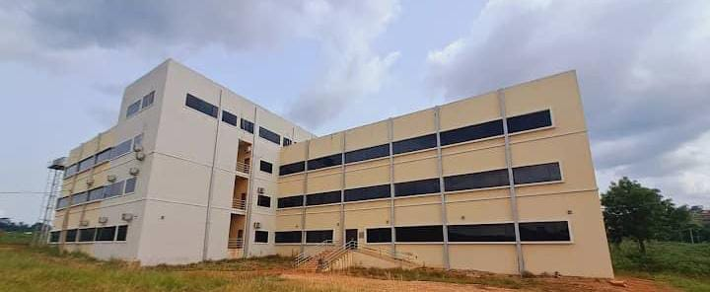

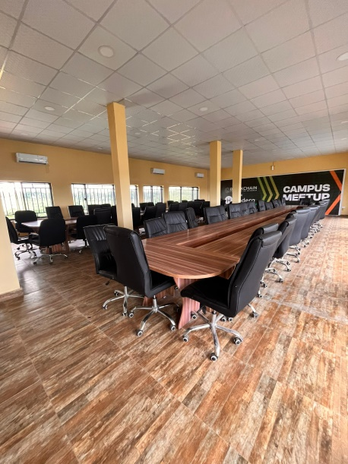

FIGURE 1.1: REAR AND INTERIOR VIEW OF ALGORITHMIC EXPLORERS
2.6 ORGANIZATIONAL CHART
The organizational chart of Algorithmic Explorers reflects a hierarchical yet collaborative structure. At the top is the Founder, followed by the Chief of Directors, who coordinates the various Directors and Sub-Community Leads. Under these leads are Mentors, Technical Teams, Developers, Researchers, and Community Members who carry out learning, development, and innovation activities. Administrative and support roles operate alongside technical teams to ensure smooth daily operations.
This organizational framework enables Algorithmic Explorers to function effectively as a global AI and technology ecosystem while maintaining a strong focus on mentorship, collaboration, and innovation.

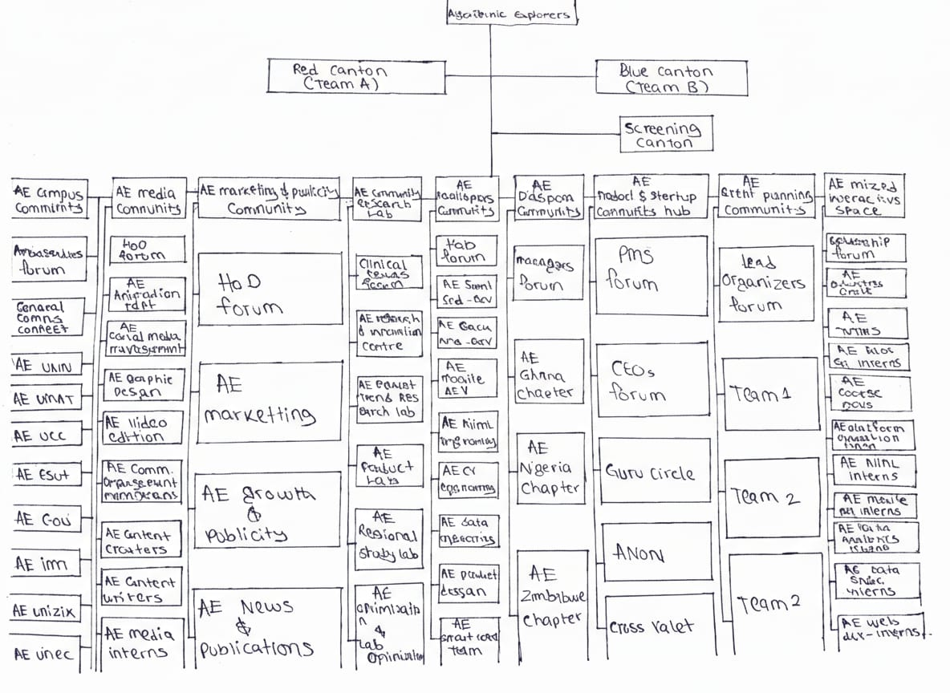

FIGURE 1.2: ORGANIZATIONAL CHART OF ALGORITHMIC EXPLORERS
CHAPTER THREE

3.0 SYSTEM ANALYSIS, DESIGN AND WORKFLOW

3.1 INTRODUCTION TO SYSTEM ANALYSIS AND DESIGN
System analysis and design is a structured approach used in software development to study an existing problem, identify user requirements, and design a solution that meets those needs efficiently. During my industrial training at Algorithmic Explorers, I was introduced to system analysis and design as a critical stage in building functional and user-centered software applications.
System analysis focuses on understanding the problem domain, defining system requirements, and identifying how users will interact with the system. System design, on the other hand, involves planning how the system will be built, including its architecture, user interface, database structure, and workflow. These concepts were applied practically during the development of the Community Relations / Grievance Management Portal, which served as my major project during the training.

3.2 SYSTEM ANALYSIS
Description of the Existing System
Before the development of the portal, grievance handling in many organizations was largely manual. Complaints were often submitted verbally, through paper forms, or informal messaging platforms. This method had several limitations, including poor record keeping, lack of transparency, delayed responses, difficulty in tracking complaints, and absence of structured feedback mechanisms.
These challenges highlighted the need for a centralized digital platform where users could submit complaints, administrators could manage them efficiently, and records could be securely stored for future reference.

---

Problems Identified in the Existing System
- Lack of a centralized platform for complaint submission and management

- Difficulty in tracking the status of submitted grievances

- Delays in response and resolution

- Poor documentation and loss of records

- Limited accountability and transparency

- No structured feedback or communication channel between users and administrators

These issues informed the functional requirements of the new system.

Objectives of the Proposed System
The proposed Community Relations / Grievance Management Portal was designed to achieve the following objectives:
- Provide a centralized platform for submitting and managing grievances

- Enable users to track the status of their complaints

- Improve transparency and accountability in complaint handling

- Ensure proper documentation and storage of grievance records

- Facilitate efficient communication between users and administrators

- Reduce response time and improve service delivery

CHATER FOUR

4.0 TRAINING EXPERIENCE, TECHNOLOGIES, AND PROJECTS

4.1 INTRODUCTION
The purpose of this chapter is to provide a detailed account of my industrial training experience at Algorithmic Explorers. It highlights the trainings undertaken, the technologies and tools used, and the projects I was involved in, particularly the development of the Community Relations / Grievance Management Portal. This chapter demonstrates how theoretical knowledge from my course was applied practically, the challenges I faced, and the skills I acquired.
During the twenty-five (25) weeks of training, I was actively engaged in both structured learning sessions and project-based tasks. I gained experience in web development, database design, software deployment, and user interface design, which gave me a solid foundation for professional IT practice.

4.2 TRAININGS UNDERTAKEN
During my attachment, I participated in multiple formal and informal training sessions, both theoretical and practical. These included:

1. Web Development Training
- Learned HTML5, CSS3, and JavaScript fundamentals.

- Applied Bootstrap for responsive, mobile-friendly design.

- Created user-friendly web interfaces for various system modules.

2. Database Management
- Designed and implemented MySQL databases to store user information, complaints, and administrative responses.

- Learned to optimize queries for efficiency.

- Practiced creating Entity-Relationship Diagrams (ERD) for planning and relational mapping.

3. Server-Side Programming (PHP)
- Developed server-side scripts to process forms, handle authentication, and manage user data.

- Implemented data validation and sanitization to secure the system.

4. System Analysis and Design
- Learned to create flowcharts, wireframes, and system design diagrams.

- Practiced modular design, ensuring features could be added or modified easily.

5. Software Deployment and Testing
- Deployed applications locally using XAMPP and on live servers.

- Conducted unit testing, integration testing, and cross-browser testing.

- Debugged errors related to connectivity, display, and functionality.

6. Professional Skills
- Participated in team meetings and project discussions.

- Learned project management techniques, including task prioritization and version control.

- Developed effective communication, problem-solving, and collaborative skills.

These trainings gave me both technical competence and professional confidence to contribute meaningfully to real projects.

4.3 TECHNOLOGIES AND TOOLS USED
The technologies and tools I used were instrumental in completing my projects effectively. They include:

Front-End Technologies:
- HTML5, CSS3, JavaScript

- Bootstrap for responsive design

- jQuery for dynamic user interactions

Back-End Technologies:
- PHP for server-side scripting

- MySQL for database management and relational mapping

- AJAX for asynchronous data retrieval

Tools and Platforms:
- XAMPP for local server setup

- Visual Studio Code (VS Code) as the primary code editor

- Git for version control and code management

- Browser Developer Tools for debugging

- Figma and draw.io for wireframes, flowcharts, and system design diagrams

Other Tools:
- Google Chrome and Mozilla Firefox for cross-browser testing

- Online validators to check HTML, CSS, and PHP syntax

These technologies were essential for developing a fully functional, user-friendly, and secure Community Relations Portal that met real-world requirements.
4.4 PROJECTS CARRIED OUT DURING TRAINING
The main practical project I worked on was the Community Relations / Grievance Management Portal. My contributions included:

1. Requirement Analysis and Planning
- Collected requirements from supervisors and potential users.

- Drafted system requirements specifications and project plan.

2. System Design
- Designed the portal layout, user interfaces, and database schema.

- Created flowcharts to map user navigation and administrative workflow.

3. Development
- Developed front-end pages: landing page, login/register page, complaint submission form, admin dashboard, and feedback display page.

- Implemented back-end logic for:

- User authentication and session management

- Complaint registration and tracking

- Admin feedback submission and monitoring

4. Testing and Debugging
- Conducted extensive testing on form validation, database integration, and UI responsiveness.

- Fixed errors related to connectivity, cross-browser compatibility, and data display.

5. Deployment
- Configured the portal on a local XAMPP server for testing.

- Deployed the system on a live environment to ensure functionality.

6. Documentation
- Prepared user manuals and administrator guides.

- Documented code and database structure for future reference.

Through this project, I developed problem-solving, coding, debugging, and deployment skills, and learned to work independently as well as in a professional team setting.

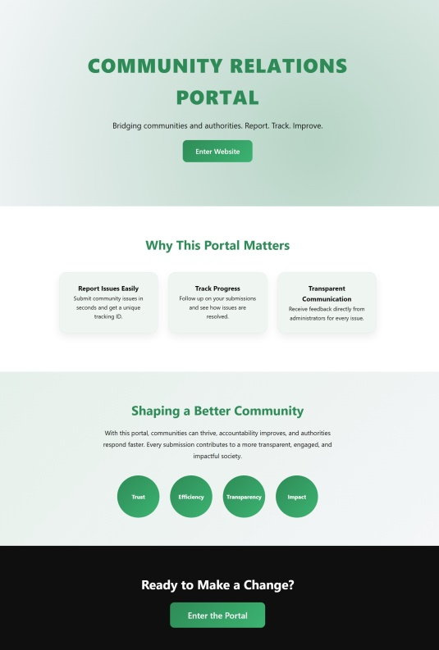
4.5 SCREENSHOTS AND OUTPUTS

FIGURE 2.1: LANDING PAGE: USER-FRIENDLY INTRODUCTION PAGE WITH NAVIGATION LINKS.
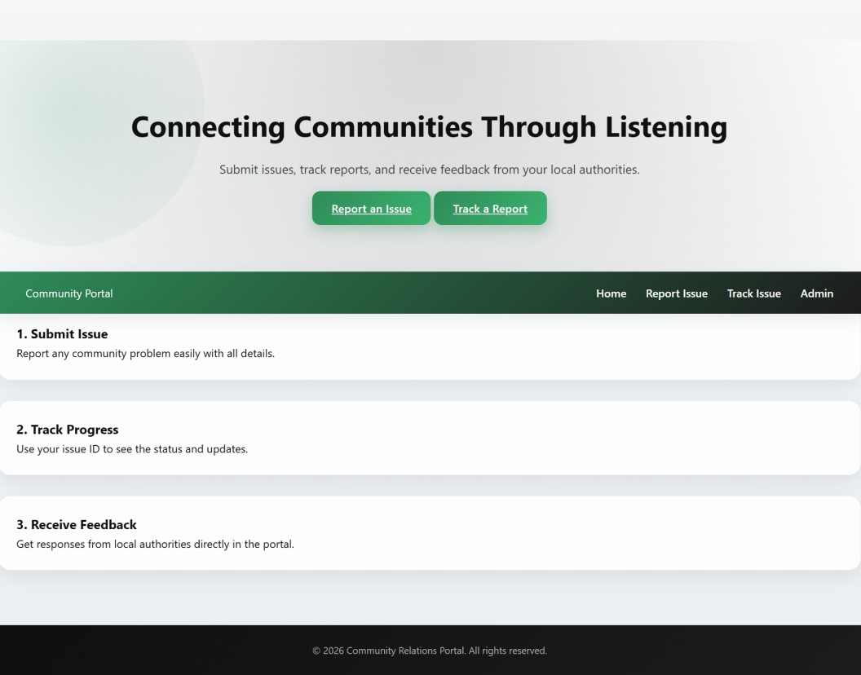

FIGURE 2.2: MAIN DASHBOARD: THIS IS THE MAIN DASHBOARD THAT DISPLAY THE NAVIGATION AROUND THE WEBSITE

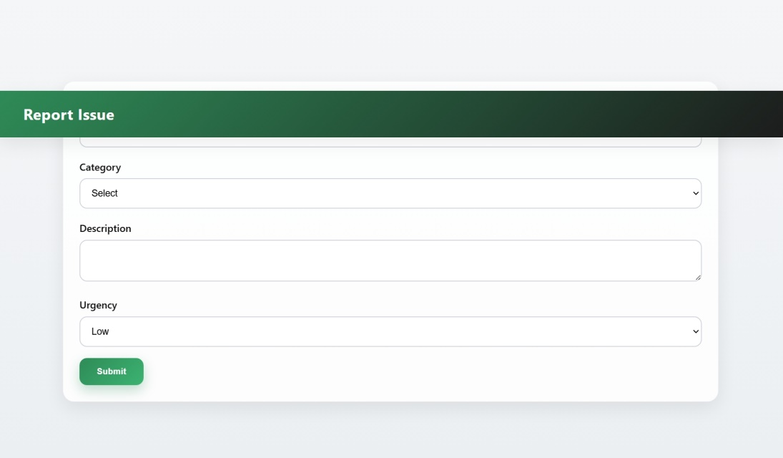

FIGURE 2.3: COMPLAINT SUBMISSION FORM: INTERFACE TO SUBMIT COMPLAINTS AND FEEDBACK.
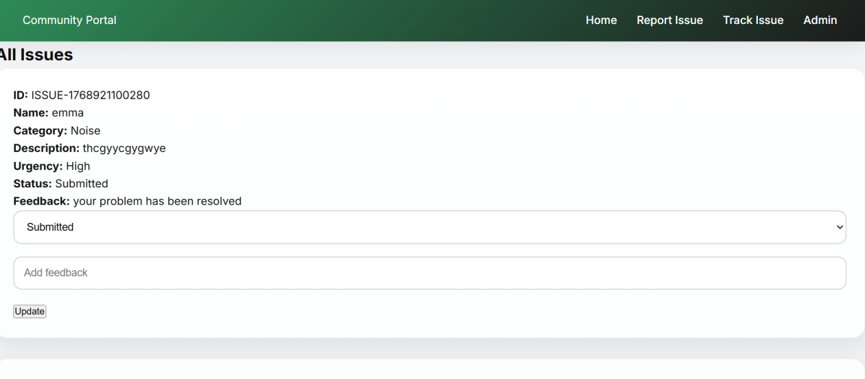

FIGURE 2.4: ADMIN DASHBOARD: REAL-TIME TRACKING OF COMPLAINTS, STATUS UPDATES, AND FEEDBACK.

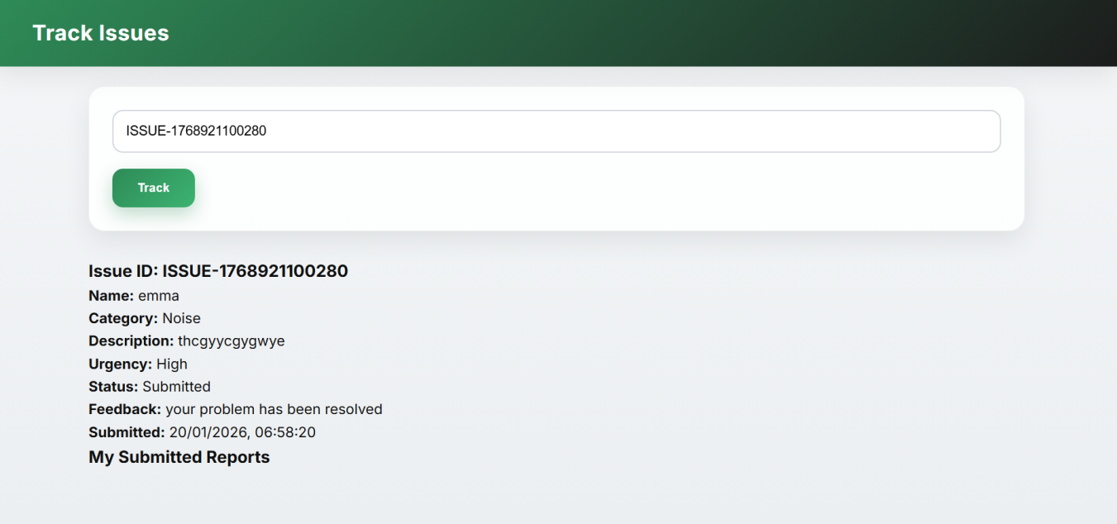

FIGURE 2.5: FEEDBACK DISPLAY PAGE: DISPLAYS ADMINISTRATIVE RESPONSES TO USERS’ COMPLAINTS.

The industrial training at Algorithmic Explorers provided a practical and immersive experience in IT development and project management. I successfully applied theoretical knowledge to real-life web development projects, gained hands-on experience with multiple programming languages and tools, and learned to solve complex problems. Challenges encountered during development improved my analytical skills, while my achievements boosted confidence in handling future IT projects.
This chapter demonstrates the breadth of my training experience, the technologies mastered, and the project deliverables that reflect my competence and growth in the IT field.

CHAPTER FIVE

5.0 SKILLS ACQUIRED, CHALLENGES, CONCLUSION AND RECOMMENDATIONS

5.1 SKILLS ACQUIRED
During my twenty-five (25) weeks of industrial training at Algorithmic Explorers, I acquired a wide range of technical and professional skills. These skills enhanced my competence and prepared me for the IT industry:
Technical Skills:
- Proficiency in web development technologies: HTML5, CSS3, JavaScript, PHP, Bootstrap.

- Database design and management using MySQL, including creating tables, queries, and relationships.

- Development and deployment of a functional Community Relations / Grievance Management Portal.

- Front-end and back-end integration, server setup, and testing of web applications.

- Practical use of development tools: Visual Studio Code, XAMPP, Git, and browser debugging tools.

Professional and Soft Skills:
- Problem-solving and debugging: Learned to identify errors, troubleshoot, and optimize code.

- Teamwork and collaboration: Worked closely with supervisors, trainers, and peers to deliver projects.

- Time management: Developed the ability to complete tasks within deadlines while maintaining quality.

- Communication: Improved documentation, reporting, and verbal explanation of technical processes.

- Adaptability: Learned to handle unexpected issues such as system errors or integration conflicts.

Project-Based Skills:
- Requirement gathering and analysis to understand system needs.

- Designing user-friendly interfaces and functional workflows.

- Testing, validating, and deploying applications in real-world scenarios.

- Applying theoretical concepts from academic studies to practical, hands-on projects.

Overall, the training equipped me with both technical proficiency and workplace readiness, strengthening my ability to function effectively in IT roles.

5.2 CHALLENGES ENCOUNTERED
While the training was highly rewarding, I faced several challenges that helped me grow professionally:
Technical Challenges:
- Difficulty integrating the portal’s front-end and back-end components initially.

- Handling database relationships and ensuring data integrity in MySQL.

- Cross-browser compatibility issues, requiring additional testing and adjustments.

- Debugging errors in JavaScript and PHP logic under time constraints.

Operational and Professional Challenges:
- Learning to balance multiple tasks, including coding, testing, and documentation.

- Adjusting to a professional work environment and adhering to deadlines.

- Understanding unfamiliar frameworks and tools without prior practical experience.

Problem-Solving Approaches:
- Consulting supervisors and trainers when stuck on complex issues.

- Conducting self-research, using online resources and documentation to solve technical problems.

- Iteratively testing and refining system components until functional.

These challenges were critical in developing perseverance, independence, and critical thinking skills, making me a more capable IT professional.

5.3 CONCLUSION
The industrial training at Algorithmic Explorers provided a comprehensive platform to apply theoretical knowledge to practical situations. By participating in real-world projects, especially the Community Relations / Grievance Management Portal, I gained invaluable experience in software development, teamwork, and professional conduct.
Key takeaways from the training include:
- Bridging the gap between academic knowledge and practical IT skills.

- Understanding the full lifecycle of software development from planning to deployment.

- Recognizing the importance of professionalism, discipline, and collaboration in a workplace setting.

- Developing confidence to solve technical problems independently and efficiently.

In conclusion, the attachment not only enhanced my technical abilities but also equipped me with workplace skills that are essential for a successful IT career.
5.4 RECOMMENDATIONS
Based on my experience, I offer the following recommendations for improving industrial training programs and maximizing trainee development:
For Students:
- Actively participate in all trainings and practical sessions.

- Document experiences and reflect on lessons learned regularly.

- Be proactive in solving problems and seeking guidance when necessary.

For Algorithmic Explorers (Organization):
- Include workshops on emerging technologies such as AI, ML, and advanced web frameworks.

- Increase opportunities for team projects to strengthen collaboration skills.

- Provide structured mentoring for follow-up and progress tracking of trainees.

For Educational Institutions:
- Encourage students to start industrial projects with clearly defined objectives.

- Regularly monitor trainee progress and provide constructive feedback.

- Partner with organizations offering hands-on experience in cutting-edge technologies.

These recommendations aim to enhance future SIWES experiences, ensuring that students gain maximum benefit from industrial attachment programs and organizations cultivate a highly skilled workforce.

REFERENCES

[1] Algorithmic Explorers, “About Us,” [Online]. Available: https://algorithmicexplorers.org/about. [Accessed: 05-Feb-2026].

[2] Algorithmic Explorers, “Community Structure and Sub-Communities,” [Online]. Available: https://algorithmicexplorers.org/community. [Accessed: 05-Feb-2026].

[3] Industrial Training Fund (ITF), “Student Industrial Work Experience Scheme (SIWES),” [Online]. Available: https://www.itf.gov.ng/siwes. [Accessed: 05-Feb-2026].

[4] National Universities Commission (NUC), “SIWES Guidelines for Tertiary Institutions,” [Online]. Available: https://www.nuc.edu.ng/siwes-guidelines. [Accessed: 05-Feb-2026].

[5] Boniface C. Emmanuel, “Algorithmic Explorers: Building AI Talent for the Future,” AE Blog, 2025. [Online]. Available: https://blog.algorithmicexplorers.org/building-ai-talent. [Accessed: 05-Feb-2026].

[6] Nwalu C. Uchechukwu, “AI Communities and Global Collaboration,” AE Insights, 2025. [Online]. Available: https://algorithmicexplorers.org/ai-insights. [Accessed: 05-Feb-2026].

[7] W. Stallings, Computer Organization and Architecture: Designing for Performance, 10th ed., Pearson, 2022.

[8] E. Balagurusamy, Programming in C, 8th ed., McGraw-Hill Education, 2021.

[9] Mozilla Developer Network, “HTML, CSS, and JavaScript Documentation,” [Online]. Available: https://developer.mozilla.org. [Accessed: 05-Feb-2026].

[10] MySQL Documentation, “MySQL 8.0 Reference Manual,” [Online]. Available: https://dev.mysql.com/doc. [Accessed: 05-Feb-2026].

APPENDIX A: KEY SYSTEM CODE IMPLEMENTATION

Project: Community Relations Portal

Figure A1: Unique Issue ID Generation (app.js)

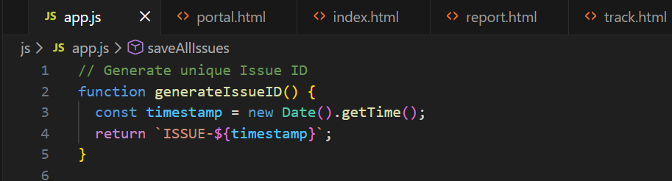
Description: Generates a unique identifier for each issue using the current timestamp.

Figure A2: Retrieving Issues from Local Storage (app.js)
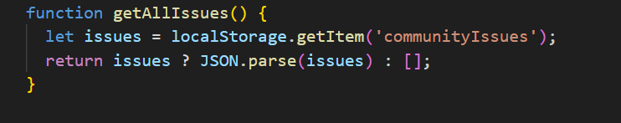
Description: Retrieves all previously stored issues from the browser’s Local Storage.

Figure A4: Report Form Submission Event Listener (report.js)

Description: Captures and prevents default form submission to process issue data using JavaScript.
Figure A5: Issue Object Creation (report.js)
Description: Searches the stored issues array to locate a specific issue using its unique ID.

Figure A6: Searching Issue by ID (track.js)
Description: Searches the stored issues array to locate a specific issue using its unique ID.

Figure A7: Displaying Issue Details Dynamically (track.js)
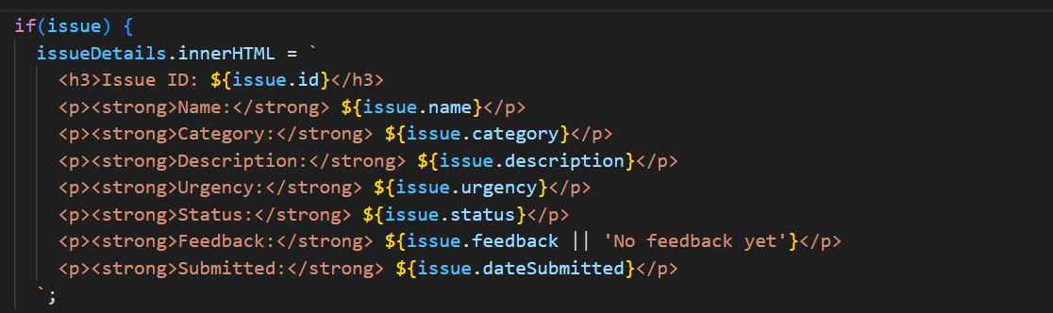
Description: Dynamically renders issue details on the tracking page after successful search.

Figure A8: Admin Login Validation (admin.js)
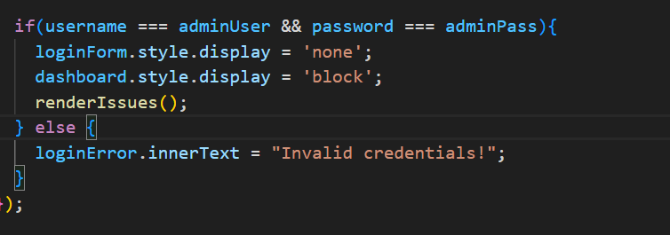
Description: Validates administrator credentials before granting access to the dashboard.

Figure A9: Rendering Issues in Admin Dashboard (admin.js)
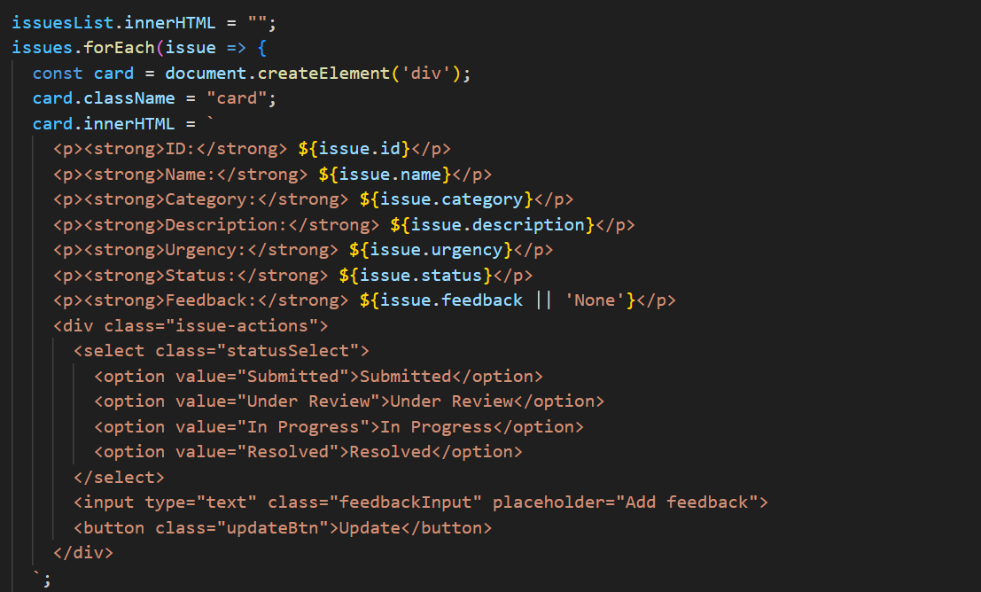
Description: Iterates through all stored issues and displays them dynamically in the admin interface.

Figure A10: Admin Issue Update Mechanism (admin.js)
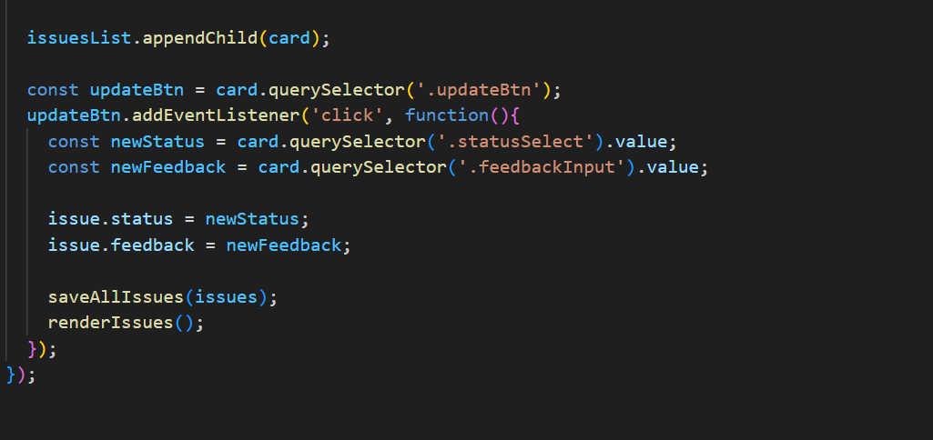
Description: Allows administrators to update issue status and feedback in real time.

